Dataset :

pokeman.csv having 721 lines

1. Log in to grunt shell using command pig -x local

2. Load data using

LOAD_DATA = LOAD '/home/acadgild/Pokemon.csv' USING

PigStorage(',')

AS(Sno:int,Name:chararray,Type1:chararray,Type2:chararray,Total:int,

HP:int,Attack:int,Defense:int,SpAtk:int,SpDef:int,Speed:int);

3.dump data and check data is loaded or not using

dump LOAD_DATA;

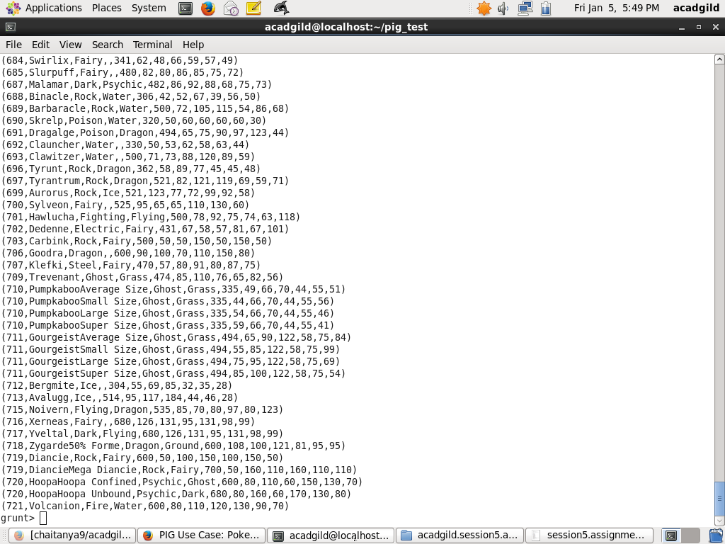

**Ques 1: Find the list of players that have been**

**selected in the qualifying round**

**(DEFENCE>55).**

grunt> selected_list = FILTER LOAD_DATA BY Defense>55;

grunt> dump selected_list;



**Ques 2: State the number of players taking part**

**in the competition after getting selected in the**

**qualifying round.**

grunt> group_selected_list = Group selected_list All;

grunt> count_selected_list = foreach group_selected_list GENERATE

COUNT(selected_list);

grunt> dump count_selected_list;

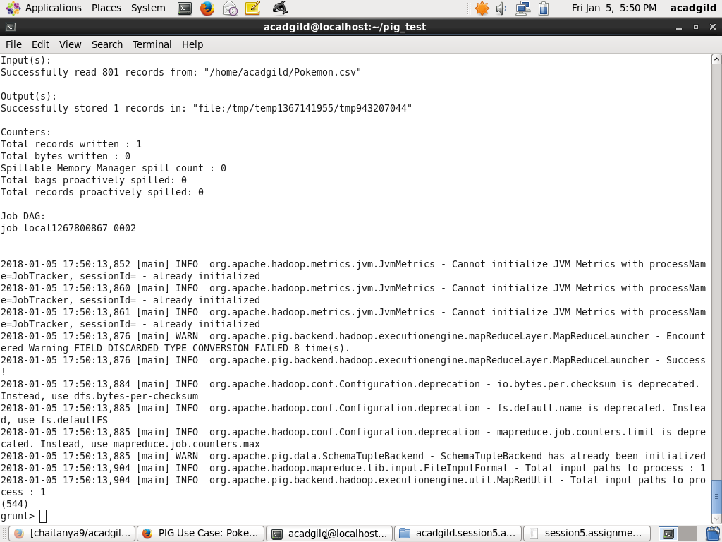

**Ques 3: Using random() generate random**

**numbers for each Pokémon on the selected**

**list.**

grunt> random_include1 = foreach selected_list GENERATE

RANDOM(),Name,Type1,Type2,Total,HP,Attack,Defense,SpAtk,SpDef,Speed;

grunt> dump random_include1;

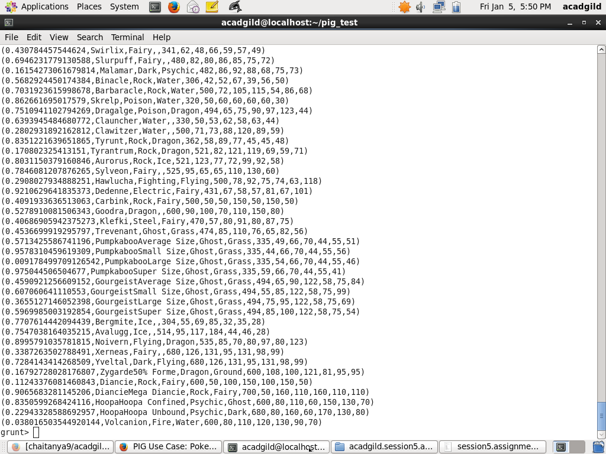

**Ques 4: Arrange the new list in a descending**

**order according to a column randomly.**

grunt> random1_desending = ORDER random_include1 BY $0 DESC;

grunt> dump random1_desending;

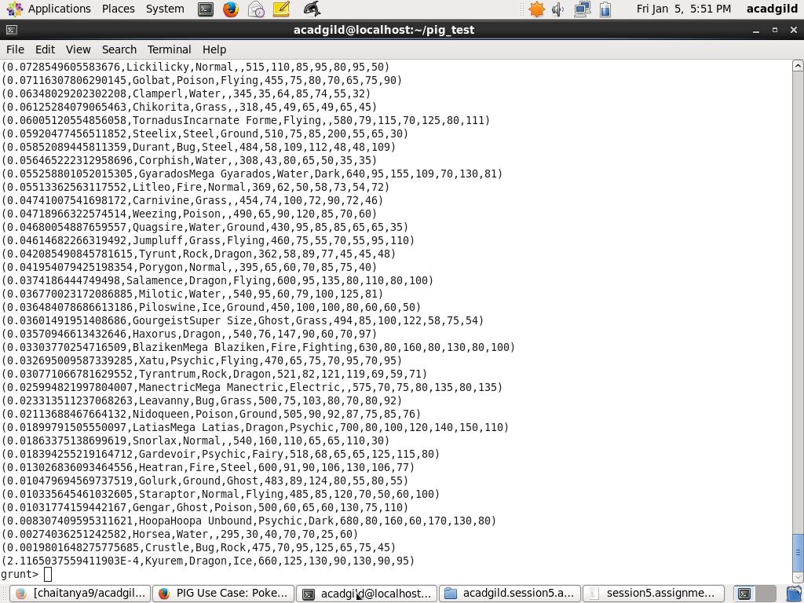

**Ques 5: Now on a new relation again associate**

**random numbers for each Pokémon and**

**arrange in descending order according to**

**column random.**

grunt> random_include2 = foreach selected_list GENERATE

RANDOM(),Name,Type1,Type2,Total,HP,Attack,Defense,SpAtk,SpDef,Speed;

grunt> dump random_include2;

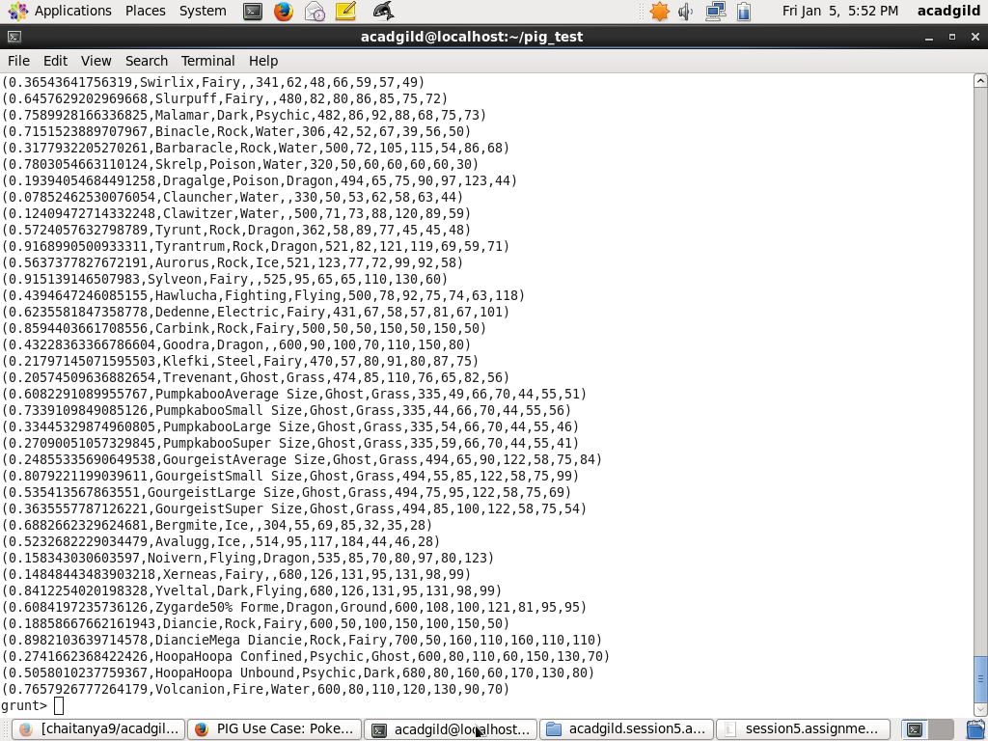

grunt> random_Desc = ORDER random_include2 BY $0 DESC;

grunt> dump;

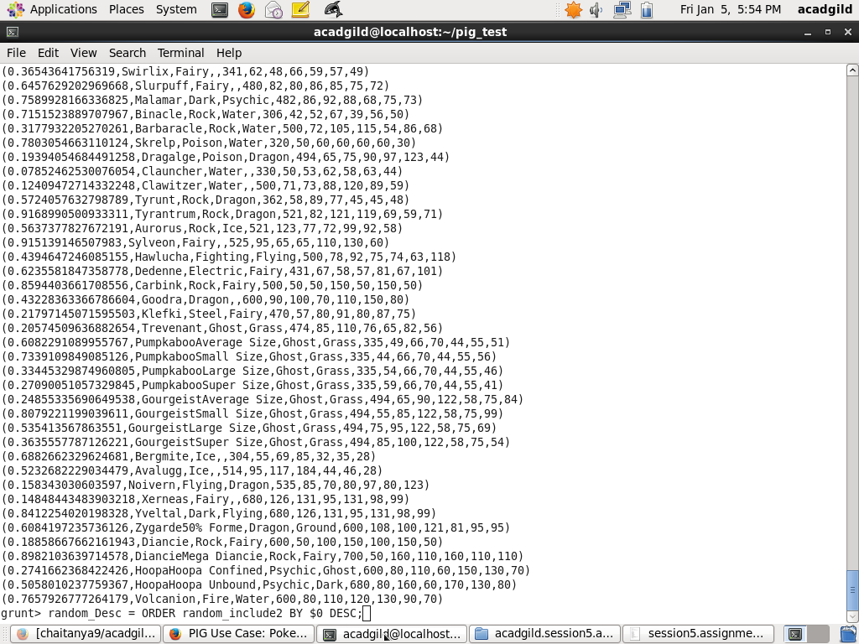

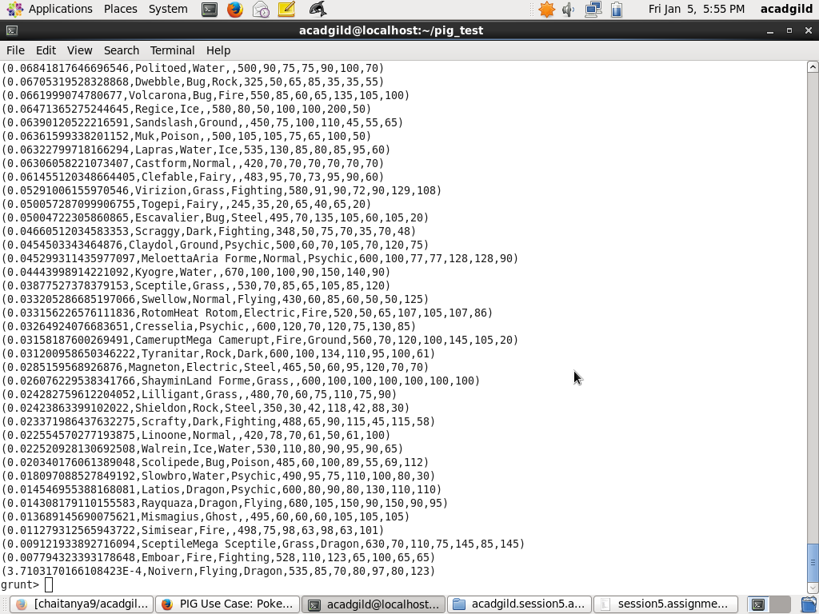

**Ques: From the two different descending lists**

**of random Pokémons, select the top 5**

**Pokémons for 2 different players.**

grunt> limit_data_random1_desending = LIMIT random1_desending 5 ;

grunt> dump limit_data_random1_desending;

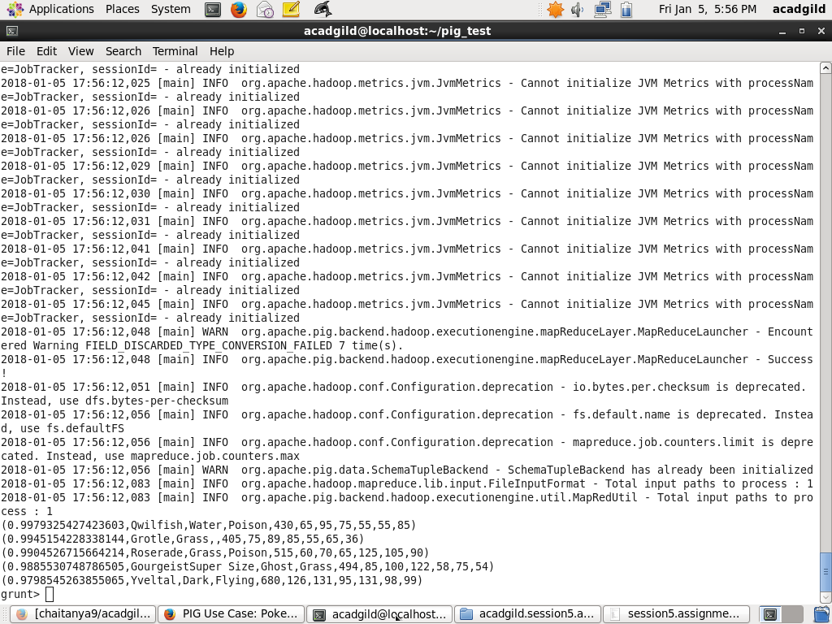

grunt> limit_data_random2_desending = LIMIT random_Desc 5 ;

grunt> dump limit_data_random2_desending;

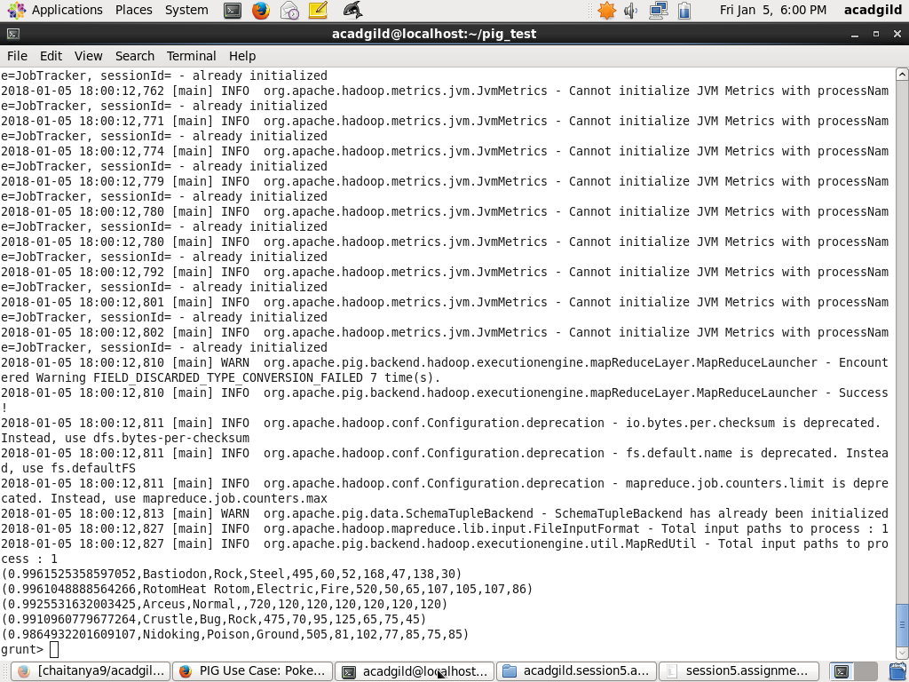

**Ques: Store the data on a local drive to**

**announce for the final match. By the name**

**player1 and player2 (only show the NAME and**

**HP).**

grunt> filter_only_name1 = foreach limit_data_random1_desending

Generate ($1,HP);

grunt> dump filter_only_name1;

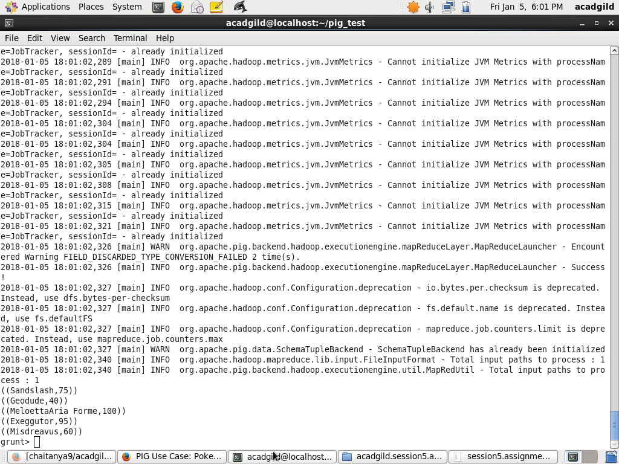

grunt> filter_only_name2 = foreach limit_data_random2_desending

Generate ($1,HP);

grunt> dump filter_only_name2;

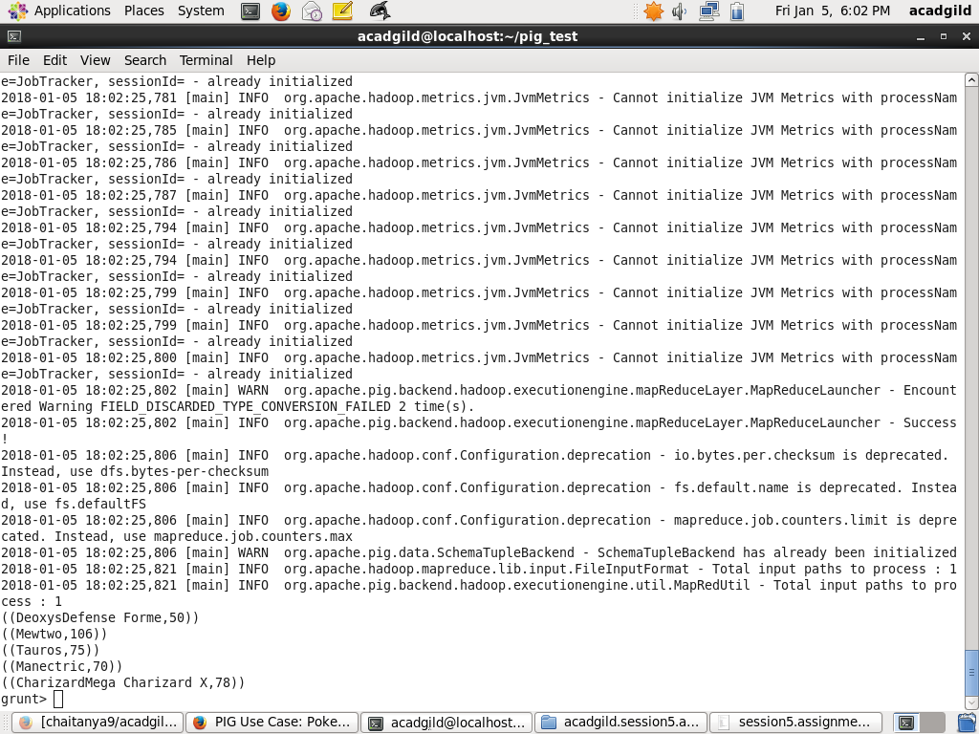

grunt> STORE limit_data_random1_desending INTO '/home/acadgild/player1';

For this querry am not getting the output

If I execute it is asking the input from terminal

