Write a Scala application to find the Nth digit in the sequence

1. Write the function using standard for loop

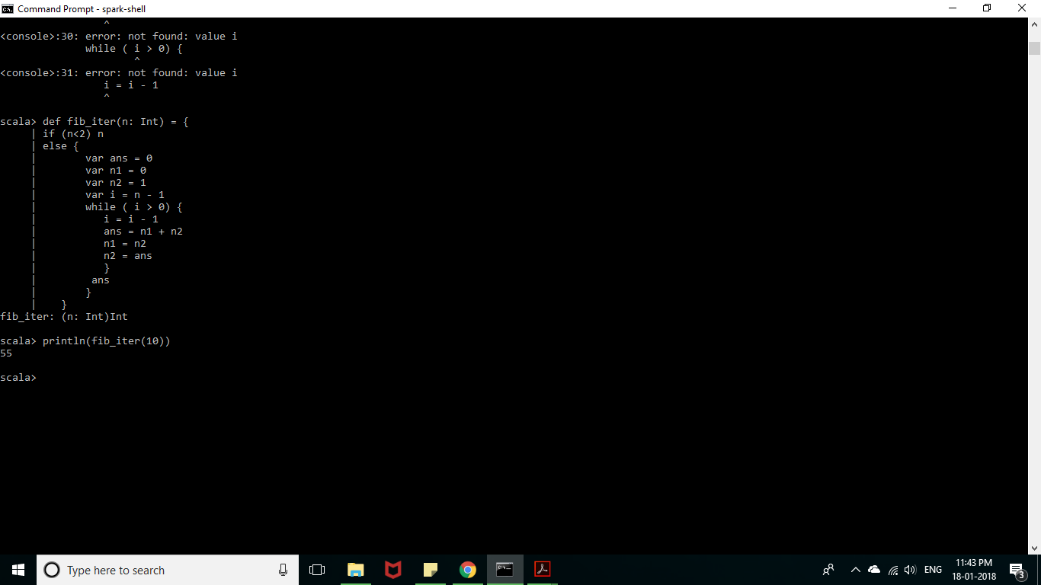

2.write the function using recursion

