**Sample application Corda**

**End Result:** 2 nodes communicate with each other ( IOU )

* 2 nodes and 1 notary – Everything in different machines
* Maven build
* Network Map implementation
* Spring Boot Framework at last

**IOU Contract**

**Setting up the nodes**

1. **Empty directory**

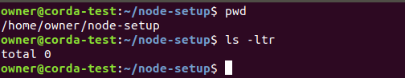

1. **Copying the required JAR files or downloading it from online**



1. **Creating a Empty folder nodes and add the respective configuration files for each node**

**2 Nodes and a notary**

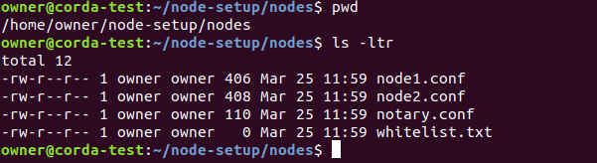

1. **What is present as part of the configuration file**

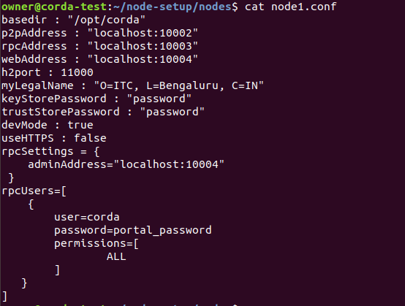

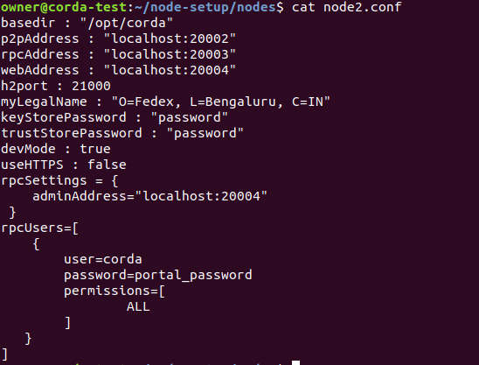

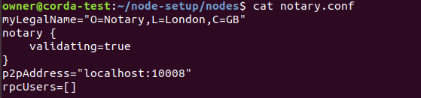

1. **Run the bootstrap utility to generate required information/config for all the jars**

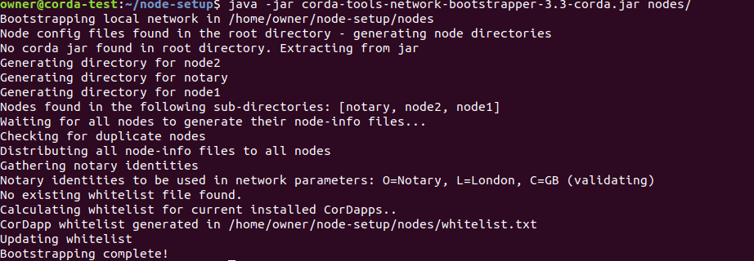

1. **After bootstrapping**

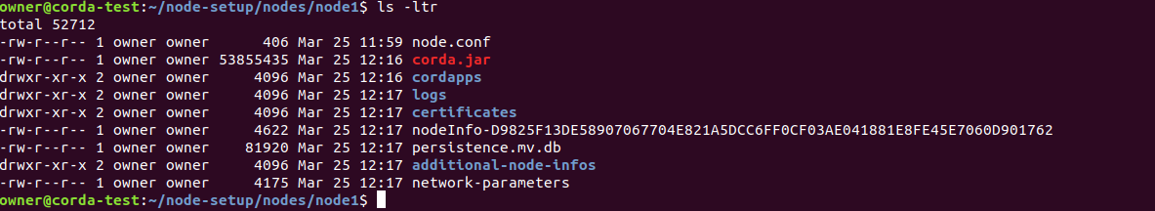

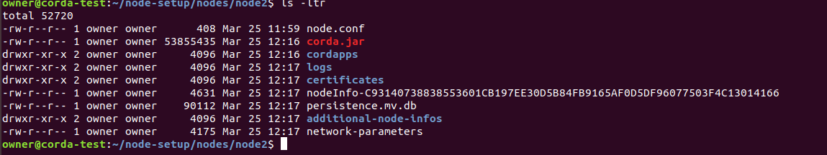

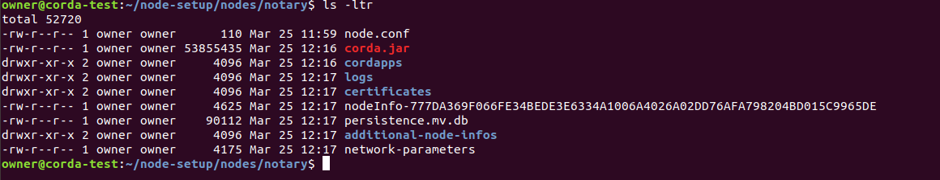

1. **Adding the cordapp JAR which was created as part of IOU application**



1. **Starting each node from separate directory**

**Use the following command to start the Corda Service**

**Similarly Start Node1 and notary Service**

