**Publishing NPM Package**

1. Introduction

Publishes a package to the registry so that it can be installed by name. All files in the package directory are included. So the same module can be installed by anyone who wishes to use it, the packages published will be available to everyone the same way other NPM open source packaged are available.

1. Prerequisite

* Npm should be installed on your machine
* To check npm is installed or not type the command **npm –version**

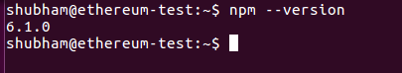

* We should get the version as output , if not we need to install **Nodejs** (**Npm comes along with node**)
* Need to have npm account
* <https://www.npmjs.com/>

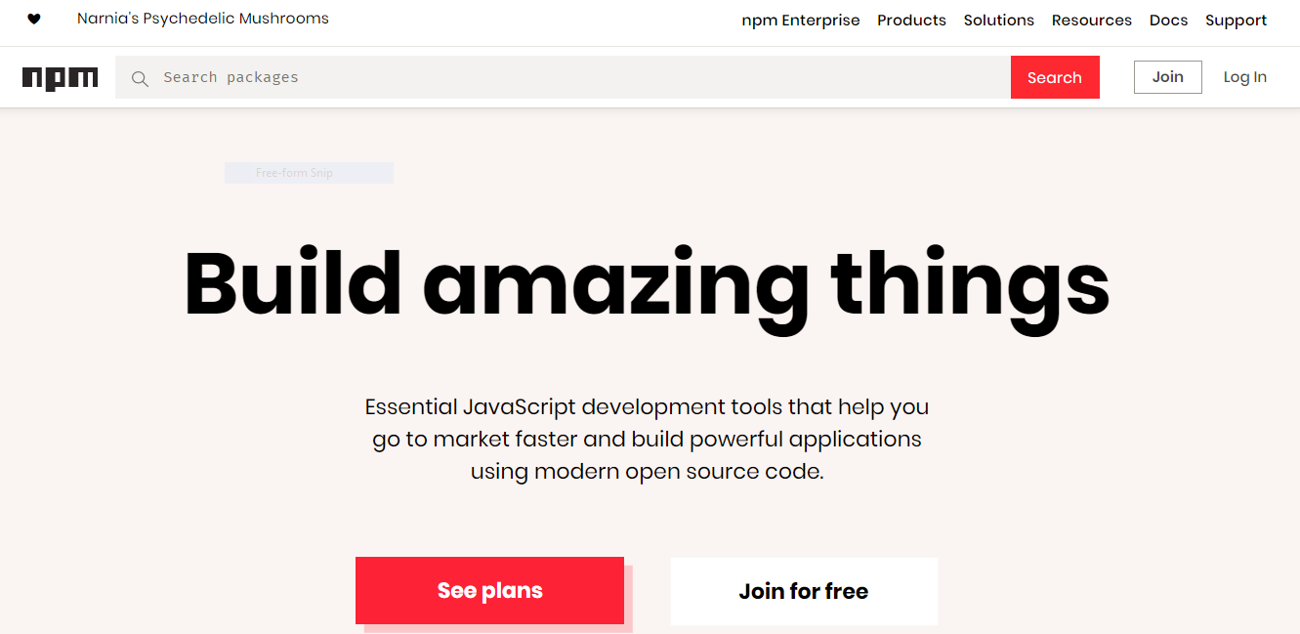

1. Publishing Package

* We have Login to our NPM account

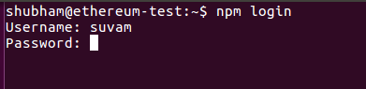

* We go to the folder of package we want to publish give the command **npm publish**



* To check we need to login to our account and check for the list of package

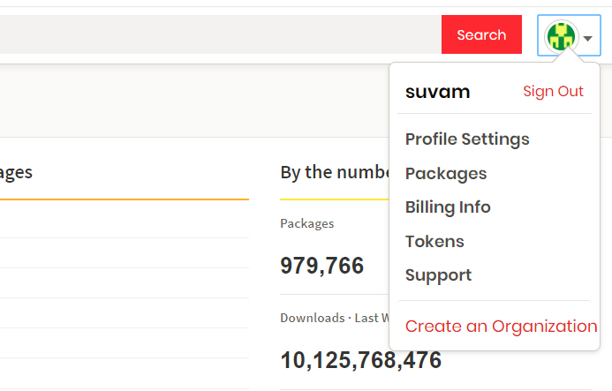

* To get list of packages published we select the packages option from the drop down
* Once we select we should have a dashboard showing the list of packages uploaded

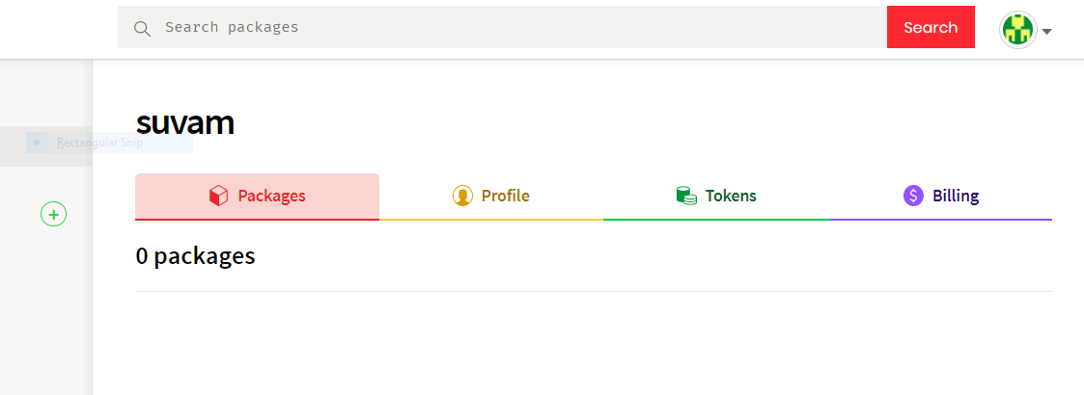

* Now in order to install the package in any of your project just type **npm install <fabric_operation>**
* Now to use node module that we have installed we need to require it and use it

