Class implementation – Interface

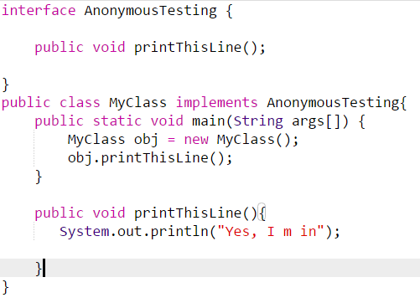

Anonymous Class implementation – Interface

For the purpose of inheritance, a class is not defined and implemented. Instead anonymous class was used and inherited )

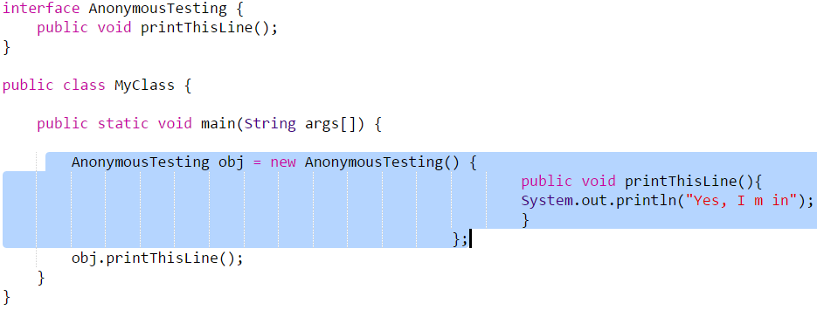

Lambda Expressions without Return

* Anonymously invoking the interface function
* **There should be only one function in this type of interface – This is called function interface. It can contain equals method**

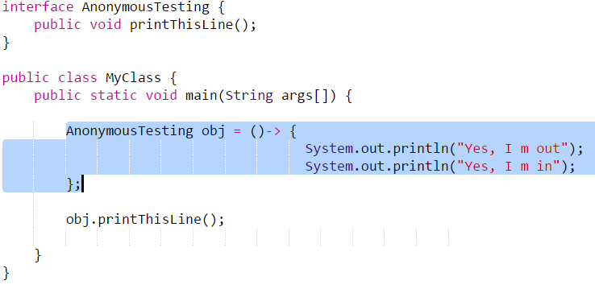

Lambda Expressions returning an integer

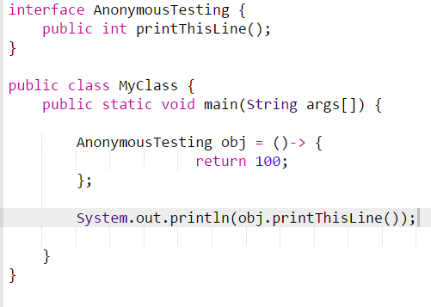

Lambda Expressions returning an integer with input params

