**Assessment Cover Sheet**

|  |  |  |  |
| --- | --- | --- | --- |
| Unit number: | ICT923 | Unit name: | Information Technology Project Management |
| Lecturer or Tutor name: |  | | |

|  |  |  |
| --- | --- | --- |
| Student ID | Student name | Contribution |
| CIHE240843 | Sunil Dahal | 25 % |
| CIHE241344 | Prashar Dahal | 25 % |
| CIHE241090 | Suman Puri | 25 % |
| CIHE240531 | Dawa Gyeltshen | 25 % |

|  |  |  |  |  |  |
| --- | --- | --- | --- | --- | --- |
| Submission Title: | **ICT923- Information Technology Project Management Assessment 2** | | | | |
| Word Count: | 3000 | Due date: | 04/05/2025 | Date submitted: | 04/05/2025 |

* I hold a copy of this assignment if the original is lost or damaged.
* I hereby certify that no part of this assessment or product has been copied from any other student’s work or from any other source except where due acknowledgement is made in the assessment.
* I hereby certify that no part of this assessment or product has been submitted by me in another (previous or current) assessment, except where appropriately referenced, and with prior permission from the Lecturer for this unit.
* No part of the assessment/product has been written/produced for me by any other person except where collaboration has been authorised by the Lecturer concerned.
* I am aware that this work will be reproduced and submitted to plagiarism detection software programs for the purpose of detecting possible plagiarism **(which may retain a copy on its database for future plagiarism checking).**

**Crown Institute of Higher Education Pty Ltd** ABN:22 611 573 301 TEQSA Provider ID: PRV 14301 CRICOS Provider Code: 03744B

116 Pacific Highway North Sydney NSW 2060 P 02 9955 0488 F 02 9955 3888

Crown Institute of Higher Education

Contents

**1.** Introduction 3

**1.1** Overview of the Project Topic 3

**1.2** Relevance and Real-World Application of the Project 3

1.3 Objectives of the Project 4

2. Project Analysis and Requirements 4

2.1 Analysis of the Project Scope and Requirements 4

2.2 Main Features the System Needs (Requirements) 4

2.3 Feasibility and Limitations 5

3. Project Design and Planning 7

3.1 How the System Will Be Built (Software Design) 7

3.2 How We’ll Work Together (Project Methodology) 7

3.3 Possible Problems and How We’ll Handle Them (Risk Assessment) 8

3.4 Who Will Do What (Team Roles) 8

4. Project Plan Using Project Libre 9

4.1 Work Breakdown Structure (WBS) 9

4.2 Project Schedule with Milestones 11

4.3 Task Dependencies and Timelines 12

4.4 Gantt Chart (to be created in Project Libre) 12

5. Software Development Process Evaluation 13

5.1 Best Practices for Good Software Development 13

5.2 Testing and Quality Assurance (QA) 13

5.3 Ethical Considerations in Software Development 14

6. Team Contribution and Responsibilities 14

7. Conclusion 14

Reference 15

# **1.** Introduction

The Online Medical Appointment System offers a user-friendly and comfortable system which meets the needs of healthcare professionals alongside patients to diminish medical appointment scheduling complexities. The system seeks to extend healthcare service reach while cutting patient wait times and enhancing overall care quality because of digital healthcare demand expansion. The system optimizes time management while decreasing healthcare provider administrative tasks through online appointment management that lets patients schedule appointments and modify or control their appointments and involves essential system components which include appointment notification features and protected payment methods and medical record storage. This digital solution provides fast and secure operations which serve the present needs of patients and health professionals amidst the digital transformation.

## **1.1** Overview of the Project Topic

Users benefit from an online application known as the Online Medical Appointment System that enables simple scheduling and adjustment of doctor appointments. The system derives from Agile methodology although it implements iterative development to achieve continuous upgrades based on user feedback and shifting requirements. The system expands appointment capabilities and enhances entire patient interactions through features such as instant access scheduling availability and automatic reminder systems together with safe transaction methods and seamless patient documentation accessibility. Agile principles enable the project to change with developing requirements and goals thus resulting in user-focused solutions that respond effectively to healthcare industry speed demands. The methodology implements constant improvements which adapt the system to meet patient expectations along with health professional requirements via staged adjustments.

## **1.2** Relevance and Real-World Application of the Project

Modern healthcare technology adoption in medical service delivery makes the Online Medical Appointment System highly applicable. The requirement to create effective easy-to-use appointment scheduling systems has increased tremendously because healthcare needs are rising because of worldwide health difficulties and technological advances. The new system eliminates healthcare limitations caused by prolonged waiting times as well as management mistakes and slow administrators typically encountered in traditional medical services. The automation of appointment booking combined with payment handling and reminder systems gives better care to patients and decreases missed appointments while healthcare personnel dedicate their efforts to treating patients. This method enables its application in hospital settings as well as clinics and private offices for better communication between patients and providers. This system enhances process operations along with medical service delivery to different patient groups as part of healthcare digital transformation. The global movement toward digital health solutions has rendered online appointment systems highly essential now because of the COVID-19 pandemic. Patients can anticipate dual benefits from the online medical appointment system because it enhances both medical access and clinical staff productivity.

## 1.3 Objectives of the Project

The key objectives of this project are

* The goal is to design and develop a user-friendly online medical appointment system.
* The goal is to automate the appointment booking process for patients and doctors.
* The goal is to ensure secure storage and handling of personal and medical data.
* The system is designed to allow administrators to track and manage appointments easily.
* Our goal is to provide a responsive platform that works seamlessly across devices.

# 2. Project Analysis and Requirements

## 2.1 Analysis of the Project Scope and Requirements

The Online Medical Appointment System emphasizes accessibility, efficiency, and security to schedule medical appointments. The project scope includes functional and non-functional needs essential to its success.

**Project Scope**

* **Enhance Accessibility**: Create a simple system for patients to schedule, change, and control appointments online.
* **Improve Time Management:** Simplify patient and provider scheduling to cut administrative load and wait times.
* **Ensure Security and Privacy**: Choose strong data protection methods for patient information security as well as maintenance of privacy standards.
* **Increase Efficiency**: The practice should enhance its efficiency through automation of both patient information handling and payment systems as well as scheduling alerts.
* **Support Scalability**: Design the system to manage more users and appointments as the site grows.
* **Facilitate Continuous Improvement**: Based on user input and changing requirements, employ an Agile strategy for iterative development and improvement.

## 2.2 Main Features the System Needs (Requirements)

**Functional Requirements:**

* **User Registration and Login:** The practice should enhance its efficiency through automation of both patient information handling and payment systems as well as scheduling alerts.
* **Appointment Booking:** Patients choose doctors based on their practice area along with clinic accessibility and free appointment timings. Patients can choose a time and schedule visits. The system delivers email/SMS confirmations to both the patient and the doctor, automatically scheduling appointments.
* **Doctor Availability Management:** Doctors can view and update their appointment schedules.
* **Appointment Reminders:** Both patients and doctors will obtain appointment notifications through email and SMS messages.
* **Admin Dashboard:** Through the application interface Admin can both view and handle profiles and appointments for patients and doctors.
* **Appointment History:** Patients together with doctors possess access to both past medical appointments and future scheduling sessions.
* **Cancellation and rescheduling:** Patients have the option to modify their appointment schedule on the system which triggers automatic confirmation notifications.

**Non-Functional Requirements:**

* **Security and privacy:** Sensitive patient and doctor data, like personal and medical information. The system must follow GDPR or HIPAA data privacy laws. MFA and strong password policies should be required for users.
* **Performance:** The system should be scalable to handle increasing traffic when patients, doctors, and administrators join, and it should respond to user activities like making an appointment in 2 seconds.
* **Reliability:** A system must exhibit fault tolerance through automated recovery of errors including server failure and enable uninterrupted service for 24 hours a day with minimal expected service interruptions below 1%.
* **Usability:**  The system design requires a simple interface that enables easy use by patients as well as doctors and administrative staff at any technical level and works across computers and mobile and tablet systems and screen dimensions.
* **Maintainability**: Ease of change execution stands as an essential requirement while existing operations should remain uninterrupted throughout the process. All code should demonstrate clear documentation which reflects best practices to sustain future code upgrades and bug resolution.
* **Load Handling**: During peak hours (evenings, weekends), the platform should handle many users.
* **Accessibility:** The system needs to fulfill all requirements of WCAG (Web Content Accessibility Guidelines) to serve disabled users.
* **Interoperability:** Listening systems will function smoothly with Electronic Health Record interfaces when transmitting information.

## 2.3 Feasibility and Limitations

Technical implementation of the online medical appointment system is possible though successful implementation demands strategic designing and sufficient funding allocation as well as limitations examination. We will analyse the project feasibility through technical feasibility as well as economic feasibility alongside operational feasibility.

**Technical Feasibility:** The scheme can work with online and mobile technology due to its technological feasibility. The technical feasibility of this scheme depends on Flask or Django web frameworks along with mobile development platforms and PostgreSQL database structures with payment processing and notification interface solutions. However, certain technical challenges must be addressed:

* **Integration with Healthcare Systems**: Due to healthcare provider standards and regulations, integrating with databases or EHR systems might be difficult. For compatibility, healthcare institutions must work closely together.
* **Security and Compliance**: Health institutions must follow security policies including HIPAA and GDPR when they manage sensitive medical information. The success criteria require encryption solutions as well as safe authentication processes plus security verification protocols.
* **Scalability**: Especially in larger hospitals, the system must manage traffic. Though difficult, load balancing and cloud services might enable the software to expand to handle more transactions and users.

**Economic Feasibility:** The project can be executed within financial limitations, but some important factors need to be considered:

* **Development Costs:** Three critical factors which determine development costs include feature complexity as well as the number of developers and integration needs with third-party services. Each part of backend development along with front-end design security policy assessment and testing requires budget allocations.
* **Maintenance and Updates**: The maintenance phase following system deployment will incur expenses for mistake corrections as well as system update installations and addition of new features. The system's expense management improves when it operates on a scalable cloud infrastructure.
* **Monetization**: The system's revenue generation may be optimized through subscription models which enable clinics to access the platform as well as transaction fees applied to consultation processing and potential advertising services. The project can sustain its financial stability through accurate predictions of various income sources.

**Operational Feasibility:** Operational feasibility looks at how well the system runs in an actual environment

* **User Adoption**: User adoption of this system depends on healthcare practitioners along with patients providing their endorsement. A system must have basic controls together with extensive documentation and smooth integration with present procedures to generate user trust and involvement.
* **Training and Support**: A training program must be developed for healthcare staff to make the system functional. User navigation of the system and technical problems need to be resolved by the support channels which customer service provides to assist users.
* **Regulatory and Legal Considerations**: Each operation area will impose specific health data rules for the system to follow whether it is HIPAA in the United States or GDPR in the European Union. Operating patient information comes with legal implications necessitating comprehensive paperwork while patients need to provide permission.
* **System Downtime and Reliability**: Healthcare service needs constant availability with minimal system downtime since patient care requires urgent response. The operation needs effective disaster recovery plans together with systematic health assessments to operate efficiently.

**Limitations:** While building the Online Medical Appointment System is feasible, there are several limitations to consider:

* **Complexity of Integration**: provider systems because significant customization and teamwork would be essential.
* **Privacy and Security Risks**: Organizations face unauthorized data breaches risks during the handling of sensitive patient information. To meet regulatory standards for protecting sensitive information, organizations require ongoing financing for encryption initiatives and auditing processes.
* **Resource Constraints**: A complex system development that requires strong features such as mobile support and multi-language support and real-time availability requires a team of experienced people including backend developers, front-end developers, security specialists, and testers. A restricted project can occur when project participants lack specific knowledge or sufficient time.
* **Regulatory Compliance Complexity**: Healthcare data regulations exist in multiple forms and display distinct patterns among different locations. Additional legal advice along with certifications and audits for complete compliance standards could result in expensive and possibly lengthy processes.

# 3. Project Design and Planning

## 3.1 How the System Will Be Built (Software Design)

* **Frontend (UI)**: The user interface implementation will utilize HTML and CSS together with JavaScript for responsive interface design that supports desktop and mobile devices. The appointment calendar serves as an example of a dynamic component that should be built using React.js.
* **Backend (Server)**: The development of the backend system will use Node.js or Django programming languages to execute tasks such as database management and user authorization and scheduling appointments and other operations. Through API management the backend will connect the frontend to the database.
* **Database**: The application will use SQLWORKBENCH for secure storage of patient records along with doctor information and appointment details.

## 3.2 How We’ll Work Together (Project Methodology)

The project will implement Agile development methodology as its core operational system. Our project work will be divided into short sprints measuring between one and two weeks which will lead to functional feature completion each time the sprint ends.

* Planning of tasks takes place at the beginning of every sprint cycle.
* We will assess the sprint progress toward the end of each sprint before making any necessary adaptations to our plans.

**Dawa** will act as our **Scrum Master**, organizing meetings and helping to keep track of the progress.

## 3.3 Possible Problems and How We’ll Handle Them (Risk Assessment)

|  |  |  |  |
| --- | --- | --- | --- |
| **Possible Problem (Risk)** | **Chance of Happening** | **How Bad It Would Be** | **Our Solution** |
| Backend takes too long to build | Medium | High | **Prasar** starts early and gives regular updates. Team helps if needed. |
| Frontend and backend don’t connect properly | Medium | Medium | **Sunil** and **Prasar** test their parts together each week. |
| Not enough time to finish all features | High | High | Focus on core features first (booking, login), add extras later. |
| Bugs and errors during testing | High | Medium | **Suman** leads testing and ensures regular bug fixes. |
| Team confusion about tasks | Medium | Medium | **Dawa** manages task allocation and checks progress. |

## 3.4 Who Will Do What (Team Roles)

|  |  |  |
| --- | --- | --- |
| **Team Member** | **Role** | **Responsibilities** |
| **Sunil** | Frontend Developer | Design and build the UI for patients and doctors. |
| **Prasar** | Backend Developer | Build the backend system, including APIs and database management. |
| **Suman** | Tester & Documentation Lead | Test the system for bugs, write documentation, and create the final report. |
| **Dawa** | Project Organizer (Scrum Master) | Organize tasks, monitor progress, and help the team stay on track. |

# 4. Project Plan Using Project Libre

4.1 Work Breakdown Structure (WBS)

WBS stands for Work Breakdown Structure. WBS serves as a management tool through which projects split into workable segments for better control. An organized Work Breakdown Structure divides team work into functional sections which enables proper planning and assignment of duties and enables tracking of progress and scope management.

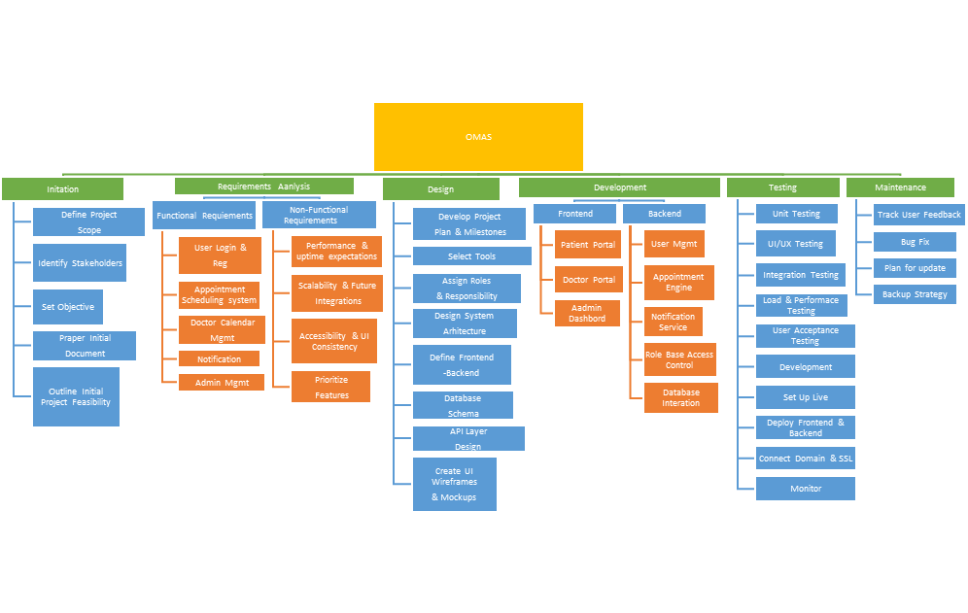

*FIG: WBS*

## 4.2 Project Schedule with Milestones

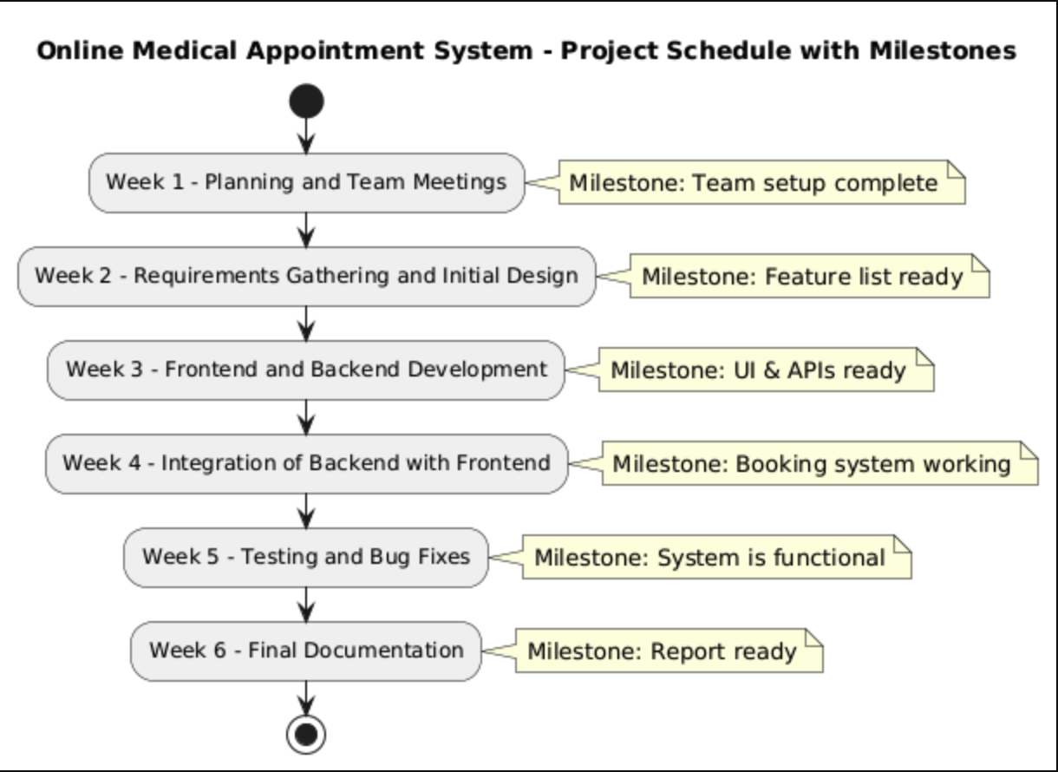

|  |  |  |
| --- | --- | --- |
| **Week** | **Main Tasks** | **Milestone** |
| Week 1 | Planning, team meetings | Team setup complete |
| Week 2 | Requirement gathering, initial design | Feature list ready |
| Week 3 | Frontend and backend development | UI & APIs ready |
| Week 4 | Backend integration with frontend | Booking system working |
| Week 5 | Testing and bug fixes | System is functional |
| Week 6 | Final documentation | Report ready |
| Week 7 | Presentation preparation | Final presentation ready |

## 4.3 Task Dependencies and Timelines

Some tasks are dependent on others:

* **Frontend design** must be done before **backend integration**.  
    
  **Database setup** must be completed before full **testing**.

## 4.4 Gantt Chart (to be created in Project Libre)

Project management relies on Gantt charts as visual tools that present both task duration distribution across time periods along with their start-time and end-time relationships. Task progression and deadline management as well as dependency detection between tasks become possible through the horizontal bars displayed in Gantt charts that show time-based representations.

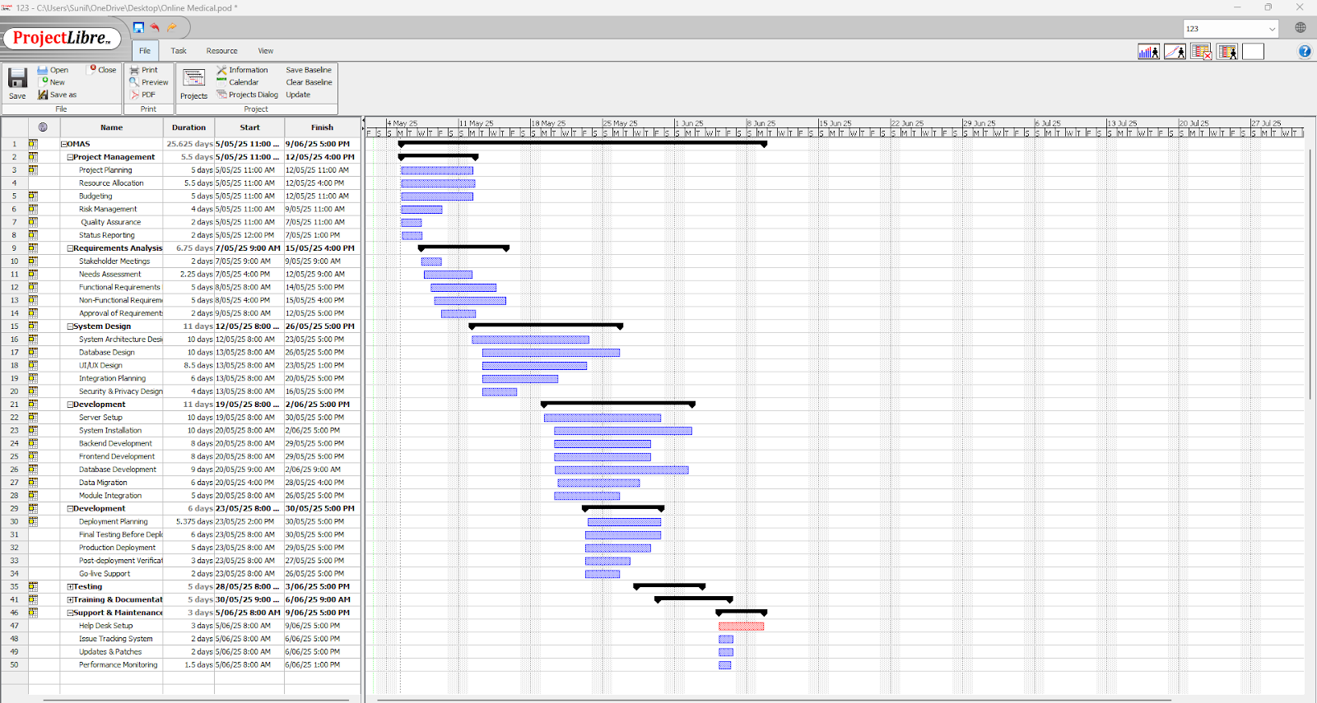

*FIG: Gantt Chart*

# 5. Software Development Process Evaluation

Agile methodology with a special focus on Scrum stands as our selection for implementing the online medical appointment system project. Our project uses agile methodology together with scrum framework due to its selection basis , is as follows:

* **Iterative development**: The healthcare system requires constant evolution which agile methods provides flexibility for appropriate changes.
* **Continuous feedback:** Regular feedback is necessary for the healthcare system to enable hospital administrators, patients, doctors to provide easy feedback in an agile methodology.
* **Rapid Prototyping**: An agile approach enables quick policy and user need adjustments because it serves as the framework.
* **Team collaborations**: The healthcare system requires team cooperation where an agile methodology improves communication throughout development testing and business user processes.

The project team conducted a method comparison that led to discarding waterfall methodology because it did not fit the requirements of the healthcare industry which experienced rapid changes.

## 5.1 Best Practices for Good Software Development

Software development of high quality online medical appointments serves as a fundamental requirement to achieve customer happiness and system dependability. The major best practices are as follows:

* **Regular Testing**: Testing must begin at early stages of development and continue until the completion of the process to uncover and resolve emerging problems.
* **Automated Testing:** Automated testing allows organizations to conduct quick quality evaluations with high efficiency.
* **User Acceptance Testing (UAT):** The software accomplishes user-targeted demands through genuine testing with end-users.
* **Clean Code**: Using simple and understandable code.

According to Merritt, K., & Zhao, S. (2021, December), regular testing, automated testing, UAT, and clean code are the best approach for a good software development.

## 5.2 Testing and Quality Assurance (QA)

An extensive testing program with quality assurance requirements needs to be implemented to enhance safety and reliability in the online medical appointment system. The following key strategies are vital for testing and quality assurance.

* **Unit Testing:** Unit testing takes place for individual backend components to assure correct functioning.
* **Frontend Testing**: The user interface functions and interacts with users for usability through frontend testing procedures.
* **Integration Testing:** Testing front-end and backend integration is a responsibility of this system.
* **Manual Testing**: System tests are manually performed to discover both bugs and usability issues.

## 5.3 Ethical Considerations in Software Development

Online medical appointment systems require special attention to ethical considerations because healthcare assets remain highly vulnerable. Major ethical considerations in our online medical appointment are as follows:

* **Data privacy and confidentiality:** Our system handles data storage and protection functions.
* **Informed Consent:** Patients must grant their consent for data utilization before the system proceeds with its usage. This builds trust in patients.
* **Transparency**: The system presents to users the details about the data processing purposes.

# 6. Team Contribution and Responsibilities

|  |  |  |
| --- | --- | --- |
| **Team Member** | **Role** | **Responsibilities** |
| **Sunil** | Frontend Developer | Built the user interface and ensured it was responsive. |
| **Prasar** | Backend Developer | Built the backend, created APIs, and set up the database. |
| **Suman** | Tester & Documentation | Led testing and ensured everything was bug-free. |
| **Dawa** | Project Organizer | Managed tasks and kept the team on track. |

# 7. Conclusion

The Online Medical Appointment System functions as the crucial instrument to improve booking and medical appointment management operations. Our team has effectively planned and allocated responsibilities throughout our tasks while expecting the system to serve medical patients and doctors in a straightforward manner. The project has high success potential thanks to best practices alongside Agile methodology and secure data management techniques.

**Future recommendations and improvements**

Future development of the Online Medical Appointment System requires the addition of EHR connectivity for data exchange between systems alongside scheduling support through AI features and automation functions and mobile applications for accessibility expansion. Dynamic functionality additions such as multilingual operations alongside telemedicine options alongside advanced analytics capabilities will expand system reach and operational potential as well as deliver better healthcare performance management and patient health outcome results to providers. The system will gain better user trust and improved experiences by following WCAG standard guidelines and further secure itself with biometric authentication and regular data assessment programs and real-time feedback functions. Symptom-based triaging procedures with emergency booking slots enable the system to execute urgent care functions effectively.

# Reference

Chaudhry, S., Batool, F., Muhammad, A. H., & Siddique, A. (2021). Designing an Online Appointment System for Semiliterate Users. *Intelligent Automation & Soft Computing*, *28*(2)

Humphries, A. W., & Naisawald, G. V. (1991). Developing a quality assurance program for online services. *Bulletin of the Medical Library Association*, *79*(3), 263.

Stober, T., & Hansmann, U. (2010). *Best practices for large software development projects*. Springer.

Gangal, A., Stoff, B., & Blalock, T. W. (2023). Ethical considerations for direct scheduling of patient appointments. *JAAD international*, *10*, 39-40.

Ajiga, D., Okeleke, P. A., Folorunsho, S. O., & Ezeigweneme, C. (2024). Navigating ethical considerations in software development and deployment in technological giants. International Journal of Ethics and Research Utilization, 7(1).

Gogoll, J., Zuber, N., Kacianka, S., Greger, T., Pretschner, A., & Nida-Rümelin, J. (2021). Ethics in the software development process: from codes of conduct to ethical deliberation. *Philosophy & Technology*, *34*(4), 1085-1108.

Acuna, S. T., De Antonio, A., Ferre, X., Maté, L., & López, M. (2001). The Software process: modeling, evaluation and improvement. In *Handbook of Software Engineering and Knowledge Engineering: Volume I: Fundamentals* (pp. 193-237).

Paz, F., & Pow-Sang, J. A. (2016). A systematic mapping review of usability evaluation methods for software development process. *International Journal of Software Engineering and Its Applications*, *10*(1), 165-178.

Tonchia, S. (2008). *Industrial Project Management Planning, Design, and Construction*. Springer.

Chung, L., Nixon, B. A., Yu, E., & Mylopoulos, J. (2012). *Non-functional requirements in software engineering* (Vol. 5). Springer Science & Business Media.

Malan, R., & Bredemeyer, D. (2001). Functional requirements and use cases. *Bredemeyer Consulting*, 335-1653.

Grady, J. O. (2010). *System requirements analysis*. Elsevier.

Winter, R., & Strauch, B. (2003, January). A method for demand-driven information requirements analysis in data warehousing projects. In *36th Annual Hawaii International Conference on System Sciences, 2003. Proceedings of the* (pp. 9-pp). IEEE.

Schwalbe, K. (2009). *Introduction to project management*. Boston: Course Technology Cengage Learning.

Highsmith, J. (2009). *Agile project management: creating innovative products*. Pearson education.