LearnToday

Spring Boot with REST Specification Document
Purpose of this document
The purpose of this document is to specify a REST API for the LearnToday application.
Definitions & Acronyms
Definition / Acronym | Description
REST | Representational State Transfer
Project Overview
LearnToday is an online training application which allows students to view all the courses and allows them to enroll for the courses. It also features trainer registration and signin actions.
Scope
- Develop LearnToday SpringBoot application using Spring REST.
- Test the actions using Postman.
Intended Audience
- Application Architect
- Project Manager
- Test Manager
- Development Team
- Testing Team
Hardware and Software Requirement
Hardware Requirement:
- Developer Desktop PC with 8GB RAM
Software Requirement:
- Eclipse/ Spring Tool Suite/ IntelliJ etc
- Maven
- JDK 8 or later
4. Postman tool

Use Case Diagram
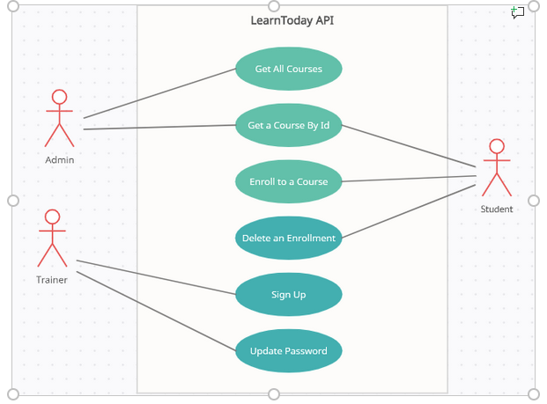
Table Specification
The sample Database and Table will be given for your reference:
Database Name: LearnTodayRESTAPIDb
Table: Course
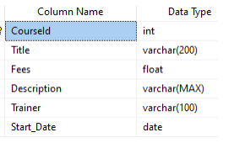
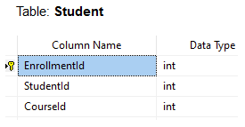
ER Diagram
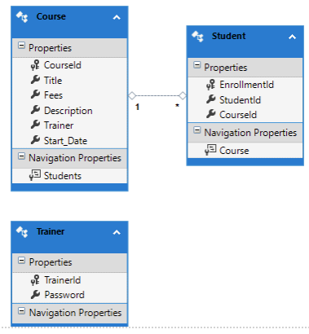

Design Considerations
- Create the Database and the set of tables as per the table specifications.
- Create the model classes as per the requirement.
- Use Spring Data JPA for data access
- Business logic should be implemented in the Service classes.
- Controller classes should hold the mapping as per the given specification.
- Use DAO layer to interact with the Database.

REST Controllers and Postman Test Specification
Create a new AdminController which will contain 2 action methods:

Method Type | Method Name | Parameter | Return Type | Description
Method: GET | getAllCourses | No Parameter | ResponseEntity<Object> | This method will return all the courses.
Method: GET | getCourseById | int id | ResponseEntity<Object> | Here the course will be searched by course id. If searched course is found it will return HttpStatus.OK and the searched course data. Otherwise it will return HttpStatus.NOT_FOUND with a message "Searched Data not Found".

Below is POSTMAN screenshot for getAllCourses action:
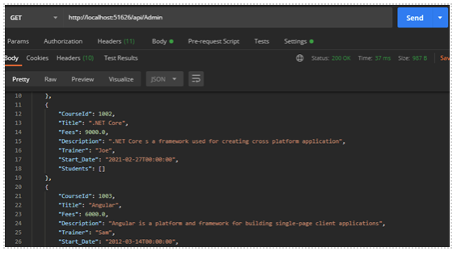
Below is POSTMAN screenshot for getCourseById action:
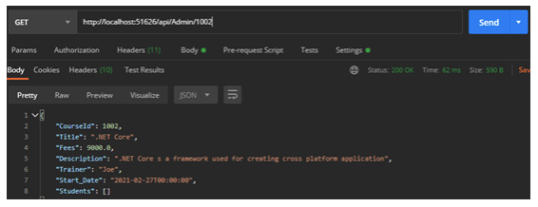
If Course is not found by searched Course Id below is the Postman result:
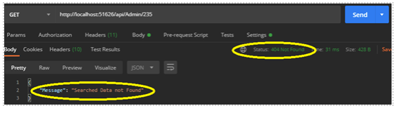
Create a new StudentController with the below 3 action methods:
Method Type | Method Name | Parameter | Return Type | Description
Method: GET | getAllCourses | No Parameter | ResponseEntity<Object> | This method will return all the courses in ascending order by start date
Method: Post | postStudent | Student model | ResponseEntity<Object> | This method is used to method to enroll student for the course. Input student information thru the request body. Use try-catch block. Return HttpStatus.CREATED with the model object if enrollment is successful; otherwise return HttpStatus.BAD_REQUEST with exception object in catch block.
Method:@DELETE | deleteStudentEnrollment | int id | ResponseEntity<Object> | This method is used to remove the student information by the enrollment id Use a try catch block. If deletion successful then return HttpStatus.OK. If enrollement information is not found by searched id then return HttpStatus.NOT_FOUND with a message "No enrollement information found". Under catch block return HttpStatus.BAD_REQUEST with exception object if some exceptions occur in the program.

Below is POSTMAN screenshot for getAllCourses action:
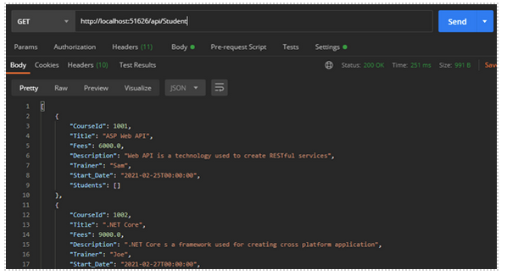

Below is POSTMAN screenshot for postStudent action:
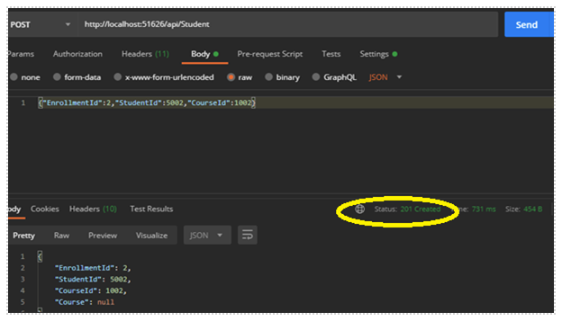
Below is POSTMAN screenshot for deleteStudentEnrollment action:
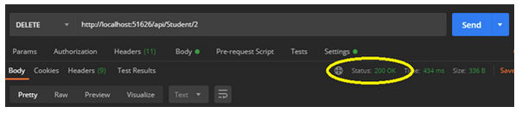
Below is POSTMAN screenshot for deleteStudentEnrollment action if searched enrolment id is not found:
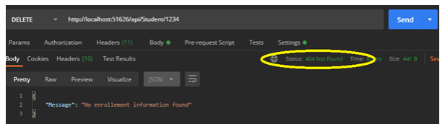
Create a new TrainerController with below 2 action methods:

Method Type | Method Name | Parameter | Return Type | Description
Method:Post | trainerSignUp | Trainer model | ResponseEntity<Object> | This method is used to register new trainer. Input trainer information by using @RequestBody annotation. Use try-catch block. Return HttpStatus.CREATED with the model object if sign up is successful; otherwise return HttpStatus.BAD_REQUEST with exception object in catch block.
Method: PUT | updatePassword | int id, Trainer model | ResponseEntity<Object> | This method will update trainer password by accepting trainer id from url and Trainer object from message body. If password update is successul then provide HttpStatus.OK response output with a message “Data updated successfully”; otherwise provide HttpStatus.NOT_FOUND response output with message "Searched Data not Found". Use try catch block. If there is any exception raised catch it and provide an HttpStatus.BAD_REQUEST response along with exception object.

Below is POSTMAN screenshot for trainerSignUp action:
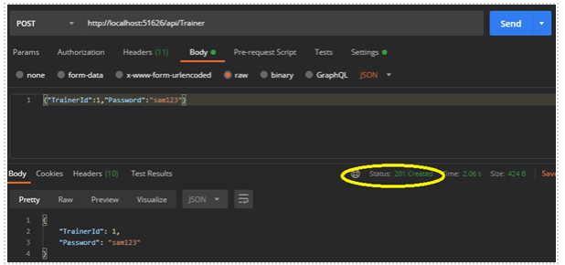
Below is POSTMAN screenshot for updatePassword action:
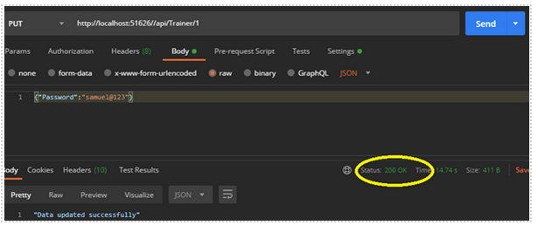
Below is POSTMAN screenshot for updatePassword action if trainer id not found:
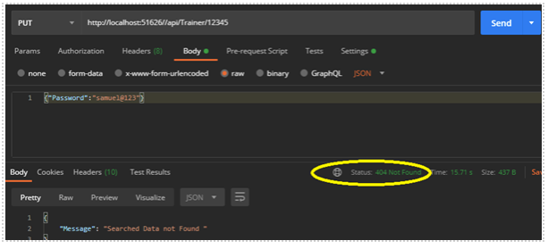
Note: Integrate JWT for Security and integrate Swagger

