Program to generate a Student’s Report Card

Expected Output
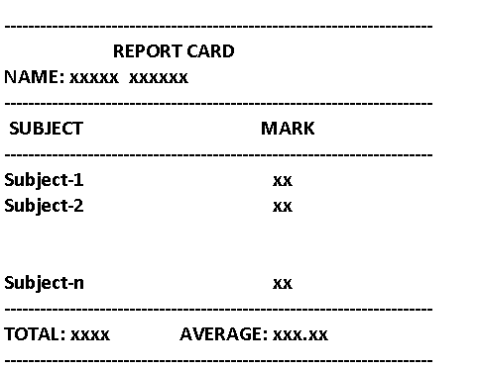

Sample Input 1
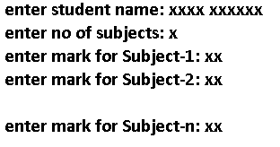
Notes:
Average should be with two fractional parts
Student’s Name should have only alphabets and spaces

