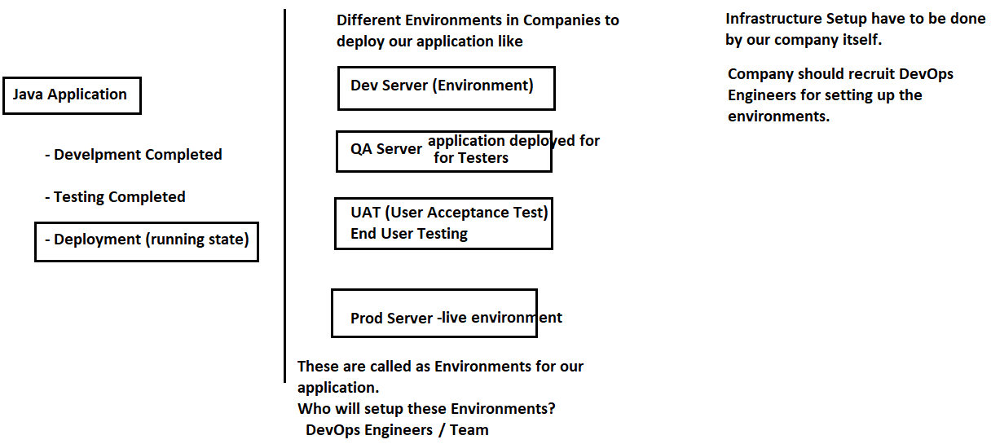

To do the above Environment Setups , we need the following

1) We need Machines 2) We need OS 3) We need Servers 4) We need Installation

5) Server Setup 6) Deployment Process 7) Monitoring 8) Managing

9) Admin People

To do all the above operations, Administrators are required

In Production, we need to deploy the application in a Server, for example Websphere. We do not know how many clients will be accessing our application, if the request increases, we should place one more production server and it may keep on increasing. Manual Installation is required in all Production Servers

These operations are not that easy, we need someone to do the environment setups.

Whenever we go for application deployment: **What are the items required?**

Machines Required Operating Systems Required Software Required Database Required Tools Required like Git, JIRA etc . If we have all these, then only we can go for application development and deployment. Whatever applications we develop may run for lifelong or for some years or may be for 1 year; just an experimental

To arrange above things , crores of rupees required and maintenance is a problem; we need employees to manage it

Instead of purchasing , go for Pay For Use concept.

Do **Pay For Use** – If somebody already having the above setup, let us take their infrastructure for 1 year

All Cloud Environments are following **Pay for Use Concept**

**Cloud Computing**: **(google)** : Cloud computing is the on-demand availability of computer system resources, especially data storage (cloud storage) and computing power, without direct active management by the user.

Cloud computing was popularized with Amazon.com releasing its **Elastic Compute Cloud product in 2006**

* **Cloud Computing Provides computer resources on-demand basis**

**Cloud Providers In Market**

1. **AWS (Amazon Web Services 34% market share) 2) GCP (Google Cloud Platform)**
2. **Microsoft Azure 4) PCF (Pivotal Cloud Foundry) 5) vmware 6) Alibaba Cloud(china based) , 6) Salesforce etc**

All Cloud Providers are working on **Pay For Use Principal** Only. They will manage the infrastructure. **Cloud Platform is nothing but we are running our application in their environment**. We are using someone else’s systems to run our application.

**Cloud Computing provides Computer Resources on-demand basis**

**Cloud Platform provides runtime environment for our applications.**

**Uses** : We don’t want to setup the infrastructure, we don’t want to manage the servers, we don’t want to manage the databases ; just I want to run my applications.

**Java Web Services is a Technology which is used to develop a distributed application and Amazon Web Services are used to run our application**

**In Cloud 3 type of Services are available (Service Models):**

**1) IaaS (Infrastructure as a Service) (DigitalOcean, Linode, Rackspace, Amazon Web Services (AWS), Cisco Metapod, Microsoft Azure, Google Compute Engine (GCE)**

**2) PaaS (Platform as a Service) (AWS, AWS Elastic Beanstalk, Windows Azure, Heroku, Force.com, Google App Engine, Apache Stratos, OpenShift) - provides the runtime environment required to run our application**

**3) SaaS (Software as a Service) (Google Workspace/ Drive, Dropbox, Salesforce, Cisco WebEx, Concur, GoToMeeting)**

**When we go to a Cloud Provider, they will ask us - What service you want? Do you want IaaS, SaaS, PaaS?**

**Google “Iaas in Cloud Computing”**

**“SaaS in Cloud Computing” -** (Google Drive, DropBox etc)

**“PaaS in Cloud Computing” -** complete runtime environment will be provided with systems, os, server, db , tools etc

**IaaS Vs SaaS Vs PaaS (google it)**

**What is Cloud Computing Definition by AWS:**

Cloud computing is the on-demand delivery of IT resources over the Internet with pay-as-you-go pricing. Instead of buying, owning, and maintaining physical data centers and servers, you can access technology services, such as computing power, storage, and databases, on an as-needed basis from a cloud provider like Amazon Web Services (AWS). <https://aws.amazon.com/what-is-cloud-computing/>

<https://www.javatpoint.com/cloud-service-models>

Different Types of **Cloud Computing Deployment Models**

Most cloud hubs have tens of thousands of servers and storage devices to enable fast loading. It is often possible to choose a geographic area to put the data "closer" to users. Thus, deployment models of cloud computing are categorized based on their location. To know which deployment model would best fit the requirements of your organization, we should know about the types of cloud deployment models

**1) Private Cloud**

**2) Public Cloud**

**3) Community Cloud**

**4) Hybrid Cloud**

**AWS**

1. AWS stands for Amazon Web Services.
2. The AWS service is provided by the Amazon that uses distributed IT infrastructure to provide different IT resources available on demand. It provides different services such as Infrastructure as a service (IaaS), platform as a service (PaaS) and packaged software as a service (SaaS).
3. Amazon launched AWS, a cloud computing platform to allow the different organizations to take advantage of reliable IT infrastructure.

**Uses of AWS**

1. A small manufacturing organization uses their expertise to expand their business by leaving their IT management to the AWS.
2. A large enterprise spread across the globe can utilize the AWS to deliver the training to the distributed workforce.
3. An architecture consulting company can use AWS to get the high-compute rendering of construction prototype.
4. A media company can use the AWS to provide different types of content such as ebox or audio files to the worldwide files.

**Pay-As-You-Go**

Based on the concept of Pay-As-You-Go, AWS provides the services to the customers.

AWS provides services to customers when required without any prior commitment or upfront investment. **Pay-As-You-Go** enables the customers to procure services from AWS.

1. Computing
2. Programming models
3. Database storage
4. Networking

**AWS Global Infrastructure**

https://aws.amazon.com/about-aws/global-infrastructure/

1. AWS is a cloud computing platform which is globally available.
2. Global infrastructure is a region around the world in which AWS is based. Global infrastructure is a bunch of high-level IT services:
3. AWS is available in 36 regions, and 114 availability zones in 2025.

The following are the components that make up the AWS infrastructure:

1. Availability Zones
2. Region
3. Edge locations
4. Regional Edge Caches

AWS offers both IaaS & PaaS.

IaaS allows organizations to utilize AWS instead of owning and operating your own datacenter. You can simply rent VMs or physical servers from AWS.

The Platform as a Service (PaaS) on the other hand removes the need for your organization to manage the underlying platforms like a database, streaming services, etc.

This allows you to focus on the deployment and management of your core applications and not worry about the IaaS and PaaS layers

AWS is a cloud infrastructure where we can host our applications

In 2006, AWS started to offer IT services to the market in the form of web services; which is nowadays known as cloud computing

Cloud computing means it is just a term referred to storing and accessing data over the Internet; so it does not store any data in our physical hard disk. I cloud computing , we can directly access the data from a remote server.

**Why AWS?**

Assume, we need to do a hosting my web application

- To host an application - first we need to purchase a server ; if any database integration, then we need to purchase a database and based on the language specification , we need to install that (like JDK) - that means we need to setup a complete infrastructure to host my application.

If huge requests is coming to our application then we need to scale it

AWS will offer you to create one Virtual Machine, inside that VM - we can add a server, a database etc, a complete IT infrastructure can be setup

This Virtual Machine instance is known as EC2 (Elastic Compute Cloud)

**EC2**

AWS offers plenty of services under different domains like – Compute, Storage, Database, Migration, Networking and Content Delivery, Developer Tools, Management Tools, Media Services, Security, Analytics, Machine Learning, Mobile Services, AR and VR, Application Integration, Customer Engagement, Business Productivity, Desktop and App Streaming, Internet of Things, Game Development etc

EC2 is one of the most popular of AWS Offering:

**EC2 stands for Amazon Elastic Compute Cloud.**

EC2 mainly consists in the capability of :

* Renting Virtual Machines in the Cloud (EC2)
* Storing Data on Virtual Drives (EBS – Elastic Block Store)
* Distributing load across machines (ELB – Elastic Load Balancing)
* Scaling the services using an auto-scaling group (ASG)

Knowing EC2 is fundamental to understand how the Cloud works.

Amazon EC2 is a web service that provides secure and resizable compute capacity in the cloud for developers. It is very easy to scale up or down our infrastructure based on the demand . EC2 can be integrated into several other services. We only pay for what we use.

Eg**: A Business Man wants to advertise his products then he can use the AWS Services like SNS (Simple Notification Service) , EC2 for compute and S3 (Simple Storage Service) for storage**

Amazon EC2 provides instances to optimize for Compute, memory, storage, GPU (Graphic Processing Unit) processing to enable you to define the right performance combination for whatever workloads you want to run. It is also easy to resize your instances based on business or application requirements. Amazon EC2 offers a choice of flexible pricing options, with On-Demand Pricing you pay only for what you use. When you stop usage then stop payments, No long terms commitments.

**What is EBS?**

EBS stands for Elastic Block Store.

EC2 is a virtual server in a cloud while EBS is a virtual disk in a cloud.

Amazon EBS allows you to create storage volumes and attach them to the EC2 instances.

Once the storage volume is created, you can create a file system on the top of these volumes, and then you can run a database, store the files, applications or you can even use them as a block device in some other way.

Amazon EBS volumes are placed in a specific availability zone, and they are automatically replicated to protect you from the failure of a single component.

EBS volume does not exist on one disk, it spreads across the Availability Zone. EBS volume is a disk which is attached to an EC2 instance.

EBS volume attached to the EC2 instance where windows or Linux is installed known as Root device of volume.

**-> Create an Account in AWS**

aws.amazon.com > create an AWS Account > Personal > Free (Personal & Basic Plan & Free | No charge in the Free Tier)

Provide Credit Card Details

-> Login to AWS Console [My Account > AWS Management Console]

Now , we logged into AWS Console

-> Type of Users

(a) **Root User** – Console Access & Programmatic Access, got complete access to everything in the AWS Account ; recommended not to use Root User for daily activities|

(b) **IAM User** - (Identity and Access Management) - Manage Access to AWS resources

**PRACTICALS :: How to create an EC2 Instance in AWS?**

EC2 stands for Elastic Compute Cloud - - just a Virtual Machine – Virtual Servers in the Cloud

EC2 is an on-demand computing service on the AWS cloud platform.

Amazon Elastic Compute Cloud (Amazon EC2) is a web service that provides secure, resizable compute capacity in the cloud - a virtual environment.

allows the user to configure their instances as per their requirements i.e. allocate the RAM, ROM, and storage according to the need of the current task.

**Step1: Launching EC2 instance**

-> Login to AWS Console

-> Change the Region to Virginia (latest updates will come first) - or any region of choice

-> All Services > Compute > EC2

-> Dashboard > click on **"Launch Instance"**

Name and Tags:: Name: cap-ec2

Application and OS Images (Amazon Machine Image) : Ubuntu - Ubuntu Server 24.04 LTS (HVM), SSD Volume Type

Select "Free tier Eligible"

Architecture: 64-bit (x86)

Instance type: - -- depends on the no of CPUs required and Memory required t2.micro

**Key pair (login):** to securely connect to instance. The key value pair plays a major role while connecting to the EC2-Instance it will act as an SSH-Key to connect to the instance. **> Create new key pair**

Key pair name: **cap-dev**

Key pair type: RSA

private key file format : .**pem (Privacy Enhanced Mail)** PPK(Putty Private Key) SSH Client

**> Create key pair** - cap-dev.pem file gets downloaded

Network settings:: Create security group - Allow SSH traffic from Anywhere Allow HTTP traffic from the Internet

Configure storage: 1 x 8 (8GB of EBS Elastic Block Store General purpose (SSD- Solid State Drive)) gp3 - volume type IOPS - I/O operations per second

Number of instances: 1 **Launch Instance**

**To connect to AWS EC2 Instance from our Computer**

**=== Approach-1 ====**

Select EC2 Instance > Connect > SSH Client (Tab) >

Copy Example: ssh -i "cap-dev.pem" ubuntu@ec2-3-94-9-195.compute-1.amazonaws.com

and apply in terminal from the directory where the key-pair is downloaded

cmd> ssh -i "cap-dev.pem" ubuntu@ec2-3-94-9-195.compute-1.amazonaws.com

-i identity_file A file from which the identity key (private key) for public key authentication is read.

“ubuntu” – user name

$pwd $whoami $date $time $ls

$sudo -i -🡪 to move to root directory

**To check all the open ports in Instance**

$netstat -antp - command generates displays that show network status and protocol statistics. You can display the status of TCP and UDP endpoints in table format, routing table information, and interface information.

$sudo apt install net-tools

$netstat -antp - command generates displays that show network status and protocol statistics. You can display the status of TCP and UDP endpoints in table format, routing table information, and interface information.

**Update Packages**

$apt-get -h 🡪 -h - help

$apt-get update - permission denied

$sudo apt-get update sudo -> substitute user do

**Install Java (JDK) on EC2 instance**

$ sudo apt install openjdk-17-jdk-headless

$ sudo javac -version

$ java -version

**Install Apache Server**

$sudo apt-get install apache2

$netstat -antp 80 port is working

Browser – http:// <<Public IPv4 address>> from AWS Console - if not opens – Security Groups – Inbound rules – Add Rule for HTTP 80

$sudo service apache2 stop

$netstat -antp

$sudo service apache2 start

$netstat -antp

$exit

**=== Approach-2 ====**

-> Download PuTTY from https://www.putty.org/

PuTTY is an SSH and telnet client, for the Windows platform. PuTTY is open source software -> Install it

PuTTY and PuTTY Gen Tools will gets installed

-> The previously created Key Pair will act as a security bridge between our computer and EC2 Instance

-> Open PuTTY Key Generator > Load > open .pem file

Save Private Key - .ppk file gets created

**In AWS Console -> Start EC2 Instance > Click on "Connect" -> SSH Client (tab)**

Select the User Name and Host Name : ec2-user@ec2-3-235-87-156.compute-1.amazonaws.com

-> Open PuTTY

Host Name: ec2-3-235-87-156.compute-1.amazonaws.com (get it from EC2 Instance Connect - SSH Client)

Port : 22

Connection > Data :

Auto-login Username : ubuntu

SSH > Auth > Credentials > Browse --- select Key Pair file

>Open

**Terminal Opens >>>>> (we are into Virtual Machine)**

$ whoami

$pwd [present working directory]

$ sudo -i [to got to root directory]

$ pwd

$ sudo apt-get upgrade [Unix command to update/upgrade all packages] APT – Advanced Packaging Tool. It's a package manager that's used to install, update, and manage software packages on Linux systems, especially Debian and Ubuntu

Ubuntu Username is : ubuntu

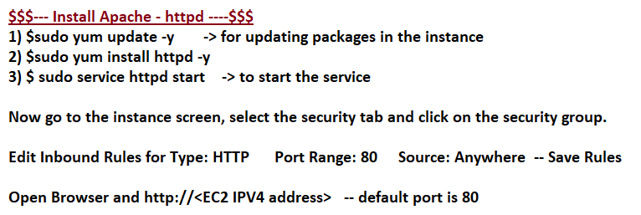

$ clear

$ pwd

$sudo apt-get update

apt-get is a package manager

--- install webserver - apache (httpd)

$ sudo yum -y install httpd

--- Start the service

$ sudo service httpd start

--- Create a mount point

First note that the DocumentRoot in the /etc/httpd/conf/httpd.conf file points to /var/www/html (DocumentRoot "/var/www/html").

$ sudo yum install httpd [tomcat 7 installation]

To Install open-jdk-8

$ sudo yum install java-1.8.0-openjdk **$ apt install openjdk-17-jdk-headless**

$ java -version

To Install open-jdk11

$ sudo yum install java-11-amazon-corretto

- Amazon Corretto is a no-cost, multiplatform, production-ready distribution of the Open Java Development Kit (OpenJDK).

$ sudo alternatives --config java

- Configures the default for the program "java". That's the Java VM

$ sudo alternatives --config java

- select the default java version $ sudo yum remove java-11-amazon-corretto