# Requirement

Phone Book Web Application

Develop a Phone Book Application for John where he can store his friends contact details.

Phone Book application should contain below functionalities

1. **Create Contact**
2. **Display All Contacts**
3. **Edit and Update Contact Details**
4. **Delete Contact**

# Technologies to be used:

1. **MVC with Spring Boot/ Spring REST, Spring Data**
2. **Embedded Database (H2)/ MySQL, Embedded Server (Tomcat)**
3. **JSP and JSTL Core Tag Library**

# User Story Details

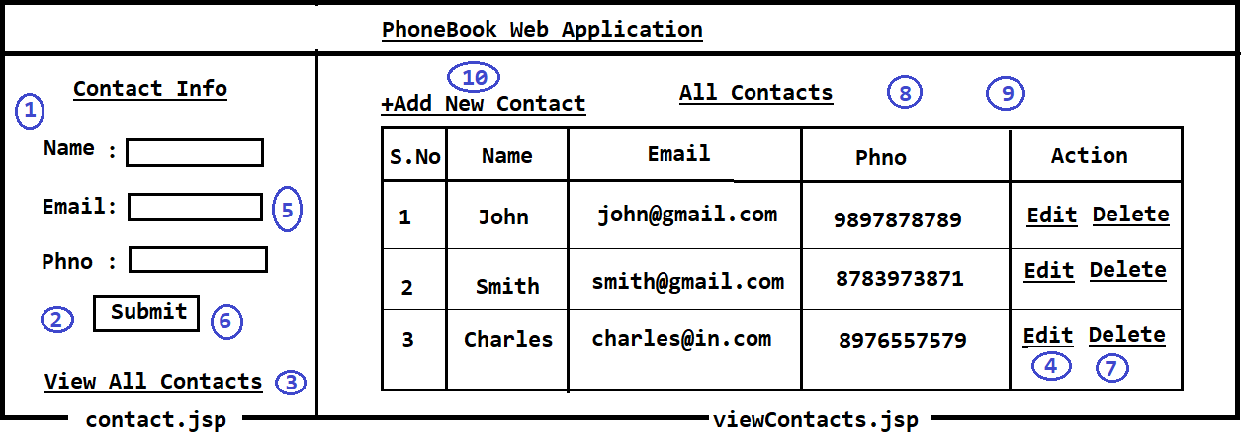

**Database Table Structure**

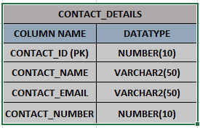

**User Story Description**

* **Note: In the above diagram, circled numbers represents functionality. Circled numbers functionality described below.**

1. **When we hit application URL (Context-Path) in browser ‘Contact Info’ form should be displayed which is contat.jsp.**
2. **When ‘Submit’ button is clicked, form data should be stored into Database and success message should be displayed as ‘Contact Saved Successfully’ in ‘Contact Info’ form.**

(The above Submit click is for new record)

1. **When ‘View All Contacts’ hyperlink is clicked, all saved Contact records should be displayed in viewContacts.jsp table.**
2. **When ‘Edit’ icon is clicked, that particular contact details should be displayed in ‘Contact Info’ form in editable model.**
3. **Once contact is displayed in editable mode, we should be able to modify Contact Data.**
4. **When ‘Submit’ button is clicked Contact data should be updated in Database and success message should be displayed as ‘Contact Updated Successfully’ in ‘Contact Info’ form.**

(The above submit click is for existing record).

1. **When ‘Delete’ hyperlink is clicked ‘Delete Confirmation Popup’ should be displayed like below.**

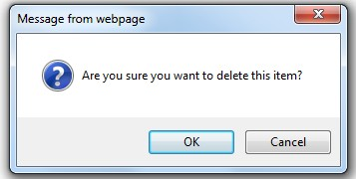

1. **When ‘Ok’ button is clicked in above popup, Contact record should be deleted from Database and success message should be displayed as ‘Contact Deleted Successfully’ in same page.**
2. **After Contact deleted, latest Contact Records should be displayed in table (Deleted Records should not be displayed).**
3. **When ‘+Add New Contact’ hyperlink is clicked ‘Contact Info Form’ should be displayed.**

# ==== Happy Coding ====

# <http://localhost:9090>/

# 

# 

# 

# View All Contacts

# 

# Click on Edit of “John”

# 

# Click on Delete of “Praveen”

# 

# 