**User Management Application**

## ➔ When user access application URL, below page should be displayed.

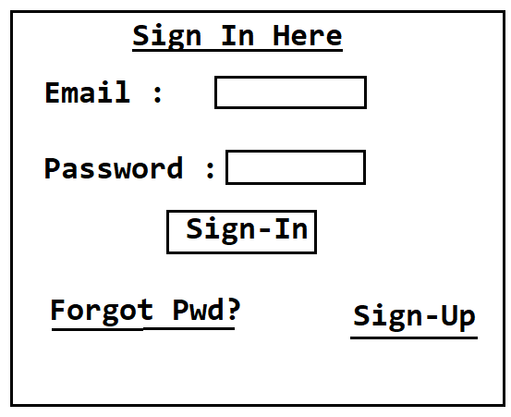

**Login Functionality**

➔ When user enter Email & Password and click on ‘Sign In’ button, we will check below conditions

1. **Credentials are valid or not**
2. **Account is Unlocked or Not**

➔ If Credentials are invalid, we will display error message as ‘Invalid Credentials’ on same screen

➔ If Account is locked, we will display error message as ‘Your Account Is Locked’ on same screen

➔ If Credentials are valid and account is Unlocked then user can login into our application.

➔ If user login is successful, display welcome page with below message. Welcome to User Management Application

➔ Display option for Logout

# Registration Functionality

➔When user click on ‘Sign Up’ option below page should be displayed

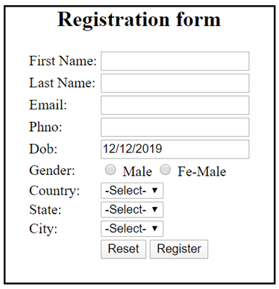

1. **Registration form should contain client side validations**
2. **Email should be unique for every User. Email should be validated asynchrony using Ajax (On Blur event)**
3. **DOB filed should contain date picker. User should select date of birth only through date picker.**
4. **Country field should display Country names in drop down**
5. **Based on selected Country, that country specific State names should be displayed in State dropdown**
6. **Based on Selected State, that State specific Cities should be displayed in City dropdown.**
7. **When user click on ‘Register’ button, application should generate a random password for user and should insert a record in Database table along with password.**
8. **After inserting record send an Email to user to unlock account like below.**

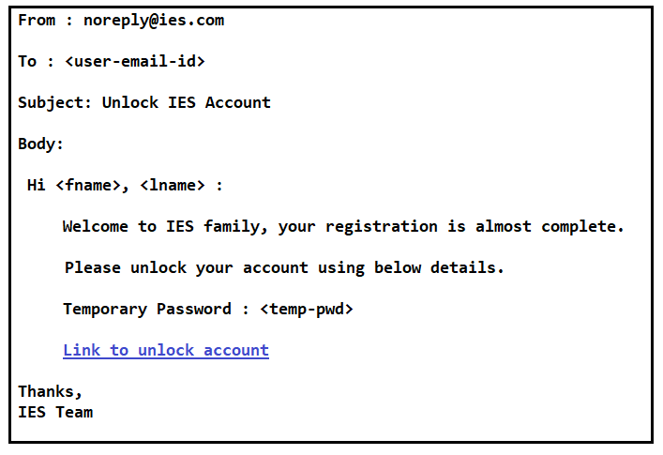

1. **After sending an email, display success message in Registration form as ‘Please check your email to unlock account’.**

# Un-Lock Account Functionality

➔ When user click on ‘Link’ sent in email, user should land on below page.

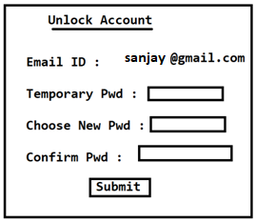

➔ User should enter temporary password which sent in email and should use new password in above screen

→ Client side validation should be there for Unlock Account screen

➔ New Password and Confirm Password should be same

➔ When User click on Submit button, we should check Temporary Pwd entered in the form is correct or not.

➔ If Temporary password is correct, then User record should be updated with new password given in Unlock Account form and User record should be Unlocked.

➔ After unlocking the account, display success message in the page as ‘Account unlocked, please proceed with login’.

# Forgot Password Functionality

➔ When user click on ‘Forgot Password’ hyperlink then below screen should be displayed.

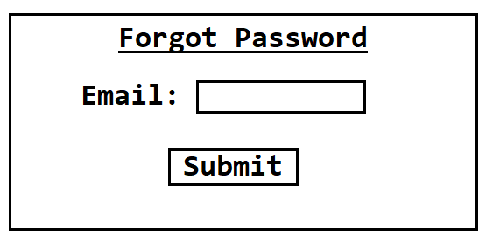

➔ When user submit this form with email, we will check given email registered in application or not. If email is registered we will send Password to User email and will display success message on the same page.

➔ If user entered email is not registered then we will display error message on the same screen.