Cross-Boundary Context Poisoning: The Hidden Threat in the Model Context Protocol (MCP)
Sunil Gentyala
Lead Cybersecurity and AI Security Consultant, HCLTech | IEEE Senior Member | Cloud Security Alliance Representative

Implicit trust in LLM context windows is an architectural failure. MCP gives AI agents a structured, interoperable way to invoke tools and share context across systems. The protocol itself, however, carries no native notion of where that context originated, how trustworthy it is, or what systems it should be permitted to influence. That absence is the attack surface. And right now, most organizations deploying agentic stacks have left it completely open.

The Architecture of the Problem
Consider a common agentic pattern: Agent A is scoped to read external intelligence, scraping public websites, competitor blogs, and market feeds. Agent B operates with access to internal APIs, code-execution sandboxes, and enterprise data stores. Agent A passes its gathered context to Agent B via an MCP tool call. Agent B processes it.
This is the cross-boundary problem. The MCP context payload arriving from Agent A looks identical to a payload sourced from a vetted internal knowledge base. The receiving tool has no mechanism to distinguish them. Both are structured data objects. Both arrive through the same channel. One of them may have been crafted by an attacker.
This attack pattern has a name: indirect prompt injection. But calling it that undersells the severity. What it actually enables is indirect privilege escalation across trust boundaries.

Figure 1: Attack Chain
Cross-boundary context poisoning via MCP
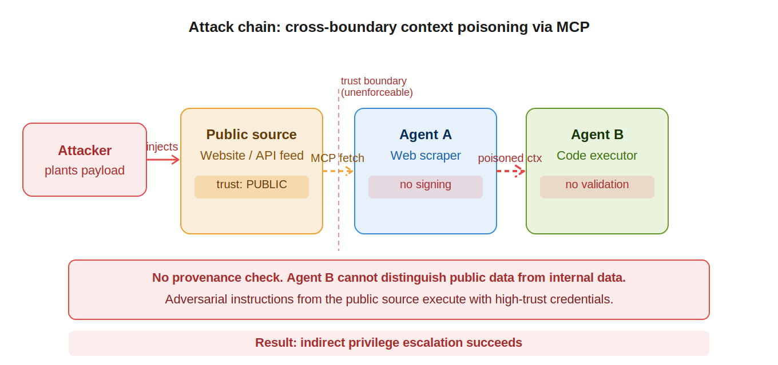
An attacker embeds adversarial instructions in a public source. Agent A fetches the content via MCP and packages it as context. Agent B, operating with high-trust credentials, receives the payload with no provenance check and executes adversarial instructions.

The Attack Chain
The mechanics are straightforward. Attackers embed adversarial instructions inside externally reachable content, knowing that an AI agent will ingest it:
- Agent A is granted read access to a low-trust external source (public site, RSS feed, third-party API).
- The page or response contains adversarial instructions disguised as legitimate content, such as a comment block instructing the agent to exfiltrate credentials or modify internal records.
- Agent A wraps this poisoned content in an MCP context payload, treating the adversarial instructions as data.
- Agent B, operating with high-trust credentials, receives the payload and acts on its contents.
- The attacker achieves privileged code execution or data access without ever touching the high-trust system directly.

The attacker does not need to compromise your network perimeter. They need to compromise the data stream feeding your agents.

Why Existing Controls Miss This
Access control policies govern who can call which tools. They do not govern the provenance or integrity of the data flowing through those calls. Sandboxing limits what an agent can do at the OS level. It does not prevent a poisoned context object from triggering a legitimate but attacker-directed API call. Input validation catches known malicious patterns. It cannot reliably detect adversarial instructions embedded in semantically valid text.
None of these controls address the core issue: a signed, attested chain of custody for MCP context objects as they traverse trust boundaries.

The Cryptographic Context-Signing Framework
The fix requires treating MCP context payloads the same way TLS treats certificates: as signed objects whose provenance is cryptographically verifiable. The framework rests on three primitives:
Trust Level Tagging. Every context object generated by an agent is tagged at creation time with a trust level enumeration: PUBLIC, INTERNAL, CONFIDENTIAL, or RESTRICTED. This tag is not a soft label. It is a field embedded in a signed JWT envelope.
Context Signing. The originating agent or tool signs the context payload using its private key. The JWT claims include the agent identity, source URI, trust level, a SHA-256 digest of the payload content, and a timestamp. Any modification to the payload after signing invalidates the signature.
Receiver-Side Validation. High-trust tools enforce a validation gate before processing any inbound context. The gate checks the signature against a known public key registry, verifies the trust level against the tool's minimum acceptable threshold, and rejects payloads that fail either check. A payload tagged PUBLIC never reaches a tool that requires INTERNAL or above.
This approach provides three security properties that current MCP deployments lack: integrity (the payload has not been tampered with), provenance (you know which agent and source generated it), and scope enforcement (low-trust context cannot influence high-trust execution).

Figure 2: Defense Architecture
Cryptographic context signing with mcp-trust-anchor
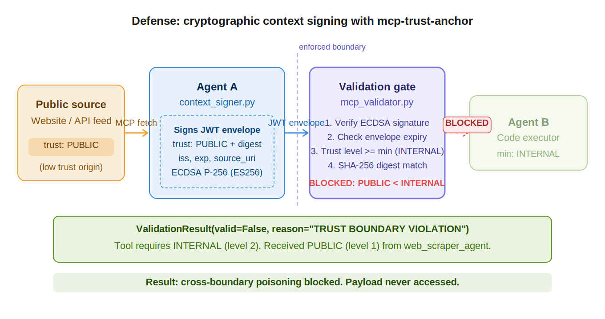
context_signer.py wraps the Agent A response in a JWT envelope asserting trust level PUBLIC. mcp_validator.py in Agent B performs four checks: signature verification, expiry, trust threshold, and digest match. The payload is blocked before Agent B can access it.

Implementation Reality
The pattern is implementable today using standard libraries. PyJWT handles signing and verification. The trust level registry is a simple key-value store mapping agent identifiers to their public keys and permitted trust scopes.
The engineering team at github.com/sunilgentyala/mcp-trust-anchor has published a working proof-of-concept. The repository includes context_signer.py, which wraps MCP tool responses in signed JWT envelopes with trust boundary metadata, and mcp_validator.py, which demonstrates the high-trust tool validation gate. Both scripts use ECDSA P-256 signing, chosen for its compact signature size and hardware security module compatibility.
The PoC deliberately omits key rotation and distributed key registry logic to keep the signal-to-noise ratio high. Both are required for production deployments. The patterns for both are documented in the repo's README.

What Engineering Teams Should Do Now
Audit every MCP tool call in your current agentic stack and classify the trust level of each context source. Any chain where a low-trust external source feeds context to a high-trust internal tool is an unmitigated privilege escalation path.
Implement context signing at the agent layer, not the infrastructure layer. The infrastructure does not know what the data means. The agent generating the context does.
Reject unsigned context in high-trust tools, without exception. Define this as a hard policy, not a best-effort check.
The MCP ecosystem is maturing fast, and the attack surface is maturing with it. Waiting for the protocol specification to address this natively is the wrong posture. The cryptographic primitives exist. The threat is active. Build the controls now.

About the Author
Sunil Gentyala is a Lead Cybersecurity and AI Security Consultant at HCLTech with more than 20 years of enterprise security experience. He is an IEEE Senior Member and the designated representative to the Cloud Security Alliance. He is the creator of the ContextGuard zero-trust middleware framework and the GSH agentic AI threat hunting framework. He publishes regularly across Dark Reading, CSO Online, SC World, Infosecurity Magazine, and Security Boulevard.
LinkedIn: linkedin.com/in/sunil-gentyala | GitHub: github.com/sunilgentyala

