B_advanced = true
9.5 1.6103896103896105 9.5
Mom_Inertia_SI: 6.906389610389614e-38
ux = 0.978 + i -0.006
uy = 0.000 + i -0.000
uz = 0.000 + i -0.000
Om_x = -3.28e-07 + i 2.70e-07
Om_y = 2.61e-06 + i -1.94e-06
Om_z = -3.45e-03 + i -1.08e-03
{'ncycles_max': 100, 'target_acc_Hz': 1.0, 'rad_Sph_SI': 1e-08, 'cellheight_SI': 2.3e-08, 'gridreso_SI': 2e-09, 'cell_diam_by_sphere_diam': 2.1, 'frac_above_surf': 0.5, 'nufac': 3.0, 'tandelinv': 5.0, 'iovt': 1, 'nx': 21, 'nz': 21, 'outInterval': 10, 't_computation_secs': 566.0}
n_dimensions 1
i cellheight_SI df dG
0 1.50e-08 -285.89 3261.73
1 1.70e-08 -283.94 3136.22
2 1.90e-08 -279.84 3024.41
3 2.10e-08 -275.48 2922.75
4 2.30e-08 -271.38 2829.19
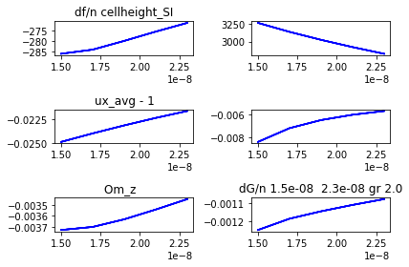

pars_1
Out[18]: array([1.5e-08, 1.7e-08, 1.9e-08, 2.1e-08, 2.3e-08])

dfc_arr.real
Out[19]:
array([-285.88618008, -283.94211043, -279.8393293 , -275.47723074,
-271.37638363])

dfc_arr.imag
Out[20]:
array([3261.73426019, 3136.2159659 , 3024.40502529, 2922.74838133,
2829.19404603])

ux_avg_arr.real-1
Out[21]: array([-0.02484638, -0.02395988, -0.02312561, -0.02234355, -0.02162047])

ux_avg_arr.imag
Out[22]: array([-0.00840982, -0.00720569, -0.00649274, -0.00602558, -0.00569623])

Om_z_arr.real
Out[23]: array([-0.00372749, -0.00369958, -0.00363032, -0.00354142, -0.00344646])

Om_z_arr.imag
Out[24]: array([-0.00124609, -0.00118475, -0.00114455, -0.00110981, -0.00107822])

B_advanced = false
9.5 1.6103896103896105 9.5
Mom_Inertia_SI: 6.906389610389614e-38
ux = 0.995 + i -0.006
uy = -0.000 + i 0.000
uz = 0.000 + i -0.000
Om_x = -2.31e-21 + i 8.65e-22
Om_y = 5.91e-19 + i -4.61e-21
Om_z = -7.41e-04 + i -1.07e-03
{'ncycles_max': 100, 'target_acc_Hz': 1.0, 'rad_Sph_SI': 1e-08, 'cellheight_SI': 2.9e-08, 'gridreso_SI': 2e-09, 'cell_diam_by_sphere_diam': 2.1, 'frac_above_surf': 0.5, 'nufac': 3.0, 'tandelinv': 5.0, 'iovt': 1, 'nx': 21, 'nz': 21, 'outInterval': 10, 't_computation_secs': 1287.0}
n_dimensions 1
i cellheight_SI df dG
0 1.50e-08 -737.34 720.65
1 1.70e-08 -737.13 720.44
2 1.90e-08 -736.87 720.29
3 2.10e-08 -736.69 720.18
4 2.30e-08 -736.55 720.12
5 2.50e-08 -736.46 720.09
6 2.70e-08 -736.40 720.06
7 2.90e-08 -736.35 720.05
8 3.10e-08 nan nan
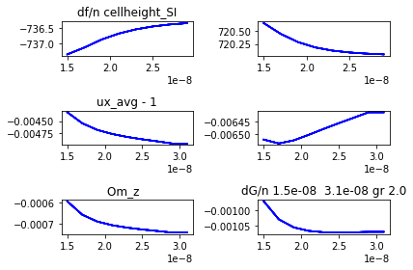
pars_1
Out[27]:
array([1.5e-08, 1.7e-08, 1.9e-08, 2.1e-08, 2.3e-08, 2.5e-08, 2.7e-08,
2.9e-08, 3.1e-08])

dfc_arr.real
Out[28]:
array([-737.3435294 , -737.12631414, -736.87406191, -736.68537359,
-736.55131499, -736.45832139, -736.39527177, -736.3543923 ,
nan])

ux_avg_arr.imag
Out[29]:
array([-0.00652235, -0.00653833, -0.00652551, -0.00650277, -0.00647862,
-0.00645531, -0.00643303, -0.00641038, -0.00641038])

dfc_arr.imag
Out[30]:
array([720.64753475, 720.44001741, 720.28512925, 720.1831913 ,
720.12249123, 720.08639275, 720.06431567, 720.04995665,
nan])

ux_avg_arr.real-1
Out[31]:
array([-0.00432084, -0.00454584, -0.00468132, -0.00476469, -0.00482481,
-0.00487286, -0.00491418, -0.0049583 , -0.0049583 ])

Om_z_arr.real
Out[32]:
array([-0.00059386, -0.00065697, -0.00068902, -0.00070652, -0.00071792,
-0.00072648, -0.00073363, -0.00074111, -0.00074111])

Om_z_arr.imag
Out[33]:
array([-0.00097079, -0.00102927, -0.00105559, -0.00106694, -0.0010714 ,
-0.00107246, -0.00107176, -0.00106999, -0.00106999])

