Parameters Chosen:
target_acc_Hz: 1.0, rad_Sph_SI: 10 nm, cellheight_SI: 15 nm,
gridreso_SI: 2 nm, frac_above_surf: 0.5 (1 - (what we called truncation)),
nufac: 3.0, tandelinv: 5.0, iovt: 1

Cell_dia/Sph_dia | Df (Hz) | DG (Hz)
1 | -770.49 | 723.58
2 | -738.95 | 720.74
3 | -727.70 | 719.68
4 | -722.87 | 719.07
5 | -720.84 | 718.08
6 | -719.26 | 718.38
7 | -719.11 | 717.11
8 | -718.32 | 717.50
9 | -717.82 | 717.65
10 | -717.69 | 717.48

Real and Imaginary
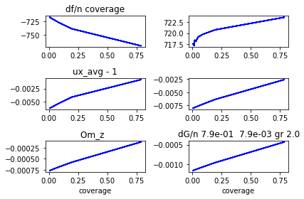

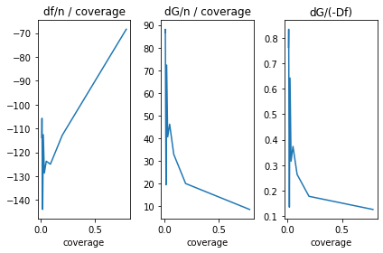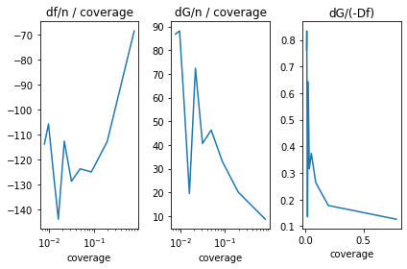
X-Axis scaled logarithmically

Parameters Chosen:
target_acc_Hz: 1.0, rad_Sph_SI: 10 nm, cellheight_SI: 15 nm,
gridreso_SI: 2 nm, frac_above_surf: 0.5 (1 - (what we called truncation)),
nufac: 5.0, tandelinv: 5.0, iovt: 1

Cell_dia/Sph_dia | Df | DG
1 | -763.16 | 719.54
2 | -739.02 | 719.31
3 | -727.87 | 718.89
4 | -722.95 | 718.71
5 | -720.88 | 717.81
6 | -719.37 | 718.25
7 | -719.04 | 716.98
8 | -718.36 | 717.40
9 | -717.90 | 717.60
10 | -717.76 | 717.28
11 | -717.65 | 717.05
12 | -717.51 | 717.03
13 | -717.41 | 716.99

Real and Imaginary
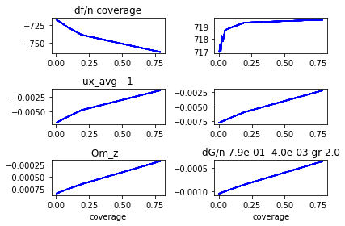

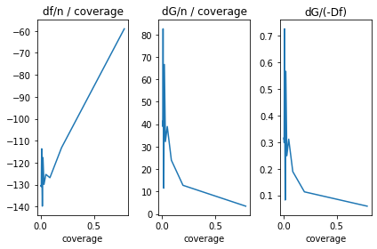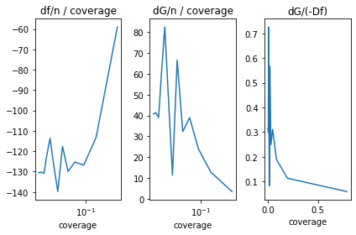
X-Axis scaled logarithmically
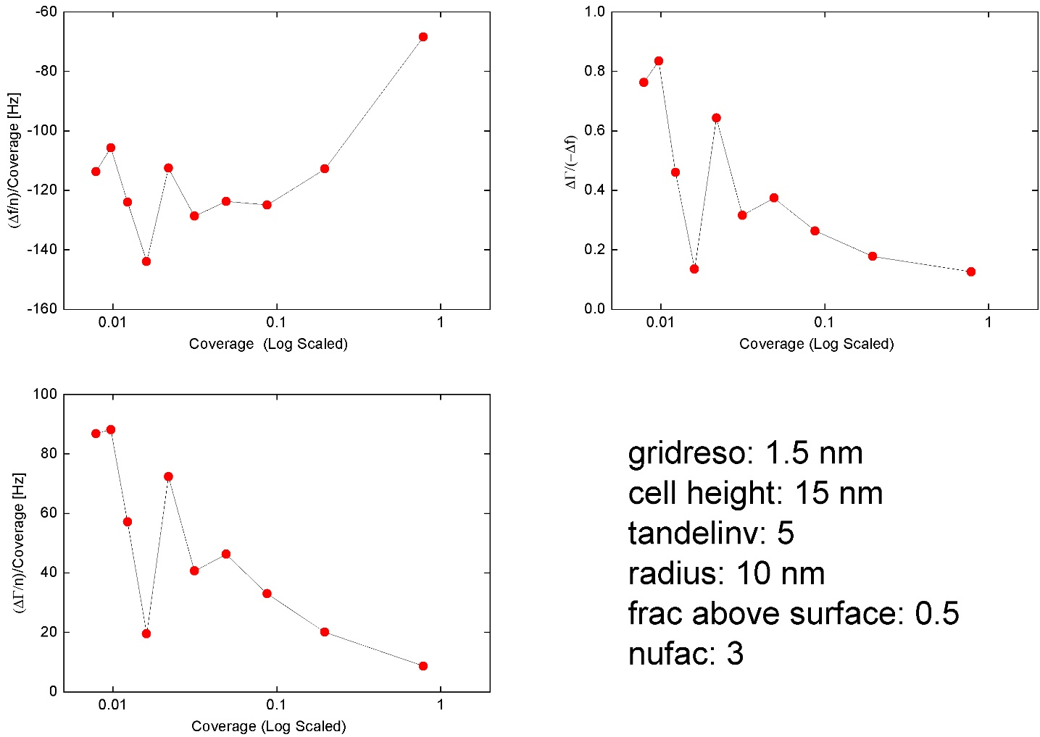

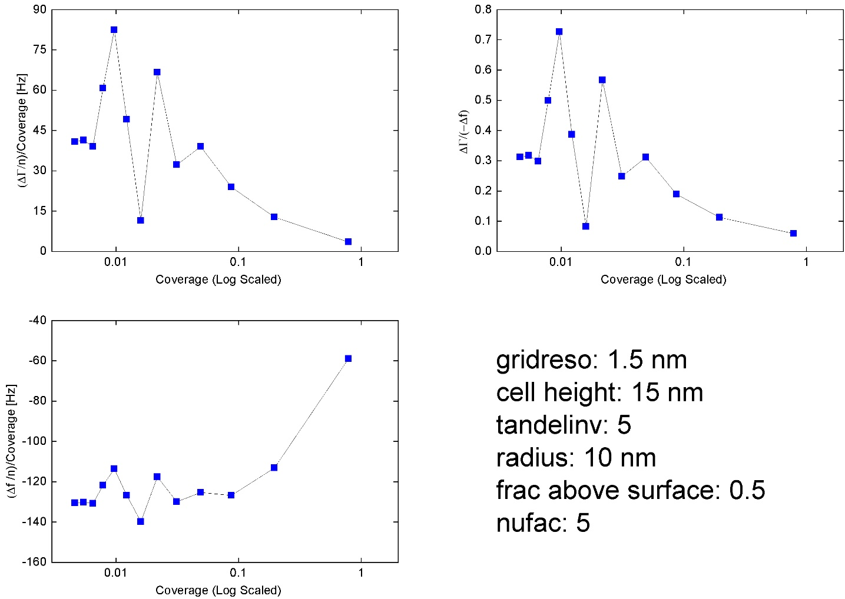

nufac = 6 and tandelinv =5
coverage
Out[422]:
array([0.78539816, 0.19634954, 0.08726646, 0.04908739, 0.03141593,
0.02181662, 0.01602853, 0.01227185, 0.00969627, 0.00785398,
0.00649089, 0.00545415, 0.00464733, 0.00400713, 0.00349066,
0.00306796])

(dfc_arr.real + 716.8) / pars_1
Out[423]:
array([ -59.05743184, -115.08139931, -125.21275241, -124.73751849,
-128.90165199, -118.49001616, -138.85578397, -127.16117096,
-115.23396363, -122.58944338, -130.9202495 , -130.33879382,
-130.59592625, -135.13655743, -138.00544453, 106.0888833 ])

(dfc_arr.imag - 716.8) / pars_1
Out[424]:
array([ 2.86440623, 13.16169497, 22.35270202, 36.75917965,
30.09392688, 64.86531478, 9.34640518, 46.62983665,
80.5571577 , 58.69295481, 36.61249339, 38.950808 ,
38.72043066, 26.74912309, 21.21979233, 799.80098446])

(dfc_arr.imag-716.8)/(-dfc_arr.real-716.8)
Out[425]:
array([ 0.04850205, 0.11436857, 0.17851778, 0.29469225, 0.23346425,
0.54743274, 0.06731016, 0.3666987 , 0.69907478, 0.47877658,
0.27965493, 0.29884278, 0.29649034, 0.19794143, 0.15376054,
-7.53897072])

0 1.00e+00 -763.18 719.05
1 2.00e+00 -739.40 719.38
2 3.00e+00 -727.73 718.75
3 4.00e+00 -722.92 718.60
4 5.00e+00 -720.85 717.75
5 6.00e+00 -719.39 718.22
6 7.00e+00 -719.03 716.95
7 8.00e+00 -718.36 717.37
8 9.00e+00 -717.92 717.58
9 1.00e+01 -717.76 717.26
10 1.10e+01 -717.65 717.04
11 1.20e+01 -717.51 717.01
12 1.30e+01 -717.41 716.98
13 1.40e+01 -717.34 716.91
14 1.50e+01 -717.28 716.87
15 1.60e+01 -717.23 716.86

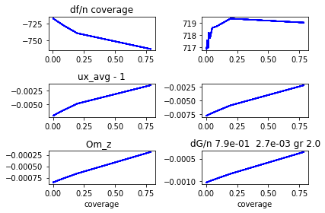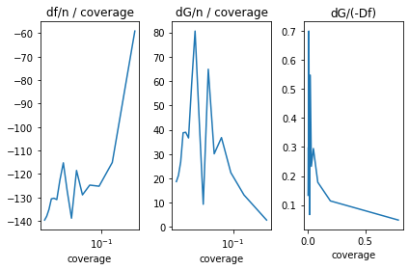

Nufac = 7 and tandelinv =5
74.5 1.6103896103896105 74.5
Mom_Inertia_SI: 6.906389610389614e-38
ux = 0.993 + i -0.008
uy = -0.000 + i 0.000
uz = -0.000 + i -0.000
Om_x = -4.04e-21 + i 3.46e-21
Om_y = -8.86e-19 + i 2.77e-20
Om_z = -8.61e-04 + i -1.01e-03
{'ncycles_max': 100, 'target_acc_Hz': 1.0, 'rad_Sph_SI': 1e-08, 'cellheight_SI': 1.5e-08, 'gridreso_SI': 2e-09, 'cell_diam_by_sphere_diam': 15.0, 'frac_above_surf': 0.5, 'nufac': 7.0, 'tandelinv': 5.0, 'iovt': 1, 'nx': 150, 'nz': 150, 'outInterval': 10, 't_computation_secs': 13373.0}
i cell_diam_by_sphere_diam df dG
0 1.00e+00 -763.22 718.71
1 2.00e+00 -739.84 718.81
2 3.00e+00 -727.79 718.81
3 4.00e+00 -722.90 718.65
4 5.00e+00 -720.83 717.77
5 6.00e+00 -719.38 718.23
6 7.00e+00 -719.00 716.95
7 8.00e+00 -718.35 717.38
8 9.00e+00 -717.92 717.59
9 1.00e+01 -717.76 717.26
10 1.10e+01 -717.64 717.04
11 1.20e+01 -717.51 717.01
12 1.30e+01 -717.40 716.98
13 1.40e+01 -717.34 716.91
14 1.50e+01 -717.28 716.87
15 1.60e+01 -716.61 718.82

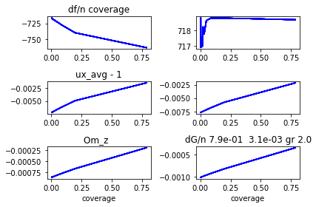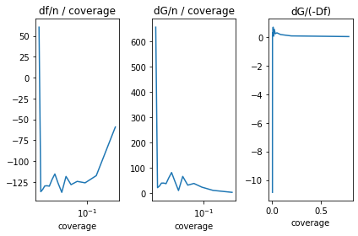coverage
Out[438]:
array([0.78539816, 0.19634954, 0.08726646, 0.04908739, 0.03141593,
0.02181662, 0.01602853, 0.01227185, 0.00969627, 0.00785398,
0.00649089, 0.00545415, 0.00464733, 0.00400713, 0.00349066,
0.00306796])

(dfc_arr.real + 716.8) / pars_1
Out[439]:
array([ -59.10878806, -117.35931852, -125.95368658, -124.225476 ,
-128.1619085 , -118.30578618, -137.35120585, -126.42186241,
-115.36383277, -122.21319893, -129.95897086, -129.47174843,
-129.71795753, -133.90544874, -136.57788043, 60.482344 ])

(dfc_arr.imag - 716.8) / pars_1
Out[440]:
array([ 2.42701065, 10.25446059, 23.05918781, 37.64793087,
30.95059864, 65.56538471, 9.58082631, 46.86263573,
80.95956129, 59.11753473, 36.81303405, 39.19523443,
39.00843951, 27.20497101, 20.98458372, 657.25960608])

(dfc_arr.imag-716.8)/(-dfc_arr.real-716.8)
Out[441]:
array([ 0.04106006, 0.08737662, 0.18307672, 0.30306127,
0.24149608, 0.55420269, 0.06975422, 0.37068459,
0.70177593, 0.48372463, 0.28326659, 0.30273195,
0.30071734, 0.20316553, 0.15364555, -10.8669665 ])

Nufac =4 and tandelinv= 5
74.5 1.6103896103896105 74.5
Mom_Inertia_SI: 6.906389610389614e-38
ux = 0.993 + i -0.008
uy = 0.000 + i 0.000
uz = 0.000 + i -0.000
Om_x = 1.73e-21 + i -2.88e-21
Om_y = 2.95e-19 + i 4.61e-21
Om_z = -8.08e-04 + i -1.09e-03
{'ncycles_max': 100, 'target_acc_Hz': 1.0, 'rad_Sph_SI': 1e-08, 'cellheight_SI': 1.5e-08, 'gridreso_SI': 2e-09, 'cell_diam_by_sphere_diam': 15.0, 'frac_above_surf': 0.5, 'nufac': 4.0, 'tandelinv': 5.0, 'iovt': 1, 'nx': 150, 'nz': 150, 'outInterval': 10, 't_computation_secs': 13029.0}
i cell_diam_by_sphere_diam df dG
0 1.00e+00 -763.48 720.42
1 2.00e+00 -739.32 719.89
2 3.00e+00 -727.76 719.20
3 4.00e+00 -722.90 718.80
4 5.00e+00 -720.87 717.89
5 6.00e+00 -719.33 718.28
6 7.00e+00 -719.06 717.01
7 8.00e+00 -718.35 717.43
8 9.00e+00 -717.87 717.61
9 1.00e+01 -717.74 717.29
10 1.10e+01 -717.65 717.07
11 1.20e+01 -717.51 717.04
12 1.30e+01 -717.40 717.00
13 1.40e+01 -717.34 716.92
14 1.50e+01 -717.29 716.89
15 1.60e+01 -716.79 718.00
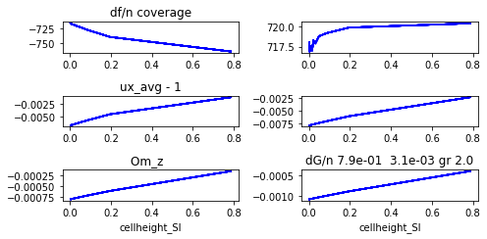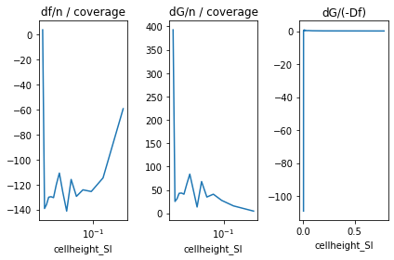
coverage
Out[70]:
array([0.78539816, 0.19634954, 0.08726646, 0.04908739, 0.03141593,
0.02181662, 0.01602853, 0.01227185, 0.00969627, 0.00785398,
0.00649089, 0.00545415, 0.00464733, 0.00400713, 0.00349066,
0.00306796])

In [71]: (dfc_arr.real + 716.8) / pars_1
Out[71]:
array([ -59.42996149, -114.71011414, -125.59289207, -124.23742622,
-129.47308118, -115.93995803, -141.24161434, -126.05039764,
-110.84883166, -120.10143101, -130.48687434, -129.73426751,
-130.11937912, -135.96908208, -139.17614923, 3.59698321])

In [72]: (dfc_arr.imag - 716.8) / pars_1
Out[72]:
array([ 4.61026311, 15.75824553, 27.50513806, 40.80849389,
34.72826406, 67.88256545, 13.38555407, 50.97438525,
83.79408549, 62.07492042, 40.85883742, 43.25221111,
42.65504607, 30.74993728, 25.28198658, 392.60838762])

In [73]: (dfc_arr.imag-716.8)/(-dfc_arr.real-716.8)
Out[73]:
array([ 7.75747283e-02, 1.37374508e-01, 2.19002346e-01, 3.28471823e-01,
2.68227679e-01, 5.85497585e-01, 9.47706109e-02, 4.04396862e-01,
7.55931156e-01, 5.16854128e-01, 3.13126034e-01, 3.33390799e-01,
3.27814706e-01, 2.26153893e-01, 1.81654592e-01, -1.09149352e+02])

Nufac = 2 and tandelinv =5
94.5 1.6103896103896105 94.5
Mom_Inertia_SI: 6.906389610389614e-38
ux = 0.995 + i -0.009
uy = 0.000 + i 0.000
uz = 0.000 + i -0.000
Om_x = 5.77e-22 + i 1.15e-21
Om_y = -1.48e-18 + i -9.23e-21
Om_z = -7.00e-04 + i -1.32e-03
{'ncycles_max': 100, 'target_acc_Hz': 1.0, 'rad_Sph_SI': 1e-08, 'cellheight_SI': 1.5e-08, 'gridreso_SI': 2e-09, 'cell_diam_by_sphere_diam': 19.0, 'frac_above_surf': 0.5, 'nufac': 2.0, 'tandelinv': 5.0, 'iovt': 1, 'nx': 190, 'nz': 190, 'outInterval': 10, 't_computation_secs': 20973.0}
i cell_diam_by_sphere_diam df dG
0 1.00e+00 -827.31 739.72
1 2.00e+00 -738.43 722.68
2 3.00e+00 -727.47 720.71
3 4.00e+00 -722.61 719.69
4 5.00e+00 -720.72 718.50
5 6.00e+00 -719.05 718.59
6 7.00e+00 -719.17 717.40
7 8.00e+00 -718.23 717.66
8 9.00e+00 -717.68 717.73
9 1.00e+01 -717.66 717.41
10 1.10e+01 -717.61 717.19
11 1.20e+01 -717.47 717.14
12 1.30e+01 -717.38 717.09
13 1.40e+01 -717.35 717.01
14 1.50e+01 -717.30 716.97
15 1.60e+01 -717.24 716.95
16 1.70e+01 -717.17 716.95
17 1.80e+01 -717.10 716.97
18 1.90e+01 -717.05 716.97
19 2.00e+01 -717.02 716.97
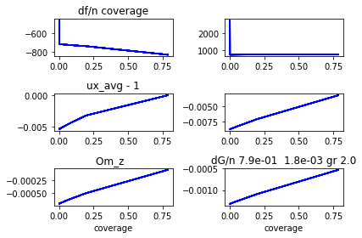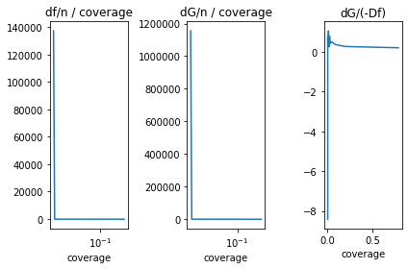

coverage
Out[448]:
array([0.78539816, 0.19634954, 0.08726646, 0.04908739, 0.03141593,
0.02181662, 0.01602853, 0.01227185, 0.00969627, 0.00785398,
0.00649089, 0.00545415, 0.00464733, 0.00400713, 0.00349066,
0.00306796, 0.00271764, 0.00242407, 0.00217562, 0.0019635 ,
0.00178095])

(dfc_arr.real + 716.8) / pars_1
Out[449]:
array([-1.40708154e+02, -1.10136831e+02, -1.22233046e+02, -1.18281718e+02,
-1.24624692e+02, -1.03000557e+02, -1.47815073e+02, -1.16242704e+02,
-9.12105556e+01, -1.09345287e+02, -1.25318064e+02, -1.23232467e+02,
-1.25788181e+02, -1.37541083e+02, -1.41883661e+02, -1.44073310e+02,
-1.36102941e+02, -1.24936573e+02, -1.16230426e+02, -1.10117543e+02,
1.37208883e+05])

(dfc_arr.imag - 716.8) / pars_1
Out[450]:
array([2.91884052e+01, 2.99344334e+01, 4.48136855e+01, 5.89225284e+01,
5.39921850e+01, 8.19756069e+01, 3.74351249e+01, 7.00326878e+01,
9.61704918e+01, 7.70700053e+01, 5.98796859e+01, 6.20392753e+01,
6.14014193e+01, 5.23509911e+01, 4.81101677e+01, 4.75089271e+01,
5.65418796e+01, 6.88195041e+01, 7.84073128e+01, 8.54104927e+01,
1.15488001e+06])

(dfc_arr.imag-716.8)/(-dfc_arr.real-716.8)
Out[451]:
array([ 0.20743933, 0.27179312, 0.36662496, 0.49815415, 0.43323826,
0.79587538, 0.25325648, 0.60246954, 1.05437897, 0.70483152,
0.47782166, 0.50343288, 0.48813346, 0.38062076, 0.3390818 ,
0.32975523, 0.41543466, 0.55083553, 0.67458509, 0.77563021,
-8.41694779])

Nufac =1 and tandelinv = 5
99.5 1.6103896103896105 99.5
Mom_Inertia_SI: 6.906389610389614e-38
ux = 0.997 + i -0.013
uy = 0.000 + i 0.000
uz = 0.000 + i 0.000
Om_x = 1.44e-21 + i 0.00e+00
Om_y = 8.86e-19 + i 2.77e-20
Om_z = -7.38e-04 + i -1.88e-03
{'ncycles_max': 100, 'target_acc_Hz': 1.0, 'rad_Sph_SI': 1e-08, 'cellheight_SI': 1.5e-08, 'gridreso_SI': 2e-09, 'cell_diam_by_sphere_diam': 20.0, 'frac_above_surf': 0.5, 'nufac': 1.0, 'tandelinv': 5.0, 'iovt': 1, 'nx': 200, 'nz': 200, 'outInterval': 10, 't_computation_secs': 23665.0}
i cell_diam_by_sphere_diam df dG
0 1.00e+00 -759.77 729.81
1 2.00e+00 -735.01 727.71
2 3.00e+00 -725.13 723.72
3 4.00e+00 -720.90 721.17
4 5.00e+00 -719.70 719.56
5 6.00e+00 -718.10 718.93
6 7.00e+00 -718.63 718.43
7 8.00e+00 -717.75 717.94
8 9.00e+00 -717.24 717.72
9 1.00e+01 -717.34 717.58
10 1.10e+01 -717.38 717.43
11 1.20e+01 -717.28 717.32
12 1.30e+01 -717.21 717.27
13 1.40e+01 -717.20 717.23
14 1.50e+01 -717.16 717.17
15 1.60e+01 -717.12 717.12
16 1.70e+01 -717.06 717.08
17 1.80e+01 -717.00 717.05
18 1.90e+01 -716.95 717.03
19 2.00e+01 -716.92 717.01

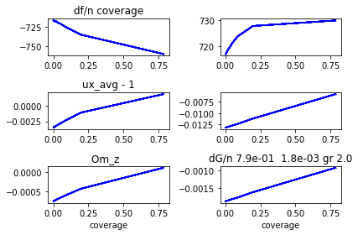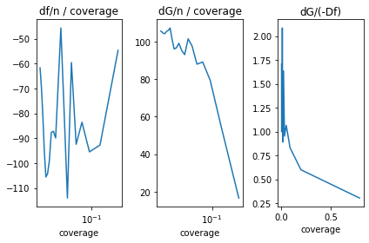

coverage
Out[455]:
array([0.78539816, 0.19634954, 0.08726646, 0.04908739, 0.03141593,
0.02181662, 0.01602853, 0.01227185, 0.00969627, 0.00785398,
0.00649089, 0.00545415, 0.00464733, 0.00400713, 0.00349066,
0.00306796, 0.00271764, 0.00242407, 0.00217562, 0.0019635 ,
0.00178095])

(dfc_arr.real + 716.8) / pars_1
Out[456]:
array([ -54.711109 , -92.74265611, -95.49824367, -83.59230579,
-92.44497785, -59.59045642, -114.04332038, -77.25960087,
-45.70372417, -68.8086334 , -89.89379527, -87.20910075,
-87.70392597, -99.04332923, -104.27281207, -105.59673807,
-95.1130921 , -80.75633665, -69.49880617, -61.7560226 ,
nan])

(dfc_arr.imag - 716.8) / pars_1
Out[457]:
array([ 16.56514981, 55.56327954, 79.29178312, 89.02704814,
87.90115153, 97.45503191, 101.39873808, 92.94846891,
95.30491266, 99.01507522, 96.58456288, 95.99067245,
101.24836938, 107.18387532, 105.88234168, 105.35652734,
104.23037408, 104.19514618, 104.97794279, 105.42931769,
nan])

(dfc_arr.imag-716.8)/(-dfc_arr.real-716.8)
Out[458]:
array([0.30277489, 0.59911245, 0.83029572, 1.06501486, 0.95084832,
1.63541342, 0.88912474, 1.20306691, 2.08527673, 1.43899203,
1.07442969, 1.10069559, 1.15443372, 1.08219177, 1.01543576,
0.99772521, 1.09585728, 1.29024112, 1.51049994, 1.70719087,
nan])

nufac = 0.5 and tandelinv =5
99.5 1.6103896103896105 99.5
Mom_Inertia_SI: 6.906389610389614e-38
ux = 0.993 + i -0.020
uy = -0.000 + i 0.000
uz = -0.000 + i 0.000
Om_x = 1.73e-21 + i -8.65e-22
Om_y = 3.25e-18 + i -2.77e-20
Om_z = -1.26e-03 + i -2.28e-03
{'ncycles_max': 100, 'target_acc_Hz': 1.0, 'rad_Sph_SI': 1e-08, 'cellheight_SI': 1.5e-08, 'gridreso_SI': 2e-09, 'cell_diam_by_sphere_diam': 20.0, 'frac_above_surf': 0.5, 'nufac': 0.5, 'tandelinv': 5.0, 'iovt': 1, 'nx': 200, 'nz': 200, 'outInterval': 10, 't_computation_secs': 23499.0}
i cell_diam_by_sphere_diam df dG
0 1.00e+00 -754.97 740.27
1 2.00e+00 -726.88 731.59
2 3.00e+00 -720.28 724.31
3 4.00e+00 -718.23 720.98
4 5.00e+00 -717.55 719.66
5 6.00e+00 -717.07 718.42
6 7.00e+00 -717.09 718.34
7 8.00e+00 -717.00 717.81
8 9.00e+00 -716.88 717.47
9 1.00e+01 -716.88 717.41
10 1.10e+01 -716.90 717.37
11 1.20e+01 -716.89 717.28
12 1.30e+01 -716.88 717.21
13 1.40e+01 -716.86 717.16
14 1.50e+01 -716.85 717.13
15 1.60e+01 -716.84 717.09
16 1.70e+01 -716.84 717.04
17 1.80e+01 -716.83 717.00
18 1.90e+01 -716.82 716.97
19 2.00e+01 -716.81 716.95
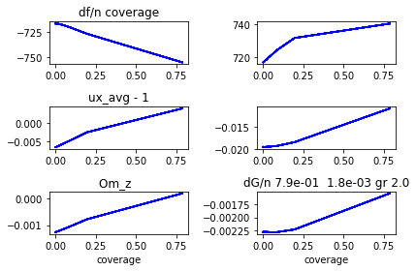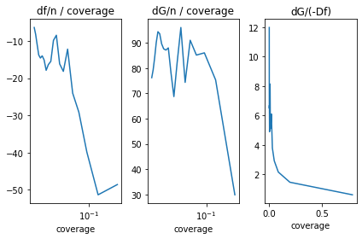
coverage
Out[461]:
array([0.78539816, 0.19634954, 0.08726646, 0.04908739, 0.03141593,
0.02181662, 0.01602853, 0.01227185, 0.00969627, 0.00785398,
0.00649089, 0.00545415, 0.00464733, 0.00400713, 0.00349066,
0.00306796, 0.00271764, 0.00242407, 0.00217562, 0.0019635 ,
0.00178095])

(dfc_arr.real + 716.8) / pars_1
Out[462]:
array([-48.5994471 , -51.35185478, -39.86943944, -29.15758225,
-24.01904033, -12.186852 , -18.16610213, -16.14296706,
-8.44848951, -9.83705613, -15.49017071, -16.32386866,
-17.87665089, -15.08953797, -13.98880392, -14.57745413,
-13.75257154, -10.94406188, -8.1880973 , -6.36550869,
nan])

(dfc_arr.imag - 716.8) / pars_1
Out[463]:
array([29.88754728, 75.33714482, 86.04190456, 85.16078157, 91.02840005,
74.35581879, 96.07830182, 82.21910326, 68.73860395, 78.21989349,
87.99102016, 87.14747012, 87.61994036, 89.60784586, 93.58939461,
94.41087805, 90.12035586, 84.11175463, 79.31130091, 76.21612444,
nan])

(dfc_arr.imag-716.8)/(-dfc_arr.real-716.8)
Out[464]:
array([ 0.6149771 , 1.46707738, 2.15809166, 2.92070793, 3.78984334,
6.10131466, 5.28887822, 5.09318411, 8.13620043, 7.95155506,
5.68044225, 5.33865298, 4.90136217, 5.93840885, 6.69030713,
6.47649975, 6.55298215, 7.68560664, 9.68616981, 11.97329673,
nan])

New runs!
Cell/sph dia = 1.1
5.0 4.066801619433198 5.0
Mom_Inertia_SI: 1.5272945748987858e-37
ux = 0.989 + i -0.013
uy = -0.000 + i -0.000
uz = -0.000 + i 0.000
Om_x = -4.97e-20 + i -1.97e-20
Om_y = 1.87e-18 + i -2.09e-20
Om_z = -1.29e-03 + i -1.65e-03
{'ncycles_max': 100, 'target_acc_Hz': 1.0, 'rad_Sph_SI': 1e-08, 'cellheight_SI': 2.5e-08, 'gridreso_SI': 2e-09, 'cell_diam_by_sphere_diam': 1.1, 'frac_above_surf': 0.91, 'nufac': 5.0, 'tandelinv': 5.0, 'iovt': 1, 'nx': 11, 'nz': 11, 'outInterval': 10, 't_computation_secs': 134.0}

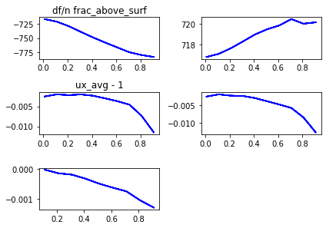

pars_1
Out[54]: array([0.01, 0.11, 0.21, 0.31, 0.41, 0.51, 0.61, 0.71, 0.81, 0.91])

dfc_arr.real
Out[55]:
array([-717.01910788, -721.44014731, -729.37556069, -739.27923011,
-748.90007966, -757.7104493 , -766.18017552, -774.48044201,
-779.29965164, -782.64236066])

dfc_arr.imag
Out[56]:
array([716.82811723, 717.12374905, 717.66048392, 718.30974042,
718.9825421 , 719.48089817, 719.8451531 , 720.45458256,
720.01290696, 720.14565006])

(dfc_arr.real + 716.8) / pars_1
Out[57]:
array([-21.91078842, -42.18315733, -59.88362233, -72.51364552,
-78.29287722, -80.21656725, -80.95110741, -81.24005917,
-77.16006375, -72.35424249])

(dfc_arr.imag - 716.8) / pars_1
Out[58]:
array([2.81172302, 2.94317315, 4.09754245, 4.87013039, 5.32327341,
5.25666308, 4.99205426, 5.14729938, 3.9665518 , 3.67653853])

(dfc_arr.imag-716.8)/(-dfc_arr.real-716.8)
Out[59]:
array([0.12832596, 0.06977129, 0.06842509, 0.06716157, 0.0679918 ,
0.06553089, 0.06166752, 0.06335913, 0.0514068 , 0.05081303])

Cell/sph dia = 2.1
10.0 4.066801619433198 10.0
Mom_Inertia_SI: 1.5272945748987858e-37
ux = 0.980 + i -0.021
uy = 0.000 + i 0.000
uz = 0.000 + i 0.000
Om_x = 3.00e-19 + i -6.47e-20
Om_y = 8.01e-19 + i 3.34e-20
Om_z = -2.81e-03 + i -2.94e-03
{'ncycles_max': 100, 'target_acc_Hz': 1.0, 'rad_Sph_SI': 1e-08, 'cellheight_SI': 2.5e-08, 'gridreso_SI': 2e-09, 'cell_diam_by_sphere_diam': 2.1, 'frac_above_surf': 0.91, 'nufac': 5.0, 'tandelinv': 5.0, 'iovt': 1, 'nx': 21, 'nz': 21, 'outInterval': 10, 't_computation_secs': 780.0}

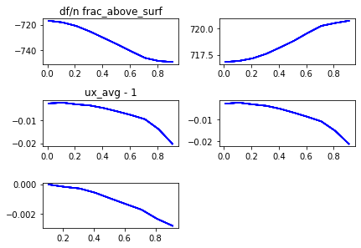

pars_1
Out[62]: array([0.01, 0.11, 0.21, 0.31, 0.41, 0.51, 0.61, 0.71, 0.81, 0.91])

dfc_arr.real
Out[63]:
array([-716.85971935, -718.16716365, -720.97026411, -725.33729591,
-730.41551176, -735.525115 , -740.93622389, -746.10839631,
-748.55786968, -749.30757164])

dfc_arr.imag
Out[64]:
array([716.81339808, 716.91057875, 717.15730999, 717.59155168,
718.18903384, 718.81361563, 719.55429388, 720.22547551,
720.49487061, 720.7088928 ])

(dfc_arr.real + 716.8) / pars_1
Out[65]:
array([ -5.97193535, -12.42876048, -19.85840053, -27.53966423,
-33.20856526, -36.71591177, -39.56758015, -41.27943142,
-39.20724651, -35.7226062 ])

(dfc_arr.imag - 716.8) / pars_1
Out[66]:
array([1.33980784, 1.00526132, 1.70147616, 2.55339252, 3.38788743,
3.94826595, 4.51523587, 4.8246134 , 4.56156866, 4.2954866 ])

(dfc_arr.imag-716.8)/(-dfc_arr.real-716.8)
Out[67]:
array([0.22435069, 0.08088186, 0.08568042, 0.09271691, 0.10201848,
0.10753556, 0.11411453, 0.11687693, 0.11634504, 0.12024561])

Cell/sph dia = 3.1
15.0 4.066801619433198 15.0
Mom_Inertia_SI: 1.5272945748987858e-37
ux = 0.976 + i -0.024
uy = -0.000 + i 0.000
uz = -0.000 + i -0.000
Om_x = 2.30e-19 + i 7.82e-22
Om_y = 8.01e-19 + i 2.50e-20
Om_z = -3.25e-03 + i -3.25e-03
{'ncycles_max': 100, 'target_acc_Hz': 1.0, 'rad_Sph_SI': 1e-08, 'cellheight_SI': 2.5e-08, 'gridreso_SI': 2e-09, 'cell_diam_by_sphere_diam': 3.1, 'frac_above_surf': 0.91, 'nufac': 5.0, 'tandelinv': 5.0, 'iovt': 1, 'nx': 31, 'nz': 31, 'outInterval': 10, 't_computation_secs': 2017.0}
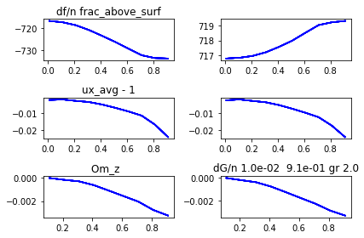
pars_1
Out[45]: array([0.01, 0.11, 0.21, 0.31, 0.41, 0.51, 0.61, 0.71, 0.81, 0.91])

dfc_arr.real
Out[46]:
array([-716.82700783, -717.43293423, -718.76722293, -720.93782926,
-723.58982741, -726.37098508, -729.40891711, -732.38122398,
-733.66458801, -733.84953399])

dfc_arr.imag
Out[47]:
array([716.81065467, 716.85639098, 716.98098623, 717.22121112,
717.57808735, 717.9867201 , 718.50669473, 719.01217986,
719.19434905, 719.28576203])

(dfc_arr.real + 716.8) / pars_1
Out[48]:
array([ -2.70078279, -5.75394756, -9.36772824, -13.34783632,
-16.56055467, -18.76663741, -20.67035592, -21.94538589,
-20.82047903, -18.73575164])

(dfc_arr.imag - 716.8) / pars_1
Out[49]:
array([1.06546739, 0.51264529, 0.86183921, 1.35874555, 1.89777402,
2.32690216, 2.79786021, 3.11574628, 2.95598648, 2.73160662])

(dfc_arr.imag-716.8)/(-dfc_arr.real-716.8)
Out[50]:
array([0.39450318, 0.08909454, 0.09200088, 0.10179519, 0.11459604,
0.12399143, 0.13535617, 0.14197728, 0.14197495, 0.14579648])

Cell/sph dia = 4.1
20.0 4.066801619433198 20.0
Mom_Inertia_SI: 1.5272945748987858e-37
ux = 0.975 + i -0.025
uy = -0.000 + i 0.000
uz = -0.000 + i 0.000
Om_x = -3.50e-19 + i -5.48e-21
Om_y = 2.67e-19 + i 4.17e-20
Om_z = -3.41e-03 + i -3.36e-03
{'ncycles_max': 100, 'target_acc_Hz': 1.0, 'rad_Sph_SI': 1e-08, 'cellheight_SI': 2.5e-08, 'gridreso_SI': 2e-09, 'cell_diam_by_sphere_diam': 4.1, 'frac_above_surf': 0.91, 'nufac': 5.0, 'tandelinv': 5.0, 'iovt': 1, 'nx': 41, 'nz': 41, 'outInterval': 10, 't_computation_secs': 3640.0}
i frac_above_surf df dG
0 1.00e-02 -716.82 716.81
1 1.10e-01 -717.16 716.84
2 2.10e-01 -717.93 716.91
3 3.10e-01 -719.20 717.06
4 4.10e-01 -720.77 717.31
5 5.10e-01 -722.43 717.60
6 6.10e-01 -724.27 717.98
7 7.10e-01 -726.07 718.35
8 8.10e-01 -726.82 718.48
9 9.10e-01 -726.87 718.51

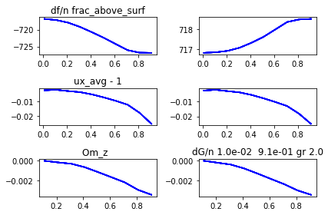
pars_1
Out[76]: array([0.01, 0.11, 0.21, 0.31, 0.41, 0.51, 0.61, 0.71, 0.81, 0.91])

dfc_arr.real
Out[77]:
array([-716.81522653, -717.16257684, -717.9338309 , -719.20135702,
-720.76845594, -722.4312156 , -724.267675 , -726.07178379,
-726.81674658, -726.86515336])

dfc_arr.imag
Out[78]:
array([716.80903771, 716.83583154, 716.90882532, 717.06464652,
717.3129154 , 717.6047992 , 717.97756679, 718.35208127,
718.48051935, 718.50915795])

(dfc_arr.real + 716.8) / pars_1

Out[79]:
array([ -1.52265262, -3.29615313, -5.39919476, -7.74631298,
-9.67916082, -11.04159921, -12.24209017, -13.05885041,
-12.36635381, -11.06060809])

(dfc_arr.imag - 716.8) / pars_1
Out[80]:
array([0.90377146, 0.32574131, 0.51821583, 0.85369845, 1.25101317,
1.57803764, 1.93043735, 2.18602995, 2.07471525, 1.87819555])

(dfc_arr.imag-716.8)/(-dfc_arr.real-716.8)
Out[81]:
array([0.59355065, 0.09882469, 0.09598021, 0.11020707, 0.1292481 ,
0.14291749, 0.15768854, 0.16739835, 0.16777098, 0.16980943])

NEW!
1.1
pars_1
Out[129]: array([0.01, 0.11, 0.21, 0.31, 0.41, 0.51, 0.61, 0.71, 0.81, 0.91])

ux_avg_arr.real-1
Out[130]:
array([-0.002557 , -0.00223857, -0.00296303, -0.00346985, -0.00461441,
-0.00609489, -0.00767619, -0.0094989 , -0.01387541, -0.02027552])

ux_avg_arr.imag
Out[131]:
array([-0.0025887 , -0.00212007, -0.00291432, -0.00359352, -0.00498823,
-0.00678934, -0.00872384, -0.0108443 , -0.01517963, -0.02126292])

Om_z_arr.real
Out[132]:
array([ nan, -2.00500763e-05, -1.73727963e-04, -2.88656539e-04,
-5.74953266e-04, -9.66495178e-04, -1.34674932e-03, -1.71999131e-03,
-2.33665694e-03, -2.80712158e-03])

Om_z_arr.imag
Out[133]:
array([ nan, -4.09102413e-05, -2.20921882e-04, -3.83961561e-04,
-7.15142006e-04, -1.13636022e-03, -1.56118243e-03, -1.97347774e-03,
-2.50923166e-03, -2.93586754e-03])

2.1
pars_1
Out[135]: array([0.01, 0.11, 0.21, 0.31, 0.41, 0.51, 0.61, 0.71, 0.81, 0.91])

ux_avg_arr.real-1
Out[136]:
array([-0.002557 , -0.00223857, -0.00296303, -0.00346985, -0.00461441,
-0.00609489, -0.00767619, -0.0094989 , -0.01387541, -0.02027552])

ux_avg_arr.imag
Out[137]:
array([-0.0025887 , -0.00212007, -0.00291432, -0.00359352, -0.00498823,
-0.00678934, -0.00872384, -0.0108443 , -0.01517963, -0.02126292])

Om_z_arr.real
Out[138]:
array([ nan, -2.00500763e-05, -1.73727963e-04, -2.88656539e-04,
-5.74953266e-04, -9.66495178e-04, -1.34674932e-03, -1.71999131e-03,
-2.33665694e-03, -2.80712158e-03])

Om_z_arr.imag
Out[139]:
array([ nan, -4.09102413e-05, -2.20921882e-04, -3.83961561e-04,
-7.15142006e-04, -1.13636022e-03, -1.56118243e-03, -1.97347774e-03,
-2.50923166e-03, -2.93586754e-03])

3.1
pars_1
Out[143]: array([0.01, 0.11, 0.21, 0.31, 0.41, 0.51, 0.61, 0.71, 0.81, 0.91])

ux_avg_arr.real-1
Out[144]:
array([-0.002559 , -0.00226737, -0.0030733 , -0.00374249, -0.00518849,
-0.00708685, -0.00918436, -0.01158171, -0.01673553, -0.02392793])

ux_avg_arr.imag
Out[145]:
array([-0.00258957, -0.00213891, -0.00299487, -0.00379249, -0.00540837,
-0.00752993, -0.00986625, -0.01244121, -0.01734213, -0.02393622])

Om_z_arr.real
Out[146]:
array([ nan, -2.02695224e-05, -1.79337089e-04, -3.08076271e-04,
-6.35585818e-04, -1.10065336e-03, -1.57493639e-03, -2.04965562e-03,
-2.76326616e-03, -3.24625660e-03])

Om_z_arr.imag
Out[147]:
array([ nan, -4.12345554e-05, -2.26444834e-04, -4.03127096e-04,
-7.69326964e-04, -1.24821768e-03, -1.74555222e-03, -2.23478707e-03,
-2.82466362e-03, -3.24966418e-03])

4.1

pars_1
Out[151]: array([0.01, 0.11, 0.21, 0.31, 0.41, 0.51, 0.61, 0.71, 0.81, 0.91])

ux_avg_arr.real-1
Out[152]:
array([-0.002559 , -0.00227487, -0.00311141, -0.00383378, -0.0053849 ,
-0.00743941, -0.00974519, -0.0123973 , -0.01787206, -0.02536993])

ux_avg_arr.imag
Out[153]:
array([-0.00258985, -0.00214576, -0.00301948, -0.00385637, -0.00554721,
-0.00778239, -0.01026813, -0.01301521, -0.01812317, -0.02488805])

Om_z_arr.real
Out[154]:
array([ nan, -2.03279362e-05, -1.81295996e-04, -3.14551902e-04,
-6.56245971e-04, -1.14792564e-03, -1.65857156e-03, -2.17607716e-03,
-2.92822695e-03, -3.41469048e-03])

Om_z_arr.imag
Out[155]:
array([ nan, -4.13333504e-05, -2.28105971e-04, -4.09182372e-04,
-7.87106556e-04, -1.28611066e-03, -1.81000369e-03, -2.32800562e-03,
-2.93751913e-03, -3.36048252e-03])

New 2.1
10.0 4.066801619433198 10.0
Mom_Inertia_SI: 1.5272945748987858e-37
ux = 0.980 + i -0.021
uy = 0.000 + i 0.000
uz = 0.000 + i 0.000
Om_x = 3.00e-19 + i -6.47e-20
Om_y = 8.01e-19 + i 3.34e-20
Om_z = -2.81e-03 + i -2.94e-03
{'ncycles_max': 100, 'target_acc_Hz': 1.0, 'rad_Sph_SI': 1e-08, 'cellheight_SI': 2.5e-08, 'gridreso_SI': 2e-09, 'cell_diam_by_sphere_diam': 2.1, 'frac_above_surf': 0.91, 'nufac': 5.0, 'tandelinv': 5.0, 'iovt': 1, 'nx': 21, 'nz': 21, 'outInterval': 10, 't_computation_secs': 800.0}
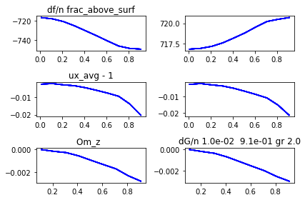
n_dimensions 1
i frac_above_surf df dG
0 1.00e-02 -716.86 716.81
1 1.10e-01 -718.17 716.91
2 2.10e-01 -720.97 717.16
3 3.10e-01 -725.34 717.59
4 4.10e-01 -730.42 718.19
5 5.10e-01 -735.53 718.81
6 6.10e-01 -740.94 719.55
7 7.10e-01 -746.11 720.23
8 8.10e-01 -748.56 720.49
9 9.10e-01 -749.31 720.71

pars_1
Out[158]: array([0.01, 0.11, 0.21, 0.31, 0.41, 0.51, 0.61, 0.71, 0.81, 0.91])

ux_avg_arr.real-1
Out[159]:
array([-0.002557 , -0.00223857, -0.00296303, -0.00346985, -0.00461441,
-0.00609489, -0.00767619, -0.0094989 , -0.01387541, -0.02027552])

ux_avg_arr.imag
Out[160]:
array([-0.0025887 , -0.00212007, -0.00291432, -0.00359352, -0.00498823,
-0.00678934, -0.00872384, -0.0108443 , -0.01517963, -0.02126292])

Om_z_arr.real
Out[161]:
array([ nan, -2.00500763e-05, -1.73727963e-04, -2.88656539e-04,
-5.74953266e-04, -9.66495178e-04, -1.34674932e-03, -1.71999131e-03,
-2.33665694e-03, -2.80712158e-03])

Om_z_arr.imag
Out[162]:
array([ nan, -4.09102413e-05, -2.20921882e-04, -3.83961561e-04,
-7.15142006e-04, -1.13636022e-03, -1.56118243e-03, -1.97347774e-03,
-2.50923166e-03, -2.93586754e-03])

New 1.1
5.0 4.066801619433198 5.0
Mom_Inertia_SI: 1.5272945748987858e-37
ux = 0.989 + i -0.013
uy = -0.000 + i -0.000
uz = -0.000 + i 0.000
Om_x = -4.97e-20 + i -1.97e-20
Om_y = 1.87e-18 + i -2.09e-20
Om_z = -1.29e-03 + i -1.65e-03
{'ncycles_max': 100, 'target_acc_Hz': 1.0, 'rad_Sph_SI': 1e-08, 'cellheight_SI': 2.5e-08, 'gridreso_SI': 2e-09, 'cell_diam_by_sphere_diam': 1.1, 'frac_above_surf': 0.91, 'nufac': 5.0, 'tandelinv': 5.0, 'iovt': 1, 'nx': 11, 'nz': 11, 'outInterval': 10, 't_computation_secs': 139.0}

i frac_above_surf df dG
0 1.00e-02 -717.02 716.83
1 1.10e-01 -721.44 717.12
2 2.10e-01 -729.38 717.66
3 3.10e-01 -739.28 718.31
4 4.10e-01 -748.90 718.98
5 5.10e-01 -757.71 719.48
6 6.10e-01 -766.18 719.85
7 7.10e-01 -774.48 720.45
8 8.10e-01 -779.30 720.01
9 9.10e-01 -782.64 720.15
pars_1
Out[166]: array([0.01, 0.11, 0.21, 0.31, 0.41, 0.51, 0.61, 0.71, 0.81, 0.91])

ux_avg_arr.real-1
Out[167]:
array([-0.002547 , -0.00201573, -0.00220197, -0.00203282, -0.00235426,
-0.003013 , -0.0037214 , -0.00458059, -0.0073652 , -0.01147085])

ux_avg_arr.imag
Out[168]:
array([-0.00258203, -0.00195553, -0.00232381, -0.00240124, -0.00300395,
-0.00391258, -0.00482612, -0.0058125 , -0.00851548, -0.01270362])

Om_z_arr.real
Out[169]:
array([ nan, -1.94151875e-05, -1.38707501e-04, -1.86877341e-04,
-3.20631810e-04, -4.87392558e-04, -6.21539190e-04, -7.44740737e-04,
-1.04346934e-03, -1.28531943e-03])

Om_z_arr.imag
Out[170]:
array([ nan, -3.89434179e-05, -1.85031329e-04, -2.78370435e-04,
-4.62690310e-04, -6.78213347e-04, -8.71183587e-04, -1.04719575e-03,
-1.35825631e-03, -1.65154458e-03])

20.07.2020
Changing frac_above_surf
Nufac – 0.5
i frac_above_surf df dG
0 1.00e-02 -716.84 716.85
1 1.10e-01 -717.79 717.64
2 2.10e-01 -719.36 719.59
3 3.10e-01 -721.35 722.44
4 4.10e-01 -723.27 725.75
5 5.10e-01 -725.06 729.32
6 6.10e-01 -726.52 732.77
7 7.10e-01 -727.93 736.13
8 8.10e-01 -728.86 738.32
9 9.10e-01 -729.23 739.25
10.0 4.066801619433198 10.0
Mom_Inertia_SI: 1.5272945748987858e-37
ux = 0.979 + i -0.041
uy = -0.000 + i 0.000
uz = 0.000 + i 0.000
Om_x = -2.63e-20 + i 1.94e-20
Om_y = 0.00e+00 + i 1.17e-19
Om_z = -3.11e-03 + i -4.18e-03
{'ncycles_max': 100, 'target_acc_Hz': 1.0, 'rad_Sph_SI': 1e-08, 'cellheight_SI': 2.5e-08, 'gridreso_SI': 2e-09, 'cell_diam_by_sphere_diam': 2.1, 'frac_above_surf': 0.91, 'nufac': 0.5, 'tandelinv': 5.0, 'iovt': 1, 'nx': 21, 'nz': 21, 'outInterval': 10, 't_computation_secs': 941.0}
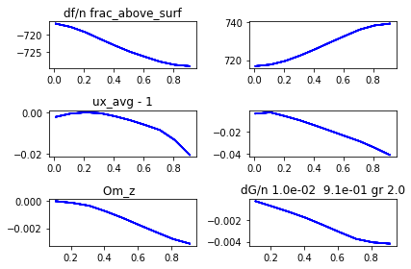

pars_1
Out[173]: array([0.01, 0.11, 0.21, 0.31, 0.41, 0.51, 0.61, 0.71, 0.81, 0.91])

dfc_arr.real
Out[174]:
array([-716.83526352, -717.79169523, -719.35502777, -721.34617352,
-723.26737566, -725.05719727, -726.51763895, -727.93066009,
-728.86013102, -729.22930555])
dfc_arr.imag
Out[175]:
array([716.8475888 , 717.64243999, 719.58779335, 722.44374372,
725.75342421, 729.32192469, 732.77486668, 736.12749362,
738.32162452, 739.25368758])
ux_avg_arr.real-1
Out[176]:
array([-2.19700000e-03, -5.94566667e-04, -3.61518987e-05, -3.96067568e-04,
-1.92360369e-03, -3.79887063e-03, -6.07798310e-03, -8.55697642e-03,
-1.33617996e-02, -2.05231053e-02])

ux_avg_arr.imag
Out[177]:
array([-0.00373329, -0.00263882, -0.00606932, -0.00986318, -0.01439855,
-0.01910333, -0.02390869, -0.02862557, -0.03445429, -0.04084833])

Om_z_arr.real
Out[178]:
array([ nan, -2.58252013e-05, -1.48593551e-04, -3.56509121e-04,
-7.71402428e-04, -1.24425569e-03, -1.76732316e-03, -2.27687165e-03,
-2.77344278e-03, -3.11237786e-03])
Om_z_arr.imag
Out[180]:
array([ nan, -0.00023084, -0.00072197, -0.00122939, -0.00177967,
-0.0024242 , -0.00309701, -0.00373495, -0.00405762, -0.00417539])

Nufac – 1
pars_1
Out[185]: array([0.01, 0.11, 0.21, 0.31, 0.41, 0.51, 0.61, 0.71, 0.81, 0.91])

dfc_arr.real
Out[186]:
array([-716.85148358, -718.05308641, -720.5693872 , -724.28552573,
-728.21180127, -732.17713109, -735.97659543, -739.67985236,
-742.09949751, -743.11765134])

dfc_arr.imag
Out[187]:
array([716.83120425, 717.25801727, 718.40885459, 720.48865869,
723.18745741, 725.90054643, 728.96090893, 731.95815541,
733.58413001, 734.36318185])

ux_avg_arr.real-1
Out[188]:
array([-0.002332 , -0.00177013, -0.00161804, -0.00108682, -0.00135293,
-0.00230681, -0.00348329, -0.00501212, -0.00920815, -0.01564185])

ux_avg_arr.imag
Out[189]:
array([-0.00307401, -0.00201618, -0.0032845 , -0.00503074, -0.00813721,
-0.01164676, -0.01553571, -0.01948123, -0.02471405, -0.03131013])

Om_z_arr.real
Out[190]:
array([ nan, 7.71534364e-06, -7.41216748e-05, -1.32477179e-04,
-4.31326608e-04, -8.23369145e-04, -1.21988279e-03, -1.61495931e-03,
-2.26211979e-03, -2.83655597e-03])

Om_z_arr.imag
Out[191]:
array([ nan, -0.00011334, -0.00041789, -0.00078063, -0.00130432,
-0.00187183, -0.00250677, -0.00312727, -0.00353724, -0.00372818]
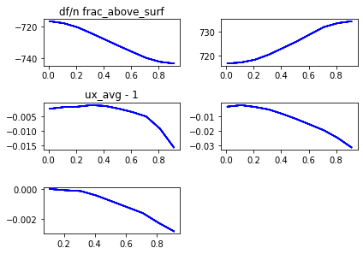
i frac_above_surf df dG
0 1.00e-02 -716.85 716.83
1 1.10e-01 -718.05 717.26
2 2.10e-01 -720.57 718.41
3 3.10e-01 -724.29 720.49
4 4.10e-01 -728.21 723.19
5 5.10e-01 -732.18 725.90
6 6.10e-01 -735.98 728.96
7 7.10e-01 -739.68 731.96
8 8.10e-01 -742.10 733.58
9 9.10e-01 -743.12 734.36

10.0 4.066801619433198 10.0
Mom_Inertia_SI: 1.5272945748987858e-37
ux = 0.984 + i -0.031
uy = -0.000 + i 0.000
uz = -0.000 + i -0.000
Om_x = 8.71e-20 + i 1.58e-19
Om_y = 5.34e-19 + i -1.08e-19
Om_z = -2.84e-03 + i -3.73e-03
{'ncycles_max': 100, 'target_acc_Hz': 1.0, 'rad_Sph_SI': 1e-08, 'cellheight_SI': 2.5e-08, 'gridreso_SI': 2e-09, 'cell_diam_by_sphere_diam': 2.1, 'frac_above_surf': 0.91, 'nufac': 1.0, 'tandelinv': 5.0, 'iovt': 1, 'nx': 21, 'nz': 21, 'outInterval': 10, 't_computation_secs': 831.0}

Nufac - 3
pars_1
Out[195]: array([0.01, 0.11, 0.21, 0.31, 0.41, 0.51, 0.61, 0.71, 0.81, 0.91])

dfc_arr.real
Out[196]:
array([-716.85874373, -718.15263649, -720.92768541, -725.25208978,
-730.27340196, -735.33052162, -740.67607026, -745.8488059 ,
-748.42524371, -749.26942174])

dfc_arr.imag
Out[197]:
array([716.81675598, 716.96817105, 717.35430221, 718.03597939,
718.97626659, 719.94823793, 721.12249059, 722.21164412,
722.56977683, 722.76649627])

ux_avg_arr.real-1
Out[198]:
array([-0.002514 , -0.0022109 , -0.00285468, -0.00323973, -0.00421542,
-0.00553586, -0.00692625, -0.00854119, -0.01280945, -0.01917069])

ux_avg_arr.imag
Out[199]:
array([-0.00266672, -0.00209229, -0.0029098 , -0.00364542, -0.00515175,
-0.00711405, -0.00923169, -0.01152184, -0.01593884, -0.02205239])

Om_z_arr.real
Out[200]:
array([ nan, -1.43280538e-05, -1.56203294e-04, -2.56009725e-04,
-5.31422162e-04, -9.14709852e-04, -1.28026993e-03, -1.63365777e-03,
-2.25642286e-03, -2.76290903e-03])

Om_z_arr.imag
Out[201]:
array([ nan, -5.11399075e-05, -2.46738580e-04, -4.34546283e-04,
-7.94311839e-04, -1.23850389e-03, -1.69326186e-03, -2.13466738e-03,
-2.65210015e-03, -3.07981042e-03])
i frac_above_surf df dG
0 1.00e-02 -716.86 716.82
1 1.10e-01 -718.15 716.97
2 2.10e-01 -720.93 717.35
3 3.10e-01 -725.25 718.04
4 4.10e-01 -730.27 718.98
5 5.10e-01 -735.33 719.95
6 6.10e-01 -740.68 721.12
7 7.10e-01 -745.85 722.21
8 8.10e-01 -748.43 722.57
9 9.10e-01 -749.27 722.77
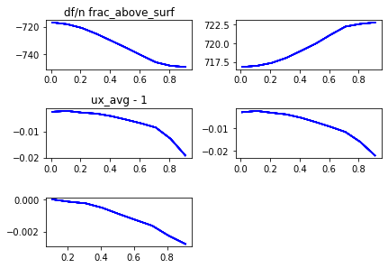
10.0 4.066801619433198 10.0
Mom_Inertia_SI: 1.5272945748987858e-37
ux = 0.981 + i -0.022
uy = -0.000 + i 0.000
uz = -0.000 + i 0.000
Om_x = 5.87e-20 + i 9.65e-21
Om_y = -2.67e-19 + i 0.00e+00
Om_z = -2.76e-03 + i -3.08e-03
{'ncycles_max': 100, 'target_acc_Hz': 1.0, 'rad_Sph_SI': 1e-08, 'cellheight_SI': 2.5e-08, 'gridreso_SI': 2e-09, 'cell_diam_by_sphere_diam': 2.1, 'frac_above_surf': 0.91, 'nufac': 3.0, 'tandelinv': 5.0, 'iovt': 1, 'nx': 21, 'nz': 21, 'outInterval': 10, 't_computation_secs': 780.0}

Nufac -5
pars_1
Out[203]: array([0.01, 0.11, 0.21, 0.31, 0.41, 0.51, 0.61, 0.71, 0.81, 0.91])

dfc_arr.real
Out[204]:
array([-716.85971935, -718.16716365, -720.97026411, -725.33729591,
-730.41551176, -735.525115 , -740.93622389, -746.10839631,
-748.55786968, -749.30757164])

dfc_arr.imag
Out[205]:
array([716.81339808, 716.91057875, 717.15730999, 717.59155168,
718.18903384, 718.81361563, 719.55429388, 720.22547551,
720.49487061, 720.7088928 ])

ux_avg_arr.real-1
Out[206]:
array([-0.002557 , -0.00223857, -0.00296303, -0.00346985, -0.00461441,
-0.00609489, -0.00767619, -0.0094989 , -0.01387541, -0.02027552])

ux_avg_arr.imag
Out[207]:
array([-0.0025887 , -0.00212007, -0.00291432, -0.00359352, -0.00498823,
-0.00678934, -0.00872384, -0.0108443 , -0.01517963, -0.02126292])

Om_z_arr.real
Out[208]:
array([ nan, -2.00500763e-05, -1.73727963e-04, -2.88656539e-04,
-5.74953266e-04, -9.66495178e-04, -1.34674932e-03, -1.71999131e-03,
-2.33665694e-03, -2.80712158e-03])

Om_z_arr.imag
Out[209]:
array([ nan, -4.09102413e-05, -2.20921882e-04, -3.83961561e-04,
-7.15142006e-04, -1.13636022e-03, -1.56118243e-03, -1.97347774e-03,
-2.50923166e-03, -2.93586754e-03])

i frac_above_surf df dG
0 1.00e-02 -716.86 716.81
1 1.10e-01 -718.17 716.91
2 2.10e-01 -720.97 717.16
3 3.10e-01 -725.34 717.59
4 4.10e-01 -730.42 718.19
5 5.10e-01 -735.53 718.81
6 6.10e-01 -740.94 719.55
7 7.10e-01 -746.11 720.23
8 8.10e-01 -748.56 720.49
9 9.10e-01 -749.31 720.71

10.0 4.066801619433198 10.0
Mom_Inertia_SI: 1.5272945748987858e-37
ux = 0.980 + i -0.021
uy = 0.000 + i 0.000
uz = 0.000 + i 0.000
Om_x = 3.00e-19 + i -6.47e-20
Om_y = 8.01e-19 + i 3.34e-20
Om_z = -2.81e-03 + i -2.94e-03
{'ncycles_max': 100, 'target_acc_Hz': 1.0, 'rad_Sph_SI': 1e-08, 'cellheight_SI': 2.5e-08, 'gridreso_SI': 2e-09, 'cell_diam_by_sphere_diam': 2.1, 'frac_above_surf': 0.91, 'nufac': 5.0, 'tandelinv': 5.0, 'iovt': 1, 'nx': 21, 'nz': 21, 'outInterval': 10, 't_computation_secs': 754.0}

New stuff – 1.1 and increasing (frac_above_surf)
26.07.2020 data taken
Nufac-0.5
10.0 10.60759493670886 10.0
Mom_Inertia_SI: 8.986734177215193e-39
ux = 0.898 + i -0.069
uy = -0.000 + i -0.000
uz = 0.000 + i 0.000
Om_x = -5.38e-19 + i 5.24e-19
Om_y = -4.54e-18 + i -5.67e-19
Om_z = -3.71e-04 + i -4.58e-04
{'ncycles_max': 100, 'target_acc_Hz': 1.0, 'rad_Sph_SI': 1e-08, 'cellheight_SI': 2.5e-08, 'gridreso_SI': 2e-09, 'cell_diam_by_sphere_diam': 2.1, 'frac_above_surf': 1.9, 'nufac': 0.5, 'tandelinv': 5.0, 'iovt': 1, 'nx': 21, 'nz': 21, 'outInterval': 10, 't_computation_secs': 951.0}
n_dimensions 1
i frac_above_surf df dG
0 1.00e+00 -729.63 737.36
1 1.10e+00 -728.17 738.45
2 1.20e+00 -692.82 774.21
3 1.30e+00 -663.91 802.61
4 1.40e+00 -630.34 835.77
5 1.50e+00 -629.81 832.14
6 1.60e+00 -629.26 828.64
7 1.70e+00 -628.71 825.28
8 1.80e+00 -628.26 822.18
9 1.90e+00 -658.60 784.54
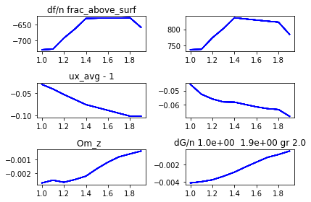

pars_1
Out[222]: array([1. , 1.1, 1.2, 1.3, 1.4, 1.5, 1.6, 1.7, 1.8, 1.9])

dfc_arr.real
Out[223]:
array([-729.63139307, -728.17371656, -692.82146092, -663.91245344,
-630.34355997, -629.81135432, -629.26479063, -628.706814 ,
-628.26473143, -658.60118375])

dfc_arr.imag
Out[224]:
array([737.36433209, 738.44560828, 774.20620476, 802.61216093,
835.77162372, 832.13574657, 828.63779645, 825.27749122,
822.1820837 , 784.5428851 ])

ux_avg_arr.real-1
Out[225]:
array([-0.03090543, -0.0410065 , -0.05331907, -0.06443326, -0.07570235,
-0.08205073, -0.08839031, -0.09479087, -0.10116759, -0.10157814])

ux_avg_arr.imag
Out[226]:
array([-0.04558369, -0.05263193, -0.05607126, -0.05818658, -0.05833502,
-0.06003714, -0.06171609, -0.06299537, -0.06364436, -0.06850779])

Om_z_arr.real
Out[227]:
array([-0.00271424, -0.00251199, -0.00266312, -0.00246458, -0.00221441,
-0.00166505, -0.00118862, -0.00079741, -0.00057981, -0.00037142])

Om_z_arr.imag
Out[228]:
array([-0.00410338, -0.00395583, -0.00374396, -0.00333863, -0.0028675 ,
-0.00227524, -0.00171723, -0.00117531, -0.00085093, -0.00045799])
Nufac -1
10.0 10.60759493670886 10.0
Mom_Inertia_SI: 8.986734177215193e-39
ux = 0.888 + i -0.068
uy = 0.000 + i 0.000
uz = 0.000 + i 0.000
Om_x = -3.22e-19 + i -4.88e-20
Om_y = -4.54e-18 + i 2.84e-19
Om_z = -3.80e-04 + i -4.67e-04
{'ncycles_max': 100, 'target_acc_Hz': 1.0, 'rad_Sph_SI': 1e-08, 'cellheight_SI': 2.5e-08, 'gridreso_SI': 2e-09, 'cell_diam_by_sphere_diam': 2.1, 'frac_above_surf': 1.9, 'nufac': 1.0, 'tandelinv': 5.0, 'iovt': 1, 'nx': 21, 'nz': 21, 'outInterval': 10, 't_computation_secs': 1011.0}
n_dimensions 1
i frac_above_surf df dG
0 1.00e+00 -740.81 731.59
1 1.10e+00 -738.50 734.12
2 1.20e+00 -700.93 804.15
3 1.30e+00 -669.86 859.77
4 1.40e+00 -633.57 923.85
5 1.50e+00 -631.14 919.28
6 1.60e+00 -629.06 914.82
7 1.70e+00 -627.26 910.51
8 1.80e+00 -625.85 906.22
9 1.90e+00 -656.23 839.53
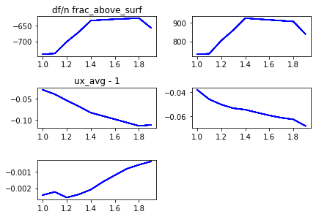

pars_1
Out[230]: array([1. , 1.1, 1.2, 1.3, 1.4, 1.5, 1.6, 1.7, 1.8, 1.9])

dfc_arr.real
Out[231]:
array([-740.81251422, -738.49857587, -700.92601916, -669.86318502,
-633.57184783, -631.13983179, -629.06417727, -627.25818358,
-625.85109334, -656.2333326 ])

dfc_arr.imag
Out[232]:
array([731.58917742, 734.11882362, 804.14548924, 859.77113595,
923.8495806 , 919.27754593, 914.82481817, 910.50679344,
906.21563844, 839.53346625])

ux_avg_arr.real-1
Out[233]:
array([-0.02854795, -0.03899158, -0.05395211, -0.06782972, -0.0829135 ,
-0.09073341, -0.09848172, -0.10635615, -0.11418828, -0.11202933])

ux_avg_arr.imag
Out[234]:
array([-0.03823029, -0.04609214, -0.0504874 , -0.05355986, -0.05474932,
-0.05720007, -0.05953044, -0.061483 , -0.06284079, -0.06824405])

Om_z_arr.real
Out[235]:
array([-0.0024105 , -0.00221953, -0.00255916, -0.0023695 , -0.00207982,
-0.00161219, -0.00120965, -0.00081826, -0.00057966, -0.00037978])

Om_z_arr.imag
Out[236]:
array([-0.00336379, -0.00315078, -0.00286721, -0.00251937, -0.00215563,
-0.0016615 , -0.00124314, -0.00087247, -0.00070664, -0.00046686])
Nufac – 3
10.0 10.60759493670886 10.0
Mom_Inertia_SI: 8.986734177215193e-39
ux = 0.864 + i -0.068
uy = -0.000 + i -0.000
uz = -0.000 + i 0.000
Om_x = -9.91e-19 + i -2.18e-19
Om_y = 4.54e-18 + i 5.67e-19
Om_z = -1.65e-04 + i -5.52e-04
{'ncycles_max': 100, 'target_acc_Hz': 1.0, 'rad_Sph_SI': 1e-08, 'cellheight_SI': 2.5e-08, 'gridreso_SI': 2e-09, 'cell_diam_by_sphere_diam': 2.1, 'frac_above_surf': 1.9, 'nufac': 3.0, 'tandelinv': 5.0, 'iovt': 1, 'nx': 21, 'nz': 21, 'outInterval': 10, 't_computation_secs': 1005.0}
n_dimensions 1
i frac_above_surf df dG
0 1.00e+00 -745.55 722.76
1 1.10e+00 -743.08 729.41
2 1.20e+00 -707.08 880.34
3 1.30e+00 -675.55 999.62
4 1.40e+00 -637.25 1135.04
5 1.50e+00 -631.88 1128.12
6 1.60e+00 -627.24 1120.67
7 1.70e+00 -623.38 1112.86
8 1.80e+00 -620.24 1104.32
9 1.90e+00 -651.18 969.99
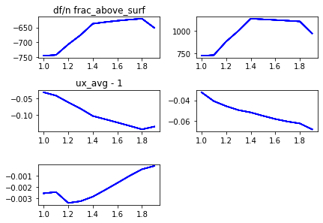

pars_1
Out[238]: array([1. , 1.1, 1.2, 1.3, 1.4, 1.5, 1.6, 1.7, 1.8, 1.9])

dfc_arr.real
Out[239]:
array([-745.55019891, -743.08161214, -707.08463269, -675.55099915,
-637.25105534, -631.8806309 , -627.23625435, -623.37628847,
-620.23608157, -651.18097948])

dfc_arr.imag
Out[240]:
array([ 722.75614378, 729.40851936, 880.33548425, 999.61800786,
1135.03563316, 1128.1211966 , 1120.66737284, 1112.86017445,
1104.32339121, 969.98690027])

ux_avg_arr.real-1
Out[241]:
array([-0.03028708, -0.04042402, -0.06104576, -0.08050733, -0.10304604,
-0.11293434, -0.12304691, -0.13341403, -0.14404191, -0.13565 ])

ux_avg_arr.imag
Out[242]:
array([-0.03215673, -0.04076496, -0.04560495, -0.04946355, -0.05173791,
-0.05504708, -0.05814486, -0.06061115, -0.06247076, -0.06821464])

Om_z_arr.real
Out[243]:
array([-0.00255362, -0.00244067, -0.00339547, -0.00324156, -0.00284547,
-0.00225691, -0.00164525, -0.00102048, -0.00045418, -0.0001645 ])

Om_z_arr.imag
Out[244]:
array([-0.00272979, -0.0024957 , -0.00201845, -0.0015964 , -0.00141002,
-0.00111464, -0.00094442, -0.00074739, -0.00077429, -0.00055151])
Nufac -5
10.0 10.60759493670886 10.0
Mom_Inertia_SI: 8.986734177215193e-39
ux = 0.849 + i -0.068
uy = -0.000 + i 0.000
uz = 0.000 + i -0.000
Om_x = 3.23e-19 + i 1.35e-19
Om_y = -4.54e-18 + i -2.84e-19
Om_z = 6.62e-06 + i -5.46e-04
{'ncycles_max': 100, 'target_acc_Hz': 1.0, 'rad_Sph_SI': 1e-08, 'cellheight_SI': 2.5e-08, 'gridreso_SI': 2e-09, 'cell_diam_by_sphere_diam': 2.1, 'frac_above_surf': 1.9, 'nufac': 5.0, 'tandelinv': 5.0, 'iovt': 1, 'nx': 21, 'nz': 21, 'outInterval': 10, 't_computation_secs': 909.0}

n_dimensions 1
i frac_above_surf df dG
0 1.00e+00 -745.89 721.02
1 1.10e+00 -743.52 729.99
2 1.20e+00 -709.27 932.34
3 1.30e+00 -678.07 1091.80
4 1.40e+00 -638.77 1272.02
5 1.50e+00 -631.89 1263.38
6 1.60e+00 -625.83 1253.55
7 1.70e+00 -620.74 1242.74
8 1.80e+00 -616.44 1230.58
9 1.90e+00 -647.65 1053.84
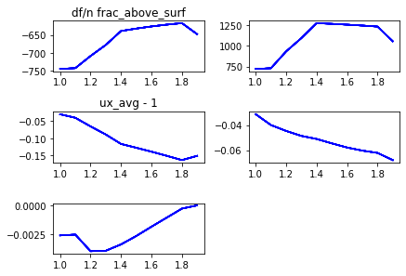
pars_1
Out[247]: array([1. , 1.1, 1.2, 1.3, 1.4, 1.5, 1.6, 1.7, 1.8, 1.9])

dfc_arr.real
Out[248]:
array([-745.88976792, -743.52122992, -709.27406619, -678.06612161,
-638.76856257, -631.88559136, -625.83304204, -620.74162641,
-616.43641223, -647.64762598])

dfc_arr.imag
Out[249]:
array([ 721.01848151, 729.98902416, 932.34421425, 1091.80169997,
1272.02209543, 1263.38022367, 1253.54727507, 1242.74342006,
1230.58226175, 1053.83504594])

ux_avg_arr.real-1
Out[250]:
array([-0.03085648, -0.04104002, -0.0658876 , -0.08916333, -0.11633383,
-0.12731114, -0.13857795, -0.1504763 , -0.1628076 , -0.15063235])

ux_avg_arr.imag
Out[251]:
array([-0.03129828, -0.0399193 , -0.04465102, -0.04859944, -0.05103483,
-0.05455608, -0.05785529, -0.06032953, -0.0621615 , -0.06789537])
Om_z_arr.real
Out[252]:
array([-2.60577210e-03, -2.53319599e-03, -3.97975101e-03, -3.93921641e-03,
-3.38691592e-03, -2.65884023e-03, -1.84741379e-03, -1.06260379e-03,
-2.74752215e-04, 6.61500368e-06])

Om_z_arr.imag
Out[253]:
array([-0.00262798, -0.00239683, -0.00187284, -0.00139407, -0.0012496 ,
-0.00100651, -0.00089802, -0.0007298 , -0.00078022, -0.00054577])
New_28_7
Nufac -0.5
10.0 10.60759493670886 10.0
Mom_Inertia_SI: 2.8757549367088618e-37
ux = 0.806 + i -0.123
uy = -0.000 + i 0.000
uz = -0.000 + i 0.000
Om_x = -2.46e-19 + i -3.47e-19
Om_y = -4.54e-18 + i -5.67e-19
Om_z = -7.35e-04 + i -7.76e-04
{'ncycles_max': 100, 'target_acc_Hz': 1.0, 'rad_Sph_SI': 2e-08, 'cellheight_SI': 5e-08, 'gridreso_SI': 4e-09, 'cell_diam_by_sphere_diam': 2.1, 'frac_above_surf': 1.9, 'nufac': 0.5, 'tandelinv': 5.0, 'iovt': 1, 'nx': 21, 'nz': 21, 'outInterval': 10, 't_computation_secs': 834.0}
n_dimensions 1
i frac_above_surf df dG
0 1.00e+00 -737.33 757.52
1 1.10e+00 -734.86 757.39
2 1.20e+00 -696.65 780.61
3 1.30e+00 -666.17 797.85
4 1.40e+00 -632.01 817.57
5 1.50e+00 -631.62 811.08
6 1.60e+00 -631.27 804.94
7 1.70e+00 -630.97 799.12
8 1.80e+00 -630.87 793.87
9 1.90e+00 -660.29 765.28

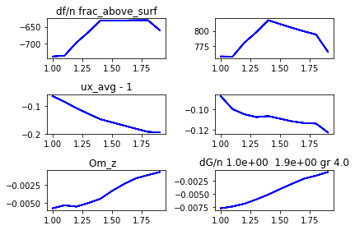

pars_1
Out[2]: array([1. , 1.1, 1.2, 1.3, 1.4, 1.5, 1.6, 1.7, 1.8, 1.9])

dfc_arr.real
Out[3]:
array([-737.33229487, -734.85631648, -696.65208276, -666.16647933,
-632.01388902, -631.62139933, -631.27453491, -630.96613711,
-630.86987725, -660.28666355])

dfc_arr.imag
Out[4]:
array([757.52236957, 757.39454084, 780.61072365, 797.84994145,
817.56790284, 811.08247139, 804.93633117, 799.11927523,
793.86598162, 765.28100844])

ux_avg_arr.real-1
Out[5]:
array([-0.06502127, -0.08519846, -0.10790904, -0.12779714, -0.14725379,
-0.15868241, -0.16992231, -0.18125631, -0.19227764, -0.19438216])

ux_avg_arr.imag
Out[6]:
array([-0.08754891, -0.10013505, -0.10511266, -0.10781035, -0.10682265,
-0.10939049, -0.11191389, -0.11354757, -0.11404067, -0.12259422])

Om_z_arr.real
Out[7]:
array([-0.00573586, -0.00532104, -0.00550046, -0.00501191, -0.00442999,
-0.00333424, -0.00238494, -0.00159883, -0.00115923, -0.00073516])

Om_z_arr.imag
Out[8]:
array([-0.007676 , -0.00732756, -0.00679963, -0.00597913, -0.00506021,
-0.00399761, -0.00300339, -0.00204239, -0.00146665, -0.0007765 ])
Nufac -1
10.0 10.60759493670886 10.0
Mom_Inertia_SI: 2.8757549367088618e-37
ux = 0.788 + i -0.120
uy = -0.000 + i 0.000
uz = -0.000 + i 0.000
Om_x = -8.96e-19 + i -1.68e-20
Om_y = 0.00e+00 + i 5.67e-19
Om_z = -7.46e-04 + i -7.83e-04
{'ncycles_max': 100, 'target_acc_Hz': 1.0, 'rad_Sph_SI': 2e-08, 'cellheight_SI': 5e-08, 'gridreso_SI': 4e-09, 'cell_diam_by_sphere_diam': 2.1, 'frac_above_surf': 1.9, 'nufac': 1.0, 'tandelinv': 5.0, 'iovt': 1, 'nx': 21, 'nz': 21, 'outInterval': 10, 't_computation_secs': 827.0}
i frac_above_surf df dG
0 1.00e+00 -759.82 748.18
1 1.10e+00 -755.35 749.81
2 1.20e+00 -709.29 804.95
3 1.30e+00 -672.16 846.36
4 1.40e+00 -630.39 892.05
5 1.50e+00 -626.82 883.79
6 1.60e+00 -624.02 875.90
7 1.70e+00 -621.80 868.39
8 1.80e+00 -620.35 861.12
9 1.90e+00 -652.11 809.15
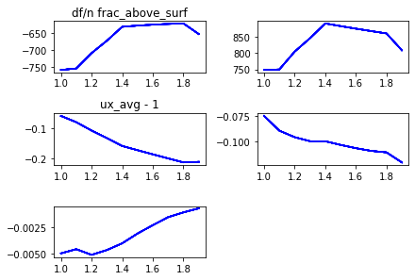

pars_1
Out[10]: array([1. , 1.1, 1.2, 1.3, 1.4, 1.5, 1.6, 1.7, 1.8, 1.9])

dfc_arr.real
Out[11]:
array([-759.81783343, -755.35387495, -709.29289023, -672.15580668,
-630.39160604, -626.82269793, -624.02038009, -621.79763529,
-620.34886382, -652.11048502])

dfc_arr.imag
Out[12]:
array([748.17767753, 749.81292268, 804.94712371, 846.36042909,
892.05169531, 883.78973601, 875.89740099, 868.38650186,
861.12031582, 809.15425459])

ux_avg_arr.real-1
Out[13]:
array([-0.05898276, -0.07986781, -0.10767511, -0.13269032, -0.15889514,
-0.17280767, -0.18659209, -0.20010357, -0.21341719, -0.21154137])

ux_avg_arr.imag
Out[14]:
array([-0.07464156, -0.08916806, -0.09556018, -0.09950836, -0.09957669,
-0.10316204, -0.10638211, -0.1090419 , -0.11051903, -0.12036613])

Om_z_arr.real
Out[15]:
array([-0.00499422, -0.00459605, -0.00513401, -0.00467867, -0.00404694,
-0.0031229 , -0.00233571, -0.0015778 , -0.00112718, -0.00074638])

Om_z_arr.imag
Out[16]:
array([-0.00637433, -0.00589865, -0.00519931, -0.00447466, -0.00375293,
-0.00286421, -0.00212109, -0.0014769 , -0.00119162, -0.00078259])
Nufac -3
10.0 10.60759493670886 10.0
Mom_Inertia_SI: 2.8757549367088618e-37
ux = 0.751 + i -0.117
uy = -0.000 + i -0.000
uz = -0.000 + i -0.000
Om_x = -7.17e-19 + i -2.16e-19
Om_y = 2.27e-18 + i 2.84e-19
Om_z = -3.82e-04 + i -9.40e-04
{'ncycles_max': 100, 'target_acc_Hz': 1.0, 'rad_Sph_SI': 2e-08, 'cellheight_SI': 5e-08, 'gridreso_SI': 4e-09, 'cell_diam_by_sphere_diam': 2.1, 'frac_above_surf': 1.9, 'nufac': 3.0, 'tandelinv': 5.0, 'iovt': 1, 'nx': 21, 'nz': 21, 'outInterval': 10, 't_computation_secs': 794.0}
i frac_above_surf df dG
0 1.00e+00 -769.97 731.68
1 1.10e+00 -764.93 738.15
2 1.20e+00 -714.15 865.85
3 1.30e+00 -670.69 961.33
4 1.40e+00 -620.08 1063.79
5 1.50e+00 -612.04 1051.68
6 1.60e+00 -605.58 1038.97
7 1.70e+00 -600.71 1026.05
8 1.80e+00 -597.33 1012.41
9 1.90e+00 -634.68 908.95
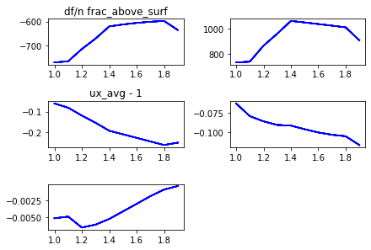

pars_1
Out[18]: array([1. , 1.1, 1.2, 1.3, 1.4, 1.5, 1.6, 1.7, 1.8, 1.9])

dfc_arr.real
Out[19]:
array([-769.96737147, -764.92545519, -714.14638682, -670.68879655,
-620.07617356, -612.04351953, -605.58400433, -600.7104154 ,
-597.33421781, -634.68017926])

dfc_arr.imag
Out[20]:
array([ 731.68099187, 738.15114346, 865.85382997, 961.33136017,
1063.78566144, 1051.67959813, 1038.97133039, 1026.04661791,
1012.40800019, 908.9530439 ])

ux_avg_arr.real-1
Out[21]:
array([-0.06100367, -0.08123889, -0.11896153, -0.15345082, -0.19149028,
-0.20850146, -0.22552561, -0.24274325, -0.25981563, -0.24861492])

ux_avg_arr.imag
Out[22]:
array([-0.06336762, -0.07957857, -0.08623962, -0.09080605, -0.0916918 ,
-0.09628005, -0.10046665, -0.10340984, -0.10530325, -0.11652819])

Om_z_arr.real
Out[23]:
array([-0.00513985, -0.00489533, -0.00651086, -0.00607858, -0.00523911,
-0.00413038, -0.00301358, -0.00188241, -0.00090637, -0.00038242])

Om_z_arr.imag
Out[24]:
array([-0.00518297, -0.00465638, -0.00354664, -0.00267939, -0.00228873,
-0.00177744, -0.00150689, -0.00120267, -0.00129033, -0.00093963])
Nufac -5
10.0 10.60759493670886 10.0
Mom_Inertia_SI: 2.8757549367088618e-37
ux = 0.729 + i -0.114
uy = 0.000 + i -0.000
uz = 0.000 + i -0.000
Om_x = 3.32e-19 + i 1.62e-19
Om_y = -4.54e-18 + i -5.67e-19
Om_z = -9.76e-05 + i -9.41e-04
{'ncycles_max': 100, 'target_acc_Hz': 1.0, 'rad_Sph_SI': 2e-08, 'cellheight_SI': 5e-08, 'gridreso_SI': 4e-09, 'cell_diam_by_sphere_diam': 2.1, 'frac_above_surf': 1.9, 'nufac': 5.0, 'tandelinv': 5.0, 'iovt': 1, 'nx': 21, 'nz': 21, 'outInterval': 10, 't_computation_secs': 799.0}
i frac_above_surf df dG
0 1.00e+00 -770.78 728.39
1 1.10e+00 -765.76 736.99
2 1.20e+00 -713.58 907.30
3 1.30e+00 -667.60 1034.25
4 1.40e+00 -612.50 1169.60
5 1.50e+00 -602.45 1154.98
6 1.60e+00 -594.26 1138.83
7 1.70e+00 -588.07 1121.68
8 1.80e+00 -583.63 1103.07
9 1.90e+00 -623.89 969.53
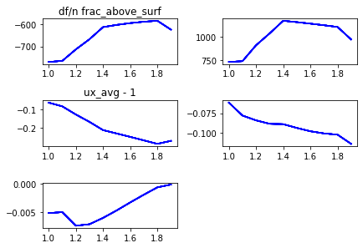

pars_1
Out[26]: array([1. , 1.1, 1.2, 1.3, 1.4, 1.5, 1.6, 1.7, 1.8, 1.9])
dfc_arr.real
Out[27]:
array([-770.77875742, -765.76216124, -713.57628023, -667.59570645,
-612.50341846, -602.44770309, -594.26047195, -588.06988868,
-583.62639666, -623.89344147])

dfc_arr.imag
Out[28]:
array([ 728.39401876, 736.99376296, 907.30339025, 1034.25436997,
1169.60200517, 1154.97543198, 1138.83372059, 1121.68230939,
1103.07324582, 969.53480779])

ux_avg_arr.imag
Out[29]:
array([-0.06177277, -0.07801443, -0.08408232, -0.0884171 , -0.0888981 ,
-0.09361064, -0.0978164 , -0.10052478, -0.1021199 , -0.11368111])

ux_avg_arr.real-1
Out[30]:
array([-0.06190932, -0.08215639, -0.12679258, -0.16709189, -0.21197822,
-0.23043907, -0.24900181, -0.26811196, -0.28717181, -0.27082529])

Om_z_arr.real
Out[31]:
array([-5.22155444e-03, -5.04981955e-03, -7.49184850e-03, -7.21947729e-03,
-6.08709757e-03, -4.75052128e-03, -3.31053933e-03, -1.92594062e-03,
-6.03621463e-04, -9.76455066e-05])

Om_z_arr.imag
Out[32]:
array([-0.00498951, -0.00446332, -0.00323439, -0.00225398, -0.0019427 ,
-0.00153657, -0.00139254, -0.00115559, -0.00130335, -0.00094089])

