Architecture Design

# Amazon Sales Data Analysis

|  |  |
| --- | --- |
| **Written By** | Lalasab Allasab Nadaf |
| **Document Version** | 1.0 |
| **Last Revised Date** |  |

**DOCUMENT CONTROL**

## Change Record:

|  |  |  |  |
| --- | --- | --- | --- |
| **VERSION** | **DATE** | **AUTHOR** | **COMMENTS** |
| 1.0 | 17-12-2022 | Lalasab Allasab Nadaf | Introduction and architecture defined |
|  |  |  |  |
|  |  |  |  |

**Reviews:**

|  |  |  |  |
| --- | --- | --- | --- |
| **VERSION** | **DATE** | **REVIEWER** | **COMMENTS** |

**Approval Status:**

|  |  |  |  |  |  |
| --- | --- | --- | --- | --- | --- |
| **VERSION** | **REVIEW**  **DATE** | **REVIEWED BY** |  | **APPROVED BY** | **COMMENTS** |
|  |  |  |  |  |  |

# Contents

1. Introduction 04
   1. Purpose of the Document? 04
   2. Scope 04
2. Architecture 05

Power Bi Architecture 05-07

# Introduction

## Purpose of the Document?

Any software needs the architectural design to represents the design of software. IEEE defines architectural design as “the process of defining a collection of hardware and software components and their interfaces to establish the framework for the development of a computer system.” The software that is built for computer-based systems can exhibit one of these many architectures.

Each style will describe a system category that consists of :

* A set of components (eg: a database, computational modules) that will perform a function required by the system.
* The set of connectors will help in coordination, communication, and cooperation between the components.
* Conditions that how components can be integrated to form the system.
* Semantic models that help the designer to understand the overall properties of the system.

## Scope

Architecture Design Document (ADD) is an architecture design process that follows a step-by-step refinement process. The process can be used for designing data structures, required software architecture, source code and ultimately, performance algorithms. Overall, the design principles may be defined during requirement analysis and then refined during architectural design work.

# Architecture

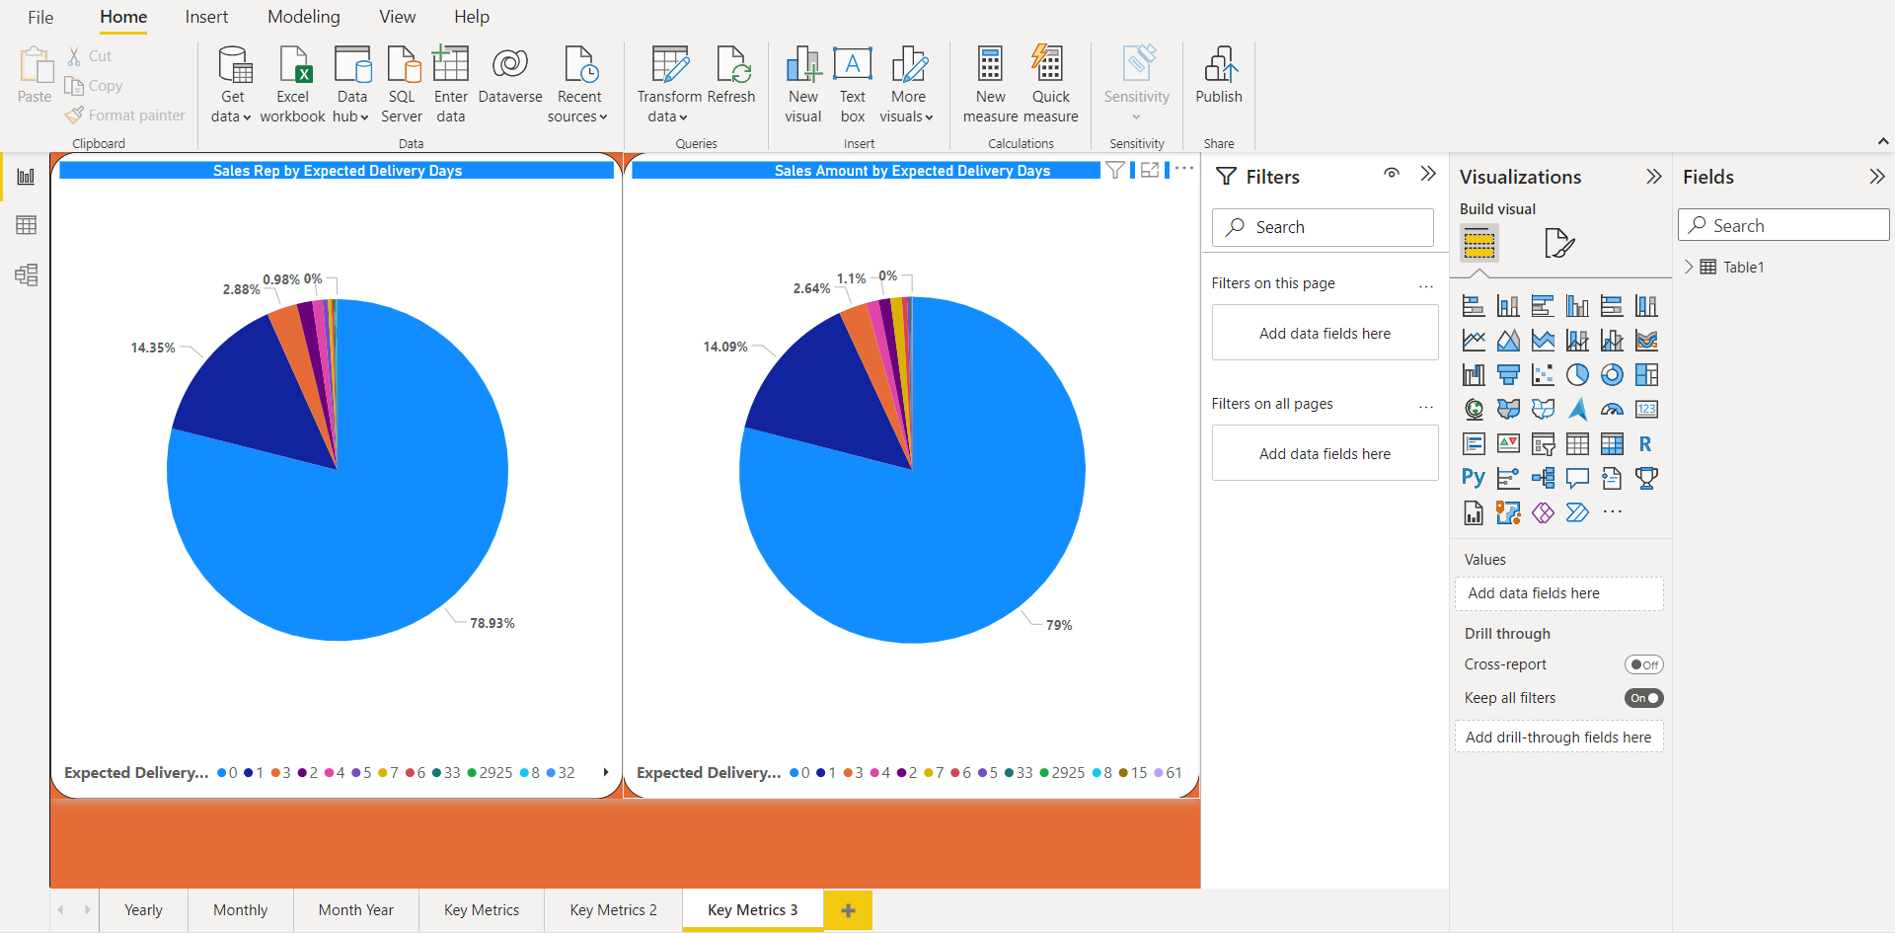

**Power Bi Architecture**

Power BI is an interactive data visualization software product developed by Microsoft with a primary focus on business intelligence. It is part of the Microsoft Power Platform. Power BI is a collection of software services, apps, and connectors that work together to turn unrelated sources of data into coherent, visually immersive, and interactive insights. Data may be input by reading directly from a database, webpage, or structured files such as spreadsheets, CSV, XML, and JSON.

### ARCHITECTURE DESIGN

**6**

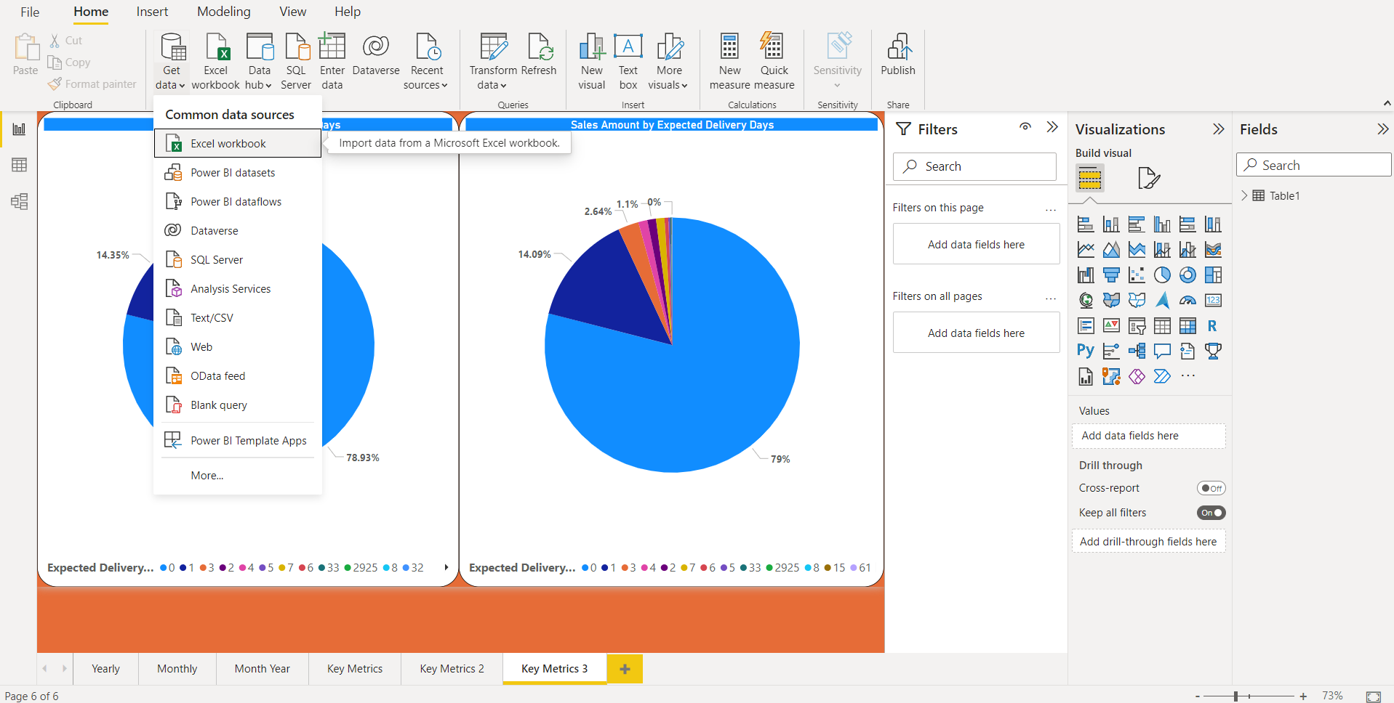

1. **Total sales by Year**

**2) Total sales by month**

1. **Total cost by year**
2. **Total cost by month**
3. **Total Profit by year**
4. **Total Profit by Month**
5. **Total sales by days taken to delivery**
6. **Total Profit by days taken to delivery**
7. **Comparision of total sales,costs and profit by year**

**10.) Comparision of total sales,costs and profit by month**