High Level Design (HLD) Amazon Sales Data Analysis

Revision Number:

Last date of revision: 17/12/2022

Lalasab Allasab Nadaf

# Document Version Control

|  |  |  |  |
| --- | --- | --- | --- |
| **Date Issued** | **Version** | **Description** | **Author** |
| **17/12/2022** | 1.0 | First Version of Complete HLD | Lalasab Allasab Nadaf |
|  |  |  |  |
|  |  |  |  |
|  |  |  |  |
|  |  |  |  |
|  |  |  |  |
|  |  |  |  |

**Contents**

Document Version Control 2

Abstract 3

1. Introduction 5
   1. Why this High-Level Design Document? 5
   2. Scope 5
2. General Description 6
   1. Product Perspective & Problem Statement 6

Housing prices are an important reflection of the economy, and housing price ranges are of great interest for both buyers and sellers. In this project, house prices will be predicted given explanatory variables that cover many aspects of residential houses. 6

* 1. Tools used 6

1. Design Details 7
   1. Functional Architecture 7
   2. Optimization 8
2. KPIs 9
   1. KPIs (Key Performance Indicators) 9
3. Deployment 9

# Abstract

Sales management has gained importance to meet increasing competition and the need

for improved methods of distribution to reduce cost and to increase profits. Sales

management today is the most important function in a commercial and business

enterprise.

With given dataset various tasks are performed like ETL( Extract, Transform & Load), Sales trend with respect to many attributes, Key Metrics & meaningful relationship between different attributes.

# Introduction

## Why this High-Level Design Document?

The purpose of this High-Level Design (HLD) Document is to add the necessary detail to the current project description. This document is also intended to help detect contradictions and can be used as a reference manual for.

The HLD will:

* + - Present all of the design aspects and define them in detail
    - Describe the user interface being implemented
    - Describe the performance requirements
    - Include design features and the architecture of the project

## Scope

The HLD documentation presents the dashboards of the dataset and helps us understand how different attributes affect each other. For, example – When Expected delivery time decreases, Sales increases and much more.

# 

# General Description

## Product Perspective & Problem Statement

Sales management has gained importance to meet increasing competition and the need

for improved methods of distribution to reduce cost and to increase profits. Sales

management today is the most important function in a commercial and business

enterprise.

With given dataset various tasks are performed like ETL( Extract, Transform & Load), Sales trend with respect to many attributes, Key Metrics & meaningful relationship between different attributes.

## Tools used

Business Intelligence tools and libraries works such as Excel, Power BI are used to build the whole framework.





# Design Details

## Functional Architecture

Figure 1: Functional Architecture of Business Intelligence

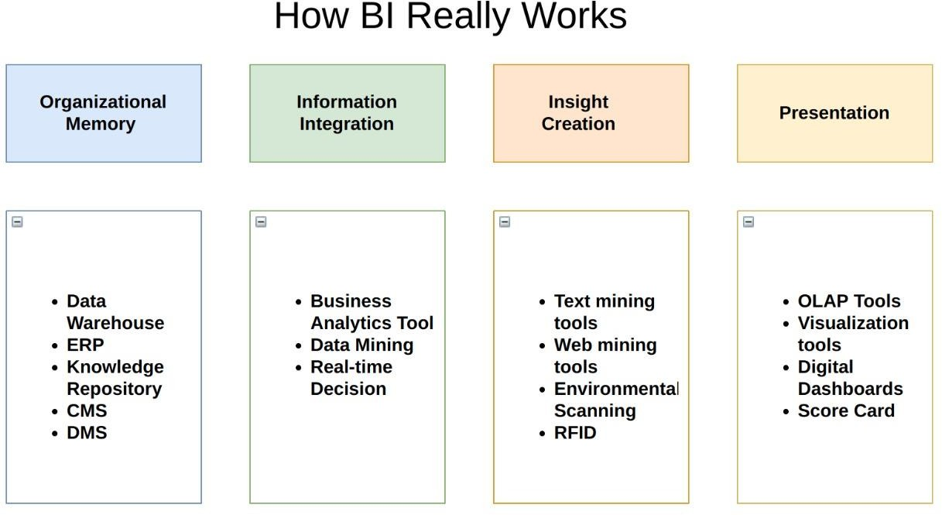

**1.Total Sales by Year**

|  |
| --- |
|  |
|  |

**2.Total sales by months**

|  |
| --- |
|  |
|  |
|  |
| [Open in Power BI](https://app.powerbi.com/MobileRedirect.html?action=OpenReport&reportObjectId=72758b49-28a8-4059-a49c-b95205b4df63&ctid=36ee6b01-7518-4b15-9cb9-dc3600611db0&reportPage=ReportSection&pbi_source=copyvisualimage) Amazon Sales Analysis Data as of 12/17/22, 5:51 PM |

1. **Total cost by year**

|  |
| --- |
|  |
|  |

1. **Total cost by Month Name**

|  |
| --- |
|  |
|  |
|  |
|  |

1. **Total Profit by Year**

|  |
| --- |
|  |
|  |

1. **Total Profit by Month**

|  |
| --- |
|  |
|  |

1. **Total Sales by Time taken to delivery**

|  |
| --- |
|  |
|  |

1. **Total Profit by Time taken to delivery**

|  |
| --- |
|  |
|  |

1. **Comparision of Total sales, costs and profit by year**

|  |
| --- |
|  |
|  |

**10.Comparision of Total sales, costs and profit by month**

|  |
| --- |
|  |
|  |