Low Level Design

# Amazon Sales Data Analysis

|  |  |
| --- | --- |
| **Written By** | Lalasab Allasab Nadaf |
| **Document Version** | 1.0 |
| **Last Revised Date** |  |

**DOCUMENT CONTROL**

## Change Record:

|  |  |  |  |
| --- | --- | --- | --- |
| **VERSION** | **DATE** | **AUTHOR** | **COMMENTS** |
| 1.0 | 17-12-22 | Lalasab Allasab Nadaf | Introduction and architecture defined |
|  |  |  |  |
|  |  |  |  |

**Reviews:**

|  |  |  |  |
| --- | --- | --- | --- |
| **VERSION** | **DATE** | **REVIEWER** | **COMMENTS** |

**Approval Status:**

|  |  |  |  |  |  |
| --- | --- | --- | --- | --- | --- |
| **VERSION** | **REVIEW**  **DATE** | **REVIEWED BY** |  | **APPROVED BY** | **COMMENTS** |
|  |  |  |  |  |  |

# Contents

#### Introduction 04

* 1. **What is Low-Level Design Document? 04**

|  |  |  |
| --- | --- | --- |
| **1.2** | | **Scope 04** |
| **2.** | **Architecture 05** | |
| **3.** | **Architecture Description 08** | |
|  | **3.1** | **Data Description 08** |
|  | **3.2** | **Web Scrapping 08** |
|  | **3.3** | **Data Transformation 08** |
|  | **3.4** | **Data insertion into database 08** |
|  | **3.5** | **Connection with SQL server 08** |
|  | **3.5** | **Export Data from database 12** |
|  | **3.6** | **Deployment 12** |
| **4.** | **Unit** | **test cases 15** |

# Introduction

## What is Low-Level design document?

The goal of the LDD or Low-level design document (LLDD) is to give the internal logic design of the actual program code for the House Price Prediction dashboard. LDD describes the class diagrams with the methods and relations between classes and programs specs. It describes the modules so that the programmer can directly code the program from the document.

## Scope

Low-level design (LLD) is a component-level design process that follows a step-by-step refinement process. The process can be used for designing data structures, required software architecture, source code and ultimately, performance algorithms. Overall, the data organization may be defined during requirement analysis and then refined during data design work.

# Architecture

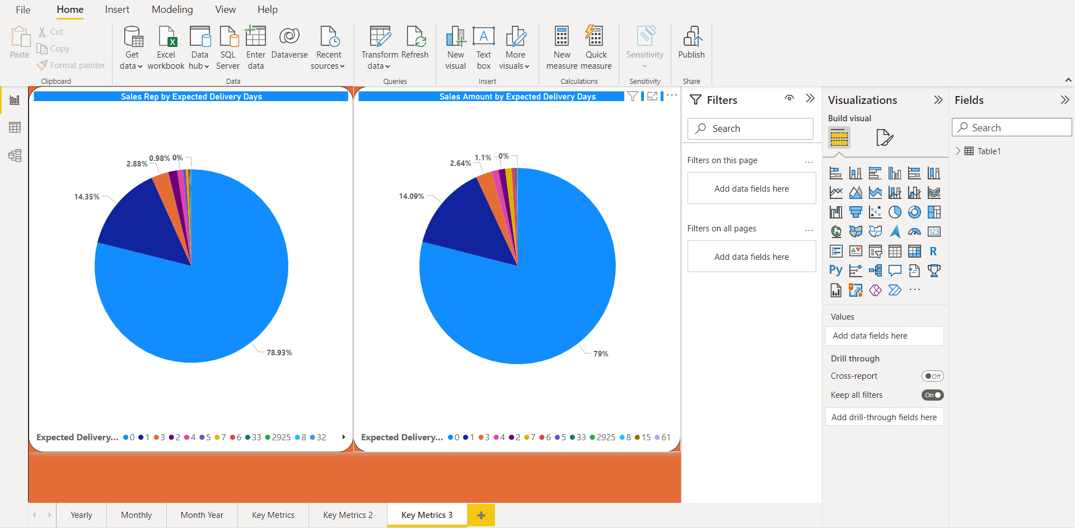

**Power Bi Architecture**

Power BI is an interactive data visualization software product developed by Microsoft with a primary focus on business intelligence. It is part of the Microsoft Power Platform. Power BI is a collection of software services, apps, and connectors that work together to turn unrelated sources of data into coherent, visually immersive, and interactive insights. Data may be input by reading directly from a database, webpage, or structured files such as spreadsheets, CSV, XML, and JSON.

### LOW LEVEL DESIGN

**6**

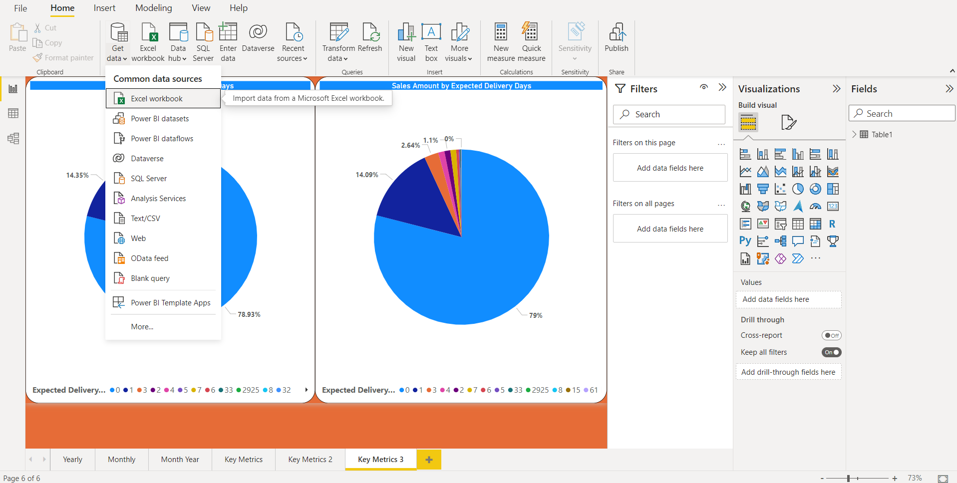

**1.) Total sales by Year**

**2) Total sales by Months**

1. **Total cost by year**
2. **Total cost by month**
3. **Total Profit by year**
4. **Total Profit by Month**
5. **Total sales by days taken to delivery**
6. **Total Profit by days taken to delivery**
7. **Comparision of total sales,costs and profit by year**

**10.) Comparision of total sales,costs and profit by month**