POST http://localhost:8080/api/v1/payments

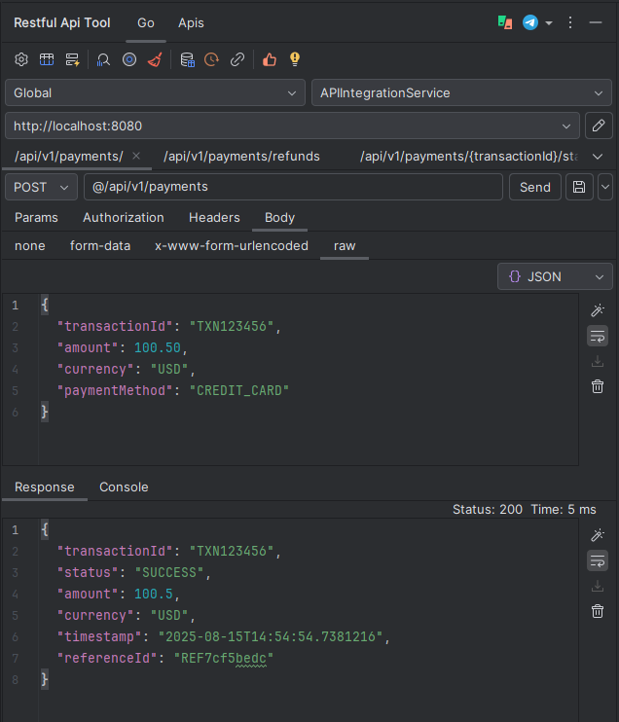

POST http://localhost:8080/api/v1/payments/refunds

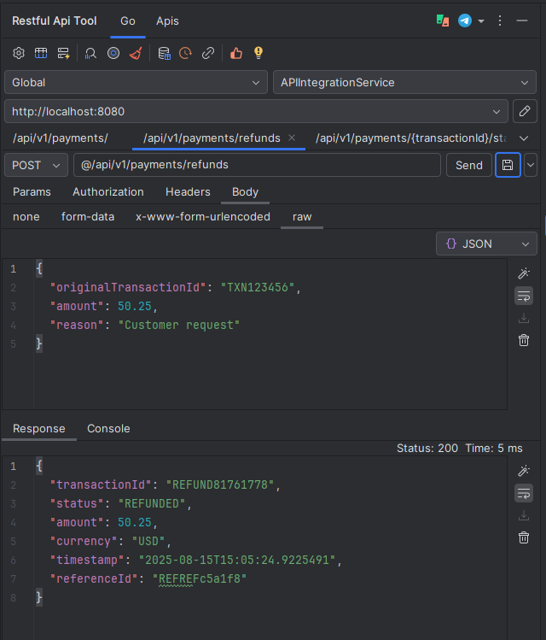

GET http://localhost:8080/api/v1/payments/TXN123456/status

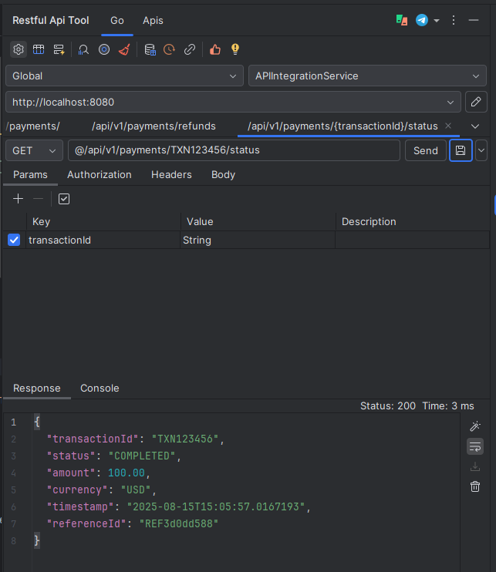

2. Monitor Health & Metrics

# Health check

http://localhost:8080/actuator/health

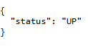

# Application metrics

http://localhost:8080/actuator/metrics

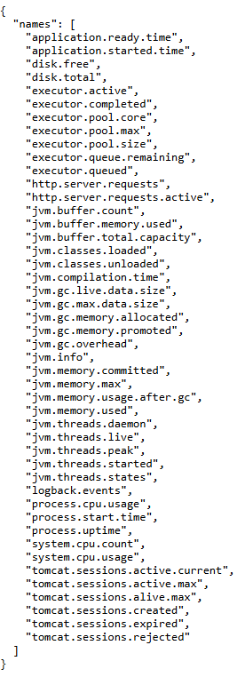

# Specific metric (e.g., HTTP requests)

http://localhost:8080/actuator/metrics/http.server.requests

