##### A Project report on

**STUDENT PERFORMANCE IN TRAININGS**

###### A Dissertation submitted to JNTU Hyderabad in partial fulfillment of the academic requirements for the award of the degree.

**Bachelor of Technology**

**in**

**Computer Science and Engineering**

Submitted by

D.SUNIL KUMAR

(20H51A0588)

B. DEEKSHA

(20H51A05G6)

B. PRANAV SAI

(20H51A0585)

Under the esteemed guidance of

Ms. M. N. Sailaja

Assistant Professor

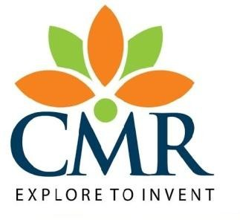

**Department of Computer Science and Engineering**

**CMR COLLEGE OF ENGINEERING& TECHNOLOGY**

(UGC Autonomous)

*Approved by AICTE *Affiliated to JNTUH *NAAC Accredited with A+ Grade

KANDLAKOYA, MEDCHAL ROAD, HYDERABAD - 501401.

#### 2020- 2024

**CMR COLLEGE OF ENGINEERING & TECHNOLOGY**

KANDLAKOYA, MEDCHAL ROAD, HYDERABAD – 501401

**DEPARTMENT OF COMPUTER SCIENCE AND ENGINEERING**

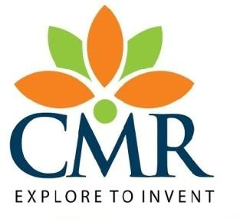

#### CERTIFICATE

This is to certify that the Major Project Phase Report entitled **"****VITAMIN DEFFICIENCY AND FOOD RECOMMENDATION SYSTEM"** being submitted by **D. SUNIL KUMAR (20H51A0588), B. DEEKSHA (20H51A05G6), B. PRANAV SAI (20H51A0585)**in partial fulfillment for the award of **Bachelor of Technology in Computer Science and Engineering** is a record of bonafide work carried out his/her under my guidance and supervision.

###### The results embodies in this project report have not been submitted to any other University or Institute for the award of any Degree.

**Ms. M N . Sailaja Dr. Siva Skandha Sanagala**

**Assistant Professor Associate Professor and HOD**

**Department of CSE Department of CSE**

#### ACKNOWLEDGEMENT

With great pleasure we want to take this opportunity to express my heartfelt gratitude to all the people who helped in making this project work a grand success.

We are grateful to **Ms. M. N. Sailaja, Assistance Professor**, Department of Computer Science and Engineering for his valuable technical suggestions and guidance during the execution of this project work.

We would like to thank **Dr. Siva Skandha Sanagala,** Head of the Department of Computer Science and Engineering, CMR College of Engineering and Technology, who is the major driving forces to complete my project work successfully.

We are very grateful to **Dr. Vijaya Kumar Koppula**, Dean-Academics, CMR College of Engineering and Technology, for his constant support and motivation in carrying out the project work successfully.

We are highly indebted to **Major Dr.V.A. Narayana,** Principal, CMR College of Engineering and Technology, for giving permission to carry out this project in a successful and fruitful way.

We would like to thank the **Teaching & Non- teaching** staff of Department of Computer Science and Engineering for their co-operation

We express our sincere thanks to **Shri. Ch. Gopal Reddy**, Secretary, CMR Group of Institutions, for his continuous care.

Finally, We extend thanks to our parents who stood behind us at different stages of this Project. We sincerely acknowledge and thank all those who gave support directly and indirectly in completion of this project work.

D. Sunil kumar 20H51A0588

B. Deeksha 20H51A05G6

B. Pranav Sai 20H51A0585

**VITAMIN DEFFICIENCY AND FOOD RECOMMENDATION SYSTEM**

**TABLE OF CONTENTS**

**CHAPTER**

**NO. TITLE PAGE NO.**

LIST OF FIGURES ii

ABSTRACT iv

**1** **INTRODUCTION** 1

1.1 Problem Statement 2

1.2 Research Objective 2

1.3 Project Scope and Limitations 3

**2** **BACKGROUND WORK** 4

2.1. Online Coding Platform (Hacker Rank)

2.1.1.Introduction 4

2.1.2.Merits,Demerits and Challenges 4

2.1.3.Implementation of Online Coding Platform 5

2.2. Full-Stack Development using the MERN Stack

2.2.1.Introduction 5

2.2.2.Merits,Demerits and Challenges 5

2.2.3.Implementation 6

**3 RESULTS AND DISCUSSION 8** 4.1 uml diagrams 8

4.2 Flowchart 9

4 **CONCLUSION** 11

5.1 Conclusion 11

**REFERENCES** **13**

CMRCET B.Tech(CSE) Page Noi

**VITAMIN DEFFICIENCY AND FOOD RECOMMENDATION SYSTEM**

**List of Figures**

**FIGURE**

**NO. TITLE PAGE NO.**

4.1 uml diagram 1 8

4.2 uml diagram 2 8

4.3 uml diagram 3 8

4.4 flowchart 9

CMRCET B.Tech(CSE) PageNoii

**VITAMIN DEFFICIENCY AND FOOD RECOMMENDATION SYSTEM**

**ABSTRACT**

A study by WHO reports that inadequate and imbalanced intake of food causes around 9% of heart attack deaths, about 11% of ischemic heart disease deaths, and 14% of gastrointestinal cancer deaths worldwide. Moreover, around 0.25 billion children are suffering from different types deficiency from Vitamin-A to vitamin -k deficiency, 0.2 billion people are suffering from iron deficiency (anaemia), and 0.7 billion people are suffering from iodine deficiency. The main objective of this work to recommend a diet to different individual. The recommender system deals with a large volume of information present from the dataset.

In this project own data set is prepared based on various high and low values of vitamins from (vitamin a , b,c,d,e,k ) and features are divided from normal and abnormal conditions of vitamins and labels are divided in to o and 1 as normal and abnormal.

Another dataset is prepared based on combination of various vitamins and their deficiency and food to be recommended based on which vitamin is deficient and third dataset is used for predicting disease based on vitamin deficiency.

In this project multiple classifier algorithms are used ( knn, decision tree, random forest, logistic regression, voting classifier ) ensembled algorithm is used to combine multiple algorithms and train a new algorithm.

Accuracy of each algorithm is calculated and best algorithm is used for prediction purpose. Prediction is shown using flask web application which will detect deficiency of vitamin and predict type of disease and recommend type of food to be taken on various combinations.

CMRCET B.Tech(CSE) PageNo iii

**VITAMIN DEFFICIENCY AND FOOD RECOMMENDATION SYSTEM**

# **CHAPTER 1**

**INTRODUCTION**

CMRCET B. Tech (CSE) Page No 1

**VITAMIN DEFFICIENCY AND FOOD RECOMMENDATION SYSTEM**

**CHAPTER 1**

**INTRODUCTION**

**1.1. Problem Statement**

The fast-food consumption rate is alarmingly high and this consequently has led to the intake of unhealthy food. This leads to various health issues such as obesity, diabetes, an increase in blood pressure etc. Hence it has become very essential for people to have a good balanced nutritional healthy diet. But in this fast pace generation not everyone has the time and money to spend on personal dietitian and nutrition who will look upon and take care of their health by advising them a healthy diet plan according to the individual personal information. In this report we have discussed person unhealthy eating habit and tried to provide a satisfactory solution to them for healthy life.

**1.2. Research Objective**

This technology is designed to uncover hidden patterns and client eating habit from various data sources. This approach will aid in tracking and improving an individual's health as well as the types of food that they should avoid in order to reduce their chance of disease.

In this article, we highlight the issue of selection of proper diet that must fulfill patients’ nutrition requirements. To address this issue, we present a cloud based food recommendation system, called Diet-Right, for dietary recommendations based on users’ pathological reports.

CMRCET B. Tech (CSE) Page No 2

**VITAMIN DEFFICIENCY AND FOOD RECOMMENDATION SYSTEM**

**1.3 Project Scope and Limitations**

The scope and limitations of a vitamin deficiency and food recommendations system project can vary based on its specific goals and resources. Here are some considerations

Scope:

1. Data Collection and Analysis: The system can collect data on users' dietary habits, medical history, and preferences to identify potential vitamin deficiencies.

2. Recommendations: It can provide personalized dietary recommendations to address deficiencies, including specific foods and supplements.

3. User Education: Offer educational content about the importance of different vitamins and their dietary sources.

4. Integration: It can integrate with health apps, wearable devices, or electronic health records for a holistic view of the user's health.

5. User Feedback: Collect feedback from users to improve recommendations and adapt to their changing needs.

Limitations:

1. Data Accuracy: Relies on accurate user data, which may not always be available or truthful.

2. Medical Advice: Cannot replace professional medical advice; users should consult healthcare providers for serious health issues.

3. Privacy Concerns: Must address privacy issues when collecting and storing personal health data.

4. Limited Data: Effectiveness depends on the availability of comprehensive dietary and medical data.

5. Resource Constraints: Limited funding and expertise may affect the system's accuracy and user experience.

6. Cultural and Dietary Variations: Recommendations may not be culturally or regionally appropriate, considering diverse dietary habits.

CMRCET B. Tech(CSE) Page No 3

**VITAMIN DEFFICIENCY AND FOOD RECOMMENDATION SYSTEM**

To address these limitations, it's essential to set clear project goals, establish ethical guidelines, and continuously improve the system through user feedback and advancements in nutrition science and technology.

CMRCET B.Tech(CSE) Page No 4

**VITAMIN DEFFICIENCY AND FOOD RECOMMENDATION SYSTEM**

**CHAPTER 2**

**BACKGROUND WORK**

CMRCET B. Tech (CSE) Page No 5

**VITAMIN DEFFICIENCY AND FOOD RECOMMENDATION SYSTEM**

**CHAPTER 2**

**BACKGROUND WORK**

A content-based food recommender system is proposed, which recommends food recipes based on the user's preferences. The user's favored recipes are broken down into ingredients, each of which is given a rating based on the preferences of previous users. The recipes that use the same ingredient are suggested. Nutritional variables and food balance are not taken into account by the writers. Furthermore, identical recommendations are possible because the user's preferences may not alter on a daily basis

**Theoretical Frameworks:**

Creating a theoretical framework for a vitamin deficiency and food recommendation system using machine learning involves defining the key concepts, principles, and models that underpin the project

**Key Concepts and Terminology:**

The concept of a vitamin deficiency and food recommendation system using machine learning revolves around addressing nutritional gaps in an individual's diet through data-driven recommendations. Vitamin deficiencies can lead to various health issues, making it crucial to understand the nutritional composition of foods and their impact on human health. In this project, we leverage machine learning models to analyze a person's dietary habits, nutrient intake, and personal preferences. These models, such as collaborative filtering and content-based filtering, generate personalized recommendations by taking into account the individual's nutritional needs and dietary preferences. Their dietary sources, and the benefits of a balanced diet. Ethical considerations, data privacy, and continuous improvement are integral to the project's framework, ensuring the system's reliability and adherence to legal and ethical standards.

CMRCET B. Tech (CSE) Page No 6

**VITAMIN DEFFICIENCY AND FOOD RECOMMENDATION SYSTEM**

**Factors Affecting Student Performance:**

The students' prior knowledge of nutrition and machine learning concepts, as well as their willingness to actively participate in the project, can significantly impact their performance.

**2.1** **Content based food recommender system**

**2.1.1 Introduction**

Content based food recommender system is proposed which recommend food recipes according to the preferences already given by the user. The preferred recipes of the user are fragmented into ingredients which are assigned ratings according to the stored users’ preferences. The recipes with the matching ingredient are recommended. The authors do not consider the nutrition factors and the balance in the diet. Moreover, chances of identical recommendation are also present because the preference of the user may not change on daily basis.

**2.1.2 Merits, Demerits, and Challenges**

Diet suggestion systems like the ones listed above are focused on certain ailments or diet plans that are out of balance. When it comes to food recommendations for specific ailments, the systems do so without understanding the severity of the disease, which might vary in different circumstances and have serious consequences for individuals. Similarly, when it comes to food recommendations for a balanced diet, nutrition elements are often overlooked, despite their importance in recommending foods and maintaining a healthy diet.

**2.1.3 Implementation of Content based food recommender system**

These recommendations are generated by leveraging a data set of users' preferences expressed in the form of users' ratings and tags, which signal the food's ingredients or features that the users like. Our empirical evaluation shows that the proposed recommendation technique significantly outperforms state-of-the-art algorithms. We have found that using tags in food recommendation algorithms can significantly increase the prediction accuracy.

CMRCET B. Tech (CSE) Page No 7

**VITAMIN DEFFICIENCY AND FOOD RECOMMENDATION SYSTEM**

**4.2 PROPOSED SYSTEM:**

The System works in a Machine Learning Environment, we use multiple machine learning algorithms to check accuracy of vitamin deficiency and predict disease based on vitamin deficiency and recommend food along with disease prediction and best model is used for prediction in flask web application. When user enters vitamin values algorithm will predict deficiency is vitamin and recommend food.

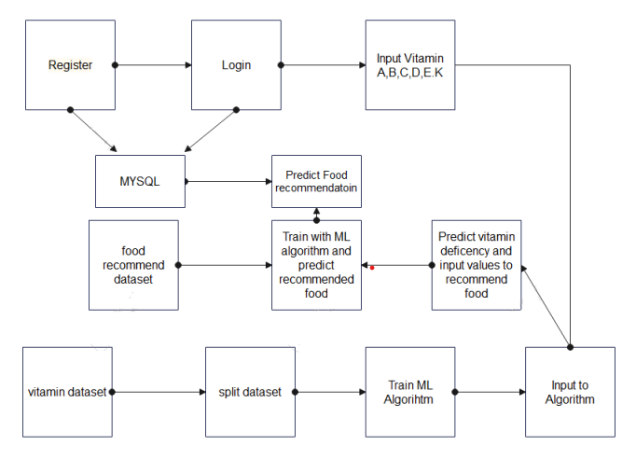

**Fig 1**

CMRCET B. Tech (CSE) Page No 8

**VITAMIN DEFFICIENCY AND FOOD RECOMMENDATION SYSTEM**

**CHAPTER 3**

**RESULTS AND DISCUSSION**

CMRCET B. Tech (CSE) Page No 9

**VITAMIN DEFFICIENCY AND FOOD RECOMMENDATION SYSTEM**

**CHAPTER 3**

**RESULTS AND DISCUSSION**

**3.1 Result:**

For training of the system, the initial process involves the dataset preparation of food items depending upon the vitamin deficiency. The prediction of various food recommendation along with disease prediction is predicted, depending upon which are essential for the for type of vitamin deficient. After the training is performed, using KNN classifier algorithm, the nearest food items are predicted which best suited for the appropriate diet.

Our diet recommendation system allows users to basically get the desired healthy diet on the bases of vitamin deficiency and disease prediction system can give updates to user changes of disease with predicted vitamin deficient values.

**3.1.1 ADVANTAGES OF PROPOSED SYSTEM:**

* Automates process of vitamin deficiency detection and food recommendation
* Previous datasets are used to training and testing.
* Accuracy of model is improved compare to existing methods.
* Predicts disease based on vitamin deficiency

**3.2 MODULES:**

1. Data collection

2. Data preprocessing

3. Testing training

4. Initializing Multiple Algorithms

5. Predict data TPO

**3.2.1. Data collection**

this project se are using vitamin dataset and food recommendation dataset which is prepared based on

CMRCET B. Tech (CSE) Page No 10

**VITAMIN DEFFICIENCY AND FOOD RECOMMENDATION SYSTEM**

min and max vitamin values from the test results and features are min and max values of vitamin a, b, c,d,e,k values and labels are deficiency and non-deficiency. Based on the vitamin deficiency food data

set is prepared with various combinations. In this feature are vitamin deficient values and labels are type of food

**3.2.2 Data Preprocessing:**

Features are extracted from data set and stored in variable as x train variable and labels are stored in y train variable. Data is preprocessing by standard scalar function and new features and labels are generated.

**3.2.3 Testing Training:**

In this stage data is sent to testing and training function and divided in to four parts x test train, and y test train. Train variables are used for passing to algorithm whereas test are used for calculating accuracy of the algorithm.

**3.2.4 Initializing Multiple Algorithms:**

In this stage machine learning algorithms are initialized and train

values are given to algorithm by this information algorithm will know what are features and what are labels. Then data is modeled and stored as pickle file in the system which can be used for prediction. Data set is trained with multiple algorithms and accuracy of each model is calculated and best model is used for prediction.

**3.2.5 Predict data:**

In this stage new data is taken as input and trained models are loaded using pickle and then values are preprocessed and passed to predict function to find out result which is showed on web application Architecture of DC Store Above architecture diagram shows three stages of data flow form one module to another module. Back-end storage and machine learning model to train vitamin dataset

CMRCET B. Tech (CSE) Page No 11

**VITAMIN DEFFICIENCY AND FOOD RECOMMENDATION SYSTEM**

**Flow chart**

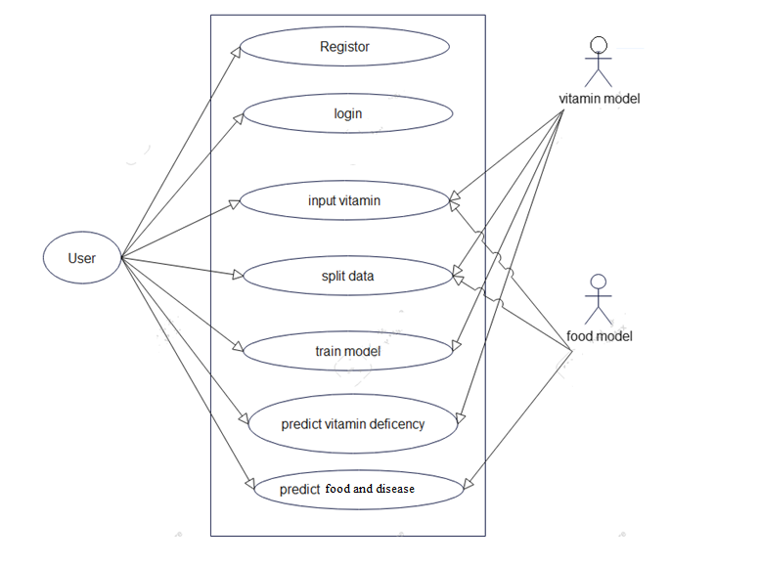

FIG:2

CMRCET B. Tech (CSE) Page No 12

**VITAMIN DEFFICIENCY AND FOOD RECOMMENDATION SYSTEM**

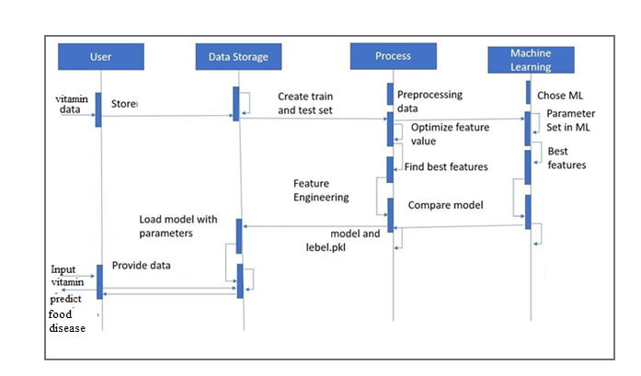

**Fig 3**

**Discussion:**

Firstly, it's important to highlight the pressing issue of vitamin deficiencies and their impact on health. Vitamin deficiencies are prevalent worldwide and can lead to a range of health problems. Therefore, a system that can effectively recommend foods to address these deficiencies has the potential to improve the well-being of individuals and communities.

However, several challenges need to be addressed in developing such a system. It requires a

CMRCET B. Tech (CSE) Page No 13

**VITAMIN DEFFICIENCY AND FOOD RECOMMENDATION SYSTEM**

deep understanding of both nutrition science and machine learning techniques. Combining

these fields is no small task, and it's essential to ensure the recommendations provided are evidence-based and safe for users. Data privacy and ethical considerations are paramount, especially when dealing with users' dietary and health information.

The success of this project hinges on the quality of data sources, the sophistication of machine learning models, and the usability of the user interface. It also necessitates the collaboration of nutrition experts, data scientists, and software developers. Education plays a pivotal role in this system. It not only informs users about the importance of vitamins but also empowers them to make healthier dietary choices.

CMRCET B. Tech (CSE) Page No 14

**VITAMIN DEFFICIENCY AND FOOD RECOMMENDATION SYSTEM**

CHAPTER 4

**CONCLUSION**

CMRCET B. Tech (CSE) Page No 15

**VITAMIN DEFFICIENCY AND FOOD RECOMMENDATION SYSTEM**

**CHAPTER 4**

**CONCLUSION**

We have created a website which recommend the food items and predicts vitamin deficiency in which we have implemented prediction by taking input as vitamins and their deficiency. For training of the system, the initial process involves the dataset preparation of food items depending upon the vitamin deficiency. The prediction of various food recommendation along with disease prediction is predicted, depending upon which are essential for the for type of vitamin deficient. After the training is performed, using KNN classifier algorithm, the nearest food items are predicted which best suited for the appropriate diet. Our diet recommendation system allows users to basically get the desired healthy diet on the bases of vitamin deficiency and disease prediction system can give updates to user changes of disease with predicted vitamin deficient values.

CMRCET B. Tech (CSE) Page No 16

**VITAMIN DEFFICIENCY AND FOOD RECOMMENDATION SYSTEM**

**REFERENCES**

CMRCET B. Tech (CSE) Page No 16

**VITAMIN DEFFICIENCY AND FOOD RECOMMENDATION SYSTEM**

## REFERENCES

Phanich, M., Pholkul, P., & Phimoltares, S., “Food recommendation system using clustering analysis for diabetic patients,” in Proc. of International Conference on Information Science and Applications, pp. 1-8, IEEE, April 2010. Article .

[2] Ge, M., Elahi, M., Fernaández-Tobías, I., Ricci, F., & Massimo, D., “Using tags and latent factors in a food recommender system,” in Proc. of the 5th International Conference on Digital Health, pp. 105-112, ACM., May 2015.

[3] Freyne, J., & Berkovsky, S., “Evaluating recommender systems for supportive technologies,” User Modeling and Adaptation for Daily Routines, pp. 195-217, Springer London, 2013.

[4] Prof. Prajkta Khaire, Rishikesh Suvarna, Ashraf Chaudhary, “Virtual Dietitian: An Android based Application to Provide Diet”, International Research Journal of Engineering and Technology (IRJET),Volume: 07 Issue: 01 | Jan 2020

[5] Shivani Singh, Sonal Bait, Jayashree Rathod, Prof. Nileema Pathak,” Diabetes Prediction Using Random Forest Classifier And Intelligent Dietician ” , International Research Journal of Engineering and Technology (IRJET), Volume: 07 Issue: 01 | Jan 2020

CMRCET B. Tech (CSE) Page No 17