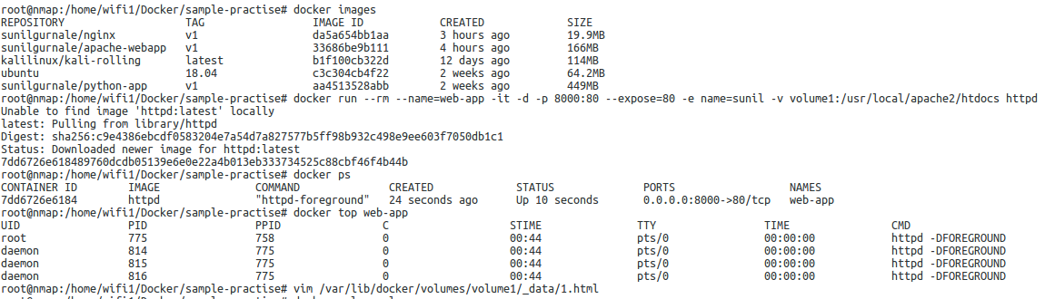
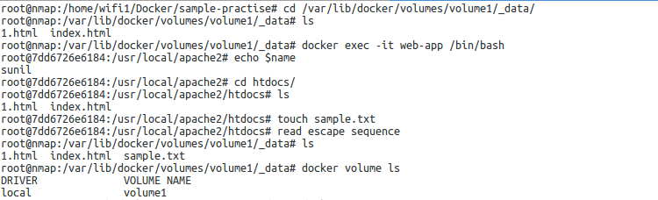
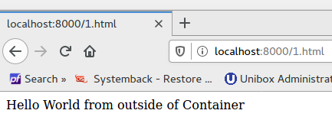
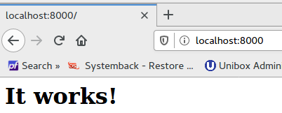
docker run -d -it --name devtest \
--mount type=bind,source="$(pwd)"/target,target=/app,readonly \
nginx:latest
Ctrl + pq
The flag --rm is used when you need the container to be deleted after the task for it is complete.

Commit and Push:
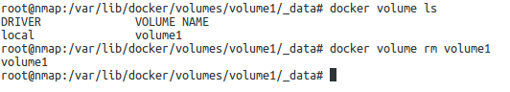
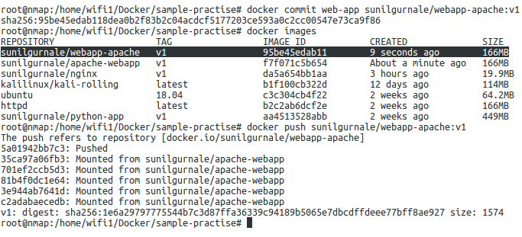
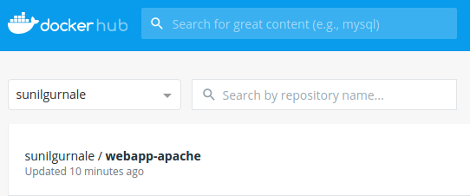
Remove / Clean :
- docker kill $(docker ps -aq)
- docker rm $(docker ps -aq)
- docker volume rm <volume_name>
- docker system prune
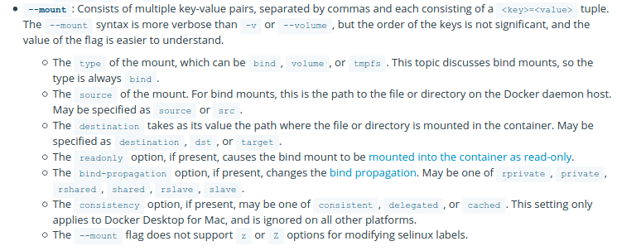

DockerFile app.py
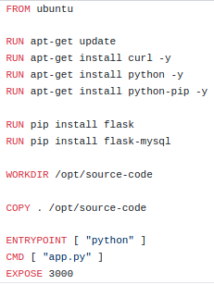
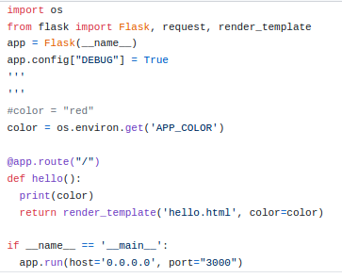

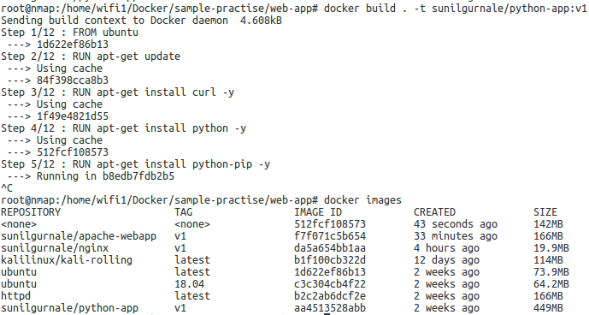
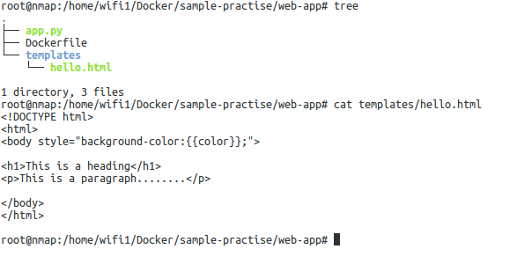

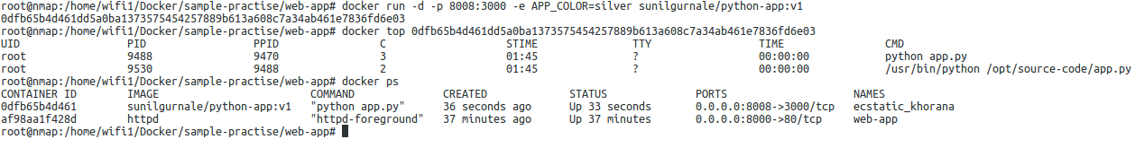
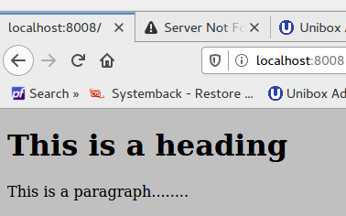
- -p = publish
- -d = detach mode
- -e = env_variable
- run –rm .....
- docker kill $(docker ps -aq)
- docker rm $(docker ps -aq)
- docker system prune

Docker-Compose: Version Present 1,2,3
Service Name
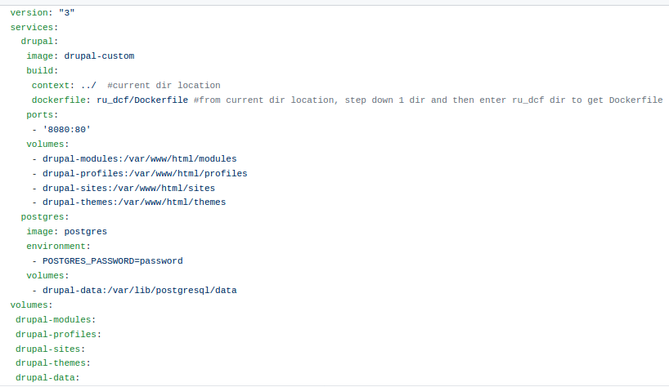
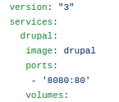
Build image from dockerfile OR pull it from docker hub
PULL
BUILD
Service Name
PULL
Install Docker-compose :
- sudo curl -L "https://github.com/docker/compose/releases/download/1.25.5/docker-compose-$(uname -s)-$(uname -m)" -o /usr/local/bin/docker-compose
- sudo chmod +x /usr/local/bin/docker-compose
- docker-compose –version
- https://docs.docker.com/compose/install/ -- installation steps

Executing steps:
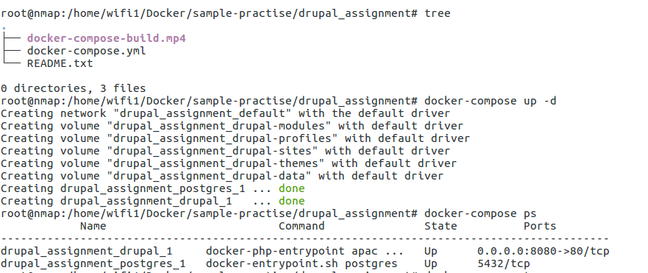

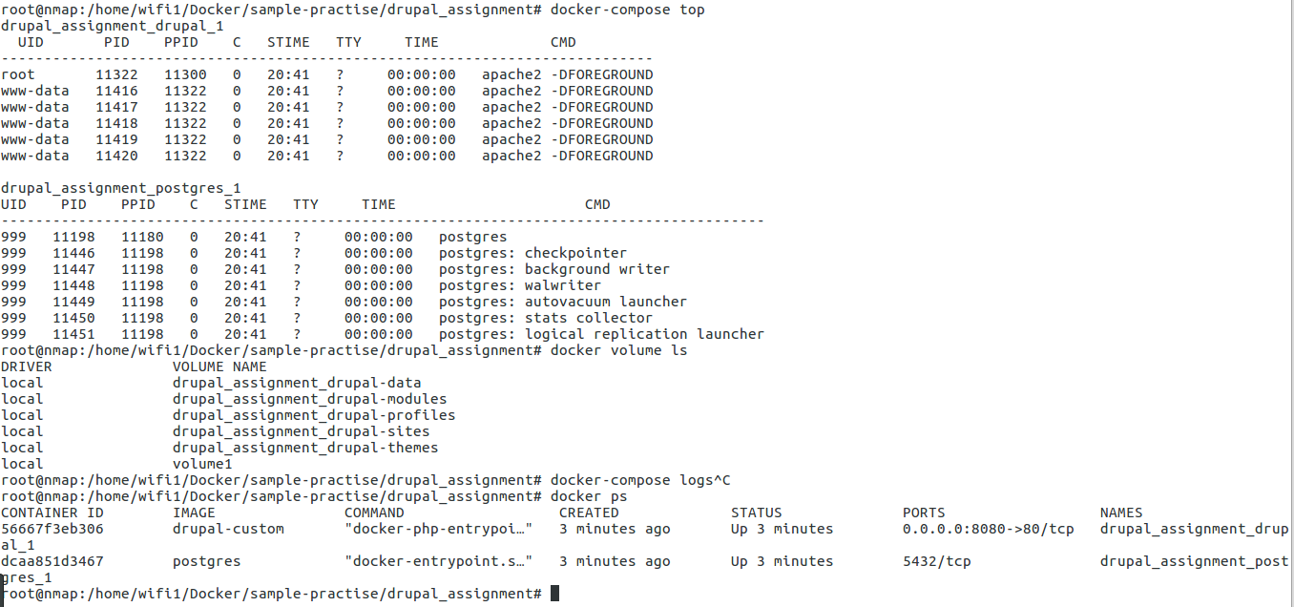
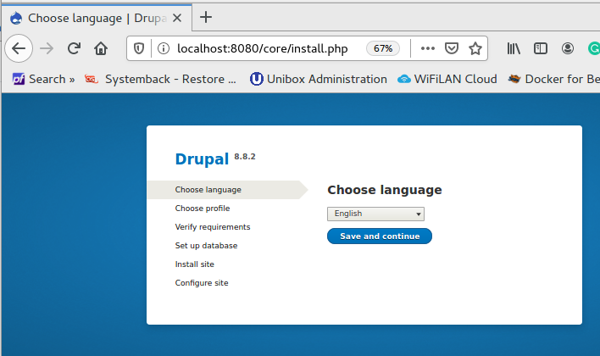
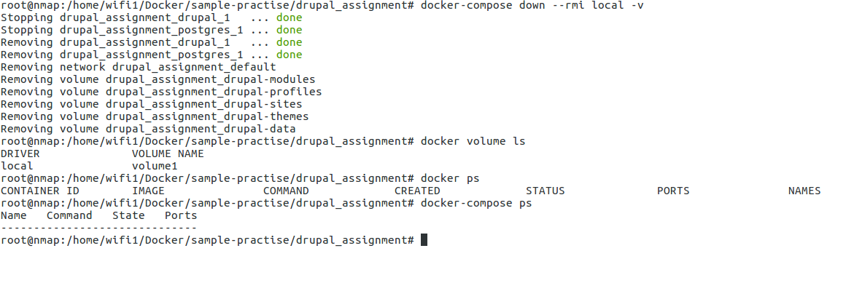
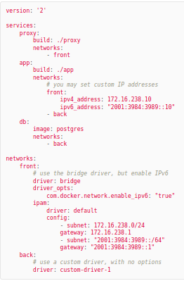

- docker network ls
- docker network inspect bridge
- brctl show

Best Example:

https://docker-k8s-lab.readthedocs.io/en/latest/docker/docker-compose.html

Networking:

bridge my_network
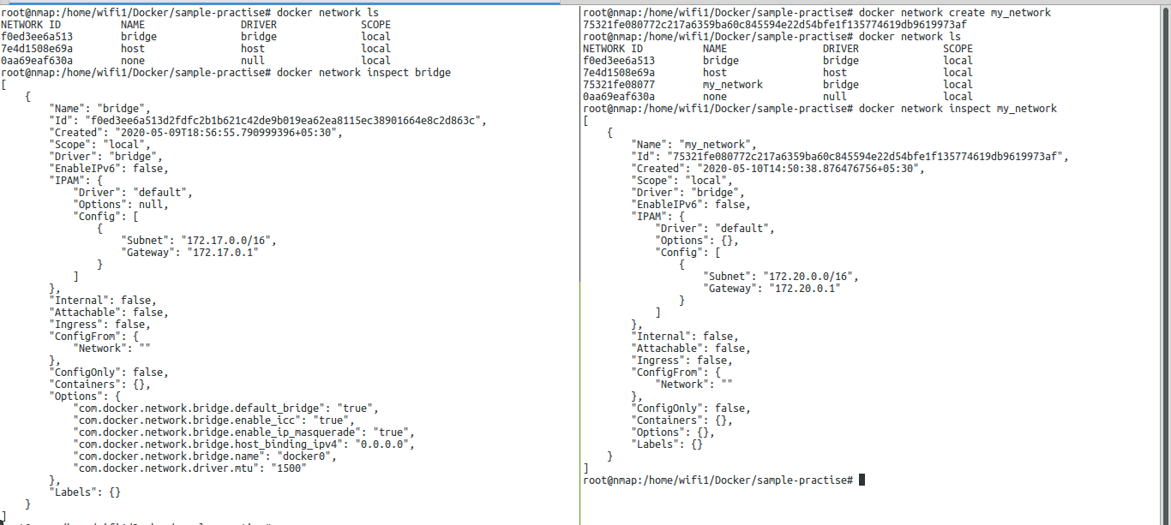
BRIDGE
my_network
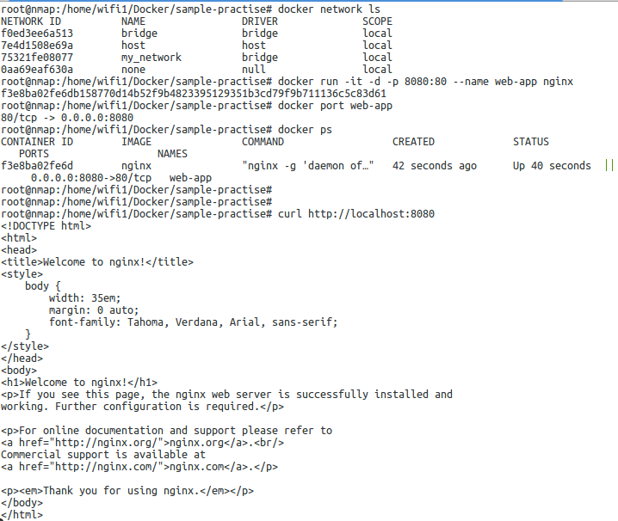
Default Bridge network is used if nothing is provided
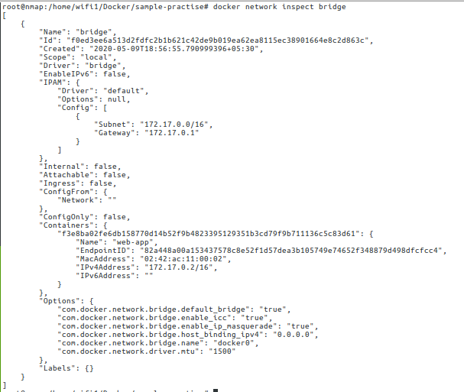
Default Bridge network is used if nothing is provided

Use newly created network: docker network create my_network
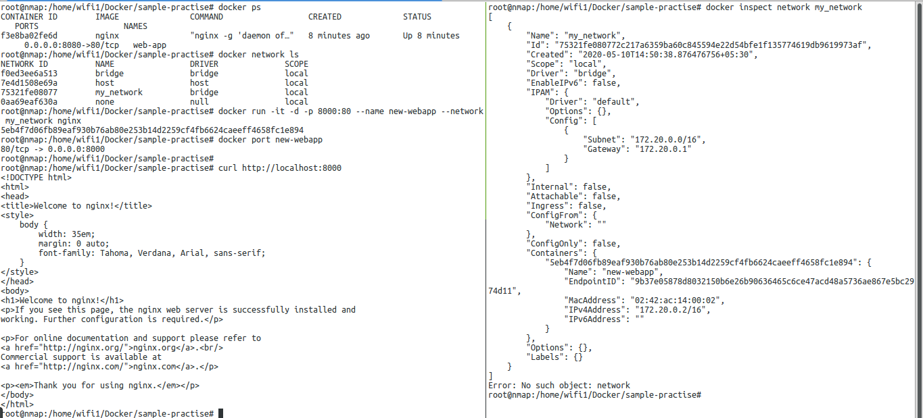
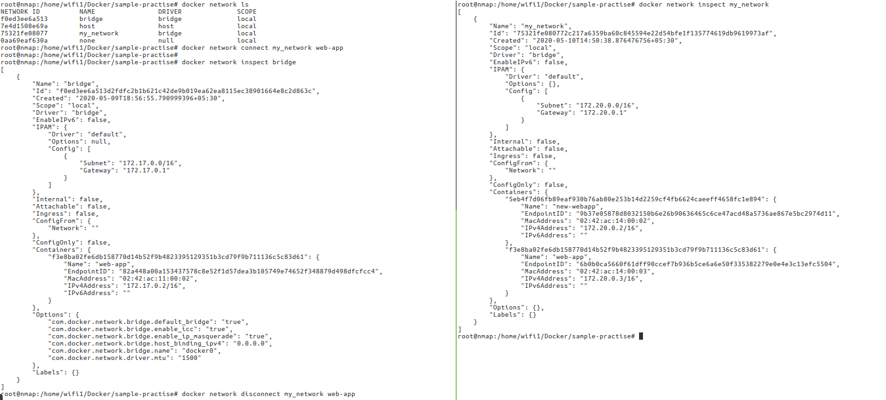
web-app
eth0
eth1
Virtual interface
n/w name
Container name
