HMacSHA256

1. HMAC-SHA256 (Hash-based Message Authentication Code with the SHA-256 hash function) is a cryptographic algorithm used for verifying the integrity and authenticity of a message or data. It is a specific type of HMAC that employs the SHA-256 (Secure Hash Algorithm 256-bit) as the underlying hash function.
2. **What is HmacSHA256?**
   * HMAC: Stands for Hash-based Message Authentication Code. HMAC is a type of message authentication code (MAC) that combines a cryptographic hash function with a secret key. Common hash functions used in HMAC include SHA-256, SHA-512, and others.
     1. Components of HMAC
        1. Message: The data you want to authenticate.
        2. Secret Key: A private key shared between the sender and receiver.
        3. Hash Function: A cryptographic hash function like SHA-256 or SHA-512.
   * SHA256: A type of cryptographic hash function that produces a 256-bit (32-byte) hash value.

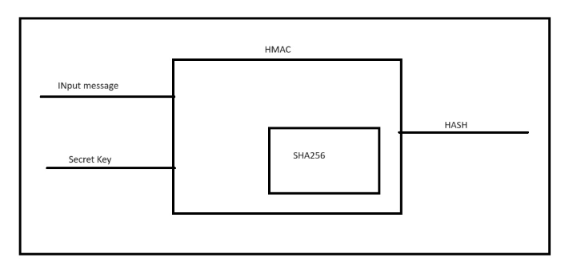

1. **Purpose of HmacSHA256**
   * HmacSHA256 is used to ensure data integrity and authenticate the origin of a message. It helps prevent data tampering and verifies that the message comes from a trusted source.
2. **How Does HmacSHA256 Work?**

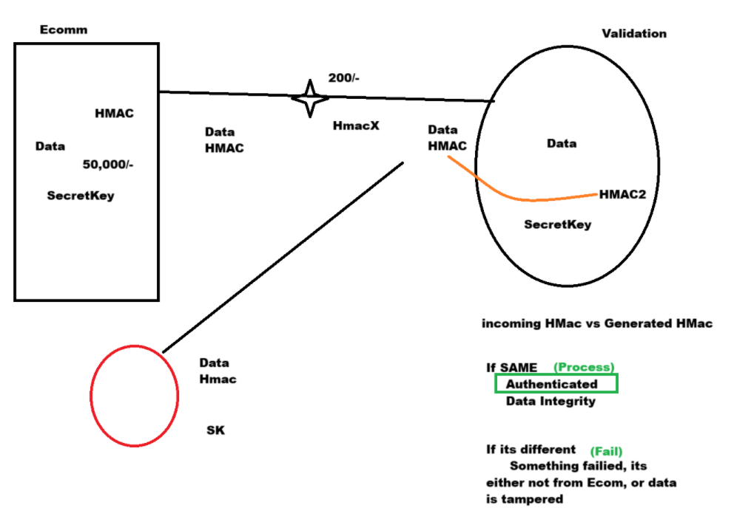

* + Shared Secret Key: Both the sender and the receiver must have a shared secret key. This key is crucial for creating and verifying the HMAC.
  + Message Hashing: The sender takes the message and the secret key, combines them, and passes them through the SHA256 hashing function. This process generates a unique hash value, known as the HMAC.
  + Message Transmission: The sender transmits the message along with its HMAC to the receiver.
  + Verification by Receiver: The receiver, who also has the shared secret key, takes the received message and generates its own HMAC using the same key and SHA256 function. If the receiver's HMAC matches the one sent with the message, the message is authenticated and considered untampered.

1. **Why HmacSHA256 is Secure**
   * Key Dependency: The HMAC depends on the secret key. Without the key, it's practically impossible for an attacker to generate the correct HMAC, even if they know the message.
   * Cryptographic Hash Function: SHA256 is designed to be resistant to collisions (where two different inputs produce the same hash) and preimage attacks (finding an input that hashes to a specific value).
   * Combining with Secret Key: The HMAC process combines the message with the secret key in a way that enhances security, making it difficult to reverse-engineer the key from the HMAC.
2. **Preventing Data Tampering and Authentication**
   * Data Integrity: If an attacker tries to alter the message, the HMAC will change. The receiver's HMAC (computed using the altered message) won't match the HMAC sent with the original message, indicating tampering.
   * Authentication: Since only the sender and receiver know the secret key, the receiver can trust that the message with the correct HMAC comes from the sender. An attacker without the key cannot forge a valid HMAC.
3. HmacSHA256 provides a way to securely verify both the integrity and authenticity of a message. By using a shared secret key and the SHA256 hashing function, it ensures that any change in the message can be detected and that the message indeed comes from a trusted source. This is essential for protecting against data tampering and unauthorized access.
4. For most applications, HmacSHA256 is sufficiently secure and offers a good balance between performance and security. However, if your application deals with highly sensitive data or requires long-term security, HmacSHA512 provides a higher security margin at the cost of some performance overhead.