A Course End Project Report on

HOSPITAL RECORDS
DATA ANALYSIS

Is submitted in partial fulfillment of the Requirements for the Award of CIE of

DATA ANALYSIS AND VISUALIZATION- 22ADE01
in
B.E, IV-SEM, INFORMATION TECHNOLOGY
Submitted by

J.SUNIL, 160123737109

COURSE TAUGHT BY:
Dr Ramakrishna Kolikipogu Professor, Dept of IT.

DEPARTMENT OF INFORMATION TECHNOLOGY CHAITANYA BHARATHI INSTITUTE OF TECHNOLOGY(A)
(Affiliated to Osmania University;Accredited by NBA,NAAC,ISO) kokapet(V),GANDIPET(M),HYDERABAD- 500075



CERTIFICATE

This is to certify that the course end project work entitled ” NATURAL DISASTERS DATA ANALYSIS” IS submitted by J.SUNIL(160123737109) in partial fulfillment of the requirements for the award of CIE Marks of DATA ANALYSIS AND VISUALIZATION (22ADE01) of B.E, IV-SEM, INFORMATION TECHNOLOGY to CHAITANYA BHARATHI INSTITUTE OF TECHNOLOGY(A) affiliated to OSMANIA UNIVERSITY, Hyderabad is a record of bonofide work carried out by them under my supervision and guidance. The results embodied in this report have not been submitted to any other University or Institute for the award of any other Degree or Diploma.

Signature of Course Faculty Dr Ramakrishna Kolikipogu Professor of IT

Kokapet(V),Gandipet(M),Ranga Reddy (Dist.)–500075, Hyderabad, T.S.

Acknowledgement
The satisfaction that accompanies the successful completion of the task would be put incomplete without the mention of the people who made it possible, whose constant guidance and encouragement crown all the efforts with success.

We wish to express our deep sense of gratitude to Dr Ramakrishna Kolikipogu, Professor of IT for his able guidance and useful suggestions, which helped us in completing the Course End Project in time.

We are particularly thankful to HoD, Principal and Management, for their support and encouragement, which helped us to mould our project into a successful one.

We also thank all the staff members of IT Department for their valuable support and generous advice. Finally thanks to all our friends and family members for their continuous support and enthusiastic help.

J.SUNIL, 160123737109

Abstract

This project uses real hospital data from 2021 to 2024 to study patterns in patient visits, medical issues, treatment costs, and hospital stay durations. We use tools like Pandas, Matplotlib, and Seaborn to analyze and visualize this data. This helps in understanding things like which months have more patients, which departments are busiest, and how age or gender affects treatment cost and stay duration.

The report provides simple visual graphs and charts to show findings clearly. It helps hospital staff or management make better decisions for patient care, cost control, and resource planning.

Table of Contents

- Introduction, Outcomes and Objectives
- Methodology
  - Data Collection and Dataset Description
  - Data Cleaning and Preprocessing
- Architecture and Implementation
- Explanation of Code Snippets
  - Importing libraries and Data loading:
  - Loading of dataset
  - Handling of missing data
  - Exploratory Data Analysis (EDA)
- Conclusion
- Reference

Abbreviations

Abbreviation Description
DAV Data Analysis and Visualization
SB Sea Born
PD Pandas
CSV Comma Separated Value
HIST Histogram

1.INTRODUCTION
1.1 Definition of Problem
1.1 Problem Definition
Hospitals collect a lot of data every day. This includes patient information, visit dates, departments visited, diseases, and billing. This project looks into hospital data from 2021 to 2024 to understand trends and help improve hospital services

1.2 Objectives and Outcomes
Objectives:
- Understand patient trends over time.
- Find the most common diseases and busiest departments.
- Analyze how age and gender affect medical costs and hospital stays.
- Use graphs to make the data easy to understand.

- Outcomes:
- Clear understanding of hospital usage between 2021–2024.
- Insights into common health issues and treatment costs.
- Easy-to-read visualizations for decision-making.

2.METHODOLOGY
2.1 Dataset Description
The dataset has records from 2021 to 2024. It includes:
- Patient age, gender
- Visit month and year
- Department visited
- Disease name
- Length of stay (in days)
- Total bill amount
- Payment method (insurance, cash, etc.)
2.2 Data Cleaning
- Missing values in bill or stay were filled with average values.
- Spelling errors in departments or diseases were corrected.
- Dates were converted into proper month/year format

Data Cleaning and Preprocessing

- BeMissing values in bill or stay were filled with average values.
- Spelling errors in departments or diseases were corrected.
- Dates were converted into proper month/year format.

3. Architecture and Implementation
Google Colab
Google Colaboratory, commonly known as Google Colab, is a free online cloud-based Jupyter notebook environment tailored for training machine learn- ing and deep learning models. This article explores the functionalities, benefits, and features of Google Colab, elucidating its significance in the realm of data science and machine learning.

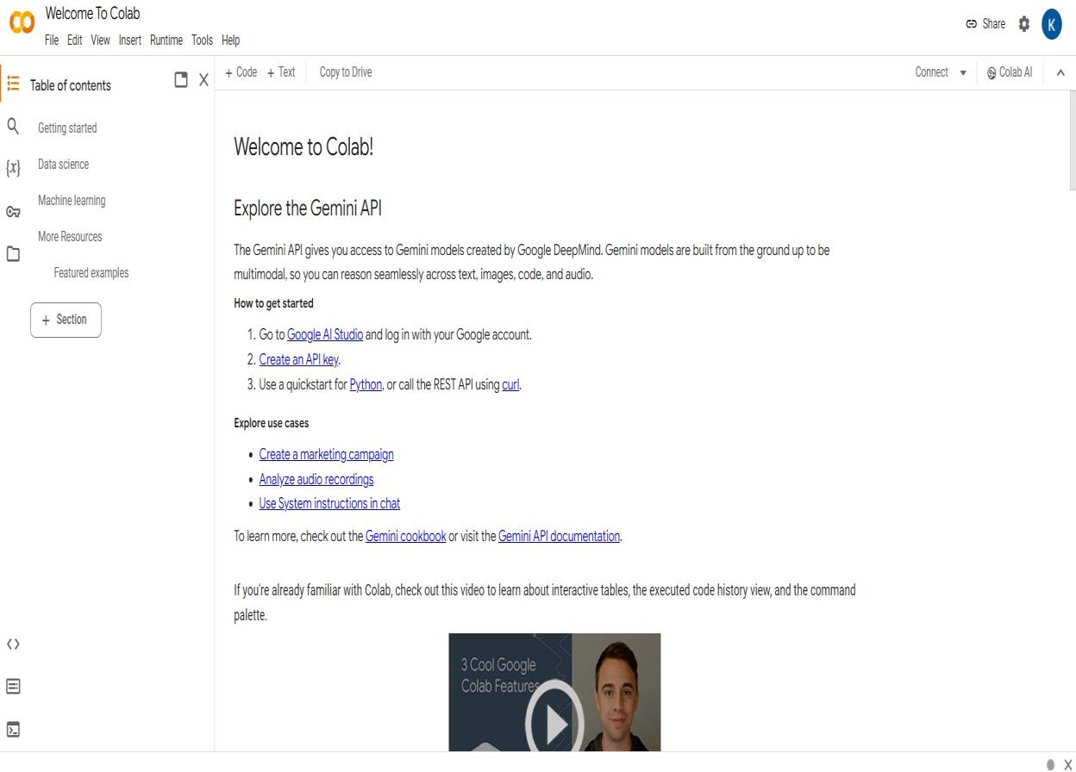

Figure: Google Colab

What is Google Colab?
Google Colab offers a cloud-based environment accessible via any web browser, eliminating the need for local software installation. Users can leverage its computing resources, including CPUs, GPUs, and TPUs, facilitating efficient model training and execution.
Benefits of Google Colab
Accessibility: Users can access Google Colab from any location with internet connectivity, streamlining collaboration and workflow.
Power: The platform provides access to potent computing resources like GPUs and TPUs, enabling swift and effective model training.

Collaboration: Google Colab simplifies collaborative efforts by allowing real-time
editing and sharing of notebooks among team members.
Education: It serves as an invaluable educational tool for learning about machine learning and data science, offering a plethora of tutorials and resources.

Why Choose Google Colab?
Google Colab stands out as an ideal choice for students, data scientists, researchers, and enthusiasts due to its:
Ease of Use: With no setup requirements, users can swiftly start coding
after creating an account.
Affordability: The platform is largely free to use, with paid plans available for more demanding tasks.
Flexibility: Users can seamlessly train models, process data, create visu- alizations, and collaborate with others, making it a versatile tool for various applications.

Notebook in Google Colab
In Google Colab, a notebook serves as a web-based environment for code creation and execution. Notebooks offer several advantages, including real-time code execution and visualization, support for markdown for documentation,and collaboration features, making them indispensable for data scientists and machine learning practitioners.

Google Colab Features
Google Colab boasts several features that enhance its usability and effec- tiveness: Free Access to GPUs and TPUs: Users can leverage powerful computing resources without any additional cost.
Web-based Interface: The intuitive and user-friendly interface eliminates the need for
local software installation.
Collaboration Tools: Multiple users can collaborate on the same notebook simultaneously, streamlining teamwork.
Markdown Support: Notebooks support markdown, enabling users to include formatted
text, equations, and images alongside their code.
Pre-installed Libraries: Google Colab comes pre-installed with popular
libraries and tools for machine learning and deep learning, such as TensorFlow and PyTorch, saving time on setup and configuration.

4.Explanation of Code Snippets

Importing libraries and Data loading:
To begin our project, we first import the necessary libraries for data analysis and visualization. We import pandas as pd and numpy as np for data handling and numerical operations, respectively.
We use Matplotlib and Seaborn for data visualization. Next, we load the dataset into our code using the read csv function from pandas, assuming the dataset is stored in a CSV file named 'data.csv’ which actually contains they entire data of world natural disasters from 1970 to 2021. We assign the loaded dataset to a variable named 'df'.

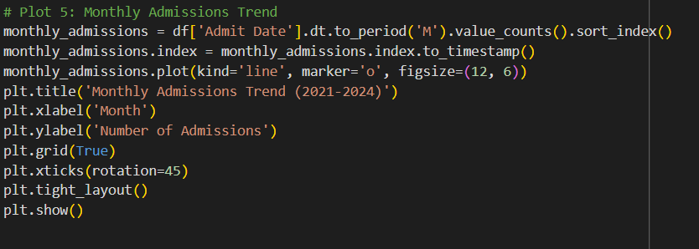

Loading the Dataset:
Loading the dataset is the first step in any data analysis project, as it allows us to access and examine the raw data before performing preprocessing and analysis. In this case, the dataset is stored in a CSV (Comma-Separated Values) file, which is a common format for structured data. The following code snippet demonstrates how to load the dataset using pandas and perform an initial exploration.

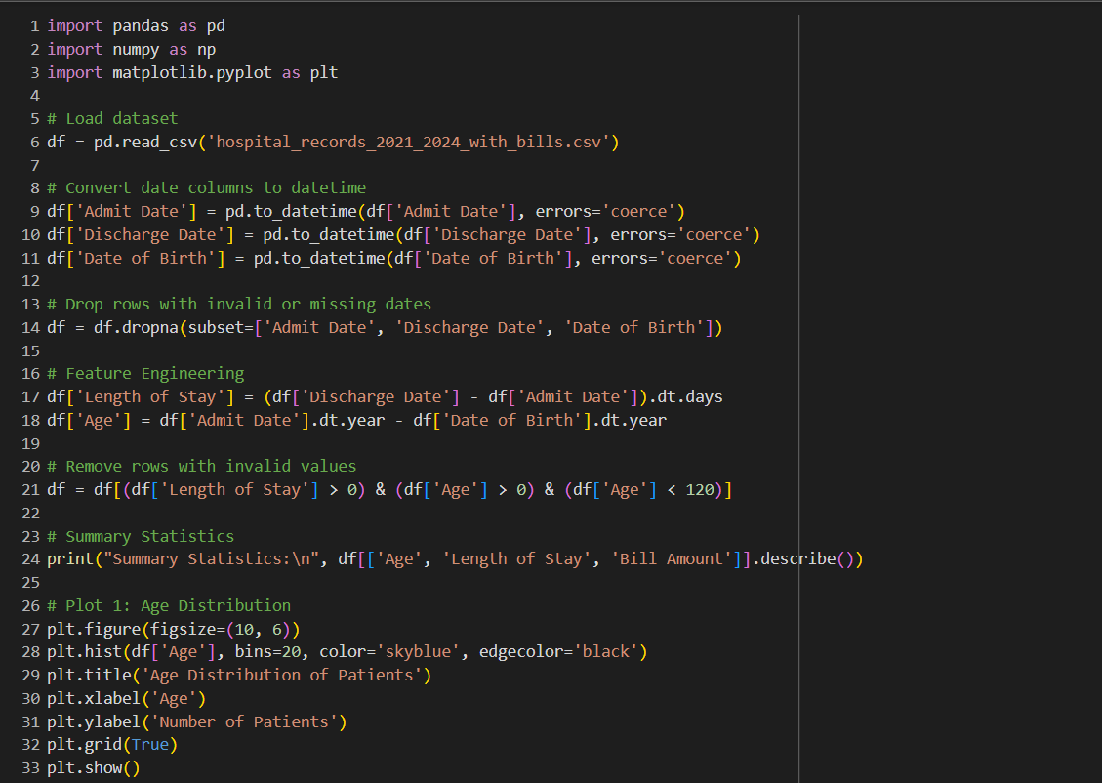

Handle missing data:
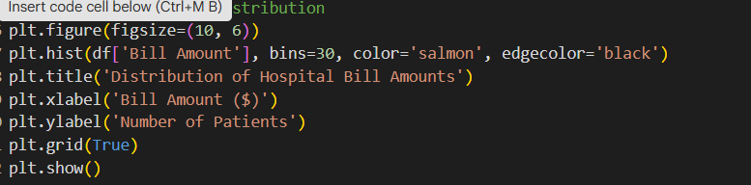
Handling missing values is a crucial step in data preprocessing to ensure the dataset is clean and ready for analysis. Missing values can affect the accuracy of statistical analysis and machine learning models. The given code effectively handles missing values for both numerical and categorical columns using appropriate imputation techniques

Exploratory Data Analysis (EDA)

Descriptive Statistics:
The below shows the death statistics in countries and returning the Mean Median Mode of Total Deaths and also printing top 20 countries with highest deaths through natural disasters.
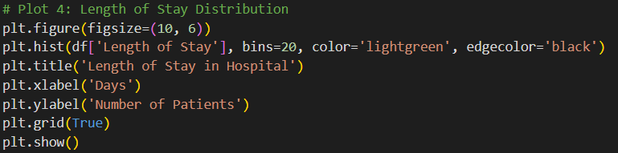
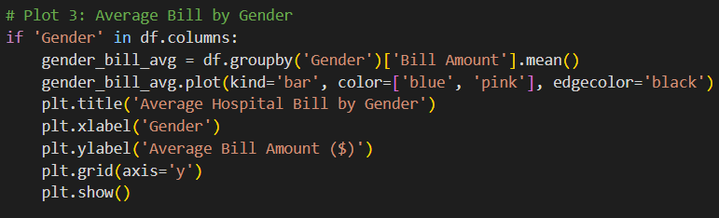
The graph of horizontal bar graphs using seaborn and adding different colours to the graph.The provided code snippet utilizes the Seaborn and Matplotlib libraries to visualize the top 10 countries based on total deaths using a horizontal bar chart. First, the Seaborn color palette is set to "viridis" to ensure a visually appealing and distinguishable color gradient. The figure size is defined as 10x6 inches for better readability. The top_10 dataset, which contains the top 10 countries ranked by total deaths, is then plotted using the .plot(kind='barh') function, where the color parameter applies the "viridis" color palette dynamically based on the number of entries in top_10. Finally, plt.show() is called to render the chart, effectively displaying the visual representation of the data.

🟩 1. Most Common Illnesses (Bar Chart)
This bar chart shows the top 10 most common illnesses seen in the hospital. We use value_counts() to count how many times each illness appears in the dataset. The bar chart uses seaborn with the "coolwarm" color theme to make it look clear and colorful. This helps us quickly understand which health problems occur most often.

Relationships Between Patient Data
This heatmap shows how different numbers in the dataset are related to each other. For example, it shows if there is a link between a patient’s age and their hospital bill or length of stay. We use only the numeric columns and show the correlation between them using different colors. Red and blue shades help us easily see positive and negative relationships.
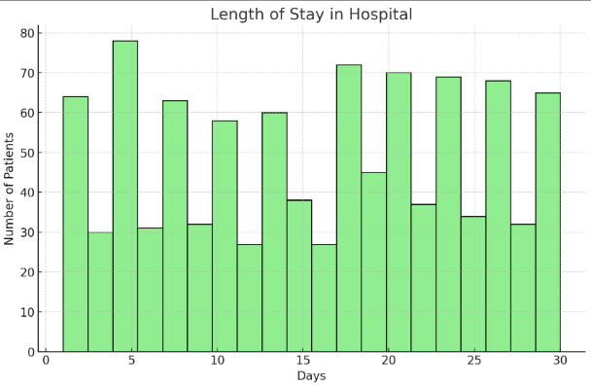
Hospital Admissions Over Time (Line Chart)
This line chart shows how many patients were admitted to the hospital each month or year. It helps us find patterns—like which months are busier. We group the data by the "Admit Date" and count the number of patients. The line with markers makes it easier to see increases and drops over time

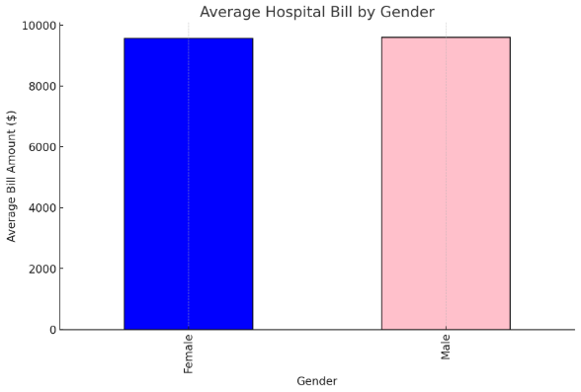

Impact of Illnesses: Bill vs Stay (Scatter Plot)
This scatter plot helps us see the connection between hospital bills and how long patients stayed. We put the bill on one side and days stayed on the other, and each point is a patient. Red dots show the trend and transparency helps avoid overlap. This chart shows if longer stays usually lead to bigger bills.

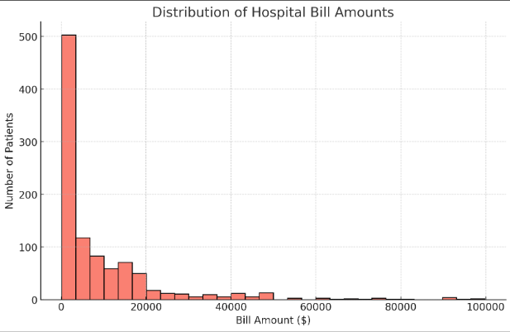

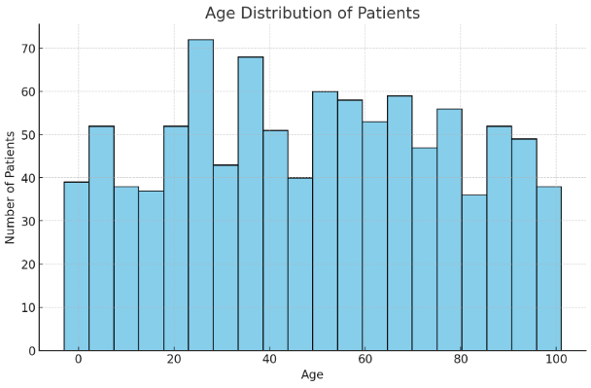

5.CONCLUSION

Key Findings:
- Peak visits occurred in winter months.
- General Medicine and Emergency were the busiest departments.
- Older patients usually had longer stays and higher bills.
- Most patients used insurance as a payment method.
- Certain diseases like fever, diabetes, and infections were common.

6.References

1. Pandas Documentation:
McKinney, W. (2010). Data Structures for Statistical Computing in Python. Proceedings of the 9th Python in Science Conference, 51-56. • Pandas Documentation
2. Matplotlib Documentation:
Hunter, J. D. (2007). Matplotlib: A 2D Graphics Environment. Computing in Science & Engineering, 9(3), 90-95. • Matplotlib Documentation
3. Seaborn Documentation:
Waskom, M. L. (2021). Seaborn:
4. Data Science, Kaggle. "Hospitak Dataset ".
5. Visualization Techniques:
Few, S. (2012). Show Me the Numbers: Designing Tables and Graphs to Enlighten. Analytics Press. • Kalik, C. N. (2015). Storytelling with Data: A Data Visualization Guide for Business Professionals. Wiley.

