** EXPERIMENT NUMBER – 1.2**

**Student Name: Surbhi priya UID: 20BCS4047**

**Branch: CSE Section/Group: 48 A**

Semester: 3RD Subject Code: 20CSP-219

**Subject Name: Java programming lab Date of Performance: 10 Sep 2021**

1. **Aim/Overview of the practical:**

Write a Program to create classes and use of different types of methods.

1. **Task to be done/ Which logistics used:**

Creating class and using different types of function.

1. **Algorithm/Flowchart (For programming based labs):**

Step 1: Start

Step 2: Create object person with name age and section

Step 3: Create and initialize objects for each person

Step 4: Display the details of person using object

Step 5: End

1. **Steps for experiment/practical/Code:**

class Person

{

String name;

int age;

char section;

public Person(String name, int age, char section)

{

this.name = name;

this.age = age;

this.section = section;

}

public void display()

{

System.out.println("Name: "+name);

class Person

{

String name;

int age;

char section;

public Person(String name, int age, char section)

{

this.name = name;

this.age = age;

this.section = section;

}

public void display()

{

System.out.println("Name: "+name);

}

Person modify(Person p)

{

p.name = "sita";

p.age = 27;

p.section = 'A';

return p;

}

}

public class Main

{

public static void main(String args[])

{

Person p = new Person("ram", 23, 'A');

p.display();

Person p1 =p.modify(p);

p1.display();

Person p2 = p1.modify(new Person("sam", 15, 'B'));

p2.display();

}

}

**5. Observations/Discussions/ Complexity Analysis:**

None

**6. Result/Output/Writing Summary:**

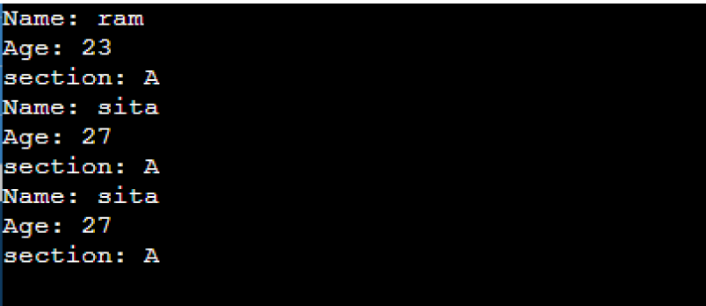

LEARNING OUTCOMES

|  |
| --- |
| * It will provide the modest experience that allows students to develop and improve their experimental skills and develop ability to analyzedata. |
| * Ability to demonstrate the practical skill on measurements and instrumentation techniques of some Physics experiments. Students will develop the ability to use appropriate physical concepts to obtain quantitative solutions to problems inphysics. |
| * Students will demonstrate basic experimental skills by setting up laboratory equipment safely and efficiently, plan and carry out experimental procedures, and report verbally and in written language the results of theexperiment. |
| * Students will develop skills by the practice of setting up and conducting an experimentwithdueregardstominimizing   measurement error. |

EVALUATION COLUMN (To be filled by concerned faculty only)

|  |  |  |  |
| --- | --- | --- | --- |
| **Sr. No.** | **Parameters** | **Maximum Marks** | **Marks Obtained** |
| 1. | Worksheet completion including writing learning objectives/Outcomes. (To be submitted at the end of the day) | 10 |  |
| 2. | Post Lab Quiz Result. | 5 |  |
| 3. | Student Engagement in Simulation/Demonstration/Performance and Controls/Pre-Lab Questions. | 5 |  |
| 4. | Total Marks | 20 |  |
| 5. | Teacher’s Signature (with date) |  | |