**Name :-Nandini Agarwal**

**Enroll No:- 180069**

**END TERM PRACTICAL EXAMINATION**

**Objectives :- Write an algorithm and program to sort n numbers using Selection sort technique**

**i) Using arrays**

|  |
| --- |
| #include<iostream>    using namespace std;    int main()  {       int i,j,n,loc,temp,min,a[30];       cout<<"Enter the number of elements:";       cin>>n;       cout<<"\nEnter the elements\n";    for(i=0;i<n;i++)   {          cin>>a[i];       }    for(i=0;i<n-1;i++)      {       min=a[i];       loc=i;          for(j=i+1;j<n;j++)          {           if(min>a[j])           {           min=a[j];           loc=j;              }          }   temp=a[i];          a[i]=a[loc];          a[loc]=temp;      }    cout<<"\nSorted list is as follows\n";      for(i=0;i<n;i++)      {          cout<<a[i]<<" ";      }   return 0;  } |

**(ii) recursion and linked list:**

#include <iostream>

using namespace std;

struct Node {

int data;

struct Node* next;

};

void swapNodes(struct Node** head_ref, struct Node* currX,

struct Node* currY, struct Node* prevY)

{

*head_ref = currY;

prevY->next = currX;

struct Node* temp = currY->next;

currY->next = currX->next;

currX->next = temp;

}

struct Node* recurSelectionSort(struct Node* head)

{

if (head->next == NULL)

return head;

struct Node* min = head;

struct Node* beforeMin = NULL;

struct Node* ptr;

for (ptr = head; ptr->next != NULL; ptr = ptr->next) {

if (ptr->next->data < min->data) {

min = ptr->next;

beforeMin = ptr;

}

}

if (min != head)

swapNodes(&head, head, min, beforeMin);

head->next = recurSelectionSort(head->next);

return head;

}

void sort(struct Node** head_ref)

{

if ((*head_ref) == NULL)

return;

*head_ref = recurSelectionSort(*head_ref);

}

void push(struct Node** head_ref, int new_data)

{

struct Node* new_node =

(struct Node*)malloc(sizeof(struct Node));

new_node->data = new_data;

new_node->next = (*head_ref);

(*head_ref) = new_node;

}

void printList(struct Node* head)

{

while (head != NULL) {

cout << head->data << " ";

head = head->next;

}

}

int main()

{

struct Node* head = NULL;

push(&head, 6);

push(&head, 4);

push(&head, 8);

push(&head, 12);

push(&head, 10);

cout << "Linked list before sorting:n";

printList(head);

sort(&head);

cout << "\nLinked list after sorting:n";

printList(head);

return 0;

}

**OUTPUT:-**

1. **Using arrays**

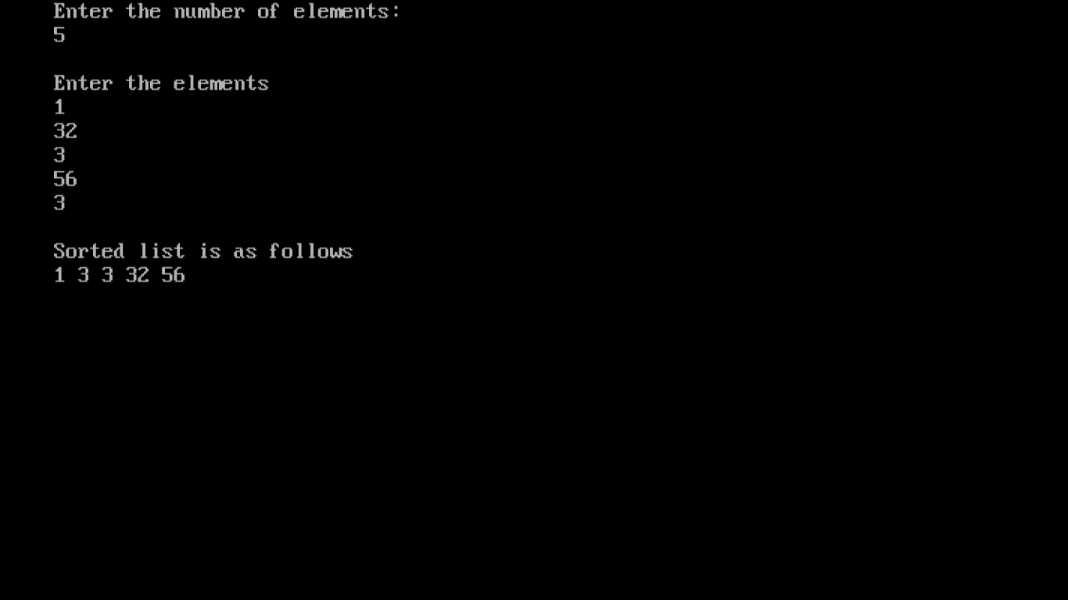

1. **Using linked list with recursion**

