**Aim:** Write a program to implement Binary Search

1. Using array
2. Using linked list

**Code for array:**

#include <stdio.h>

#include<conio.h>

void main()

{

clrscr();

int i, low, high, mid, n, key, array[100];

printf("Enter number of elements: ");

scanf("%d",&n);

printf("Enter %d integers: ", n);

for(i = 0; i < n; i++)

scanf("%d",&array[i]);

printf("Enter value to find: ");

scanf("%d", &key);

low = 0;

high = n - 1;

mid = (low+high)/2;

while (low <= high) {

if(array[mid] < key)

low = mid + 1;

else if (array[mid] == key) {

printf("%d found at location %d", key, mid+1);

break;

}

else

high = mid - 1;

mid = (low + high)/2;

}

if(low > high)

printf("Not found! %d isn't present in the list", key);

getch();

}

**Output:**

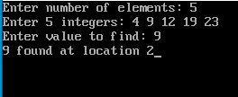

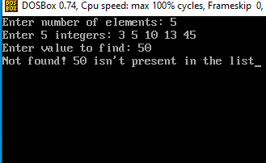

**Code for linked list:**

#include<stdio.h>

#include<stdlib.h>

#include<conio.h>

struct node{

int data;

struct node *link;

};

struct node *head,*n;

void insert(){

int x;

struct node *ptr;

ptr=head;

printf("Enter the value of new node in ascending order: ");

scanf("%d",&x);

n=(struct node *)malloc(sizeof(struct node));

n->data=x;

if(head==NULL){

n->link=NULL;

head=n;

}else{

while(ptr->link!=NULL){

ptr=ptr->link;

}

n->link=NULL;

ptr->link=n;

}

}

void traversal(){

struct node *ptr;

ptr=head;

if(head==NULL){

printf("List is empty");

getch();

}

else{

while(ptr!=NULL){

printf("%d-> ",ptr->data);

ptr=ptr->link;

}

getch();

}

}

void srch(){

struct node *ptr;

ptr=head;

int m,l=1,u=0,t,c=0,key;

if(head==NULL){

printf("List is empty");

}

else{

printf("Enter key value: ");

scanf("%d",&key);

while(ptr!=NULL){

ptr=ptr->link;

u++;

}

do{

t=0;

ptr=head;

m=(l+u)/2;

while(t!=m-1){

ptr=ptr->link;

t++;

}

if(ptr->data==key){

printf("%d found at position %d",key,m);

c=1;

}

else if(key>ptr->data){

l=m+1;

}

else{

u=m-1;

}

}while(l<=u&&c==0);

if(c==0){

printf("Value not found");

}

}

getch();

}

void main(){

int c;

L:system("cls");

printf("1. Insertion\n");

printf("2. Traversal\n");

printf("3. Search\n");

printf("4. Exit\n");

printf("Enter your choice: ");

scanf("%d",&c);

switch(c){

case 1:

insert();

goto L;

case 2:

traversal();

goto L;

case 3:

srch();

goto L;

case 4:

exit(0);

default:

printf("Invalid choice...Enter your choice again");

getch();

goto L;

}

}

**Output:**

