**Program:20**

**AIM:** Write a program to implement linear separability for AND function.

**CODE:**

import numpy as np

import matplotlib as plt

x = np.array([0,1,0])

y = np.array([0,0,1])

plt.pyplot.scatter(x,y,c='red')

plt.pyplot.scatter(1,1,c="blue")

plt.pyplot.xlabel('Input 1')

plt.pyplot.ylabel('Input 2')

w=-1

b=1.5

x = np.linspace(0,1.5)

plt.pyplot.plot(x,w*x+b,c='black')

plt.pyplot.show()

**OUTPUT:**  
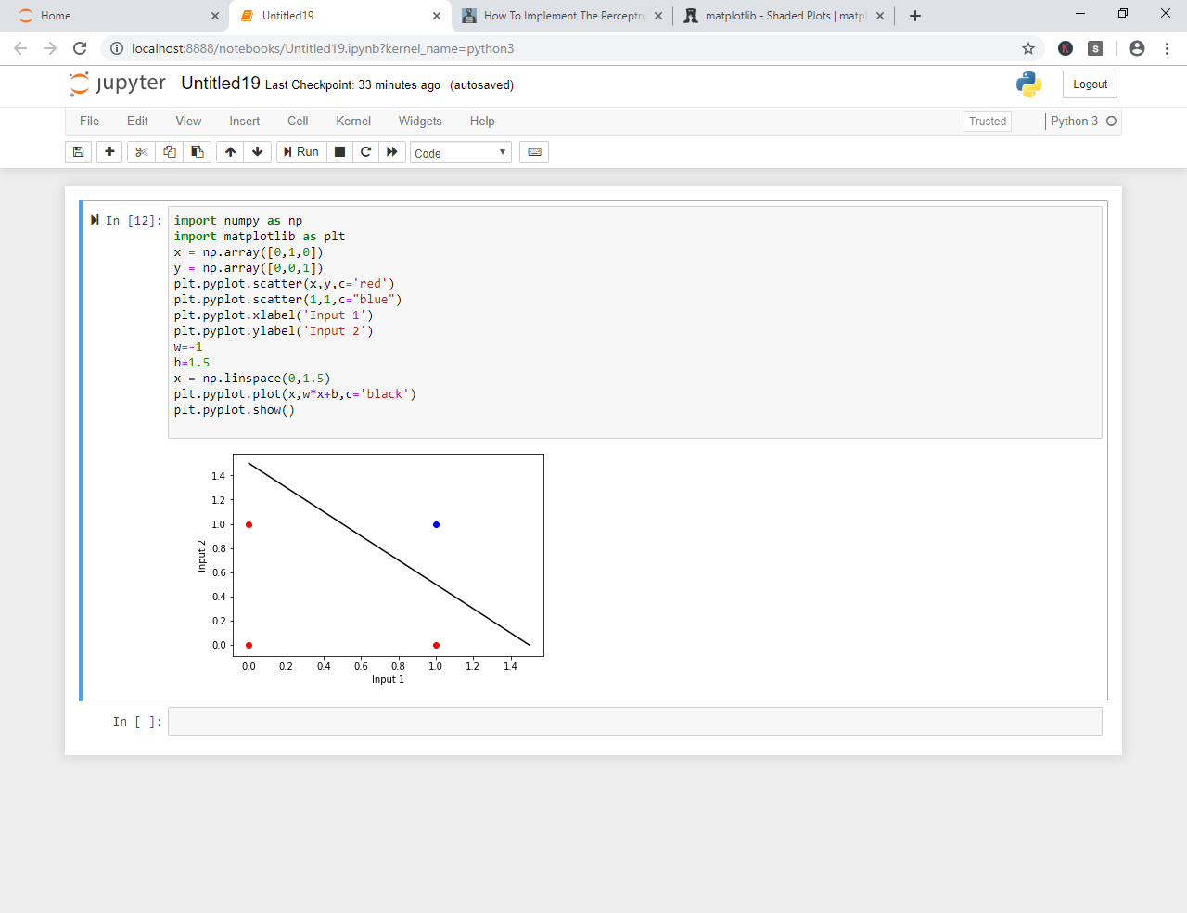

**Program 18**

**AIM:** Write a program to implement linear separability for OR function.

**CODE:**

import numpy as np

import matplotlib as plt

x = np.array([0,1])

y = np.array([0,1])

plt.pyplot.scatter(x,y,c='red')

x = np.array([1,0])

y = np.array([0,1])

plt.pyplot.scatter(x,y,c="blue")

plt.pyplot.xlabel('Input 1')

plt.pyplot.ylabel('Input 2')

w=-1

b=1.5

x = np.linspace(0,1.5)

plt.pyplot.plot(x,w*x+b,c='black')

plt.pyplot.show()

**OUTPUT:**

