Program - 7
AIM: Plot the graph for following equations
- y={1 x<10 0 else
import matplotlib.pyplot as plt
x=[num for num in range(0,20)]
y=[]
for i in x:
if i>=10:
y.append(1)
else:
y.append(0)
plt.plot(x,y)
plt.xlabel("x axis")
plt.ylabel("y axis")
plt.title("y=1 if x>=10 else y=0")
plt.show()
Output:
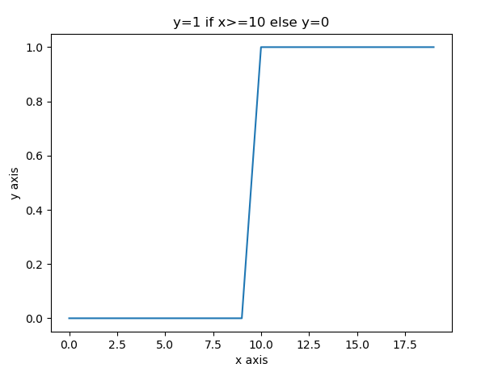
- .y=eaxfor different values of a.
import numpy as np
import matplotlib.pyplot as plt
num=[num for num in range(0,10)]
a=2 #constant value
x=np.array(num)*2
y=np.exp(x)
plt.plot(x,y)
plt.xlabel("x axis")
plt.ylabel("y axis")
plt.title("y=e**ax")
plt.show()
Output:
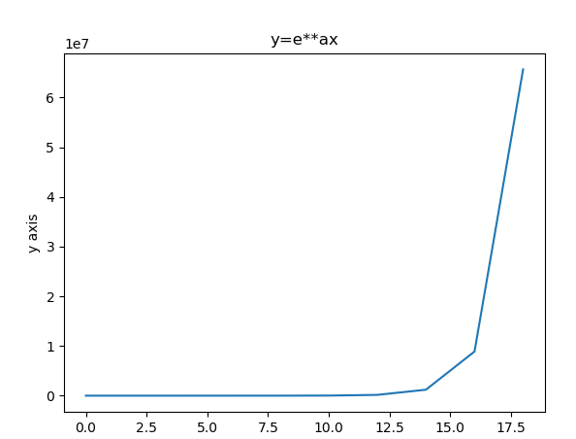
3.y=7x2+3x+10 for 2x5
import matplotlib.pyplot as plt
x=[x for x in range(2,6)]
y=[]
for i in x:
y.append(7*pow(i,2)+3*i+10)
plt.plot(x,y)
plt.xlabel('x axis')
plt.ylabel('y axis')
plt.title('y=7x^2+3x+10')
plt.show()
Output:
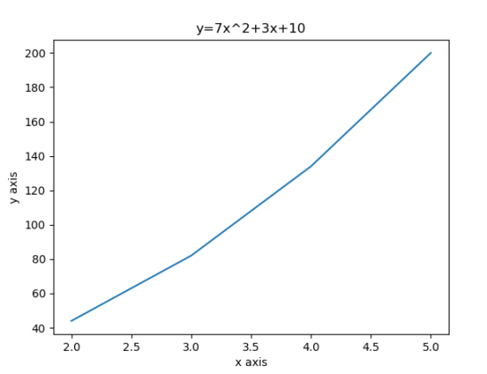
4.y=11+e-x
import matplotlib.pyplot as plt
import numpy as np
x=[x for x in range(0,20)]
p=np.array(x)
p=1+np.exp(-p)
y=1/p
plt.plot(x,y)
plt.xlabel('x axis')
plt.ylabel('y axis')
plt.show()
Output:
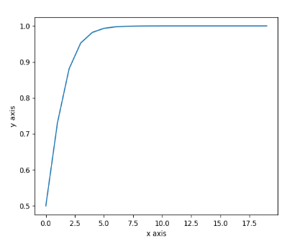
5. y=1-e-ax1+e-axfor different values of a.
import matplotlib.pyplot as plt
import numpy as np
num=[num for num in range(0,21)]
num=np.array(num)
a=2
p=1-np.exp(-num*a)
q=1+np.exp(-num*a)
y=p/q
plt.plot(num,y)
plt.xlabel('x axis')
plt.ylabel('y axis')
plt.show()
Output:
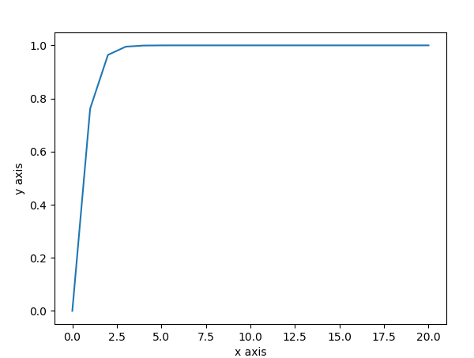
6. y=tan hx
import numpy as np
import matplotlib.pyplot as plt
in_array = np.linspace(0, np.pi, 12)
h=2
out_array =h*np.tan(in_array)
print("in_array : ", in_array)
print("\nout_array : ",out_array)
# red for numpy.tan()
plt.plot(in_array, out_array, color='red', marker="o")
plt.title("numpy.tan()")
plt.xlabel("X")
plt.ylabel("Y")
plt.show()
Output:
