**SOFT COMPUTING - LAB PRACTICAL EXAM**

**AIM:** Write a program in Python to implement single layer perceptron for AND function.

**CODE:**

import numpy as np

x=np.array([[1,1],[1,-1],[-1,1],[-1,-1]])

t=np.array([[1],[1],[1],[-1]])

w=np.array([[0],[0]])

b=0

theta=float(input("Enter new theta:"))

alpha=float(input("Enter new alpha:"))

yin=np.zeros(shape=(4,1))

y=np.zeros(shape=(4,1))

i=0

found=0

while(found==0):

    yin=x[i][0]*w[0]+x[i][1]*w[1]

    yin = yin+b

    if(yin>theta):

        y[i] = 1

    elif(yin<=theta and yin>=-theta):

        y[i]=0

    else:

        y[i]=-1

    if (y[i]==t[i]):

        print("NO UPDATION REQUIRED")

        print(y[i])

        if(i<3):

            i=i+1

        else:

            i=0

    else:

        print("MODEL IS NOT TRAINED")

        print("The value of output is")

        print(y)

        w[0]=w[0]+alpha*x[i][0]*t[i]

        w[1]=w[1]+alpha*x[i][1]*t[i]

        b = b+alpha*t[i]

        if(i<3):

            i=i+1

        else:

            i=0

    if(y==t).all():

        found=1

print("The final weight matrix is:")

print(w)

print("The final output is:")

print(y)

**OUTPUT:**  
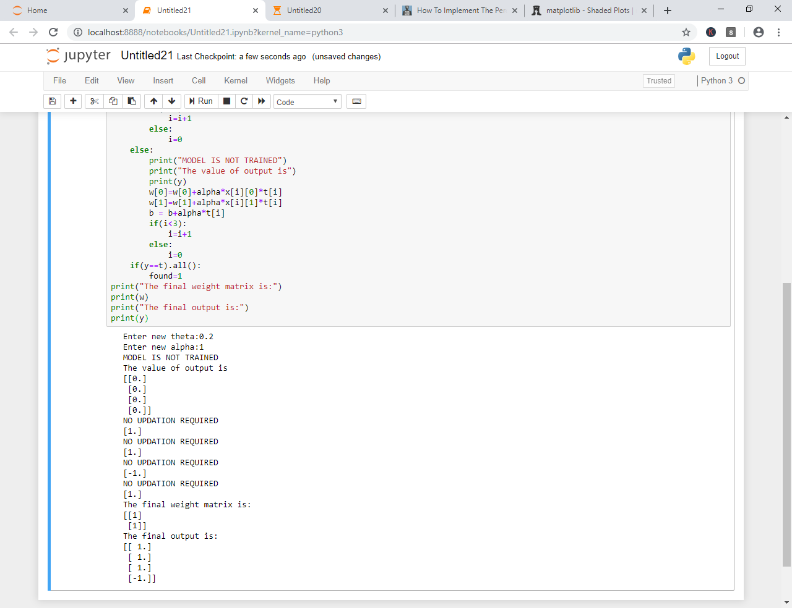

**SOFT COMPUTING – LAB PRACTICAL EXAM**

**AIM:** Write a program in Python to implement single layer perceptron for AND-NOT function.

**CODE:**

import numpy as np

x=np.array([[1,1],[1,-1],[-1,1],[-1,-1]])

t=np.array([[-1],[1],[-1],[-1]])

w=np.array([[0],[0]])

b=0

theta=float(input("Enter new theta:"))

alpha=float(input("Enter new alpha:"))

yin=np.zeros(shape=(4,1))

y=np.zeros(shape=(4,1))

i=0

found=0

while(found==0):

    yin=x[i][0]*w[0]+x[i][1]*w[1]

    yin = yin+b

    if(yin>theta):

        y[i] = 1

    elif(yin<=theta and yin>=-theta):

        y[i]=0

    else:

        y[i]=-1

    if (y[i]==t[i]):

        print("NO UPDATION REQUIRED")

        print(y[i])

        if(i<3):

            i=i+1

        else:

            i=0

    else:

        print("MODEL IS NOT TRAINED")

        print("The value of output is")

        print(y)

        w[0]=w[0]+alpha*x[i][0]*t[i]

        w[1]=w[1]+alpha*x[i][1]*t[i]

        b = b+alpha*t[i]

        if(i<3):

            i=i+1

        else:

            i=0

    if(y==t).all():

        found=1

print("The final weight matrix is ")

print(w)

print("The final output is:")

print(y)

**OUTPUT:**

