End-to-End Hands-On Lab Manual
MySQL → Snowflake Integration (Banking Use Case)
This lab walks you through a real enterprise-style pipeline:
MySQL (OLTP) → CSV Export → Stage → Snowflake (OLAP) → Streams → Tasks → Analytics

🔹 Lab Architecture Overview
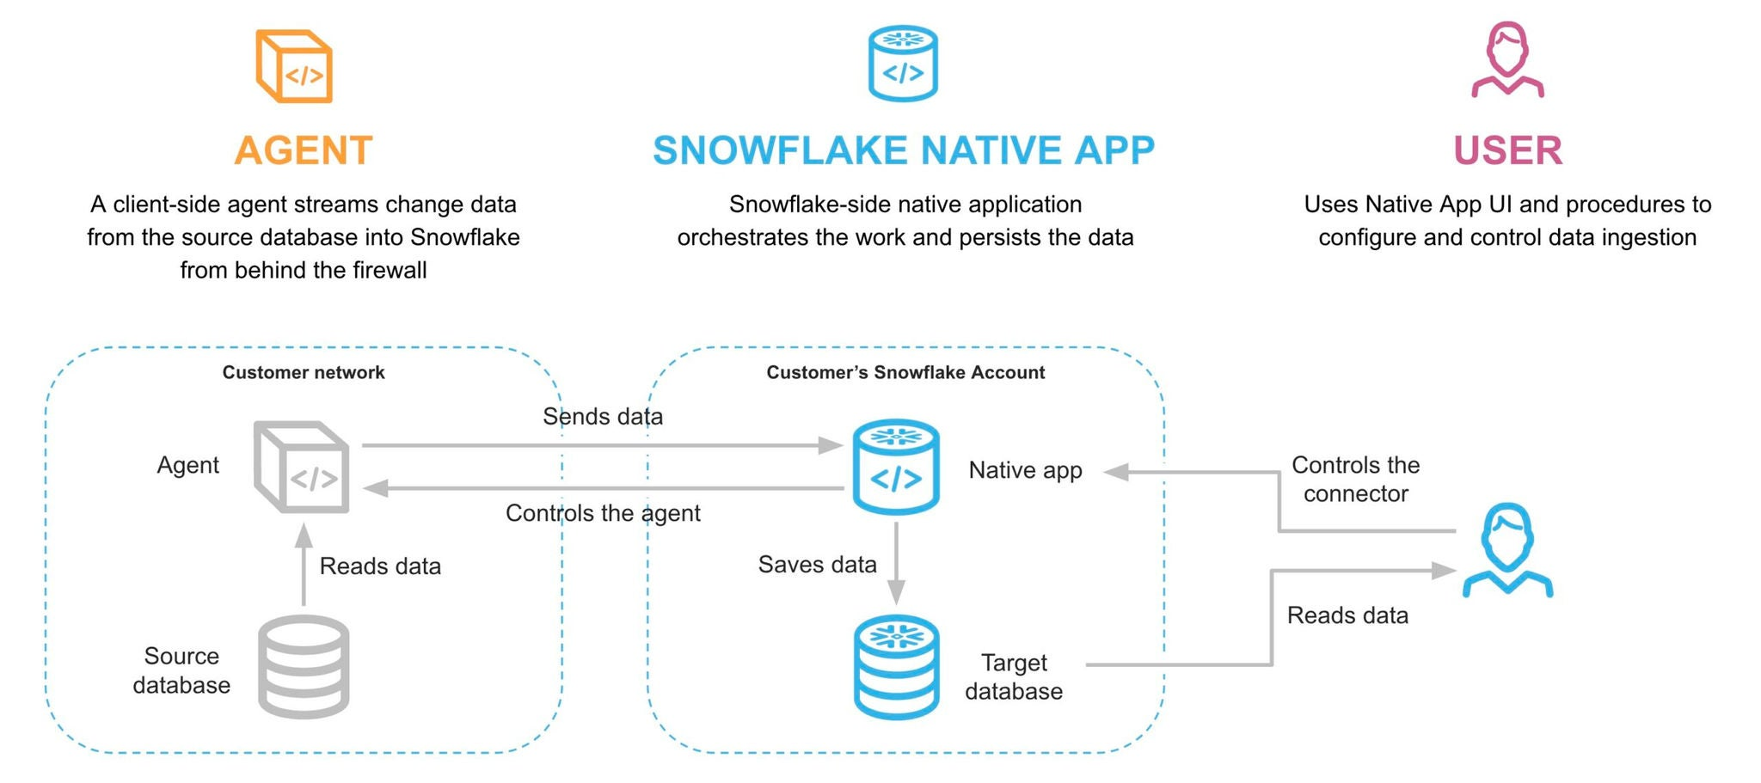
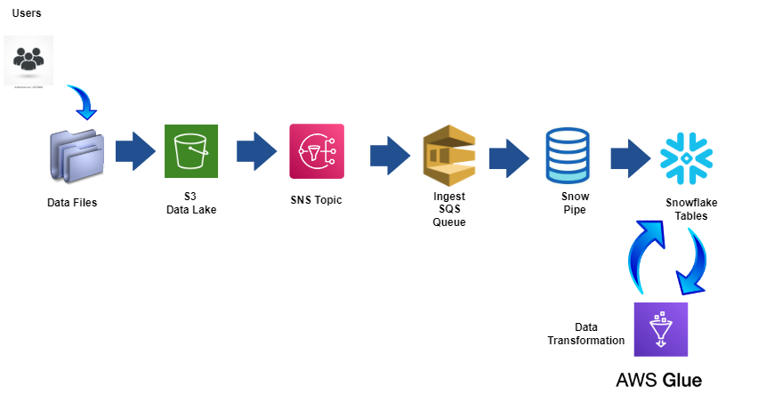
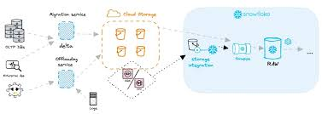
4

🧪 LAB 1: Setup MySQL (Source System)
Step 1: Create Database
CREATE DATABASE banking_core;
USE banking_core;
Step 2: Create Tables
CREATE TABLE accounts (
account_id INT PRIMARY KEY,
customer_name VARCHAR(100),
balance DECIMAL(12,2),
status VARCHAR(20),
last_updated TIMESTAMP DEFAULT CURRENT_TIMESTAMP
);

CREATE TABLE transactions (
transaction_id INT PRIMARY KEY,
account_id INT,
transaction_type VARCHAR(20),
amount DECIMAL(10,2),
transaction_time TIMESTAMP DEFAULT CURRENT_TIMESTAMP,
FOREIGN KEY (account_id) REFERENCES accounts(account_id)
);
Step 3: Insert Sample Data
INSERT INTO accounts VALUES
(101, 'John', 75000, 'ACTIVE', NOW()),
(102, 'Mary', 120000, 'ACTIVE', NOW()),
(103, 'David', 50000, 'ACTIVE', NOW());

INSERT INTO transactions VALUES
(1, 101, 'DEPOSIT', 5000, NOW()),
(2, 102, 'WITHDRAWAL', 70000, NOW()),
(3, 101, 'WITHDRAWAL', 2000, NOW()),
(4, 103, 'DEPOSIT', 90000, NOW());

🧪 LAB 2: Export Data from MySQL
SELECT * FROM transactions
INTO OUTFILE '/tmp/transactions.csv'
FIELDS TERMINATED BY ','
ENCLOSED BY '"'
LINES TERMINATED BY '\n';

To find the mysql configurations -- services.msc Mysql80 Properties Path C:\ProgramData\MySQL\MySQL Server 8.0\my.ini
- Open file in Admin Role
- Search for the line containing secure-file-priv.
- To disable the restriction entirely (allowing operations from any directory), set the value to an empty string: secure-file-priv = ""
- To specify a different directory, set the value to the path of your desired folder: secure-file-priv = "/path/to/your/folder/"
- Save the file and restart the MySQL server

Upload transactions.csv to:
- Snowflake internal stage OR
- AWS S3 bucket

🧪 LAB 3: Snowflake Environment Setup
Using Snowsight UI of Snowflake.
Step 1: Create Database & Schema
CREATE DATABASE BANK_ANALYTICS;
USE DATABASE BANK_ANALYTICS;

CREATE SCHEMA RAW;
USE SCHEMA RAW;
Step 2: Create Table
CREATE OR REPLACE TABLE TRANSACTIONS (
TRANSACTION_ID INT,
ACCOUNT_ID INT,
TRANSACTION_TYPE STRING,
AMOUNT NUMBER(10,2),
TRANSACTION_TIME TIMESTAMP
);

🧪 LAB 4: Create File Format & Stage
CREATE OR REPLACE FILE FORMAT CSV_FORMAT
TYPE = 'CSV'
FIELD_OPTIONALLY_ENCLOSED_BY = '"'
SKIP_HEADER = 0;

CREATE OR REPLACE STAGE BANK_STAGE
FILE_FORMAT = CSV_FORMAT;

>> Upload file to stage via UI.
Snowsight > Ingestion > Add data > Load files into a Stage
- Select Database, Schema and Stage
- Browser “tmp/transactions.csv”
- > Upload

>> to display files in stage
LIST @BANK_STAGE;

🧪 LAB 5: Load Data into Snowflake
COPY INTO TRANSACTIONS
FROM @BANK_STAGE/transactions.csv
FILE_FORMAT = (FORMAT_NAME = CSV_FORMAT)
ON_ERROR = 'CONTINUE';

Verify:
SELECT * FROM TRANSACTIONS;
select * from BANK_ANALYTICS.RAW.TRANSACTIONS;

🧪 LAB 6: Create Transformation Layer
CREATE SCHEMA TRANSFORMED;
Daily Summary Table
CREATE OR REPLACE TABLE TRANSFORMED.DAILY_SUMMARY AS
SELECT
DATE(TRANSACTION_TIME) AS TXN_DATE,
COUNT(*) AS TOTAL_TXNS,
SUM(AMOUNT) AS TOTAL_AMOUNT
FROM RAW.TRANSACTIONS
GROUP BY DATE(TRANSACTION_TIME);

🧪 LAB 7: Fraud Detection (Stream + Task)
Step 1: Create Fraud Table
CREATE OR REPLACE TABLE FRAUD_ALERTS (
TRANSACTION_ID INT,
ACCOUNT_ID INT,
AMOUNT NUMBER(10,2),
ALERT_TIME TIMESTAMP DEFAULT CURRENT_TIMESTAMP
);
Step 2: Create Stream
CREATE OR REPLACE STREAM TRANSACTION_STREAM
ON TABLE TRANSACTIONS;
Step 3: Create Task (Every 5 Minutes)
CREATE OR REPLACE TASK FRAUD_TASK
WAREHOUSE = COMPUTE_WH
SCHEDULE = '5 MINUTE'
AS
INSERT INTO FRAUD_ALERTS
SELECT TRANSACTION_ID, ACCOUNT_ID, AMOUNT
FROM TRANSACTION_STREAM
WHERE AMOUNT > 50000;
ALTER TASK FRAUD_TASK RESUME;

🧪 LAB 8: Performance Optimization
Clustering
ALTER TABLE TRANSACTIONS
CLUSTER BY (DATE(TRANSACTION_TIME));
Materialized View
CREATE MATERIALIZED VIEW MV_DAILY_SUMMARY AS
SELECT
DATE(TRANSACTION_TIME) AS TXN_DATE,
SUM(AMOUNT) AS TOTAL_AMOUNT
FROM TRANSACTIONS
GROUP BY DATE(TRANSACTION_TIME);

🧪 LAB 9: Secure Access
CREATE ROLE ANALYST_ROLE;

GRANT USAGE ON DATABASE BANK_ANALYTICS TO ROLE ANALYST_ROLE;
GRANT SELECT ON TABLE TRANSFORMED.DAILY_SUMMARY TO ROLE ANALYST_ROLE;

🧪 LAB 10: Time Travel Demo
Delete data:
DELETE FROM TRANSACTIONS WHERE TRANSACTION_ID = 1;
Recover:
SELECT * FROM TRANSACTIONS
AT (OFFSET => -60*2);

📊 Expected Final Architecture
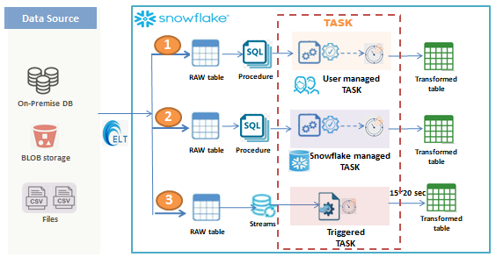
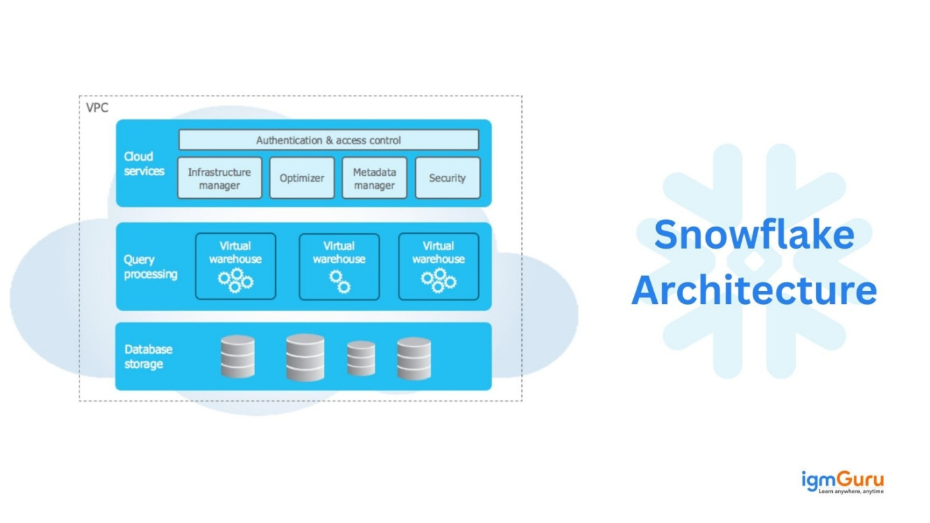
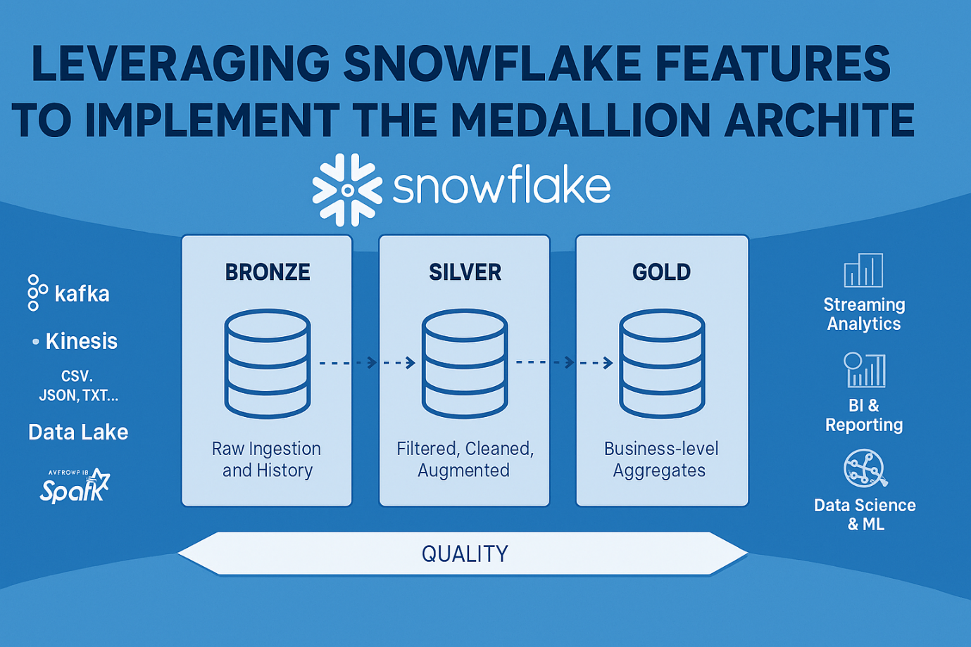
4

🎯 Final Outcome
After completing this lab, you will know:
✅ MySQL OLTP setup
✅ Batch export to Snowflake
✅ Stage & COPY INTO
✅ Stream & Task automation
✅ Fraud detection logic
✅ Performance tuning
✅ Role-based security

