**Program to generate a Student’s Report Card**

**Expected Output**

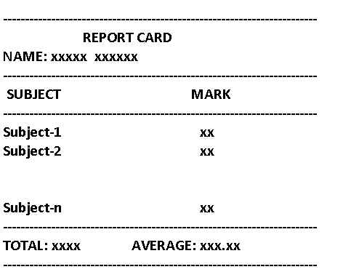

**Sample Input 1**

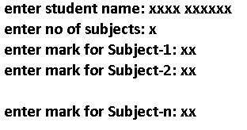

**Notes:**

**Average should be with two fractional parts**

**Student’s Name should have only alphabets and spaces**