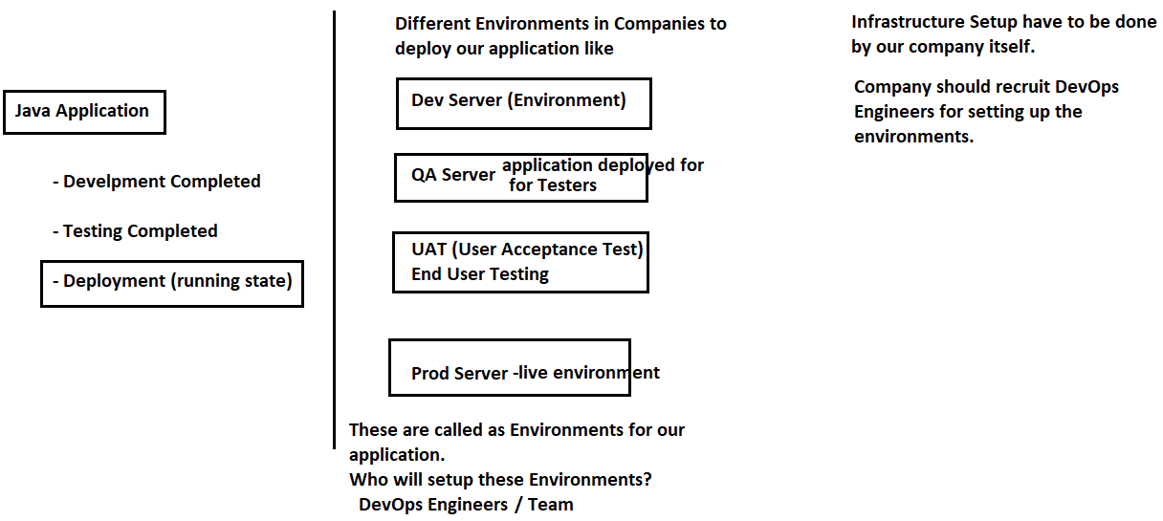

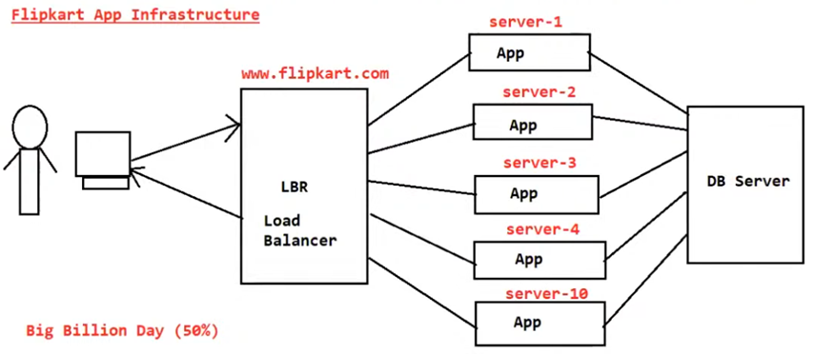
Per minute – 1 Crore Request (expectation) – (reality 3cr requests)
(20 Servers are Sufficient)

To do the above Environment Setups , we need the following:

1) We need Machines 2) We need OS 3) We need Servers 4) We need Installation
5) Server Setup 6) Deployment Process 7) Monitoring 8) Managing
9) Admin People etc

To do all the above operations, Administrators are required

In Production, we need to deploy the application in a Server, for example Websphere. We do not know how many clients will be accessing our application, if the request increases, we should place one more production server and it may keep on increasing. Manual Installation is required in all Production Servers

These operations are not that easy, we need someone to do the environment setups.

Whenever we go for application deployment: What are the items required?
- Machines Required
- Operating Systems Required
- Software Required
- Database Required
- Tools like Git, JIRA etc Required

If we have all these, then only we can go for application development and deployment. Whatever applications we develop may run for lifelong or for some years or may be for 1 year; just an experimental

To arrange above things , crores of rupees required and maintenance is a problem; we need employees to manage it.
Instead of purchasing , go for Pay For Use concept.
Do Pay For Use – If somebody already having the above setup, let us take their infrastructure for 1 year

All Cloud Environments are following Pay for Use Concept

Cloud Computing: (google) : Cloud computing is the on-demand availability of computer system resources, especially data storage (cloud storage) and computing power, without direct active management by the user.
Cloud computing was popularized with Amazon.com releasing its Elastic Compute Cloud product in 2006
- Cloud Computing Provides computer resources on-demand basis

Cloud Providers In Market
- AWS (Amazon Web Services 34% market share) 2) GCP (Google Cloud Platform)
- Microsoft Azure 4) PCF (Pivotal Cloud Foundry)
5) vmware 6) Alibaba Cloud(china based) ,
7) Salesforce etc

All Cloud Providers are working on Pay For Use Principal Only. They will manage the infrastructure. Cloud Platform is nothing but we are running our application in their environment. We are using someone else’s systems to run our application.

- Cloud Computing provides Computer Resources on-demand basis
- Cloud Platform provides runtime environment for our applications.

Uses : We don’t want to setup the infrastructure, we don’t want to manage the servers, we don’t want to manage the databases ; just I want to run my applications.

AWS -> big and leading player in the cloud market; many services are available, world-wide data centers are available, and got more stability. many companies from startups to large enterprises prefer AWS.

GCP -> Data, AI, Machine Learning, Data Engineering area - GCP is the top performer

Azure -> Microsoft Cloud Platform; Windows, Office 365, Active Directory like Microsoft products using companies prefer Azure - perfect choice - for Enterprise Integration Azure is the strong player

- AWS is the market leader in cloud computing
- Azure is the enterprise friendly platform for Microsoft Products
- GCP for AI, data, Machine learning operations

Java Web Services is a Technology which is used to develop a distributed application and Amazon Web Services are used to run our application

In Cloud 3 type of Services are available (Service Models):

1) IaaS (Infrastructure as a Service) (DigitalOcean, Linode, Rackspace, Amazon Web Services (AWS), Cisco Metapod, Microsoft Azure, Google Compute Engine (GCE) ----> You take servers, database, LBR for rent. You setup infrastructure how you want for your application. Ex: AWS

2) PaaS (Platform as a Service) (AWS, AWS Elastic Beanstalk, Windows Azure, Heroku, Force.com, Google App Engine, Apache Stratos, OpenShift) - provides the runtime environment required to run our application ---> You just give application source code to cloud provider. Cloud Provider will prepare infrastructure for your application Ex: Azure

3) SaaS (Software as a Service) (Google Workspace/ Drive, Dropbox, Salesforce, Cisco WebEx, Concur, GoToMeeting)
---> Just use the application which is already developed Ex: Salesforce, Zoom, Google Drive, Dropbox etc

When we go to a Cloud Provider, they will ask us - What service you want? Do you want IaaS, SaaS, PaaS?

AWS is well known in market for IaaS
Now a days AWS is providing PaaS also with EBS – Elastc Beanstalk

Google “Iaas in Cloud Computing”
“SaaS in Cloud Computing” - (Google Drive, DropBox etc)
“PaaS in Cloud Computing” - complete runtime environment will be provided with systems, os, server, db , tools etc
IaaS Vs SaaS Vs PaaS (google it)

What is Cloud Computing Definition by AWS:
Cloud computing is the on-demand delivery of IT resources over the Internet with pay-as-you-go pricing. Instead of buying, owning, and maintaining physical data centers and servers, you can access technology services, such as computing power, storage, and databases, on an as-needed basis from a cloud provider like Amazon Web Services (AWS). https://aws.amazon.com/what-is-cloud-computing/
https://www.javatpoint.com/cloud-service-models

Different Types of Cloud Computing Deployment Models
Most cloud hubs have tens of thousands of servers and storage devices to enable fast loading. It is often possible to choose a geographic area to put the data "closer" to users. Thus, deployment models of cloud computing are categorized based on their location. To know which deployment model would best fit the requirements of your organization, we should know about the types of cloud deployment models

1) Private Cloud
2) Public Cloud
3) Community Cloud
4) Hybrid Cloud

AWS
- AWS stands for Amazon Web Services.
- The AWS service is provided by the Amazon that uses distributed IT infrastructure to provide different IT resources available on demand. It provides different services such as Infrastructure as a service (IaaS), platform as a service (PaaS) and packaged software as a service (SaaS).
- Amazon launched AWS, a cloud computing platform to allow the different organizations to take advantage of reliable IT infrastructure.

Uses of AWS
- A small manufacturing organization uses their expertise to expand their business by leaving their IT management to the AWS.
- A large enterprise spread across the globe can utilize the AWS to deliver the training to the distributed workforce.
- An architecture consulting company can use AWS to get the high-compute rendering of construction prototype.
- A media company can use the AWS to provide different types of content such as ebox or audio files to the worldwide files.

Pay-As-You-Go
Based on the concept of Pay-As-You-Go, AWS provides the services to the customers.
AWS provides services to customers when required without any prior commitment or upfront investment. Pay-As-You-Go enables the customers to procure services from AWS.
- Computing
- Programming models
- Database storage
- Networking

AWS Global Infrastructure
https://aws.amazon.com/about-aws/global-infrastructure/
- AWS is a cloud computing platform which is globally available.
- Global infrastructure is a region around the world in which AWS is based. Global infrastructure is a bunch of high-level IT services:
- AWS is available in 39 geographics regions, and 123 availability zones in 2026.
The following are the components that make up the AWS infrastructure:
- Availability Zones
- Region
- Edge locations
- Regional Edge Caches

Main Components of AWS Global Infrastructures

AWS Global Infrastructure is basically the foundation that powers all the AWS services world-wide. It is designed to deliver high availability, Low Latency, Fault Tolerance & High Availability.

The AWS Cloud spans 123 Availability Zones within 39 Geographic Regions, with announced plans for 7 more Availability Zones and 2 more AWS Regions in the Kingdom of Saudi Arabia, and Chile.

1. Region - Geographical or Physical Location or Area. Each region is completely independent and isolated from other
Ex: US-East-One is one of the regions in North America
We can consider - any major city as a region in which we can have 2 or more Availability Zones

2. Availability Zone - It is basically one Data Center or combination of multiple Data Centers within a region and each one is having its own power, cooling and networking. Our actual work out runs here - whatever resources you launch like EC2, S3, etc which actually stores under availability zones - and for better fault tolerance, high availability every region contains multiple availability zones. Our applications will be deployed in multiple Availability Zones

3. Edge Locations - it is also called as PoP (Point of Presence Location) - with this AWS delivers data with low latency. The purpose of Point of Presence locations is to cache data near to end customer geographical location- this will be like small data centers

Data Center - is a physical facility that houses Networked Computers, storage systems and Infrastructure to securely store, process and manage large volumes of data for organizations.

AWS offers both IaaS & PaaS.
IaaS allows organizations to utilize AWS instead of owning and operating your own datacenter. You can simply rent VMs or physical servers from AWS.
The Platform as a Service (PaaS) on the other hand removes the need for your organization to manage the underlying platforms like a database, streaming services, etc.
This allows you to focus on the deployment and management of your core applications and not worry about the IaaS and PaaS layers

AWS is a cloud infrastructure where we can host our applications
In 2006, AWS started to offer IT services to the market in the form of web services; which is nowadays known as cloud computing
Cloud computing means it is just a term referred to storing and accessing data over the Internet; so it does not store any data in our physical hard disk. I cloud computing , we can directly access the data from a remote server.

Why AWS?
Assume, we need to do a hosting my web application
- To host an application - first we need to purchase a server ; if any database integration, then we need to purchase a database and based on the language specification , we need to install that (like JDK) - that means we need to setup a complete infrastructure to host my application.
If huge requests is coming to our application then we need to scale it

AWS will offer you to create one Virtual Machine, inside that VM - we can add a server, a database etc, a complete IT infrastructure can be setup

This Virtual Machine instance is known as EC2 (Elastic Compute Cloud)

EC2

AWS offers plenty of services under different domains like – Compute, Storage, Database, Migration, Networking and Content Delivery, Developer Tools, Management Tools, Media Services, Security, Analytics, Machine Learning, Mobile Services, AR and VR, Application Integration, Customer Engagement, Business Productivity, Desktop and App Streaming, Internet of Things, Game Development etc

EC2 is one of the most popular of AWS Offering.

EC2 stands for Amazon Elastic Compute Cloud.

EC2 mainly consists in the capability of :
- Renting Virtual Machines in the Cloud (EC2)
- Storing Data on Virtual Drives (EBS – Elastic Block Store - acting as virtual hard drives for databases, file systems, and applications)
- Distributing load across machines (ELB – Elastic Load Balancing)
- Scaling the services using an auto-scaling group (ASG)

Knowing EC2 is fundamental to understand how the Cloud works.

Amazon EC2 is a web service that provides secure and resizable compute capacity in the cloud for developers. It is very easy to scale up or down our infrastructure based on the demand . EC2 can be integrated into several other services. We only pay for what we use.

Eg: A Business Man wants to advertise his products then he can use the AWS Services like SNS (Simple Notification Service) , EC2 for compute and S3 (Simple Storage Service) for storage
Amazon EC2 provides instances to optimize for Compute, memory, storage, GPU (Graphic Processing Unit) processing to enable you to define the right performance combination for whatever workloads you want to run. It is also easy to resize your instances based on business or application requirements. Amazon EC2 offers a choice of flexible pricing options, with On-Demand Pricing you pay only for what you use. When you stop usage then stop payments, No long terms commitments.

What is EBS?
EBS stands for Elastic Block Store.
EC2 is a virtual server in a cloud while EBS is a virtual disk in a cloud.
Amazon EBS allows you to create storage volumes and attach them to the EC2 instances.
Once the storage volume is created, you can create a file system on the top of these volumes, and then you can run a database, store the files, applications or you can even use them as a block device in some other way.
Amazon EBS volumes are placed in a specific availability zone, and they are automatically replicated to protect you from the failure of a single component.
EBS volume does not exist on one disk, it spreads across the Availability Zone. EBS volume is a disk which is attached to an EC2 instance.
EBS volume attached to the EC2 instance where windows or Linux is installed known as Root device of volume.

PRACTICALS

-> Create an Account in AWS
aws.amazon.com > create an AWS Account > Personal > Free (Personal & Basic Plan & Free | No charge in the Free Tier)
Provide Credit Card/ UPI Details

-> Login to AWS Console [My Account > AWS Management Console]
Now , we logged into AWS Console

-> Type of Users

(a) Root User – Console Access & Programmatic Access, got complete access to everything in the AWS Account ; recommended not to use Root User for daily activities

(b) IAM User - (Identity and Access Management) - Manage Access to AWS resources

PRACTICALS :: How to create an EC2 Instance in AWS?

EC2 stands for Elastic Compute Cloud - - just a Virtual Machine – Virtual Servers in the Cloud

EC2 is an on-demand computing service on the AWS cloud platform.

Amazon Elastic Compute Cloud (Amazon EC2) is a web service that provides secure, resizable compute capacity in the cloud - a virtual environment.

Allows the user to configure their instances as per their requirements i.e. allocate the RAM, ROM, and storage according to the need of the current task.

Step1: Launching EC2 instance
-> Login to AWS Console
-> Change the Region to Virginia (latest updates will come first) - or any region of choice (Mumbai – ap-south-1)
-> All Services > Compute > EC2
-> Dashboard > click on "Launch Instance"

Name and Tags:: Name: cap-ec2

Application and OS Images (Amazon Machine Image) : Ubuntu - Ubuntu Server 24.04 LTS (HVM), SSD Volume Type
Select "Free tier Eligible" HVM – Hardware Virtual Machine
Architecture: 64-bit (x86) SSD – Solid State Drive
Instance type: - -- depends on the no of CPUs required and Memory required t3.micro

Key pair (login): to securely connect to instance. The key value pair plays a major role while connecting to the EC2-Instance it will act as an SSH-Key to connect to the instance. SSH – Secure Shell

> Create new key pair
Key pair name: cap-dev

Key pair type: RSA
Private key file format : .pem (Privacy Enhanced Mail) PPK(Putty Private Key) SSH Client
> Create key pair - cap-dev.pem file gets downloaded

Network settings:: Create security group - Allow SSH traffic from Anywhere
- Allow HTTP traffic from the Internet

Configure storage: 1 x 8 (8GB of EBS Elastic Block Store General purpose (SSD- Solid State Drive)) gp3 - volume type IOPS - I/O operations per second

Number of instances: 1

> Launch Instance

How to Add a User Data Script?

User data scripts are used to automate the initial configuration of an EC2 instance when it is first launched.
They can be specified using the AWS Management Console, AWS CLI, or Infrastructure as Code tools like Terraform.

You can add a user data script via the AWS Console when launching an instance:

- Log in to the AWS Management Console and navigate to the EC2 Dashboard.
- Click the "Launch instance" button.
- Fill in the basic instance details (Name, AMI, Instance type, Key pair, Network settings).
- Scroll down to the Advanced details section and expand it.
- Find the "User data field" and paste your script into the text box. The AWS Console handles the required base64 encoding automatically.
- Complete the remaining configurations and launch the instance.

Example Linux Bash Script:
The script below installs and starts an Apache web server on an Amazon Linux instance. User data scripts run as the root user by default.
bash

#!/bin/bash
# Update all installed packages
sudo yum update -y
# Install Apache web server
sudo yum install -y httpd
# Start Apache service
sudo systemctl start httpd
# Enable Apache to start on boot
sudo systemctl enable httpd
# Write a simple HTML file to the web server root
echo "<h1>Hello from my EC2 instance!</h1>" > /var/www/html/index.html

Accessing User Data from within the instance: You can retrieve the user data from within the instance using the instance metadata service URL: curl http://169.254.169.254/latest/user-data

To connect to AWS EC2 Instance from our Computer

=== Approach-1 ====

Select EC2 Instance > Connect > SSH Client (Tab) >

Copy Example: ssh -i "cap-dev.pem" ubuntu@ec2-3-94-9-195.compute-1.amazonaws.com

and apply in terminal from the directory where the key-pair is downloaded

cmd> ssh -i "cap-dev.pem" ubuntu@ec2-3-94-9-195.compute-1.amazonaws.com

-i identity_file A file from which the identity key (private key) for public key authentication is read.
"ubuntu"– user name

$ pwd
$ whoami
$ date
$ date +%T
$ date +%H:%M:%S
$ ls
$sudo -i - to move to root directory/ switch to root directory

To check all the open ports in Instance
$netstat -antp - command generates displays that show network status and protocol statistics. You can display the status of TCP and UDP endpoints in table format, routing table information, and interface information.

$sudo apt install net-tools

$netstat -antp - command generates displays that show network status and protocol statistics. You can display the status of TCP and UDP endpoints in table format, routing table information, and interface information.

Update Packages
APT - Advanced Package Tool (in Ubuntu)
APT is a package management system

$ apt-get -h -h – help $apt -h
$ apt-get update - permission denied $apt update
$ sudo apt-get update sudo -> substitute user do $sudo apt update

Install Java (JDK) on EC2 instance
$ sudo apt install openjdk-17-jdk-headless $ sudo apt install openjdk-17-jdk
$ sudo javac -version $ clear
$ java -version

Install Apache Server
$ sudo apt install apache2
$ netstat -antp 80 port is working
$ whereis apache2
$ which apache2 ---> verify apache

apt is the modern, user-friendly tool intended for interactive use at the command line, while apt-get is a legacy, low-level interface that is primarily maintained for backward compatibility and scripting

Browser – http:// <<Public IPv4 address>> from AWS Console - if not opens – Security Groups – Inbound rules – Add Rule for HTTP 80
- http://<<Public DNS>>

$sudo service apache2 stop $ sudo systemctl stop apache2
$netstat -antp
$sudo service apache2 start
$netstat -antp

$exit

=== Approach-2 ====

-> Download PuTTY from https://www.putty.org/
PuTTY is an SSH and telnet client, for the Windows platform. PuTTY is open source software -> Install it

PuTTY and PuTTY Gen Tools will gets installed

-> The previously created Key Pair will act as a security bridge between our computer and EC2 Instance

-> Open PuTTY Key Generator > Load > open .pem file (PuTTYgen)
Save Private Key - .ppk file gets created

In AWS Console -> EC2 Dashboard > Instances (running) > Click on "Connect" -> SSH Client (tab)
Select the User Name and Host Name : ubuntu@ec2-65-2-188-213.ap-south-1.compute.amazonaws.com

-> Open PuTTY
Host Name: ec2-65-2-188-213.ap-south-1.compute.amazonaws.com (get it from EC2 Instance Connect - SSH Client)
Port : 22
Connection > Data :
Auto-login Username : ubuntu

SSH > Auth > Credentials > Browse --- select Key Pair file
>Open
Terminal Opens >>>>> (we are into Virtual Machine)

$ whoami
$pwd [present working directory]
$ sudo -i [to got to root directory]
$ pwd

$ sudo apt-get upgrade [Unix command to update/upgrade all packages] APT – Advanced Packaging Tool. It's a package manager that's used to install, update, and manage software packages on Linux systems, especially Debian and Ubuntu

Ubuntu Username is : ubuntu
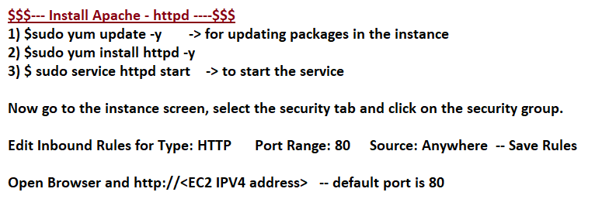

$ clear
$ pwd

$sudo apt-get update
apt-get is a package manager

--- install webserver - apache (httpd)

$ sudo yum -y install httpd

--- Start the service
$ sudo service httpd start

--- Create a mount point
First note that the DocumentRoot in the /etc/httpd/conf/httpd.conf file points to /var/www/html (DocumentRoot "/var/www/html").

$ sudo yum install httpd [tomcat 7 installation]
To Install open-jdk-8

$ sudo yum install java-1.8.0-openjdk $ apt install openjdk-17-jdk-headless

$ java -version

To Install open-jdk11

$ sudo yum install java-11-amazon-corretto

- Amazon Corretto is a no-cost, multiplatform, production-ready distribution of the Open Java Development Kit (OpenJDK).

$ sudo alternatives --config java

- Configures the default for the program "java". That's the Java VM

$ sudo alternatives --config java
- select the default java version $ sudo yum remove java-11-amazon-corretto

