**PROBLEM 3 (Q&A)**

**1.**   You have a file <<yourname>>.txt ;  This needs to be added to a existing git repository ; What is the process one would follow?  Provide a flow chart for the same

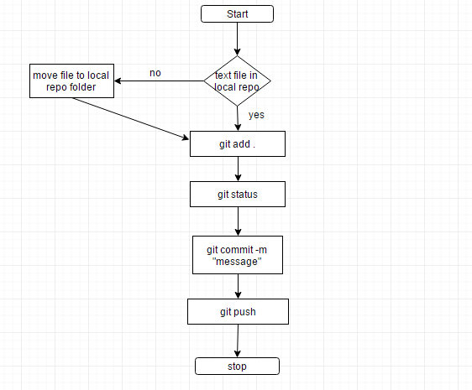

**2.**  You have been asked to design a parking system for a car park; The system must allow cars into the garage only when there is a open spot; Otherwise it should not allow .

- Extend the above design , we also want to indicate to a car where it should park in the garage ( ex Spot #)  when a ticket is issued

**Solution - Design Algorithm**

1. Let us assume the capacity of parking lot to be 20. Store the initial empty parking spaces in a data structure. Queue( p1,p2,p3……..p20).

2. Allot the waiting cars with parking space till the queue is empty i.e. till queue(empty). Parking ticket specifies the spot# as the element that pops out of the queue.

3. When a cars leaves the parking space, the ticket is checked and that spot is marked as free . The free parking spot# is pushed into the queue. For example first spot#p5 is left free then spot#p2.

Queue(p5,p2),

4. The next waiting car is assigned spot#p5 and so on…..