- Micro services
- API Gateways
- Service Discovery
- Security
- Tools
- Docker
- Kubernetes
- SOA vs Microservices
- Microservice Design Patterns
- OKTA / OpenID
- Sso
- Saml
- Opened connect
- Oauth

SAML -
- CA Certificate
- PRIVATE Key
- A certificate signing request (CSR) is one of the first steps towards getting your own SSL Certificate.

Micro-service Architecture-----------

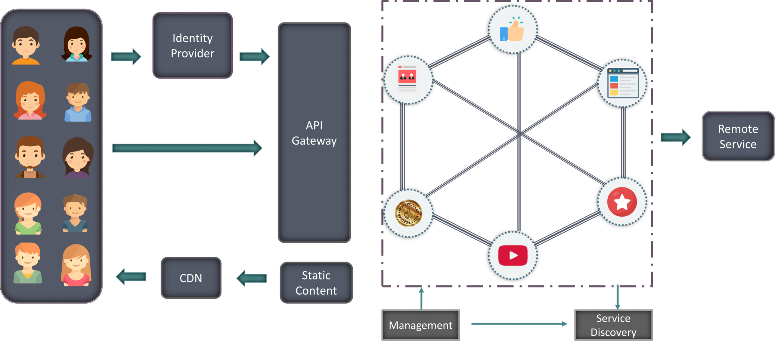

API Gateway (FAÇADE PATTERN) https://smartbear.com/learn/api-design/api-gateways-in-microservices/
Spring Cloud Gateway provides a library to build an API Gateway.
- Azure Application Gateway
https://docs.microsoft.com/en-us/dotnet/architecture/microservices/architect-microservice-container-applications/direct-client-to-microservice-communication-versus-the-api-gateway-pattern
- Netflix API Gateway.
- Netflix Zuul Gateway
- Amazon API Gateway

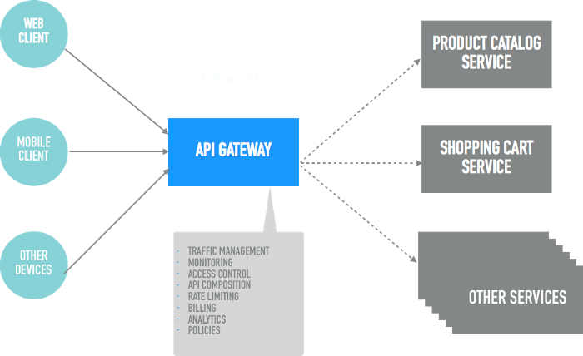

Service Discovery..
https://www.nginx.com/blog/service-discovery-in-a-microservices-architecture/
- NETFLIX Eureka
- Zookeeper
- consul

Spring Cloud:
Spring cloud gateway—

Problems :
TCP port exhaustion..
CMIS
MS database.. whoISActive, Whois2
OCR/ICR
SSO/SAML ,IDP
Micro-service

Practical way…….

1. Springboot SAML/OKTA example..
This example basically covers the SAML(A&A) concept using well known IDP okta/ping federate or Salesforce.

Exercise :

OKTA-SpringBoot………
Fortunately, there’s no need. Spring Security and Spring Boot have made implementing a web application using OAuth 2.0 nice and simple. And Okta, a software-as-service identity access provider, have built on top of Spring Boot to make the process even easier.

- Multi-factor Authentication

Microservice Uundestanding..

Architecture
Client Side Service Discovery
(Eureka server)
https://www.youtube.com/watch?v=GboiMJm6WlA&t=6s
Server side service discovery..
(AWS,NGINX)

My-Course ..
Design Pattern
SOLID
Low level design
Java-8 features
Lambda expression
Functional interface
Stream for-each and Filter method
Spring
Spring Boot
Micro-services-Started
Cloud-Started
SAML-2/OAUTH-2.0
Open-ID Connect
HTTP/HTTPS SSl
Arrayblocking Queue
Arraylists
Docker
Kubernetes
Zookeeper

Spring Boot: https://docs.spring.io/spring-boot/docs/current/reference/htmlsingle/#cli
https://docs.spring.io/spring-boot/docs/current/reference/html/

Spring boot key components..
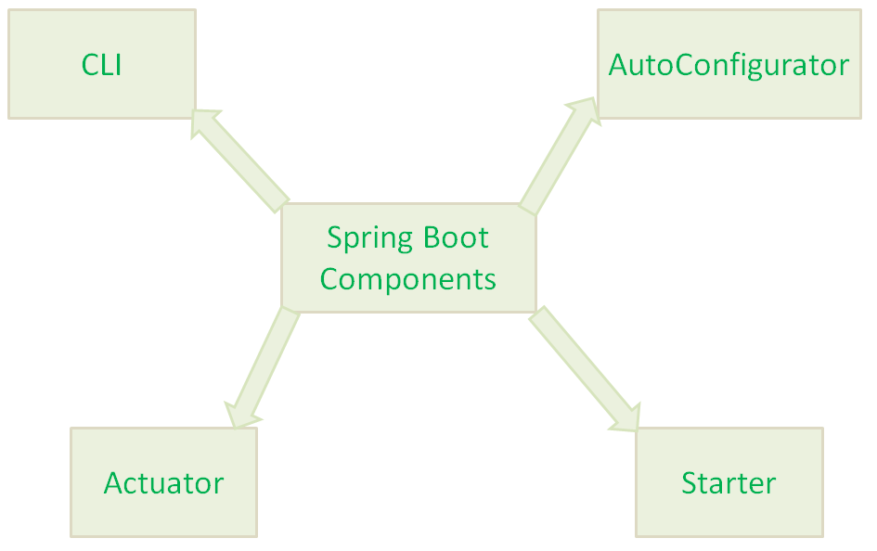
Spring boot starters
Actuators
Developer Tools (spring-boot-devtools) (Hot Swapping)
@SpringBootApplication
Profiles in spring boot
@PostConstruct
AOP

#-------
Spring Profiles—
- How we can set..
@ActiveProfiles(“raining”)

Or via property
Spring.profiles.active

