<https://en.wikipedia.org/wiki/Memory_cell_(computing)>

1. During any time if you need help on git ..

Just type on git bash

git help <verb>

git <verb> --help

ex.

git help config

git config --help

1. 2 common scenario..
   1. Existing local project you wanaa tracking using git
      1. Git init

Result : placed .git repository

Before any commit

Run

Git status

Run touch .gitignore , if we want to untrack any file

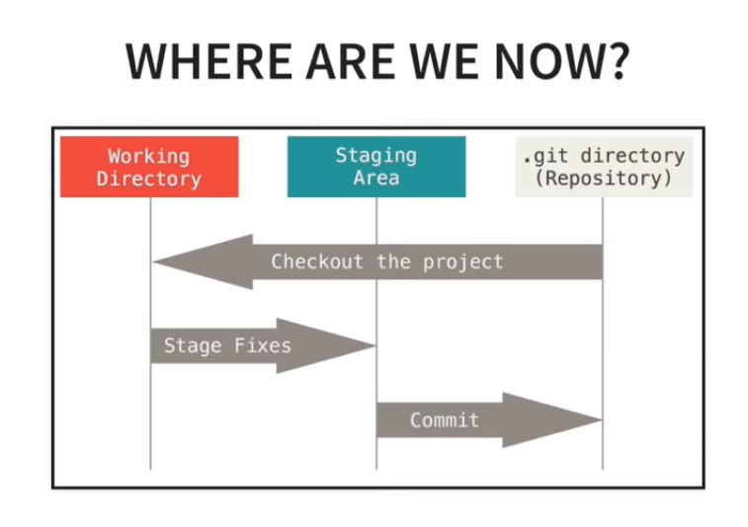

Add files to staging area

Git add –A

Git status

Remove files from Stagging area

Git reset <filename>

Git status

Commit

Git commit –m “messsage”

* 1. Remote repository

Clonnng a remote repo

Git clone <url>

Git clone

View information about the remote repository

Git remote –v

Git branch –a

PUSHING CHANGES :

Commit changes as we did previously

Then PUSH

* Git pull origin master
* Git push origin master

COMMON WORFLOW

(DAY TO DAY PRACTICE TO WORK IN GIT)

* Create a branch for desired feature
  + Git branch <branch-name>
  + Git checkout <branch-name>

(if you want to work over created branch)

* After commit PUSH branch to remote
  + Git push –u origin <branch-name>
  + Git branch –a
* MERGE A BRANCH
  + Git checkout master
  + Git pull origin master
  + Git branch –merged
  + Git merge <branch-name>
  + Git push origin master
* DELETING BRANCH
  + Git branch –merged
  + Git branch –d <branch-name>
  + Git branch –a
  + Git push origin --delete <branch-name>
* Install DIFFMERGE for better view among difference between files
  + <https://sourcegear.com/diffmerge/webhelp/sec__git__windows__github.html>
  + Verify by *git config –list*
  + Git difftool

**Know Commit History:**