1. Log On screen :

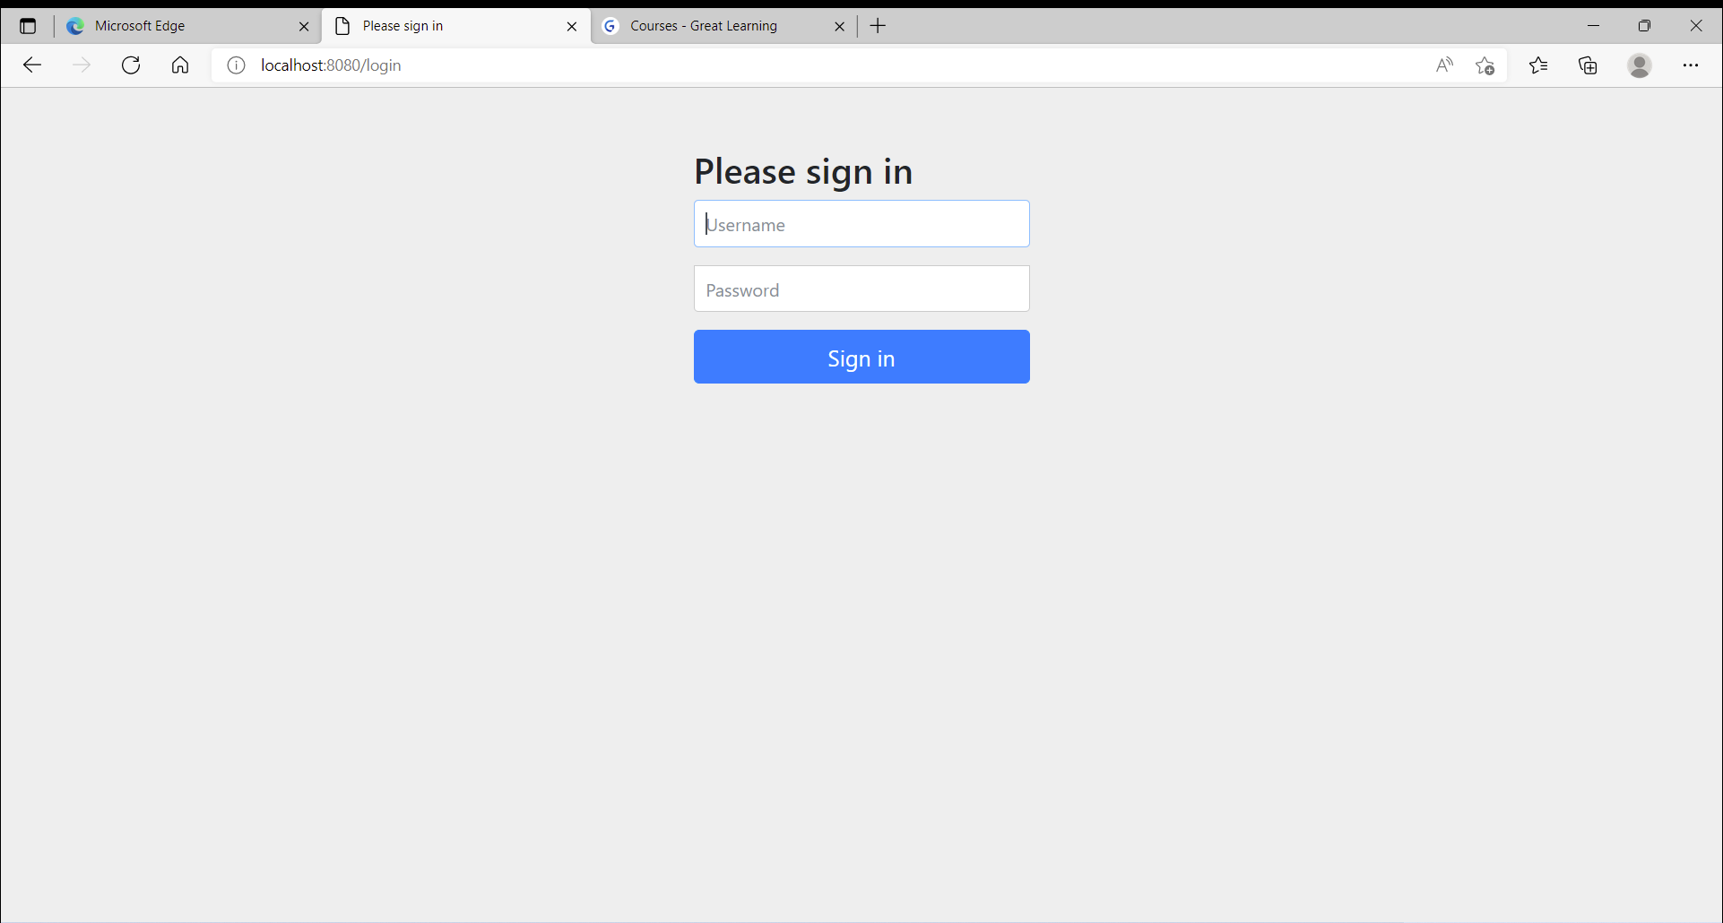

1. Home page opens post logon

As per project Only Rest APIs are provided and Swagger-UI is enabled to access Rest APIs

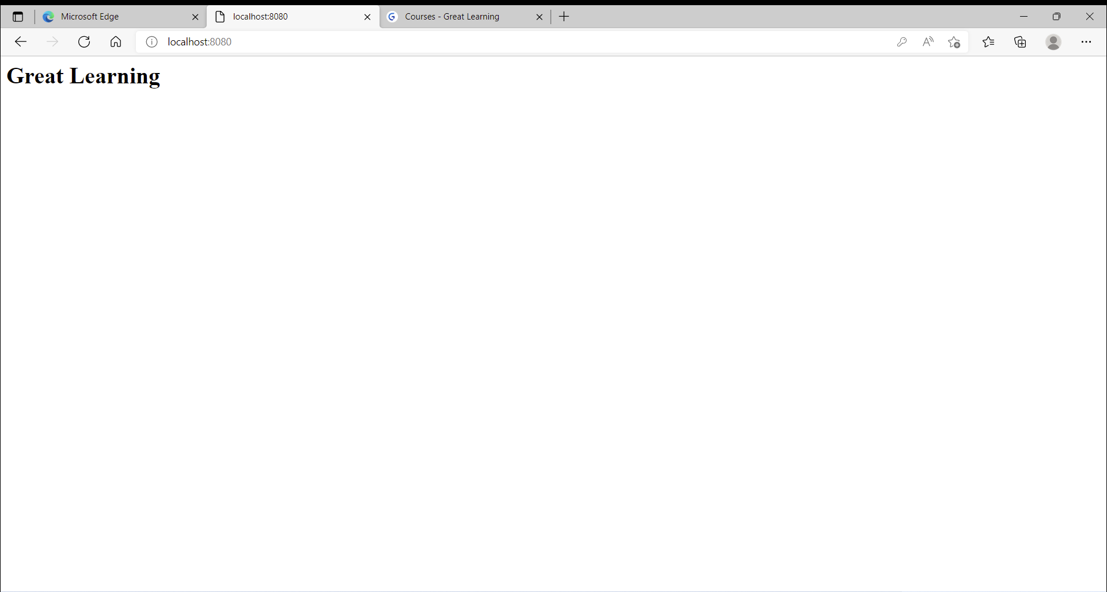

1. Localhost:8080/swagger-ui.html

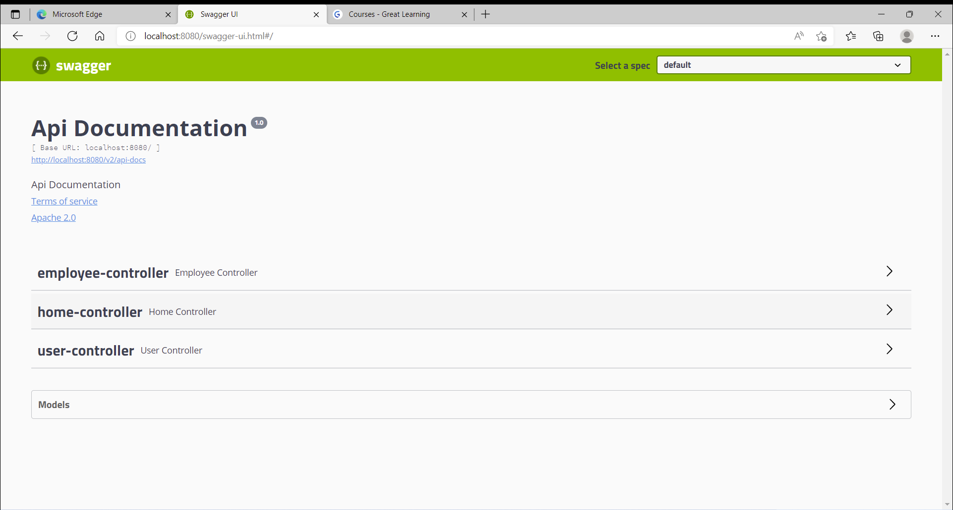

Employee-contoller - All employee Rest API are organized here

Home-controller – Home page

User-controller – User roles and role creation APIs are organized here

1. Add A Role

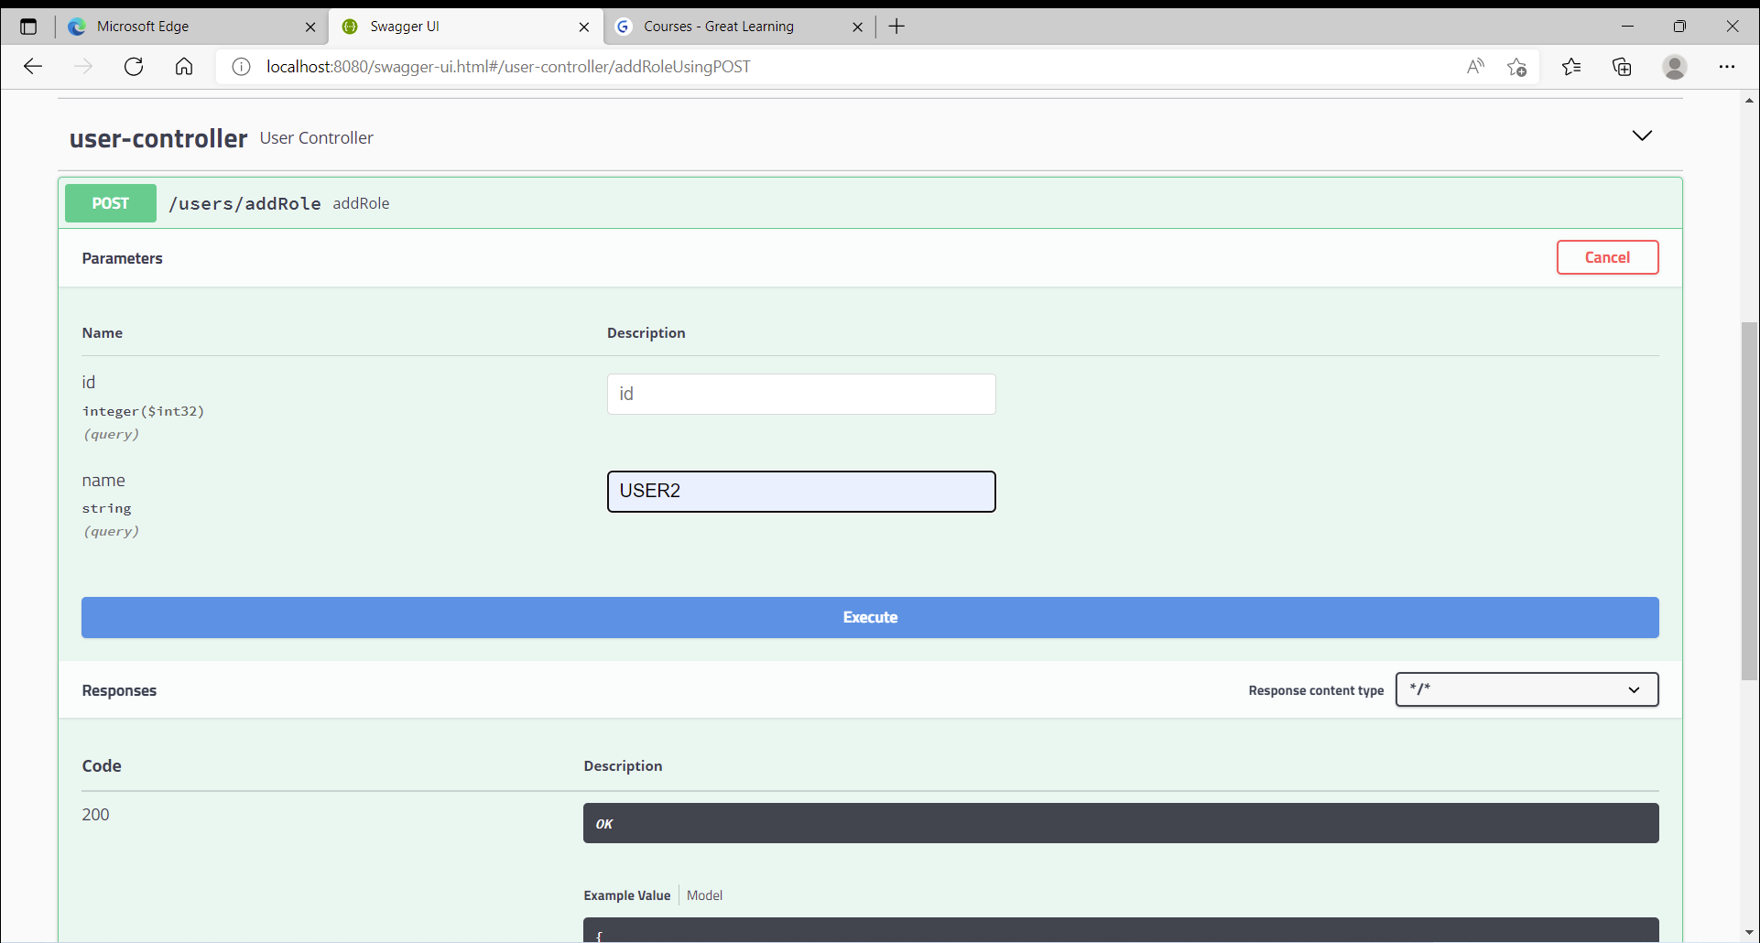

NOTE :

A ADMIN and USER roles are created as part of initial setup and authorizations are provided for them.

ADMIN roles has access to perform all operations

USER roles has access to perform only view operations.

Add Role Results

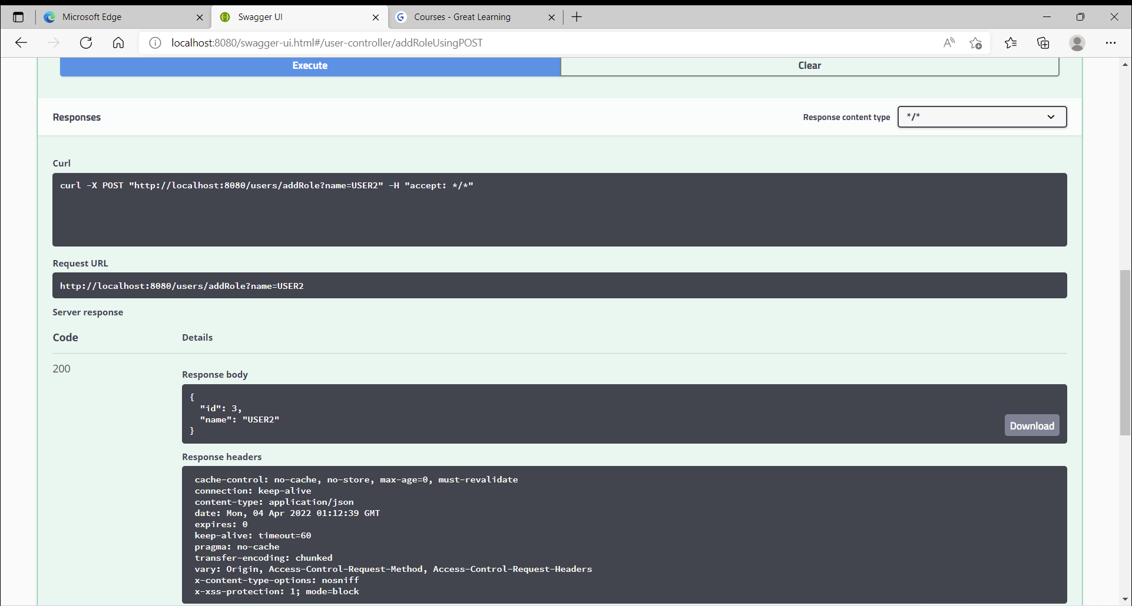

1. Add User

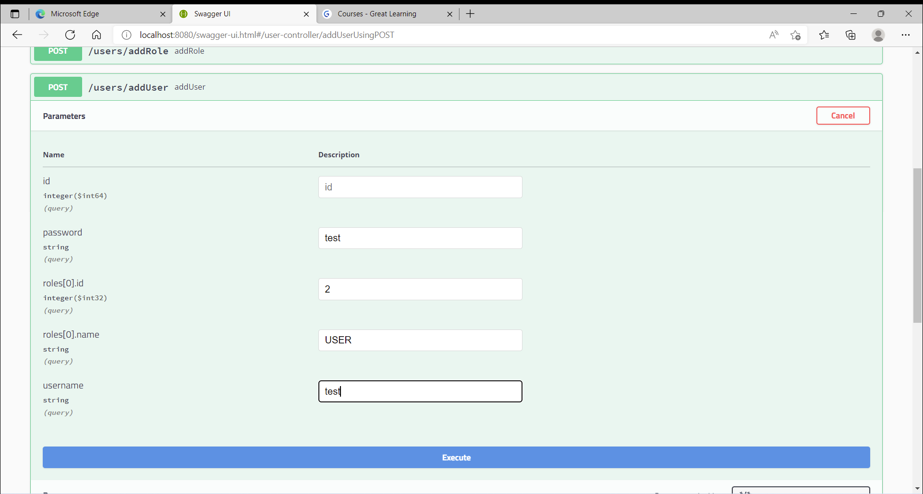

Password is encrypted and saved.

Currently role name is not mapped to existing ROLE. This just shows how to create Users

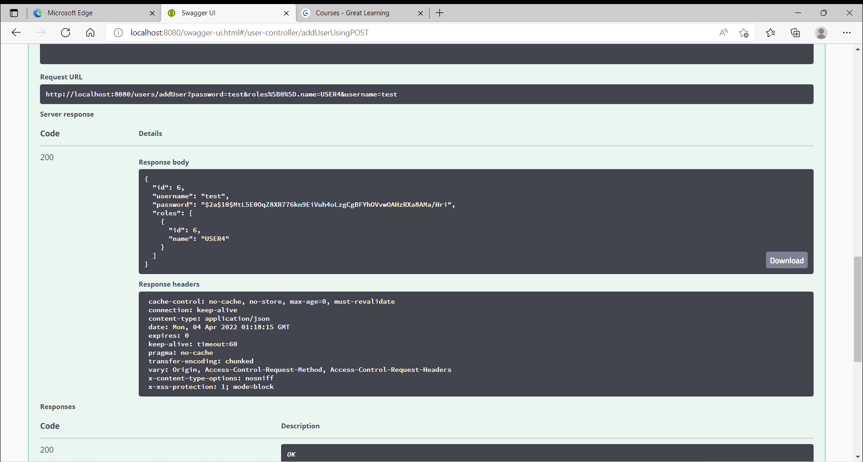

1. Add Employee

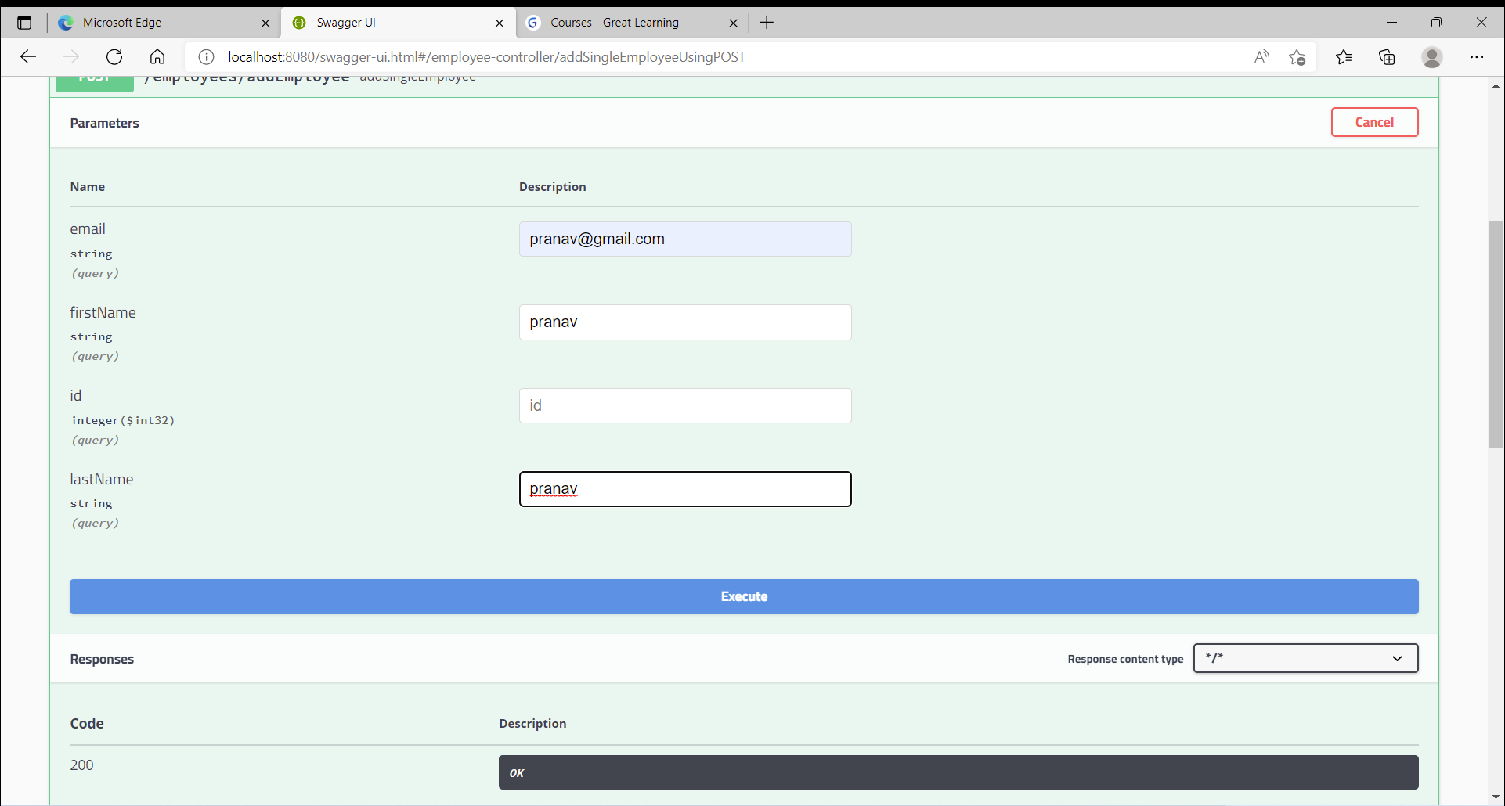

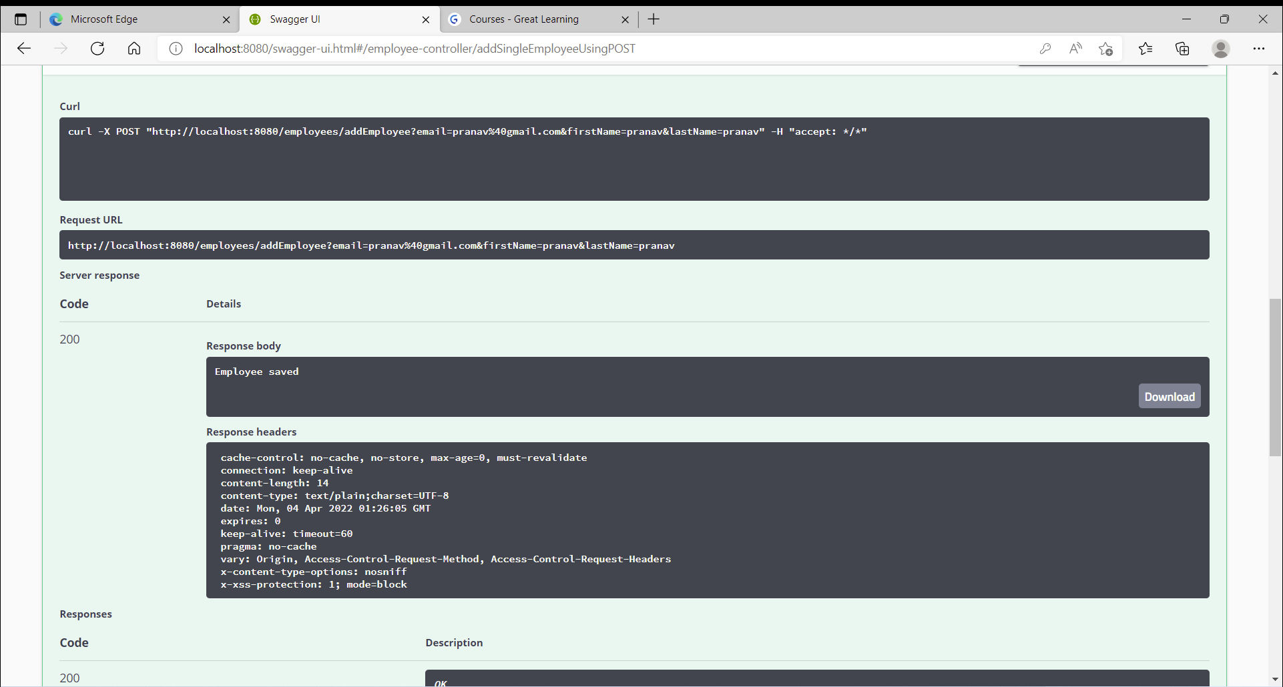

1. Delete Employee with ID 1

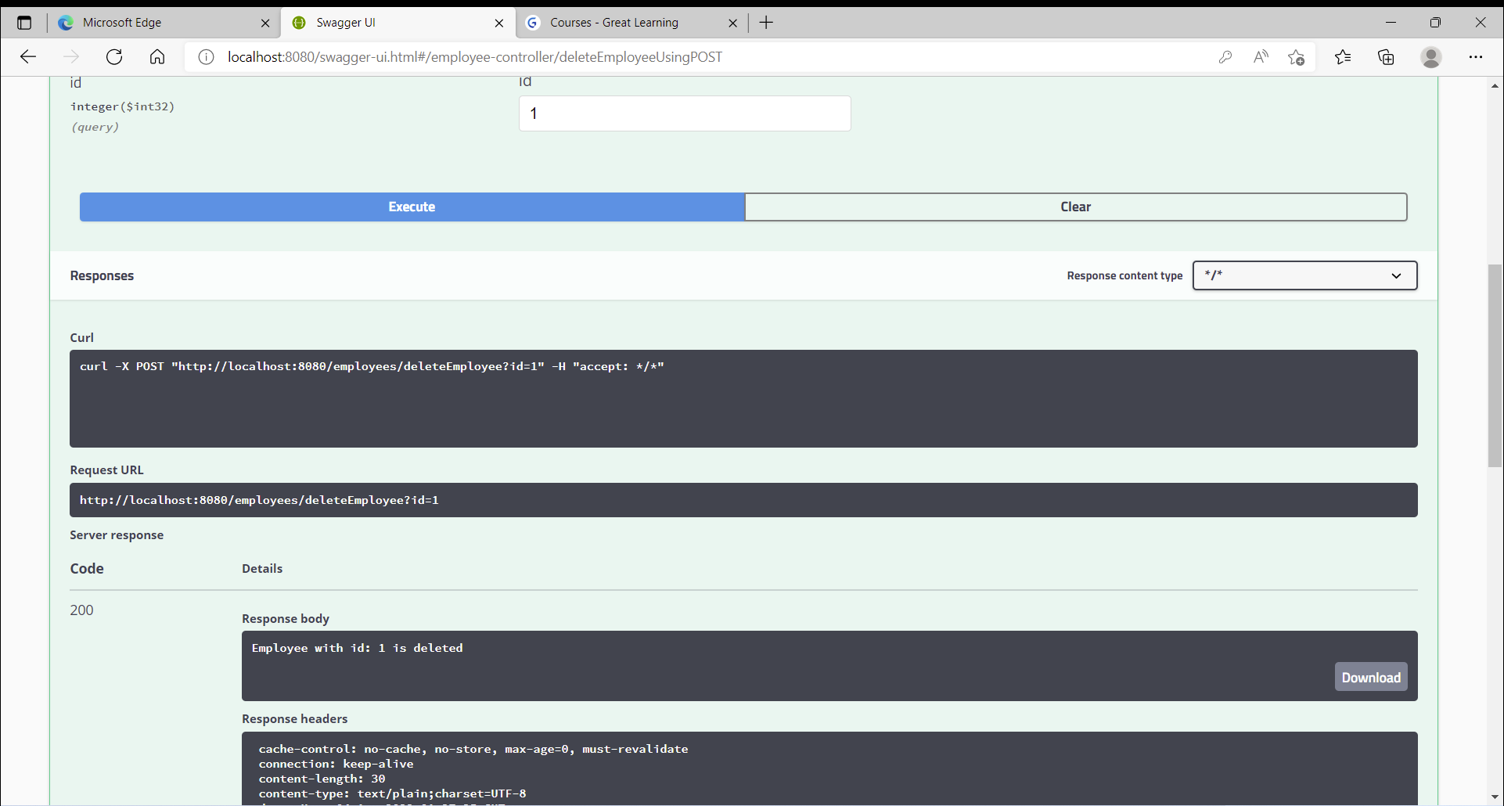

1. Get Employee with id 2

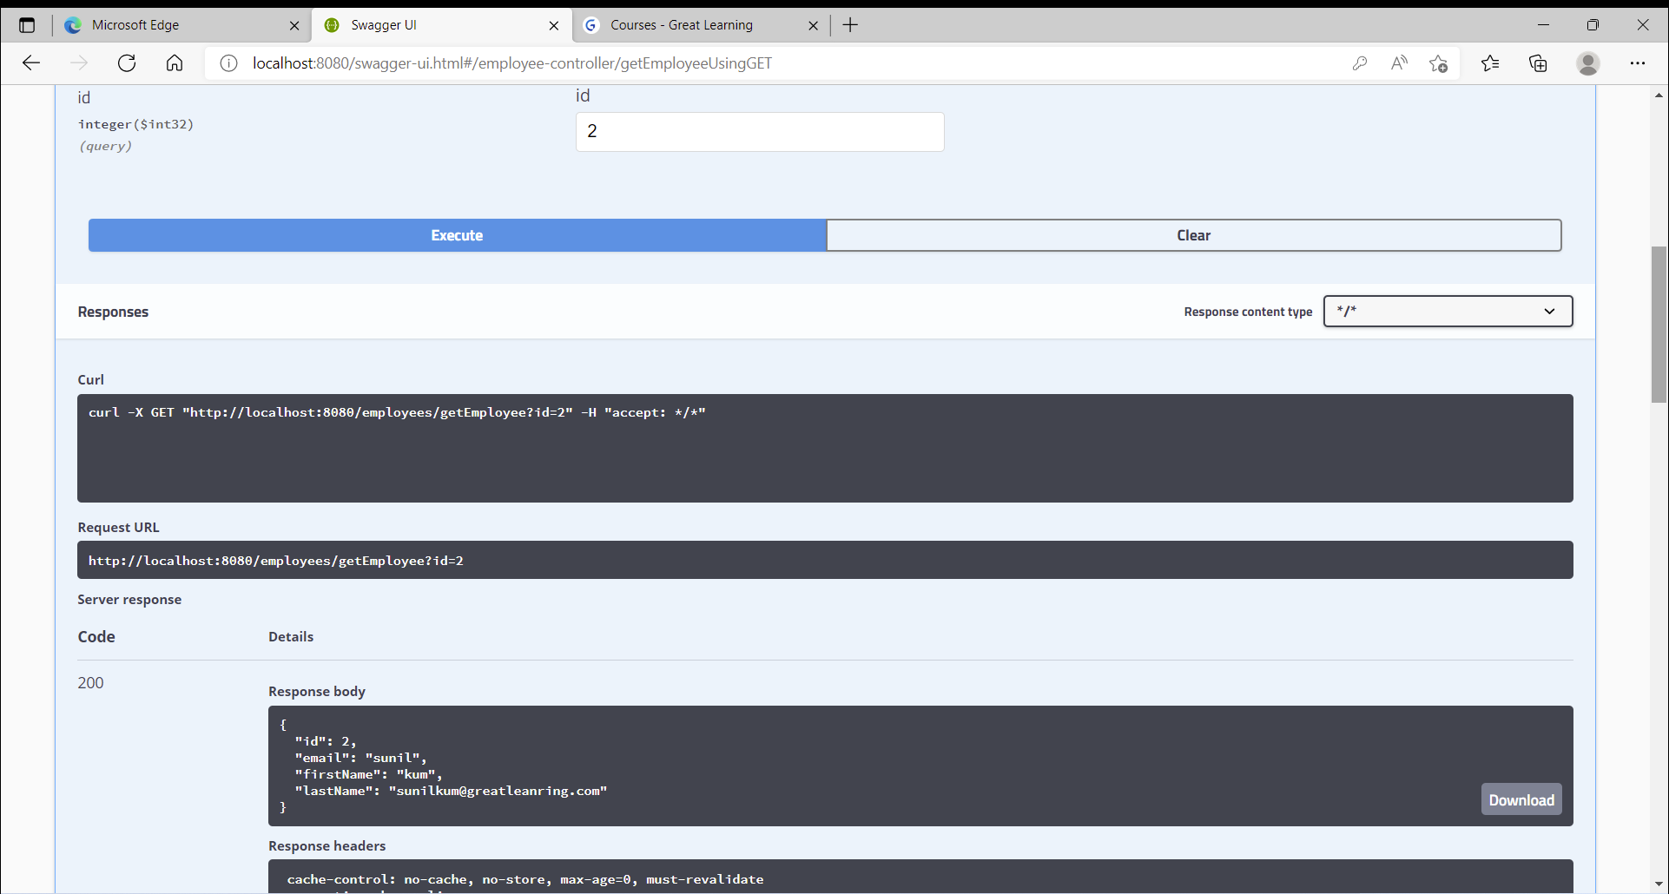

1. Update employee with ID 2

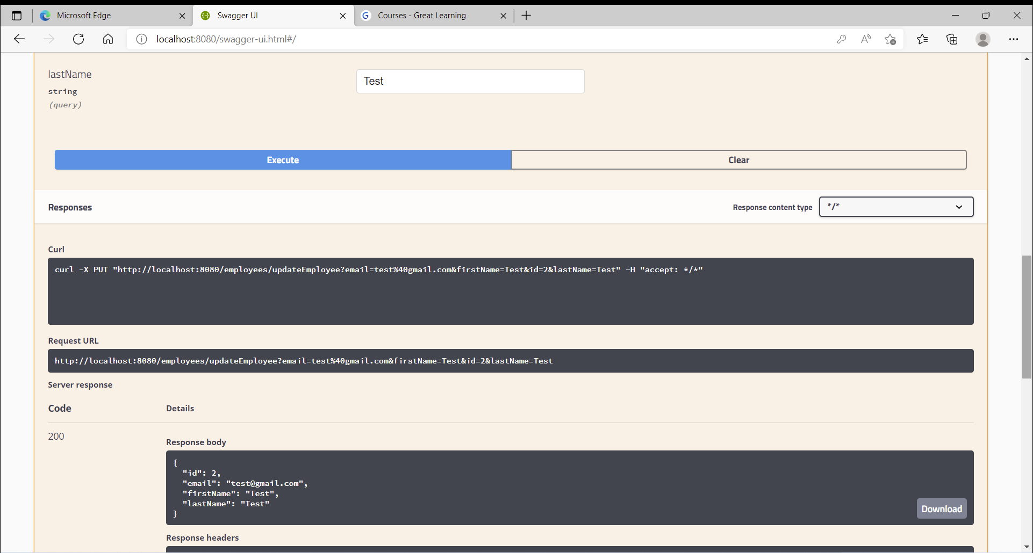

Post update Get Id 2 records

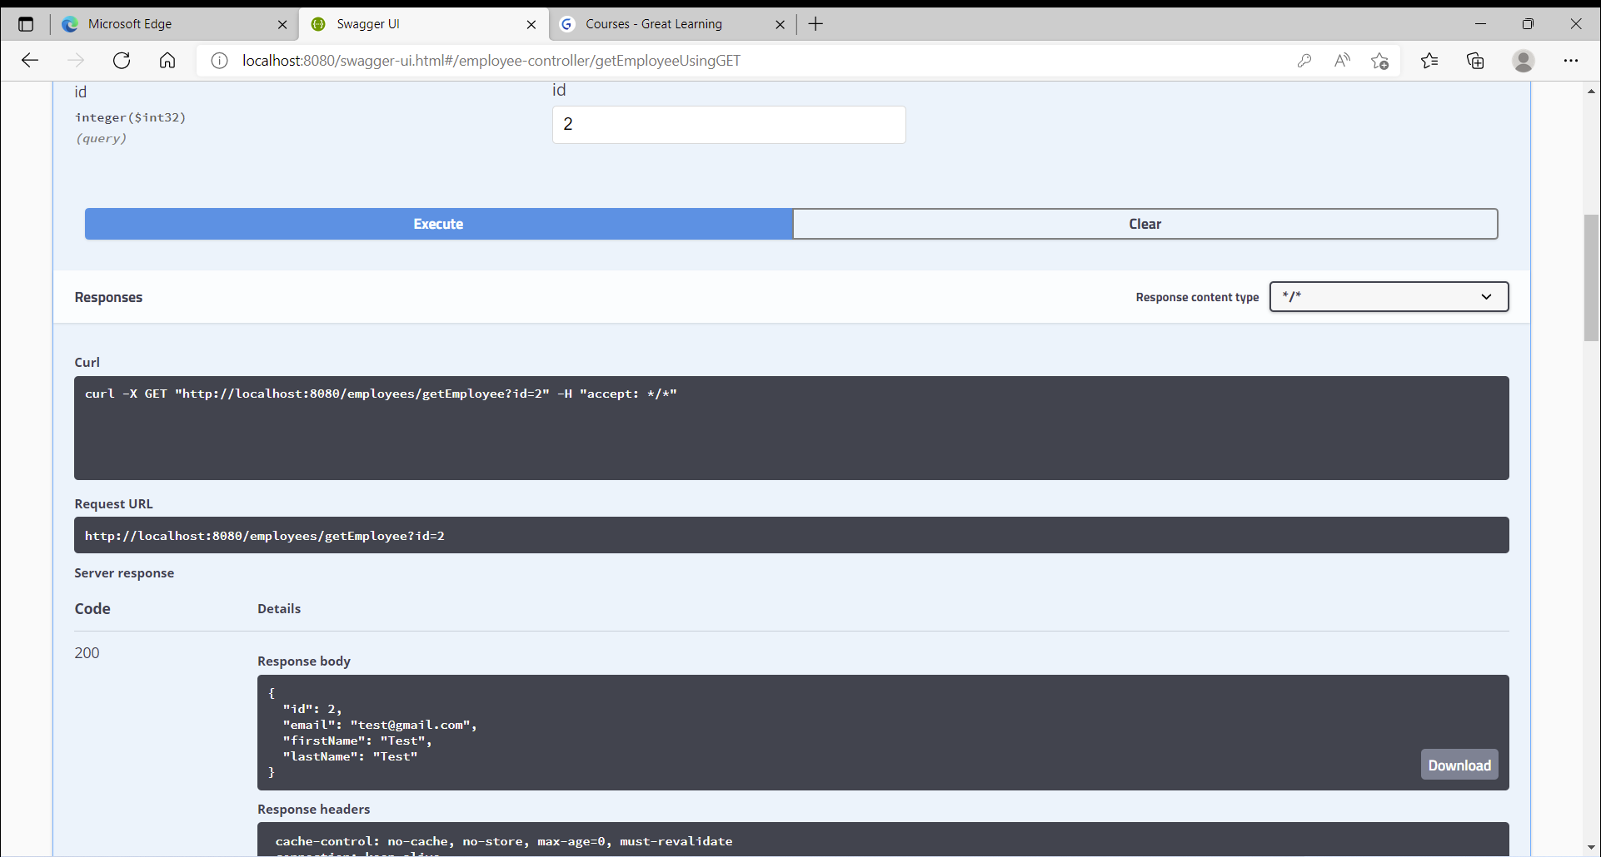

1. List All employees

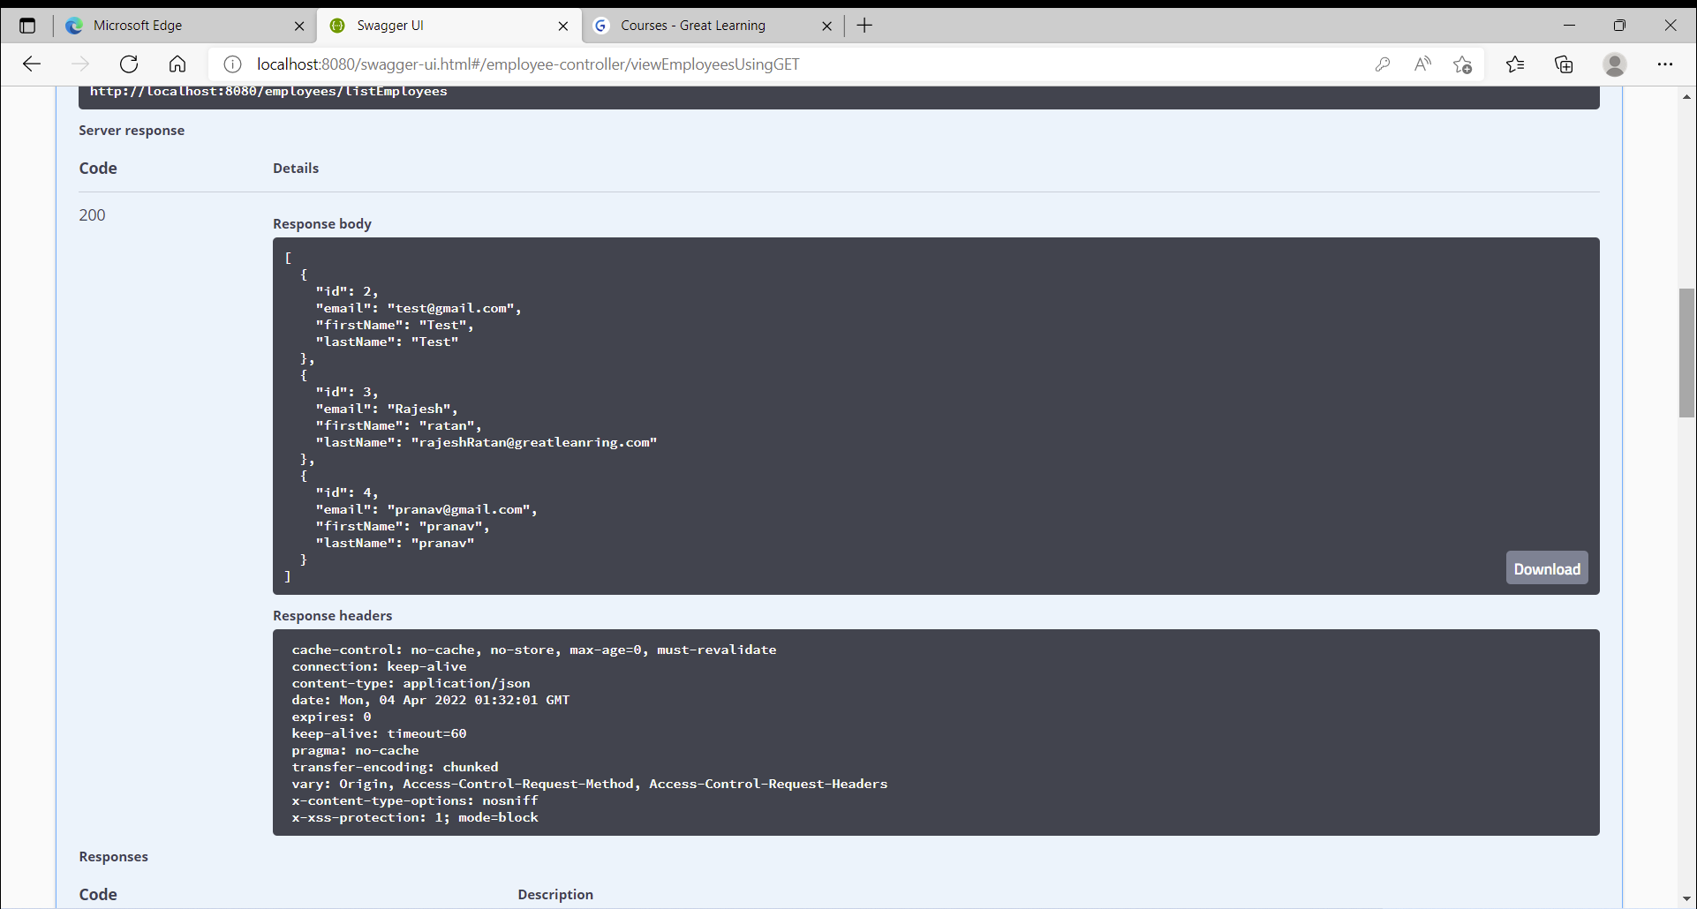

1. Search by first name

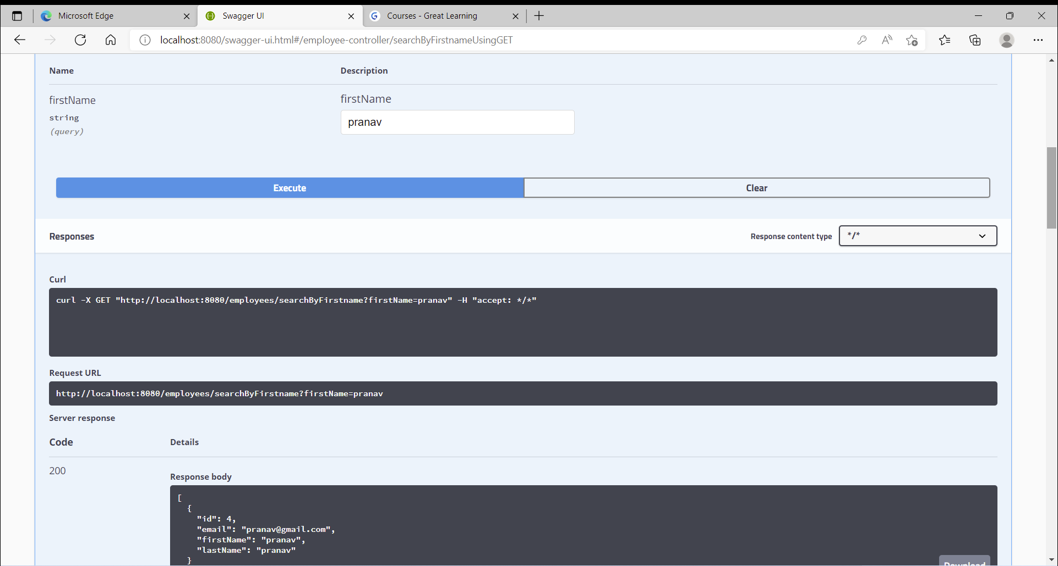

1. Sort by first Name (ASC)

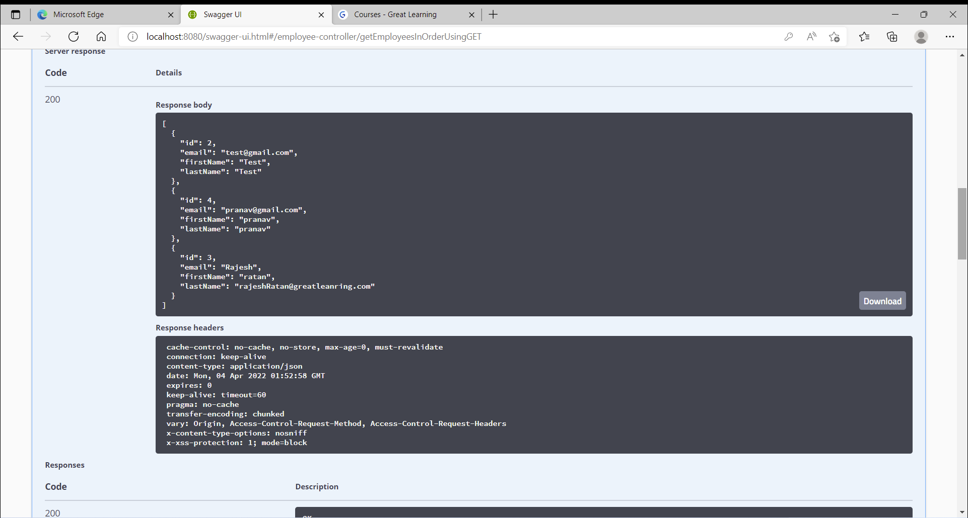

Sort by first Name(DESC)

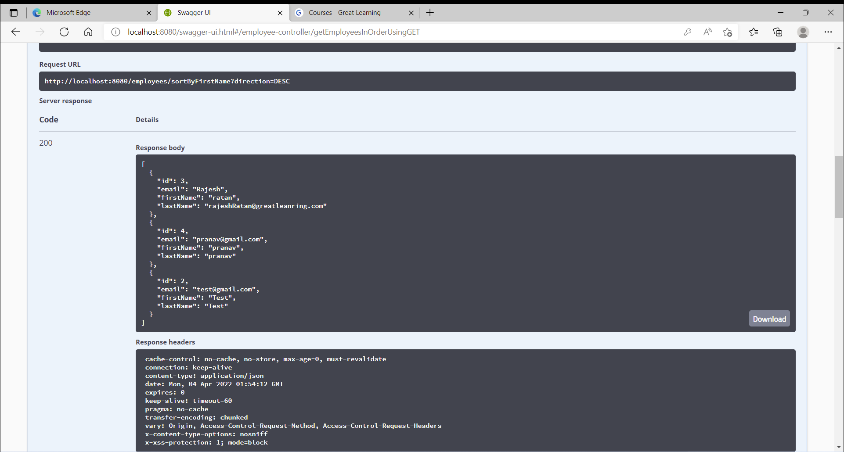

1. Error response for any record modifications are performed by user with other than ADMIN role

