Why AI Agents Keep Breaking Local Systems (And How Cocoon Fixes It in < 5ms)
Running untrusted LLM-generated code across Python, Node.js, Bun, Go, and Rust without containers, VMs, or file corruption.
Author: Sunil K Sundaram | Publication: Medium Engineering & AI | Open Source (MIT)
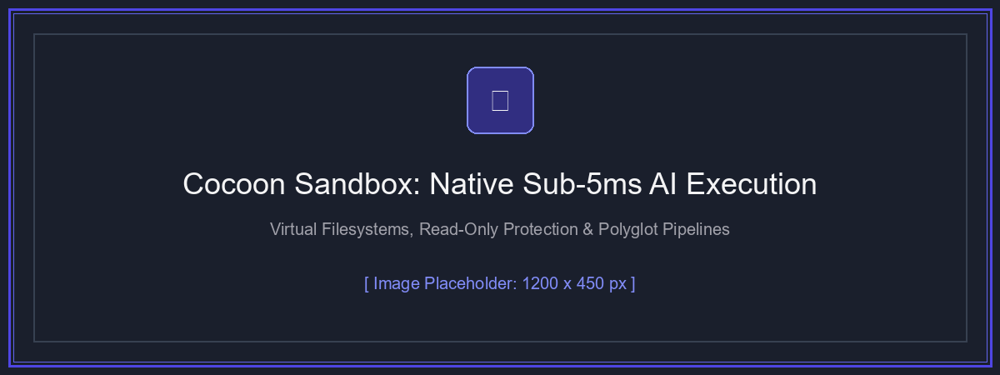
Figure 1: High-level architectural overview of Cocoon's kernel-level isolation drivers and virtual scratchpad.
If you have built an autonomous coding assistant, a data analysis agent, or an interactive LLM reasoning loop in the past two years, you know the dread of this function signature:
def run_code(code: str) -> str:
# Danger zone: arbitrary host execution
return subprocess.check_output(['python', '-c', code])

Autonomous agents do not simply answer questions anymore. They write code, test hypotheses, manipulate datasets, install libraries, and refactor files. Yet, giving an LLM terminal access on your workstation or production server is an engineering nightmare:
- Catastrophic Host Mutation: A subtle hallucination like os.system('rm -rf data /') or shutil.rmtree(os.path.dirname('.')) can instantly wipe the developer's workspace or system root.
- Cache & Disk Pollution: Every Python invocation drops __pycache__ folders and .pyc files into source trees; npm or pip clutter the developer's global package paths.
- Infinite Loops & Memory Spikes: An LLM writing an un-converged while True: loop or allocating an uncapped multi-gigabyte numpy array freezes the host operating system.

1. The Real Problem: The Container Tax vs. The Security Void
When modern engineering teams attempt to sandbox AI-generated code, they usually consider three architectures — and each encounters severe limitations in real-time, interactive agent workflows:
Sandboxing Approach | Startup Overhead | Safety / Risk Level | Agent Developer Experience
1. Raw subprocess | < 5 ms (Fast) | Critical Risk (Zero Host Safety) | Dangerous; files modified directly; no loop limits
2. Docker Containers | 1,200 ms - 3,500 ms | High Isolation | Slow in multi-turn ReAct loops; requires Docker Desktop
3. MicroVMs (Firecracker) | 150 ms - 400 ms | Hypervisor Grade | Requires specialized bare-metal virtualization infrastructure
4. Cocoon Sandbox | < 3 ms (Native) | Kernel-Enforced Read-Only | Instantaneous, zero daemon requirement, polyglot

Why existing solutions struggle with autonomous agent loops:
• Docker is too slow for 10-turn ReAct reasoning loops (adds 30+ seconds of pure daemon spin-up overhead).
• Docker requires client installation and root/hypervisor permissions on developer laptops.
• WebAssembly (WASM) engines cannot run native Python C-extensions (NumPy, PyTorch, Pandas) or arbitrary CLI toolchains.

2. What is Cocoon?
Cocoon is an open-source, native systems engine written in Rust. It does not run a guest operating system. Instead, it leverages native operating system kernel primitives to jail processes in under 5 milliseconds:
- Windows Driver: Utilizes Windows Job Objects for hard memory limits and recursive process tree termination, combined with inherited NTFS Deny ACEs (Access Control Entries).
- Linux Driver: Leverages unprivileged user namespaces, read-only bind mounts (MS_RDONLY), ephemeral tmpfs scratchpads, and optional Bubblewrap / Landlock LSM.
- macOS Driver: Employs Apple's kernel Seatbelt Sandbox (libsandbox via dynamic SBPL profiles) to enforce hardware-grade read-only barriers.

3. The 4 Built-In Invariants
Invariant 1: Read-Only Host by Default (--ro .)
The current working directory is automatically mounted as strictly read-only. Opening files in 'w' or 'a' mode, or calling deletion routines, triggers an immediate PermissionError enforced by the OS kernel.
Invariant 2: Ephemeral Copy-on-Write (--copy and --work)
When an agent needs to refactor or test modifications, files are safely staged into an isolated writable folder with --copy. The original host files remain completely pristine.
Invariant 3: Hard 30-Second Timeout & RAM Limits
Every invocation is automatically capped at 30 seconds by default (customizable via --timeout). Runaway scripts or infinite loops terminate cleanly at the process-tree level.
Invariant 4: Universal Polyglot Support (12+ Runtimes)
Built-in presets automatically locate and isolate Python, Node.js, Bun, Deno, Go, Java, Rust/Cargo, PowerShell, Bash, Ruby, PHP, and Lua.

4. The Killer Feature: Polyglot Multi-Language Pipelines
Real-world AI agents often require tools across different language ecosystems: Python extracts data from a dataframe, Node.js formats it, Bun validates it, and PowerShell or Bash packages the output. With cocoon pipeline, steps execute sequentially within the exact same virtual filesystem:
cocoon pipeline \
-s "python:import json; json.dump({'source':'Python','count':42}, open('state.json','w'))" \
-s "node:const fs = require('fs'); const d = JSON.parse(fs.readFileSync('state.json')); d.count *= 2; fs.writeFileSync('state.json', JSON.stringify(d));" \
-s "bun:const d = await Bun.file('state.json').json(); console.log('Bun verified final count:', d.count);" \
--json

5. Real-World Use Cases Across AI, Web & App Development
1. Autonomous Coding Agents (Claude Desktop, Cursor, Antigravity, AutoGen)
AI agents in developer IDEs should never have unrestricted shell access. Wrapping tool execution with Cocoon guarantees that uncommitted git changes cannot be accidentally deleted or overwritten.
2. Multi-Tenant AI Web Services & Backend APIs
SaaS applications allowing users to 'Chat with your CSV / Database' can replace sluggish 3-second Docker containers with 3ms Cocoon sandboxes, scaling throughput by orders of magnitude.
3. Automated Benchmark & Pull Request Evaluations
Executing untrusted benchmarks (like SWE-bench or HumanEval) without host bytecode cache contamination (__pycache__) or rogue network access.
4. Safe Dependency Installation & Package Testing
Agents can test packages using pip install --target or bun add inside an isolated workspace without modifying or breaking host Python or Node environments.

6. Comprehensive Architecture Comparison
Technical Capability | Raw Subprocess | Docker Engine | WebAssembly (WASM) | Cocoon Sandbox
Startup Latency | < 2 ms | 1,500 - 4,000 ms | < 10 ms | < 3 ms (Native)
Host Filesystem Protection | None (Zero Safety) | High (Container Jailed) | High (Virtual VFS) | Kernel-Enforced Read-Only
Native C-Extensions (NumPy, Torch) | Full Support | Full Support | Very Limited / Stubbed | Full Native Support
Supported Runtimes | Host Installed | Requires Giant Images | Language Specific | 12+ Runtimes Built-in
Multi-Language Shared Workspace | Unsafe | Complex Volume Mounts | Difficult | Built-in (cocoon pipeline)
Daemon / Service Requirement | None | Requires Docker Daemon | None | None (Single Static Binary)
Cross-Platform (Win / Mac / Linux) | Yes | Yes (via Hypervisor/WSL) | Yes | Native Drivers per OS

7. Getting Started with Cocoon
Cocoon is distributed on PyPI and Crates.io with pre-compiled wheels for Windows, macOS, and Linux:
# Install via Python (Pip) - Zero Rust compiler required:
pip install cocoon-sandbox
# Install via Rust (Cargo):
cargo install cocoon-sandbox
# Verify system driver & detected runtimes:
cocoon info
# Run a sandboxed script:
cocoon run --ro . -r python -c "import sys; print('Operational on', sys.platform)"

Conclusion & Repository Links
Autonomous AI agents are fundamentally shifting software engineering from static text generation to dynamic execution. Cocoon provides the missing systems layer: instant sub-millisecond execution, kernel-level read-only protection, and polyglot multi-language pipelines.
• GitHub Repository: https://github.com/sunilksundaram/cocoon
• PyPI Package: https://pypi.org/project/cocoon-sandbox/
• Crates.io Package: https://crates.io/crates/cocoon-sandbox

