**Devops-test**

Git hub

Local

developer pull code automatically

push code by using jenkins

Pre-prod/UAT

production

Test/staging

deploy code to various environment by passwdless authentication

we generally deploy manually to production server

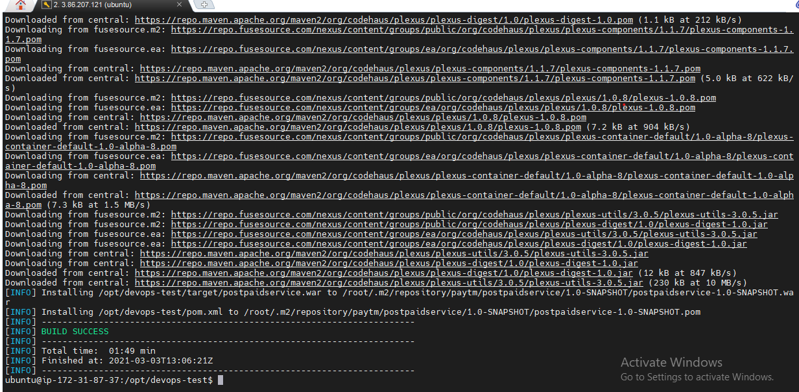

After getting .war file >>> we copy .war file to tomcat/webapps directory

After services are UP by using tomcat web application

**We also use Jenkins for automation our jobs**

we use master and slave concept for deploy services into various environment

github

prod

UAT

testing

Slave1

Slave-3

Slave2

Jenkins

master

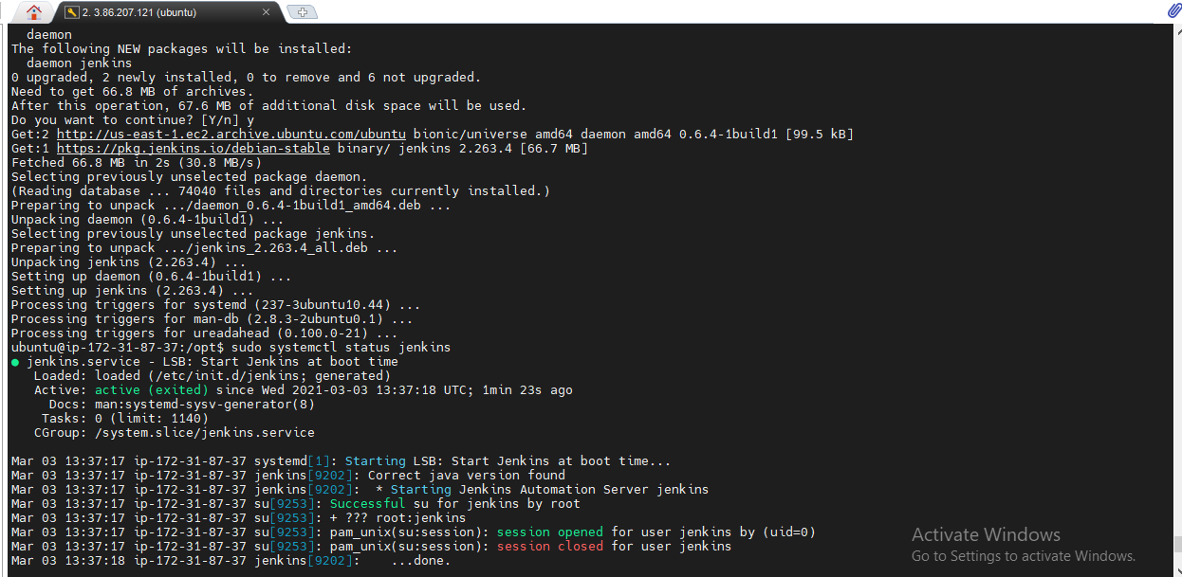

We use freestyle jobs for deploying by using triggering jobs

Also we use pipeline jobs for deploying by using Groovy scripting

And we also use docker for Building images and store in dockerhub registry.

Default passwd for Jenkins is located in /var/lib/jenkins/secrets/initialAdminPassword

Pipeline script

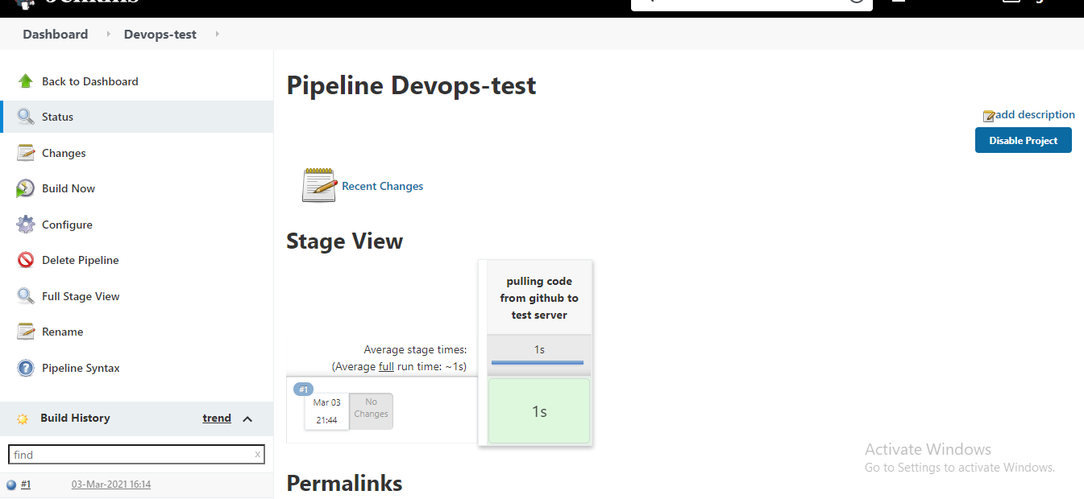

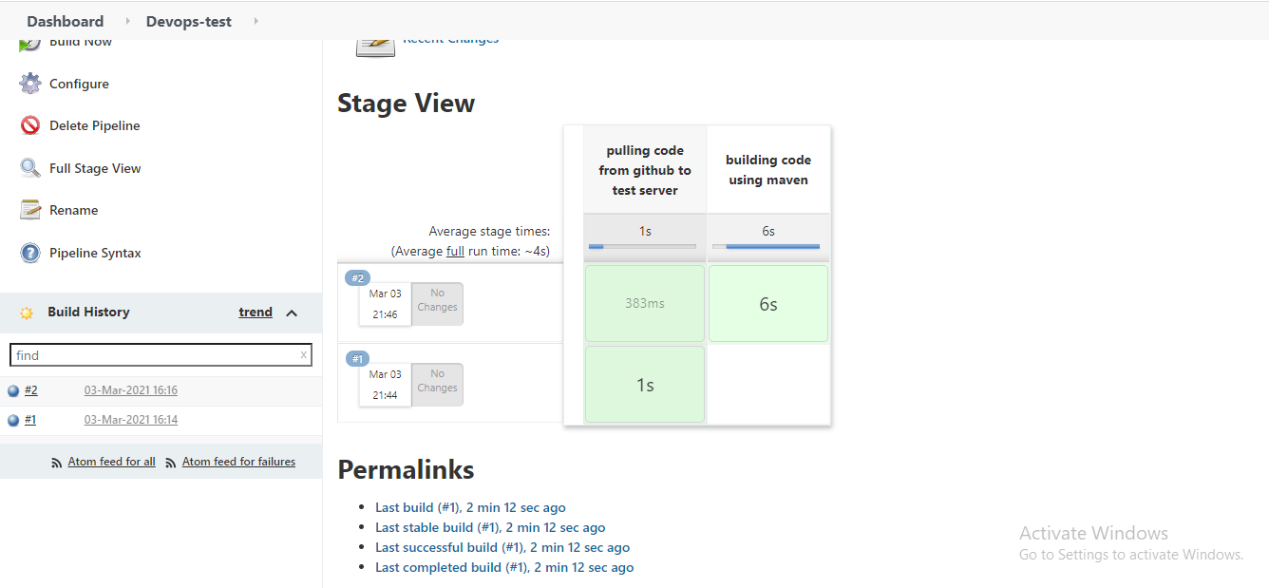

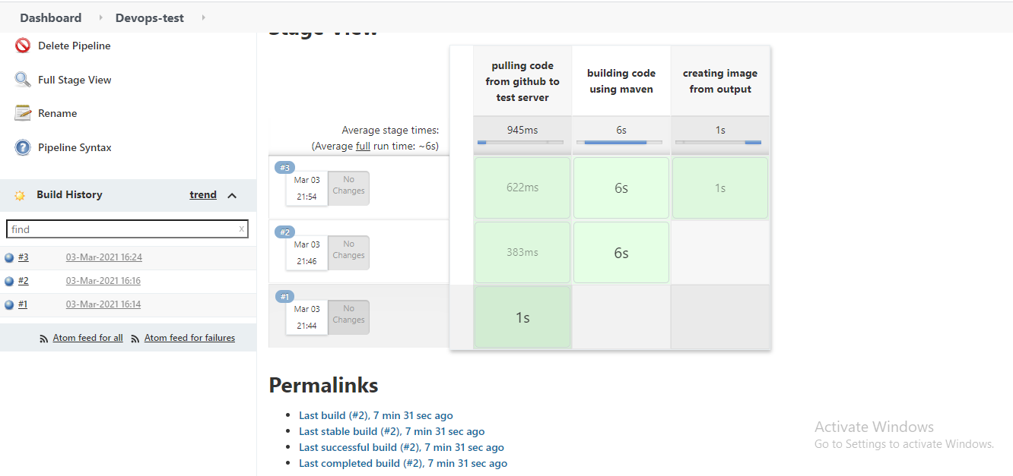

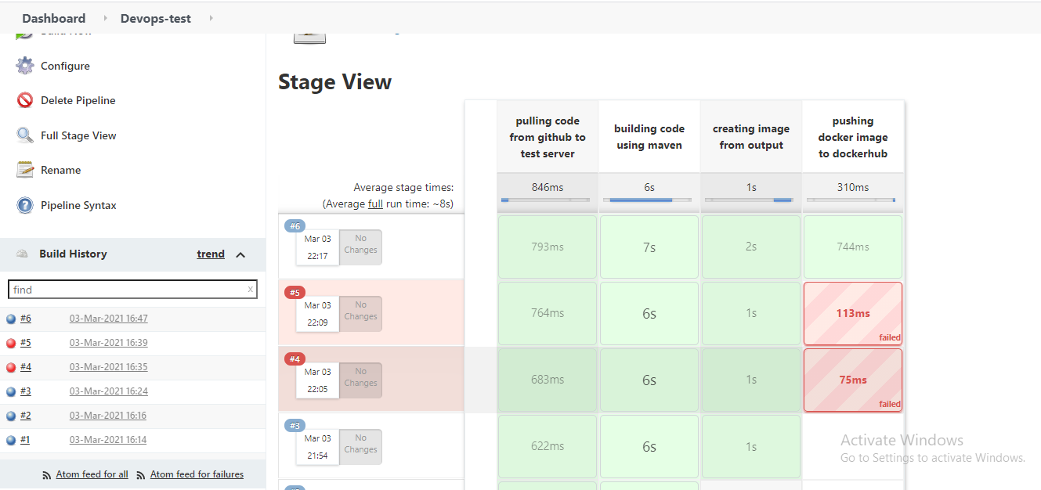

Now we have successfully created docker image and push to dockerhub by using jenkins

Next time if any developer do commit in git repository jenkins will all above jobs automatically

Pipeline-syntax

node{

stage('pulling code from github to test server'){

git credentialsId: 'ea896b10-7294-47fa-b897-03764dc41429', url: 'https://github.com/sunilkumar047/devops-test.git'

}

stage('building code using maven'){

sh 'mvn clean install'

}

stage('creating image from output'){

sh 'docker build -t sunilkumar0/devops:1 .'

}

stage('pushing docker image to dockerhub'){

withCredentials([string(credentialsId: '5203da37-a614-4bf6-b37c-afea59d612a7', variable: 'docker123')]) {

sh "docker login -u sunilkumar0 -p ${docker123}"

}

}

sh 'docker push sunilkumar0/devops:1'

}

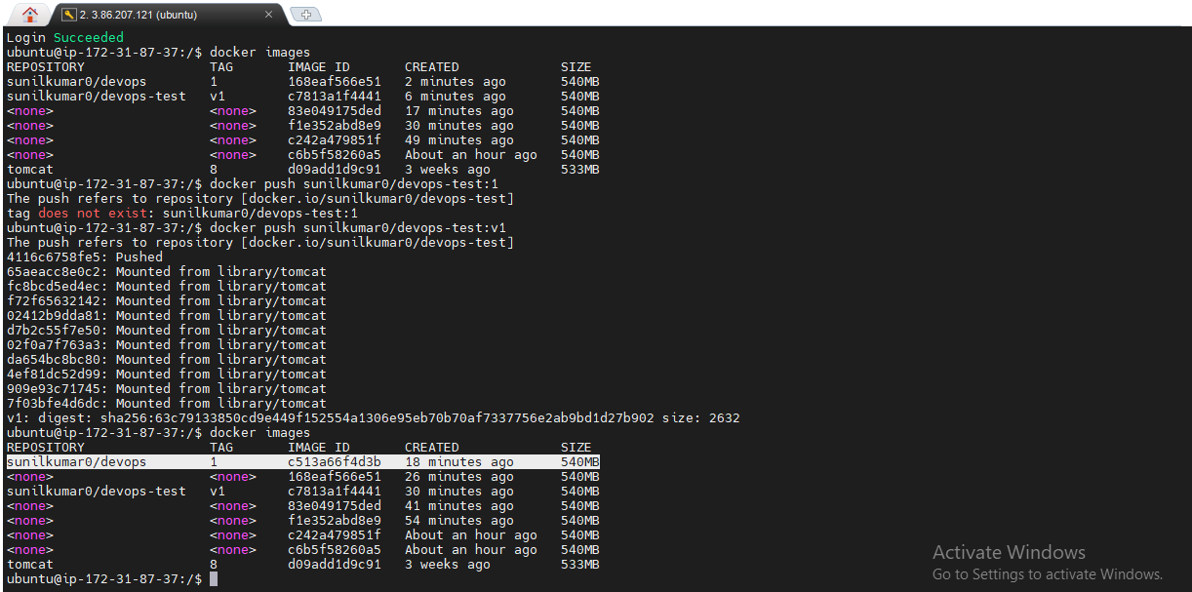

Checking of logs

All logs of services stored in apache2

I have used to check logs in >>> var/log apache2 directory

Monitoring

I used nagios to monitor all services,network,hosts etc from NAGIOS-Master by install nagios-NRPE plugin

NRPE

Host1

Nagios-master

NRPE-nagios remote plugin excutor

NRPE

Host2

If any down time of server arises then I used to make service with autoscaling depending upon LOAD on server

I also docker-swarm for auto-scaling by replicas of services