**Physical Shopping Cart**

**Introduction**

The main purpose of “Physical Shopping Cart ” is to provide the shopping details of any customers, easy way of selection of items from the shelf in the store to the cart, store can easily store the registered customer details in their storage space.

**Main Objective**

The main objective of “Physical Shopping Cart” is to design and implement a physical shopping store Simulation.

**Modules**

1) RegistrationImpl: When the shopper enters in to the store as per the shoppers interest he will get registered in the RegistrationImpl. The data will be located in the particular file in the local system

2) ShopperActivity: This is to provide the information about who enters the shop at what time to the shop and how many shoppers are there in particular point of time.

3) CartImpl: It ‘s an Interface of provide cart time of shoppers

4) StockPrice: It Provides list of items before going to add to the cart and shopper can able to know the price of interested items, can able to add to the cart, know the state of the shoppers cart at time, able to able selected items to the cart from the list and know the price

5) InventoryImpl: It is a pojo class which is used to set and get the items

6) ManagerImpl: The manager checks whether the stock is there in the shelf or not if no, the Manager adds items to the shelf

7) BillingImpl: It is an interface to provide bill of the user

Class Diagram

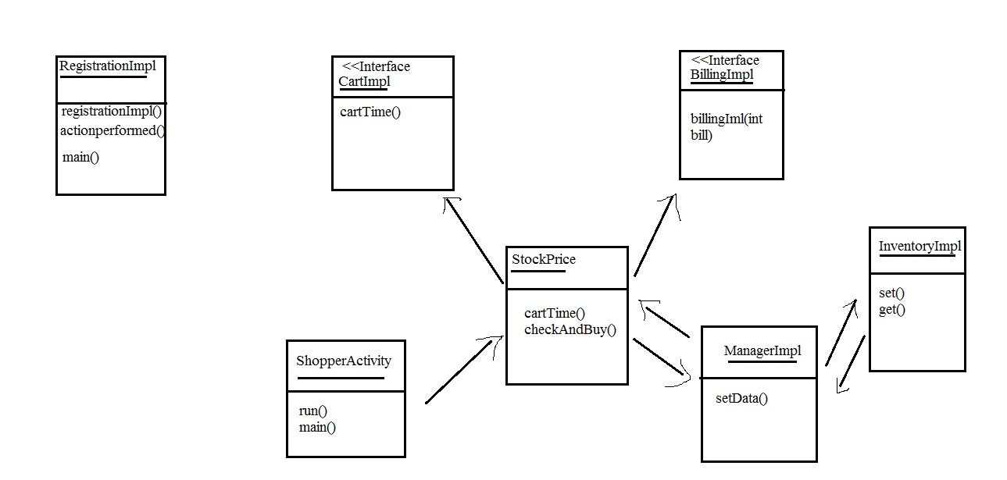

Output: