Video 1:
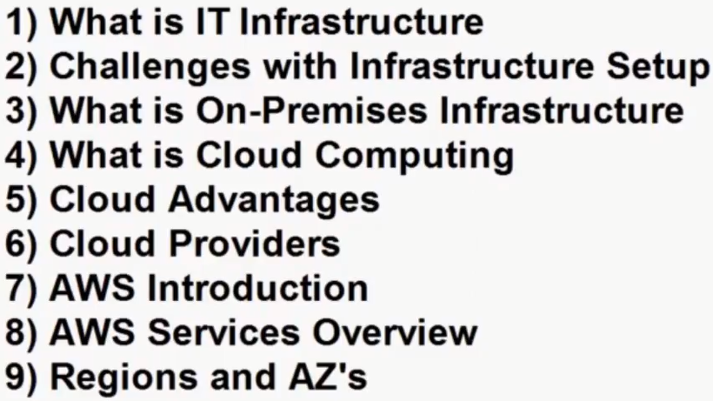
AWS: It provides It-Infrastructure. Commonly known as Cloud Computing.
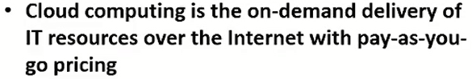
School Infrastructure: Board, tables, chairs, markers, duster ….,
Hotel Infrastructure: Building, power, Air conditioner, tables, chairs, plates …
It Infrastructure: Machine, web servers, Application servers, Data base servers, Network, power, storage, security, load balancer, Monitoring ….
How to run one software application: like below
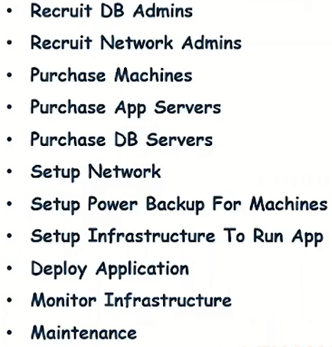
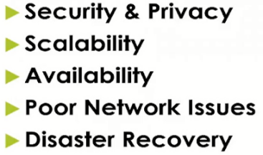

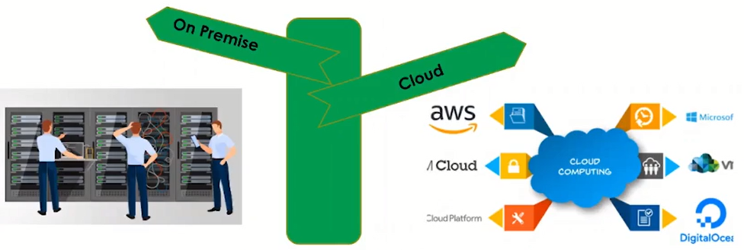
What is cloud computing
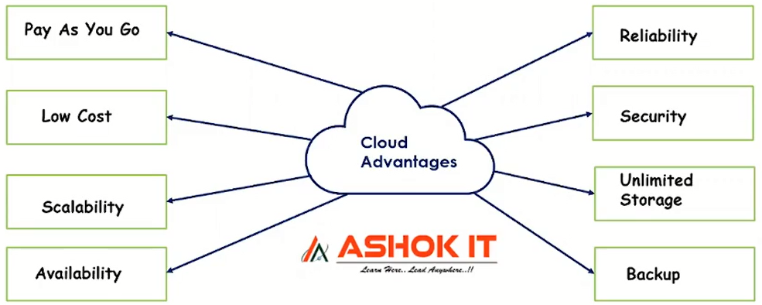
Availability: 24/7 Resources are available.
Reliability: Strong and Robert structure.
Cloud Providers:
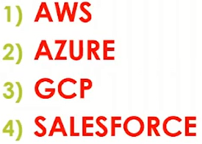
AWS Services it offers 200+ services:
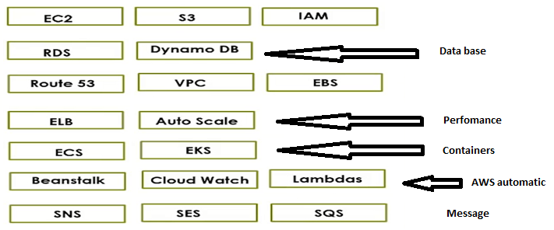
EC2, ECS, EBS, EKS, ELB, RDS, SES,
EC2 (Elastic compute cloud): Create virtual machines.
S3: simple storage service.
RDS: Relational data base service. if you want to create a database in cloud. supports sql databases.
Dynamo DB: Creating No sql Data base.
Route 53: Is a DNS service which is used to map domain name to the application. Server url map to domain. To map to the server url to domain name we will go for Route53.
EBS: Elastic black storage. Which is used to represent the volumes our EC2 instances.
It is like a hard disk. Whenever we create EC2 instance it will create EBS instance.
VPC: Virtual private cloud. It will provide isolated network for our resources in AWS cloud.
Whatever EC2 machine we are creating whatever data base we are creating for those thing VPC is a networking service which will provide the network for all the resources in AWS cloud.
ELB: Elastic load balancer. It will provide load balancer for our servers.
Auto Scale: whenever we want to increase or decrease the servers then we can use.
IAM: Identity Access Management. To manage users, Users permissions, User Groups, User Role, in the AWS we will go with IAM service.
Bean Stack: is used to run our applications without bothering about Infrastructure. Whatever Infrastructure required for the application AWS will provide as platform. Bean stack is basically plat from as a service.
Cloud Watch: is a monitoring service. Whatever infrastructure we are running we can monitor that Infrastructure by using Cloud watch. CW is basically a monitoring service.
ECS: Stands for Elastic container service. To run our docker container we can use ECS service.
EKS: Elastic Kubernetes service. to run Kubernetes applications on the cluster directly we can use this service.
Lambdas: Used for server less computing. Without bothering about servers, we can run App.
AWS will provide fully managed control plane to run our Kubernetes application.
Send Notifications:
SNS: Simple Notification service.
SES: Simple Email service.
SQS: Simple Queue service.
Region and Availability Zones:
Region: means one geo graphical location (here AWS maintain their Infrastructure).
In one Regien: multiple Availability zones are available.
Availability zones: Means a Data center. Here AWS maintain infrastructure. There servers, building, their network, they power, We are connecting data center through their Region. And we setting up our Infrastructure.
In India: Mumbai and Hyderabad the AWS Regions are available.
