**Stochastic Gradient Descent**

To run the program, run the command “python sgd.py” on command prompt.

**Required Libraries:**

Numpy, random, matplotlib

**SGD**:

This is the main function that will run the stochastic gradient descent. It will take learningRate(eta), cost function, dimensions of the parameters(/weights) as input. It will find the local partial derivatives in each iteration, and move to a new set of parameters depending on the gradient and learning rate. It will stop moving further if it reaches local minima. The function will plot the cost in each iteration as one chart and the movement of the parameters (taking only the first two dimensions for plotting purpose) across iterations as the other chart. And the axis labels will explain where the parameters are converging.

**Test cases**:

The program will run SGD on two cost functions for demo purpose.

1. Cost function 1: [x1,x2,x3…xn ] are the parameters, then cost = sum(xi2) from i = 1 to n.
2. Cost function 2: [x1,x2,x3…xn ] are the parameters, then cost = sum(Cosine(xi)) from i = 1 to n.

**Result for Cost function 1(sum of squares)**

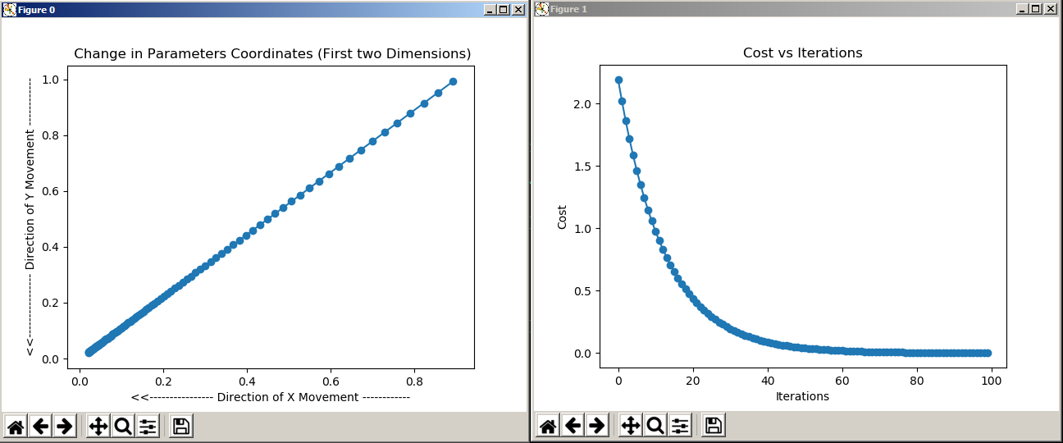

**Result for Cost function 2(sum of cosines)**

