Different types of modules in angular ?

Feature modules : dividing components, directives , pipes… based on the module. Instead of placing everything in the app.module. we can improve the readability of the code.

But we can declare the components , directives or pipes only one time . we can’t declare in both featuremodule and app.module.

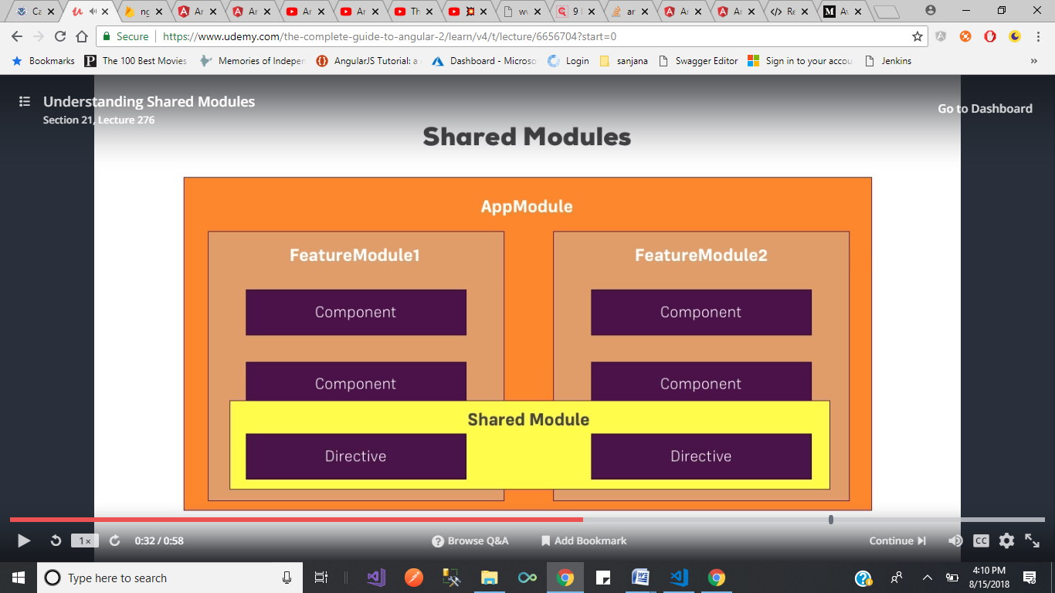

Shared modules:

Suppose if we have the requirement like we have some feature to share between two modules , then we use shared module.

( suppose we have a dropdown in our application . we are using that one in header component and recipesdetail component