**SMART VOTING SYSTEM USING COMPUTER VISION & DEEP LEARNING**

**OBJECTIVE:**

In this application, we describes model for online voting system for India. This system is much secure and efficient than the traditional voting system. Manipulation of votes and delay of results can be avoided easily. A unique voter identity (like aadhar or any other unique voter id number) is the center point of our proposed model. It leads to the easier verification of both voters and candidates.

**ABSTRACT:**

An online voting system for Indian election is proposed for the first time in this paper. The proposed model has a greater security in the sense that voter high security password is confirmed before the vote is accepted in the main database of Election Commission of India. The additional feature of the model is that the voter can confirm if his/her vote has gone to correct candidate/party. In this model a person can also vote from outside of his/her allotted constituency or from his/her preferred location. In the proposed system the tallying of the votes will be done automatically, thus saving a huge time and enabling Election Commissioner of India to announce the result within a very short period.

**KEYWORDS:** Voting, Online, Computer Vision, Deep Learning, Haarcascading, OpenCV, OTP.

**SYSTEM SPECIFICATIONS:**

**SOFTWARE REQUIREMENS**

* Operating System : Windows 7+
* GUI : Flask
* IDE : PyCharm IDE
* Libraries Used : Pandas, os, Pillow, pymysql, numpy.

**HARDWARE REQUIREMENTS**

# Processor - I3/Intel Processor

# RAM - 4GB (min)

* Hard Disk - 128 GB
* Key Board - Standard Windows Keyboard
* Mouse - Two or Three Button Mouse

**BLOCK DIAGRAM:**

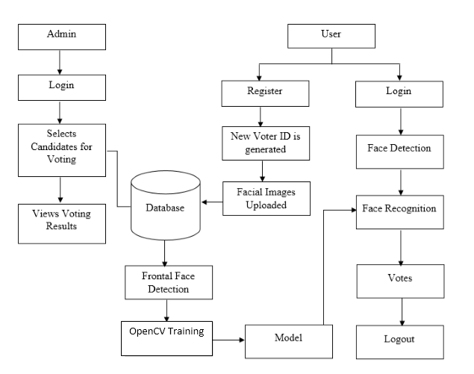

**EXISTING SYSTEM:**

In existing systems, voters go to the voting centers and they use their votes manually. It is time consuming and there is chance of gambling the votes. These system relies on huge number of skilled people to work at polling booths and hence is difficult to scale up.

**DISADVANTAGES:**

* Chance of frauds.
* Time consuming.
* Difficult to handle.
* Expensive.
* Difficult to scale.

**PROPOSED SYSTEM:**

In the proposed system, we have tried to build a secure online voting system that is free from unauthorized access while casting votes by the voters. The server aspects of the proposed system have such distribution of authority that server does not enable to manipulate the votes. It is expected that the proposed online voting system will increase the transparency and reliability of the existing electoral system

**ADVANTAGES**

* Time consumption is reduced.
* Fraud/gambling’s can be reduced.
* Privacy and secure.
* Highly convenient.
* Easy to scale up.
* Inexpensive.

**LEARNING OUTCOMES:**

* Scope of Real Time Application Scenarios
* Importance of web development.
* Working of computer vision.
* Sending automatic emails.
* Implementing a haarcascading based system.
* Facial recognition.
* Deep learning.
* Objective of the project
* How Internet Works
* Introduction to basic technologies used for
* How project works.
* Input and Output modules
* Practical exposure to
  + Hardware and software tools.
  + Solution providing for real time problems
  + Working with team/ individual
  + Work on Creative ideas
* Frame work use
* Data base connections
* About python
* Crud operations
* Python built in function
* How the voting system performs