**SMART VOTING SYSTEM USING DEEP LEARNING & COMPUTER VISION**

**PROBLEM STATEMENT:**

In this application, we create a system for online voting for India. This system is much secure and efficient than the traditional voting system. Manipulation of votes and delay of results can be avoided easily. A unique voter identity (like aadhar or any other unique voter id number) is the center point of our proposed model. It leads to the easier verification of both voters and candidates.

**ABSTRACT:**

An online voting system for Indian election is proposed for the first time in this application. The proposed model has a greater security in the sense that voter high security password is confirmed before the vote is accepted in the main database of Election Commission of India. The additional feature of the model is that the voter can confirm if his/her vote has gone to correct candidate party. In this model a person can also vote from outside of his/her allotted constituency or from his/her preferred location. In the proposed system the tallying of the votes will be done automatically, thus saving a huge time and enabling Election Commissioner of India to announce the result within a very short period.

**INTRODUCTION**

Online voting system is a way that helps public to select their representatives and express their preferences for how they will be governed. The belief of the election process is utmost important. Election process is secure if anything goes wrong in Elections the system will increase the security levels. But there is a chance for Maoist attacks and rigging problems in some areas, there is a chance to lost their vote and life. So public needs a more secure way of casting their vote.

Online voting systems offer advantages compared to other voting processes. An Online voting system may be involved in any one of a number of steps in the setup, voting, collecting, distributing and counting of ballots.

The question of who gets to count your vote was addressed in while in the voting security has been analyzed. The same problem has also been addressed in more abstractly to ponder over its perception and reality. It is hard to make the voting system trustworthy only because it has high security requirements: confidentiality and integrity. Confidentiality means all voters get assured about the privacy of votes and prevent selling of votes.

Integrity means the assurance of election results and the votes are counted correctly. The proposed system provides peoples to vote in a secure manner without any fear. The online voting system also provides the security to the voter’s by storing the vote in a secure digital form, if the voter votes against malevolent candidate.

**LITERATURE SURVEY:**

**[1] Z. A. Usmani, K. Patanwala, M. Panigrahi and A. Nair, "Multi-purpose platform independent online voting system," 2017 International Conference on Innovations in Information, Embedded and Communication Systems (ICIIECS), Coimbatore, India, 2017, pp. 1-5, doi: 10.1109/ICIIECS.2017.8276077.**

The voting system is the backbone of every democracy and organization. The voting system has experienced many efficient changes in the past few decades. There are various voting techniques used such as Paper Ballot Voting System, E-Voting System also known as Electronic Voting System, Internet Voting System, SMS and Miss Calls Voting System. In this paper, we have discussed various voting system and their advantages and disadvantages. The primary goal of this paper is to make the voting system multipurpose and make it work multiplatform on any operating system**.**

**[2] M. M. THIGA, "Increasing Participation and Security in Student Elections through Online Voting: The Case of Kabarak University," 2020 IST-Africa Conference (IST-Africa), Kampala, Uganda, 2020, pp. 1-7.**

Electronic voting systems have enhanced efficiency in student elections management in universities, supporting such elections to become less expensive, logistically simple, with higher accuracy levels as compared to manually conducted elections. However, e-voting systems that are confined to campus hall voting inhibits access to eligible voters who are away from campus. This study examined the challenges of lack of wide access and impersonation of voter in the student elections of 2018 in Kabarak University. The main objective of this study was therefore to upgrade the offline electronic voting system through developing a secure online voting system and deploying the system for use in the 2019 student elections at Kabarak University. The resultant system and development process employed demonstrate the applicability of a secure online voting not only in the higher education context, but also in other democracies where infusion of online access and authentication in the voting processes is a requisite.

**[3] C. Garcia-Zamora, F. Rodriguez-Henriquez and D. Ortiz-Arroyo, "SELES: an e-voting system for medium scale online election," Sixth Mexican International Conference on Computer Science (ENC'05), Puebla, Mexico, 2005, pp. 50-57, doi: 10.1109/ENC.2005.40.**

Recent advances in communication networks and cryptographic techniques have made possible to consider online voting systems as a feasible alternative to conventional elections. Until today several protocols for electronic voting have been proposed, unfortunately only a few of them have been implemented in an end-to-end fully functional system. In this paper, we present a secure electronic voting system for medium scale online elections (SELES). Our system efficiently implements a security communication protocol offering protection against double voting and others frauds while avoiding any private voting channel. SELES accomplishes all the standard properties of conventional voting systems, namely, accuracy, democracy, privacy, verifiability, simplicity, flexibility and double voting detection. Our system has been tested in a distributed and heterogeneous Internet network comprised by workstations, laptops and PDA nodes interacting through wired and wireless connections. Additionally, SELES has been designed to deal with communication failures, thus achieving a certain degree of robustness.

**[4] B. Madhuri, M. G. Adarsha, K. R. Pradhyumna and B. M. Prajwal, "Secured Smart Voting System using Aadhar," 2017 2nd International Conference On Emerging Computation and Information Technologies (ICECIT), Tumakuru, India, 2017, pp. 1-3, doi: 10.1109/ICECIT.2017.8453308.**

India is a Democratic country which means people has the power to select their leaders. For selection we have an election process which is prone to fraud and has many disadvantages. India is losing the actual meaning of Democracy as the percentage of voting is decreasing drastically day by day. In order to overcome this problem there is a need to provide an easy and secured process by developing Mobile Application. Now a days mobile has mobile has replaced everything and has made every process simple and secured. The main perspective of this paper is to provide a simple and secured voting system in India. Since it is app-based it is more secured than online voting system. This system uses fingerprint for unique identification and Aadhar details are fetched based on fingerprint data. This paper provides significance for the senior citizens, disabled, patients, soldiers and migrants. People can participate in voting where ever they are located. Results will be announced immediately after completion of election process. This help to move a step ahead towards Digitalize India and Make in India.

**[5] G. Manikandan, G. Anandaraju and B. Karthikeyan, "A Candidate Aware Internet Voting System For Indian Scenario," 2020 6th International Conference on Advanced Computing and Communication Systems (ICACCS),Coimbatore, India, 2020, pp.783-786.**

India is the largest democratic nation in the world. Democracy is considered as one of the best forms of government that allow the citizens to cast a vote and elect a government of their choice. A vote can change the future of the country as well as the fate of the citizens. It gives the ultimate power to shape the destiny of the country. According to the Election Commission of India (ECI), the number of electors registered is 834 million and the highest ever turnout of the voters is about 66.40%. The main reason behind this low turnout was due to constraints in the current (traditional) voting system. This paper suggests a new online voting method for Indian government elections to increase the number of voter's participation in the election process. The proposed method employs two approaches 1) Novel candidate verifiability mechanism and 2) OTP (one-time-password) mechanism. The candidate verifiability allows the candidate to check the integrity of the vote and OTP acts as an additional authentication factor to identify the voter.

**EXISTING METHOD**

In existing systems, voters go to the voting centers and they use their votes manually. It is time consuming and there is chance of gambling the votes. These system relies on huge number of skilled people to work at polling booths and hence is difficult to scale up.

**DISADVANTAGES**

* Chance of frauds.
* Time consuming.
* Difficult to handle.
* Expensive.
* Difficult to scale.

**PROPOSED METHOD:**

In the proposed system, we have tried to build a secure online voting system that is free from unauthorized access while casting votes by the voters. The server aspects of the proposed system have such distribution of authority that server does not enable to manipulate the votes. It is expected that the proposed online voting system will increase the transparency and reliability of the existing electoral system. It uses computer vision techniques for person identification.

**PROJECT FLOW:**

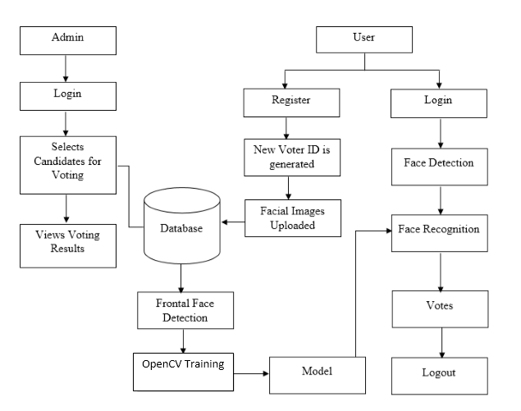

**ADVANTAGES:**

* Time consumption is reduced.
* Fraud/gambling’s can be reduced.
* Privacy and secure.
* Highly convenient.
* Easy to scale up.
* Inexpensive.

**APPLICATIONS:**

* Used in National Elections.
* Used in Television shows.
* Used in taking mass opinions.

**HARDWARE & SOFTWARE REQUIREMENTS**

**SOFTWARE REQUIREMENS**

* Operating System : Windows 7+
* GUI : Flask
* IDE : PyCharm IDE
* Libraries Used : Pandas, os, Pillow, pymysql, numpy.

**HARDWARE REQUIREMENTS**

# Processor - I3/Intel Processor

# RAM - 4GB (min)

* Hard Disk - 128 GB
* Key Board - Standard Windows Keyboard
* Mouse - Two or Three Button Mouse

**ARCHITECTURE:**



USER

DATA BASE

ADMIN



USER DEVICE

ADMIN SYSTEM

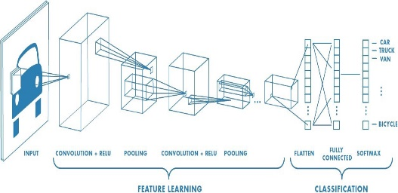

Modelling

**CONCLUSION**

We have successfully developed an online voting system. The system has a new registration feature which takes in frontal facial images of the person registering. The user needs to verify their emails using OTP as well for a successful registration. Once someone is registered, the models has to be trained again by the admin in order to detect and recognize the new person. A registered user is identified by their face and then allowed to vote unless they have already voted as no one can vote more than once. Frontal Face Haarcascading is used for facial embedding generation. Computer Vision is employed for image preprocessing and video streaming. Flask is used for the User Interface via Python.

**REFERENCES**

[1] Kohno, T., Stubblefield, A., Rubin, A. D., & Wallach, D. S. (n.d.). Analysis of an electronic voting system. IEEE Symposium on Security and Privacy, 2004. Proceedings. 2004. doi:10.1109/secpri.2004.1301313

[2] D. Chaum, "Secret-ballot receipts: True voter-verifiable elections," in IEEE Security & Privacy, vol. 2, no. 1, pp. 38-47, Jan.-Feb. 2004, doi: 10.1109/MSECP.2004.1264852.

[3] Evans, D., & Paul, N. (2004). Election security: perception and reality. IEEE Security & Privacy Magazine, 2(1), 24–31. doi:10.1109/msecp.2004.1264850

[4] Jefferson, D., Rubin, A. D., Simons, B., & Wagner, D. (2004). Analyzing internet voting security. Communications of the ACM, 47(10), 59. doi:10.1145/1022594.1022624

[5] Evans, D., & Paul, N. (2004). Election security: perception and reality. IEEE Security & Privacy Magazine, 2(1), 24–31. doi:10.1109/msecp.2004.1264850