PersonalUsageExperience
Research Work Made for Competitors of Exam Smith

1, JungleAI

https://app.jungleai.com/learning-journey/mini-lesson-preview/ivT2wdS3OyL5UTy5VYkB?r=h2qOZmejPlaq46dTYbGC4gQvq860jI

Inference: Not exactly generates question paper, just generating some questions with the
Uploaded Maths book class 10th. It completed extraction of first 30 pages within 2 mins and given me these set of questions. Tried with free version

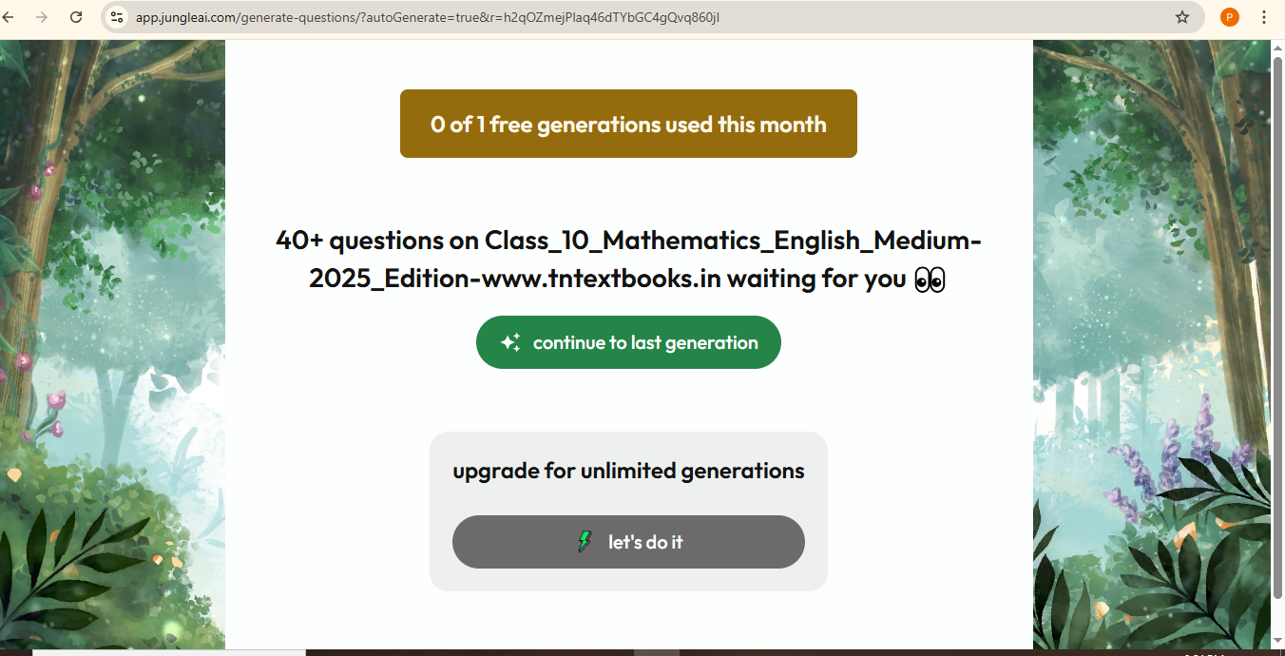

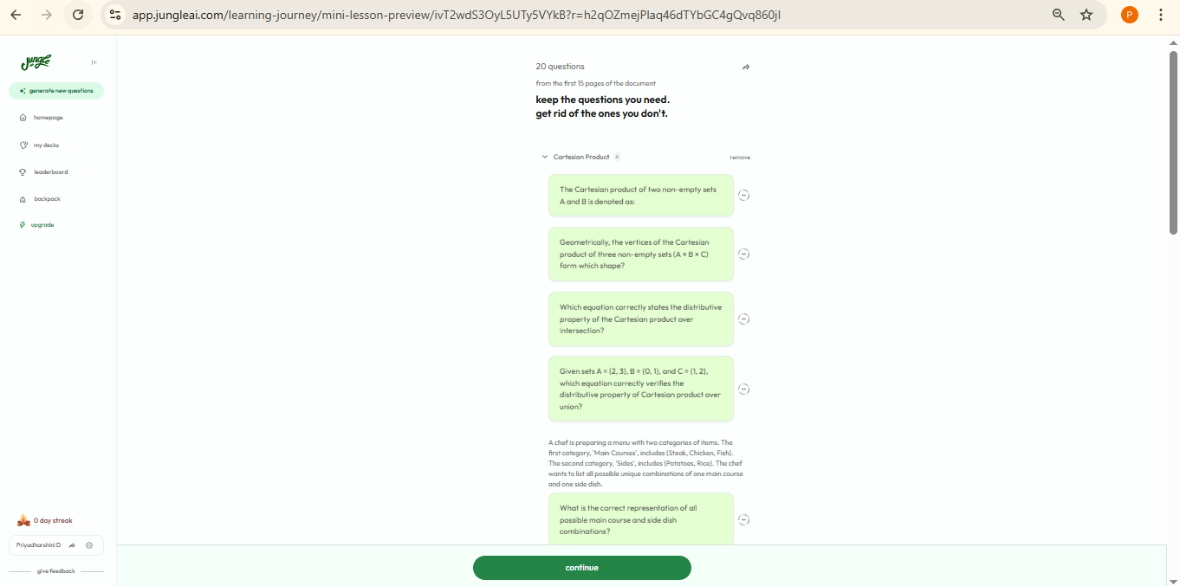

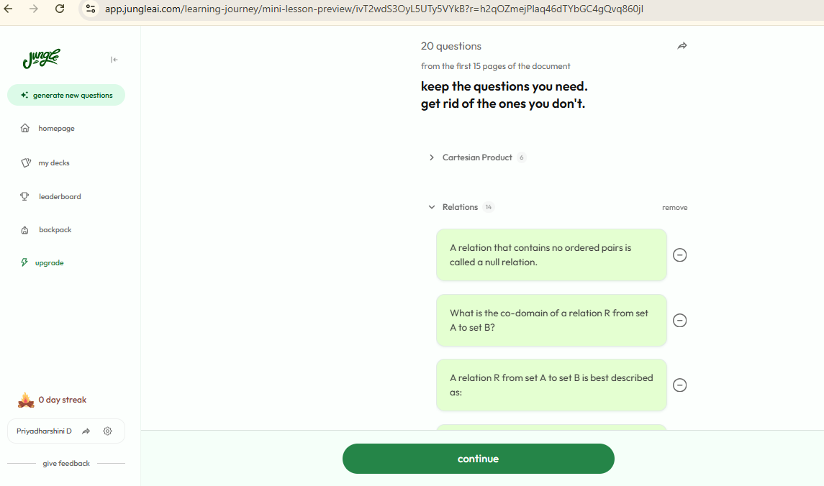

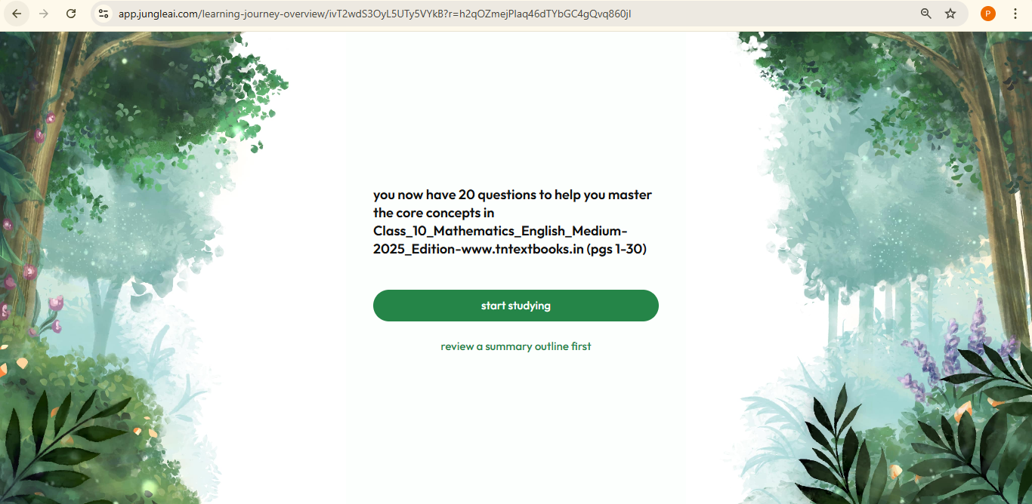
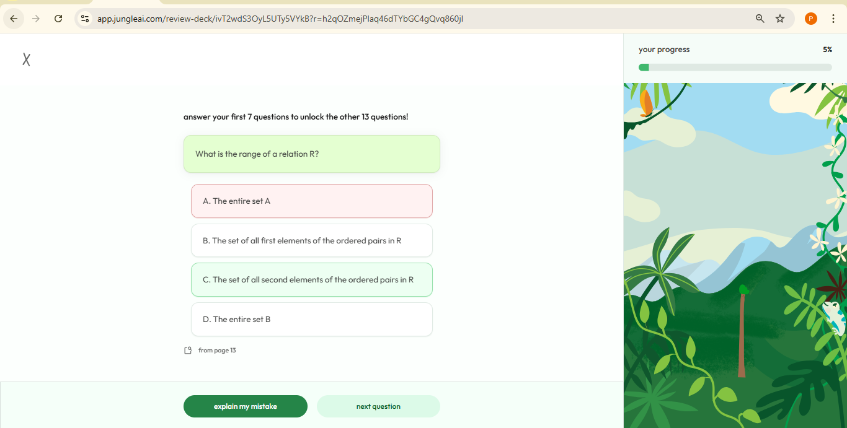

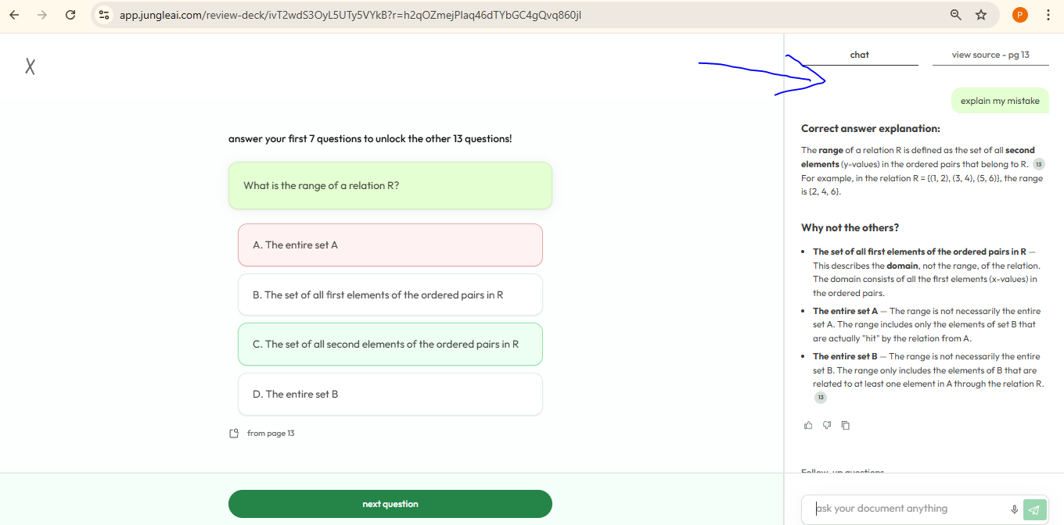

2, prepai

https://app.prepai.io/register?utm_source=chatgpt.com&_gl=1*1ap9o7s*_gcl_au*MTcxNDcwNzA0Mi4xNzY4NDg1MzQ2

Inference: Only quiz generates with cbse syllabus

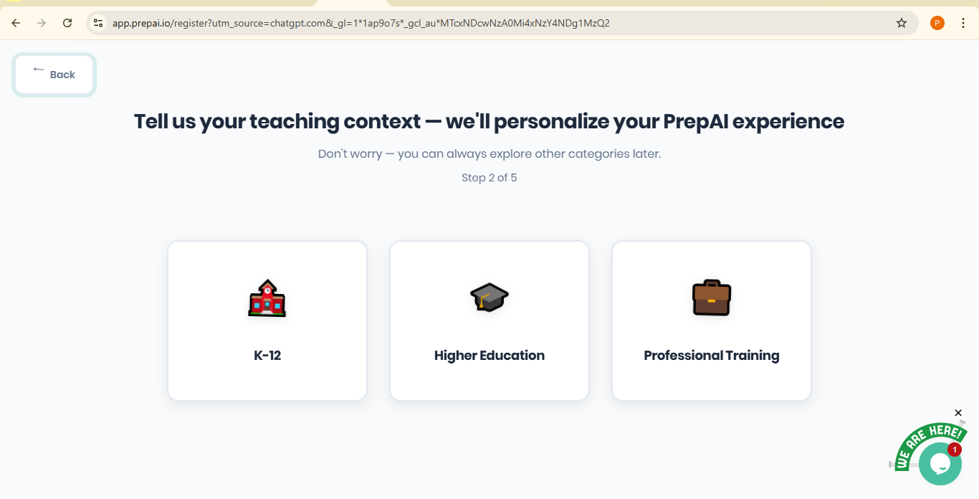

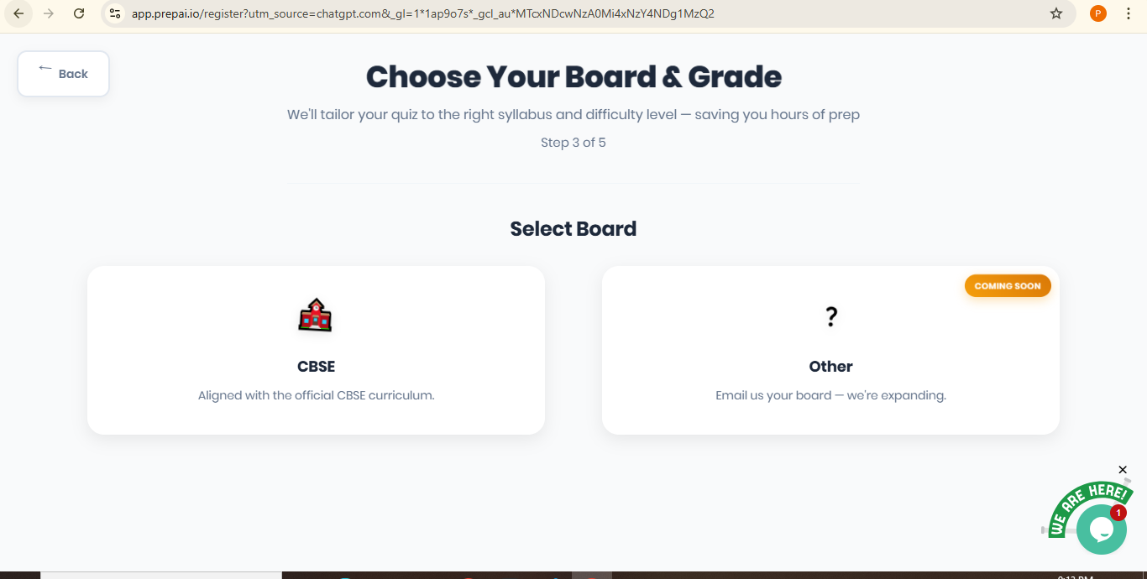

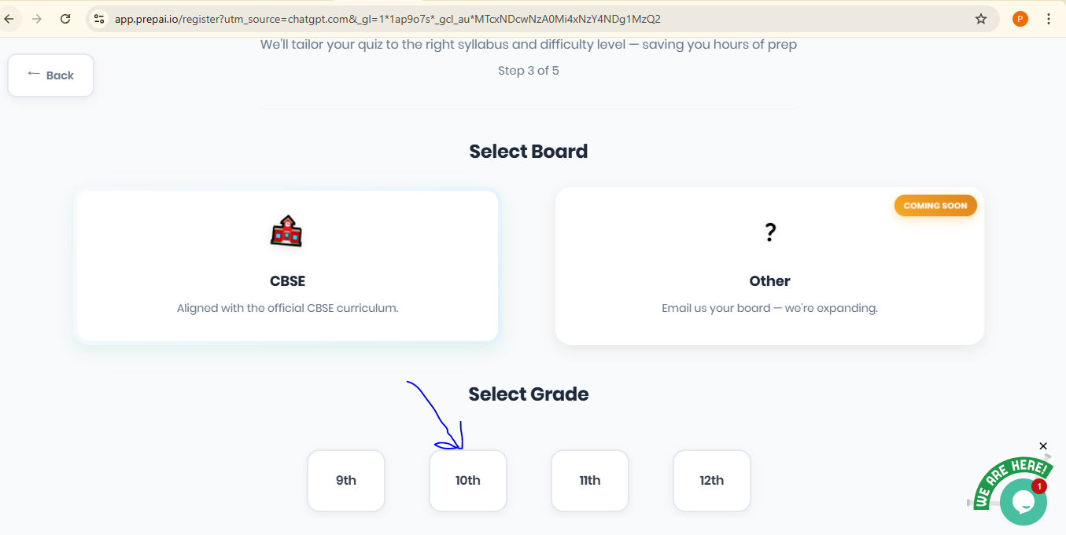

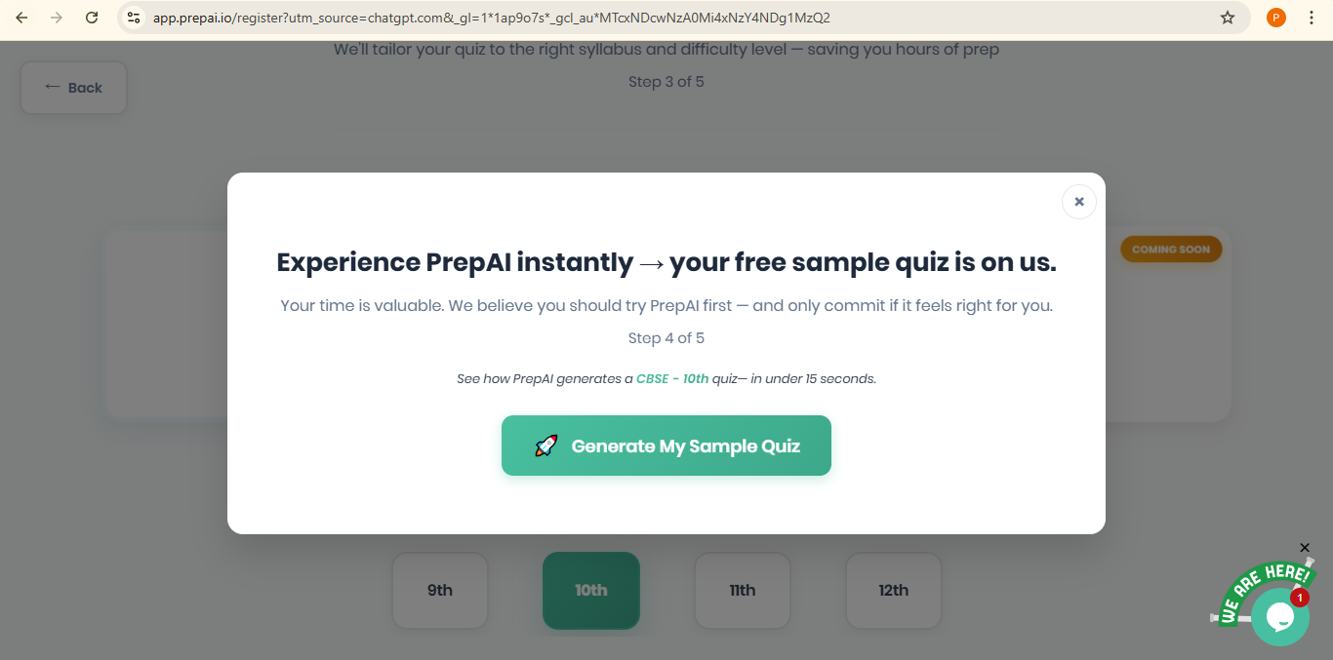

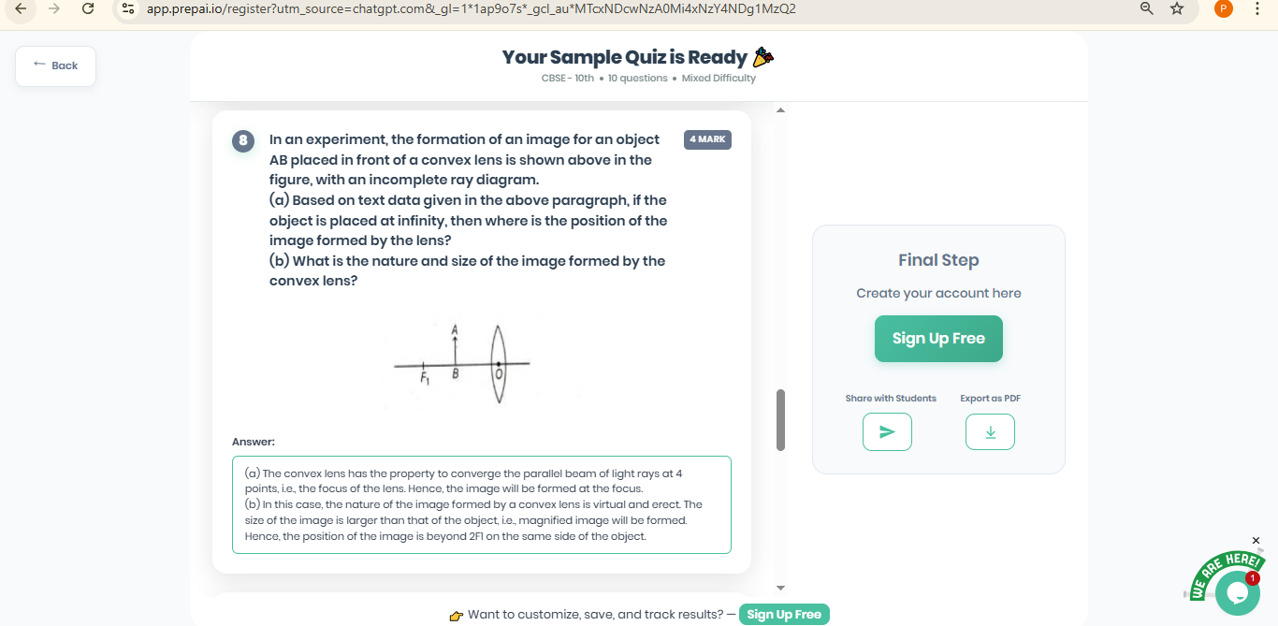

🔎 Core Technology Stack above sites used

AI + Machine Learning + NLP (Natural Language Processing)
PrepAI uses natural language processing (NLP) and machine learning algorithms to:
- Parse input content (text, PDFs, Word docs, video transcripts, links, etc.)
- Understand context and structure of that content
- Extract key concepts, facts, and relationships from input material
- Generate relevant questions of different types (MCQs, true/false, fill-in-the-blank, descriptive, etc.) from that content
Official PrepAI descriptions emphasize the use of “advanced AI algorithms” and “NLP technology” to automate question creation and content-analysis tasks.

🔹 A. Direct Text Extraction
For text-based PDFs the system can extract text directly (e.g., with PDF parsing libraries).

🔹 B. OCR (Optical Character Recognition)
For scanned or image-based PDFs, the system must first recognize the characters in the image using OCR technology, which converts images of text into machine-readable text.
- Popular tools include Tesseract, Amazon Textract, and other OCR engines.
- The OCR step turns the visual content of the page (pixels) into strings of text that computers can work with.
—----------------------------------
An AI platform that takes PDFs and returns context-aware questions almost certainly does some combination of:

🧾 Text Extraction
- If the PDF has embedded text → direct extraction.
- If it’s scanned/graphical → OCR + text extraction.

📄 Chunking
Splitting the extracted text into manageable pieces so the model can reason about sections rather than entire huge documents at once. This is how most systems handle long PDFs even without RAG. (RAG is one structured way to do this.)

🧠 Semantic Understanding / Generation
Using a large language model (LLM) to:
- Understand the meaning of text
- Generate questions from it
- Possibly keep some context in longer prompts
—------------------------------------------------------------------------------------------

Competitors

🧠 Main Competitors in the Market
Below are the top existing tools that provide AI-based assessment or question generation capabilities:

🔹 PrepAI
A well-known AI exam & question paper generator.
Key features:
- Auto-generate full exam papers or quizzes from source content.
- Supports various question types: MCQ, true/false, fill-in-the-blanks, short/long answer.
- Difficulty level selection (Easy/Medium/Hard).
- Customization options for educators. (PrepAI)
Platform type: Web app

🔹 QuestionPaper.ai
AI tool focused on academic assessment paper creation.
Key features:
- Generate AI-powered question papers.
- Supports workflow with Bloom’s Taxonomy levels (K1-K6).
- Teachers can edit question papers.
- Export with answer keys. (QuestionPaper.ai)
Platform type: Web app

🔹 TestGenie AI
Instant question paper generator with an app-like interface.
Key features:
- Generate full question papers for various difficulty levels and subjects.
- Includes answer keys.
- Download as PDFs.
- App available for iOS/Android. (testgenie.in)
Platform type: Website & Mobile App

🔹 Smallpdf AI Question Generator
General purpose AI question generator.
Key features:
- Generate questions/quizzes from PDF content.
- Create MCQs, true/false, open-ended questions. (Smallpdf)
Platform type: Web tool

🔹 Questgen.ai
AI quiz & assessment generator.
Key features:
- Generates MCQs, multiple correct answers, true/false questions.
- Focused on quick generation from input text. (Questgen - AI Quiz Generator)
Platform type: Web tool / API

🔹 EdutorAI
AI content-based quiz & flashcard generator.
Key features:
- Generates quizzes and flashcards from text content.
- Can upload images and text.
- Customizable output. (EdutorAi)
Platform type: Web platform

🔹 Penseum
AI learning + assessment tool for questions and quizzes.
Key features:
- Generates tailored exams, practice questions, flashcards.
- Upload PDFs, videos, PowerPoints. (Penseum)
Platform type: Web app

🔹 OpExams Free Questions Generator
Free AI question generator with multimedia inputs.
Key features:
- Create questions from text, links, video, and PDF. (opexams.com)
Platform type: Web tool

🔹 Quizbot AI
AI quiz generator creating varied question types.
Key features:
- Generates multiple question formats, including MCQs and fill-ins. (quizbot.ai)
Platform type: Web tool

Feature_Comparison

📊 Feature Comparisons

In Image:
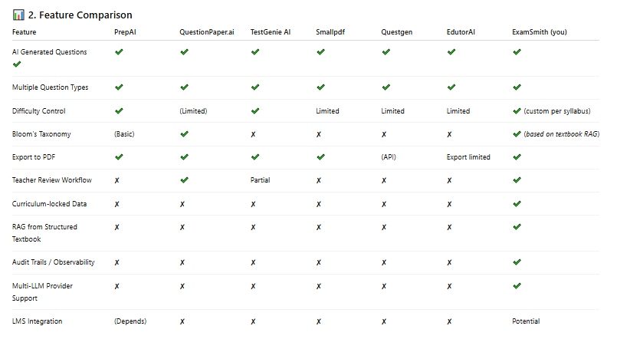

In Text:

Feature | PrepAI | QuestionPaper.ai | TestGenie AI | Smallpdf | Questgen | EdutorAI | ExamSmith (you)
AI Generated Questions ✔ | ✔ | ✔ | ✔ | ✔ | ✔ | ✔ | ✔
Multiple Question Types | ✔ | ✔ | ✔ | ✔ | ✔ | ✔ | ✔
Difficulty Control | ✔ | (Limited) | ✔ | Limited | Limited | Limited | ✔ (custom per syllabus)
Bloom’s Taxonomy | (Basic) | ✔ | ✘ | ✘ | ✘ | ✘ | ✔ (based on textbook RAG)
Export to PDF | ✔ | ✔ | ✔ | ✔ | (API) | Export limited | ✔
Teacher Review Workflow | ✘ | ✔ | Partial | ✘ | ✘ | ✘ | ✔
Curriculum-locked Data | ✘ | ✘ | ✘ | ✘ | ✘ | ✘ | ✔
RAG from Structured Textbook | ✘ | ✘ | ✘ | ✘ | ✘ | ✘ | ✔
Audit Trails / Observability | ✘ | ✘ | ✘ | ✘ | ✘ | ✘ | ✔
Multi-LLM Provider Support | ✘ | ✘ | ✘ | ✘ | ✘ | ✘ | ✔
LMS Integration | (Depends) | ✘ | ✘ | ✘ | ✘ | ✘ | Potential

🟡 3. How ExamSmith is Uniquely Positioned
ExamSmith has several capabilities that competitors generally do not combine:

✅ Curriculum-Locked Generation
ExamSmith uses retrieval-augmented generation (RAG) from verified structured textbook content — ensuring questions are always aligned with the actual syllabus and textbooks, not just LLM hallucinations.
→ Most competitors generate questions directly via LLM inference, without strict curricular grounding. (Eklavvya)

✅ Structured Lifecycle & Workflow (State Machine)
ExamSmith forces content to pass through a defined state machine (e.g., create → draft → evaluate → review → approve → export).
→ Many tools have simple generate/edit flows but lack enforced review processes and lifecycle control.

✅ Teacher Review as a Mandated Step
Every exam generated must be explicitly approved by a teacher before final export.
→ Most competitors either allow editing or do not mandate a human-in-the-loop (HITL) process.

✅ Observability & Auditing
ExamSmith tracks:
- Token usage
- Latency
- Model choice
- Generation cost
→ Competitors mainly produce output without transparent logging or cost observability.

✅ Multi-Model & Provider Flexibility
ExamSmith can switch among LLM providers and track performance — competitors are largely single-model systems.

Suggestions to make Exam Smith even stronger

📈 Suggestions to Make ExamSmith Even Stronger
To compete strategically and surpass what’s available today, here are concrete differentiating features you could add:

🌟 1. Adaptive Difficulty & Performance Analytics
- Track student performance over multiple exams.
- Use analytics to suggest optimal exam difficulty levels based on past results.
👉 Competitors deliberately lack adaptive analytics.

🌟 2. LMS & Education System Integration
- Provide connectors with:
  - Google Classroom
  - Moodle
  - Canvas
  - Blackboard
→ This would allow seamless exam scheduling and reporting.

🌟 3. Automatic Grading & Feedback
Add:
- Auto-grading for objective formats (MCQ, fill-in),
- AI-assisted grading commentary for subjective answers.
This bridges toward products like Gradescope. (Wikipedia)

🌟 4. Question Bank & Reuse Management
- Build reusable, tagged question banks.
- Suggestions for similar or variant questions automatically.
→ Add difficulty distribution balancing.

🌟 5. Collaborative Workflow for Educators
- Support multiple reviewers.
- Comment threads on draft papers.
- Version history with rollback.

🌟 6. Security & Anti-Leakage Controls
Competitor tools don’t always focus on exam security.
Add:
- Encryption,
- Time-limited access,
- Randomized versions of papers per student.

🌟 7. Accessibility & Multilingual Support
- Local language support (e.g., vernacular languages based on region).
- Tools for special needs accessibility.

🌟 8. AI Explanation / Rationales
- For each question, generate:
  - correct answer rationale
  - difficulty explanation
→ Useful for teacher review and student learning.

🧭 5. Overall Competitive Landscape Summary
Competitor class 1 – Quick AI generators (Smallpdf, Questgen, OpExams):
- Very fast, web-based and simple
– Limited academic rigor, no workflow, no curriculum grounding
Competitor class 2 – Teacher-friendly tools (PrepAI, QuestionPaper.ai, TestGenie):
- Generates full papers, some customization
– Still not RAG/curriculum-locked, minimal observability
Competitor class 3 – Edtech platforms with broader educational tools (Penseum, EdutorAI):
- Adds learning resources beyond exams
– Not assessment lifecycle focused
ExamSmith:
📌 Best fit for controlled, curriculum-aligned academic assessments with all major enterprise features (audit, lifecycle, observability).

Final Conclusion

📌 Final Conclusion
✔ Yes — AI exam/question paper generation is a real and growing product category (e.g., PrepAI, QuestionPaper.ai, TestGenie AI). (PrepAI)
✔ Most competitors focus on ease of use and quick generation.
✖ Few combine rigorous curriculum alignment, enforced teacher reviews, structured workflows, and full observability — which is where ExamSmith stands out.

GdriveSheet https://docs.google.com/document/d/1Ag8okL_LN3YHVf3r110JXdIwRQf2oVLRGPtkp1K-blo/edit?tab=t.0

