**Assignment ID: 05_JQuery_Assignment1**

In this assignment I have replace the java script with jquery snippets in the projects, experience & educational pages.

Source code #



Projects Page #

1. I am creating the table dynamically by submitting the required inputs in this page. And also editing and deleting dynamically at the row level. Please find the below snippets.

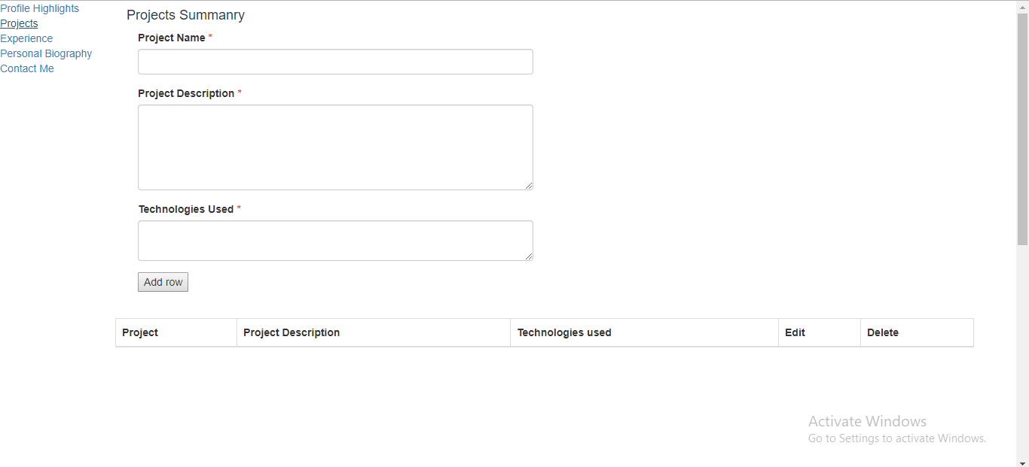

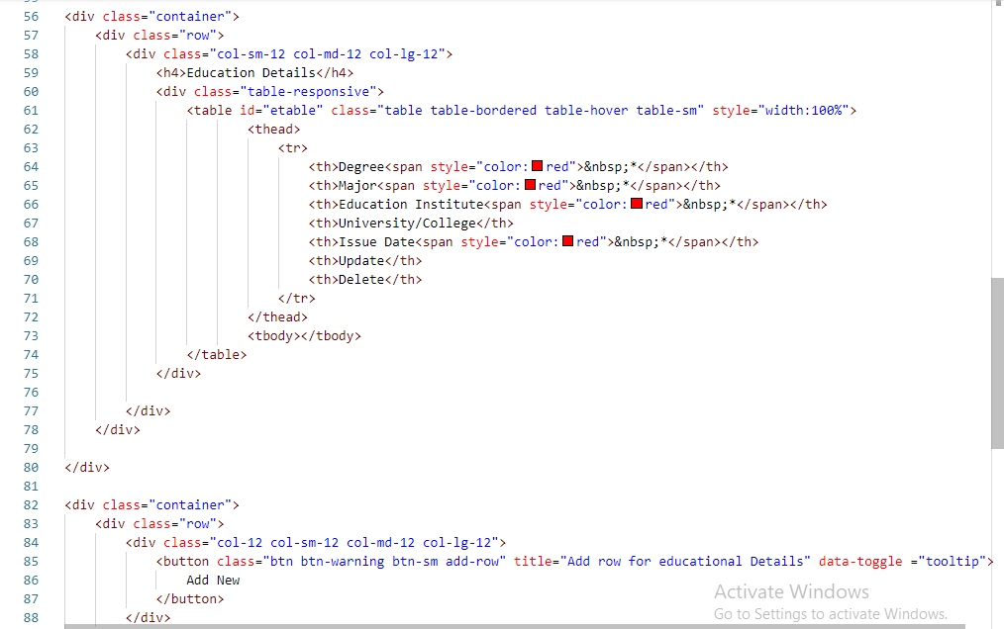

1. I applied validation on the input field without entering mandatory data, data wont insert.

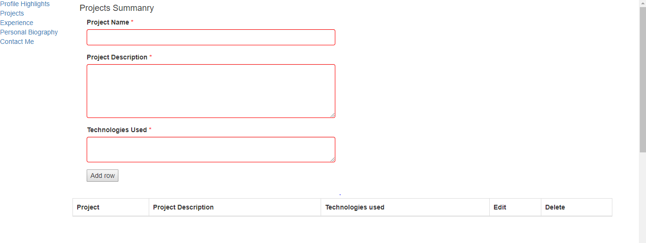

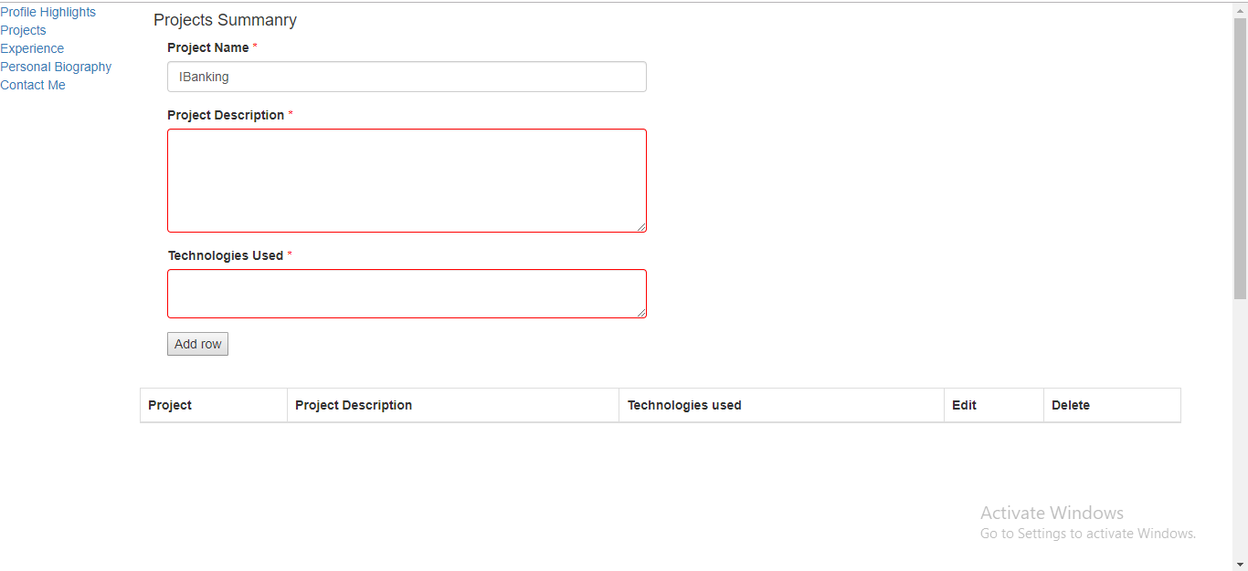

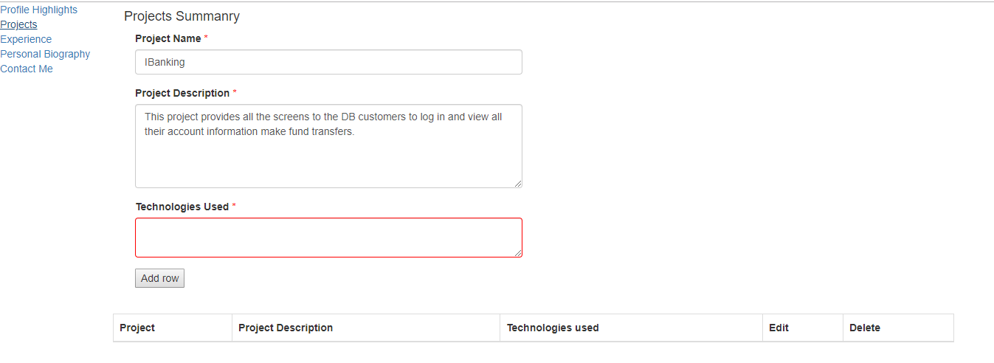

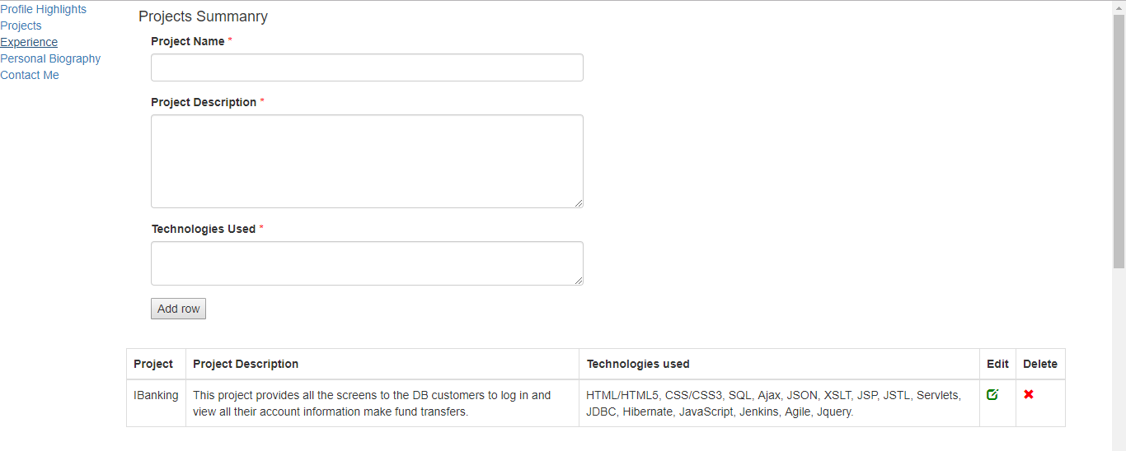

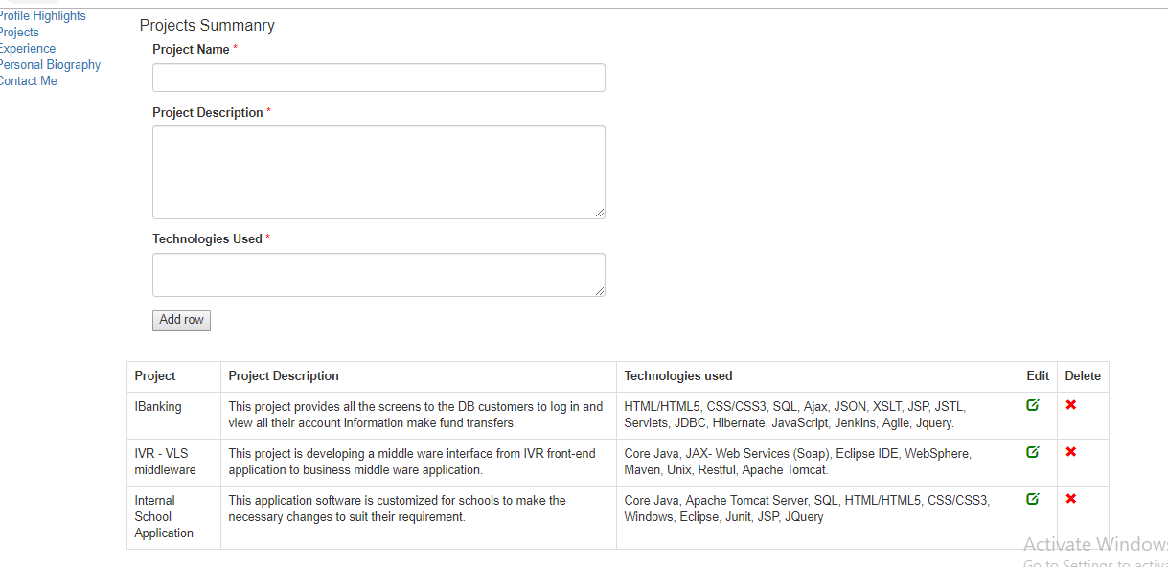

1. I enabled the edit & delete features in the screen while editing save button will enable after updating the fields it will save the data to Html table.

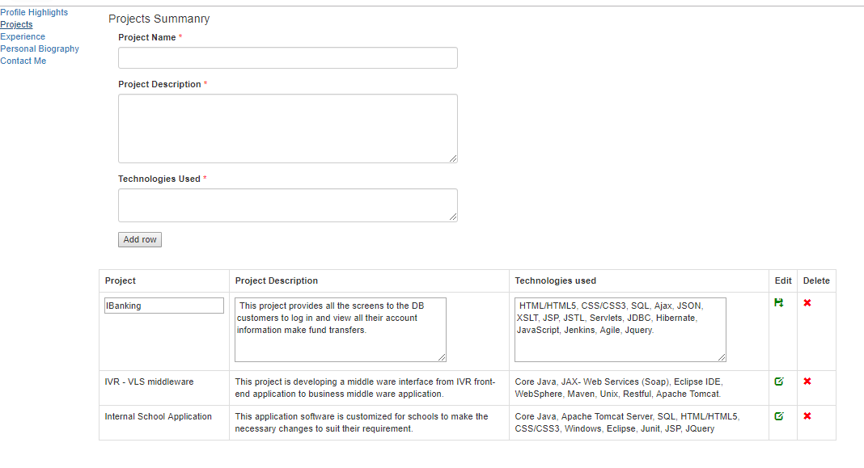

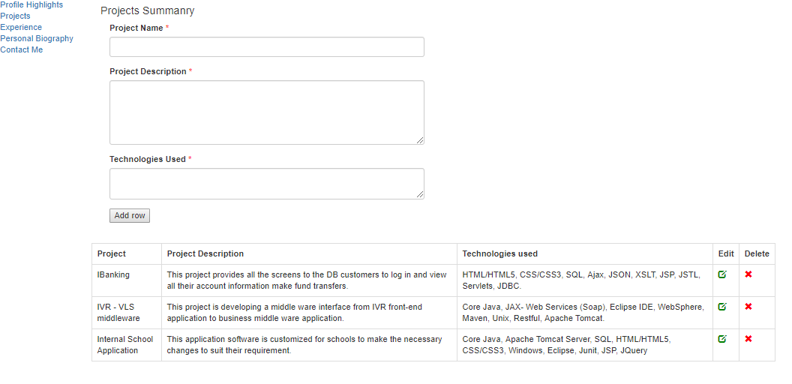

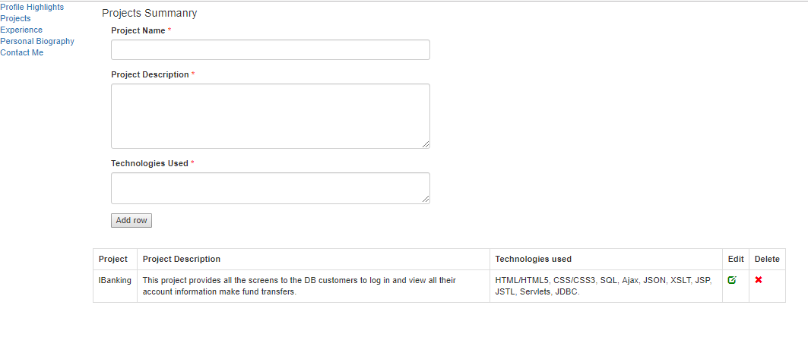

1. The below one is educational page by adding new row I am adding the details related to educational to the html table. Please find the snippets.

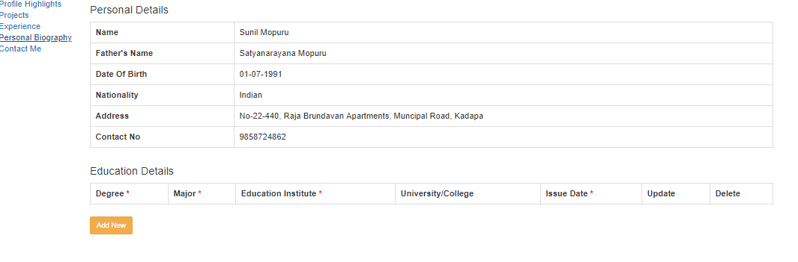

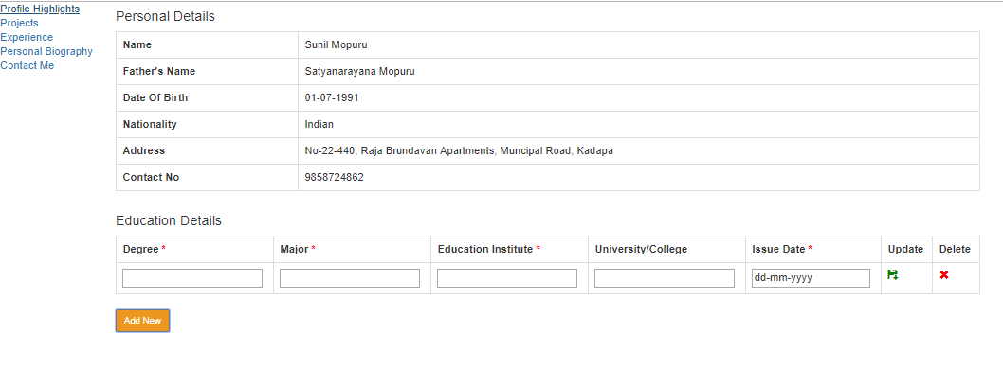

1. Without entering the data not allowing to save the data.

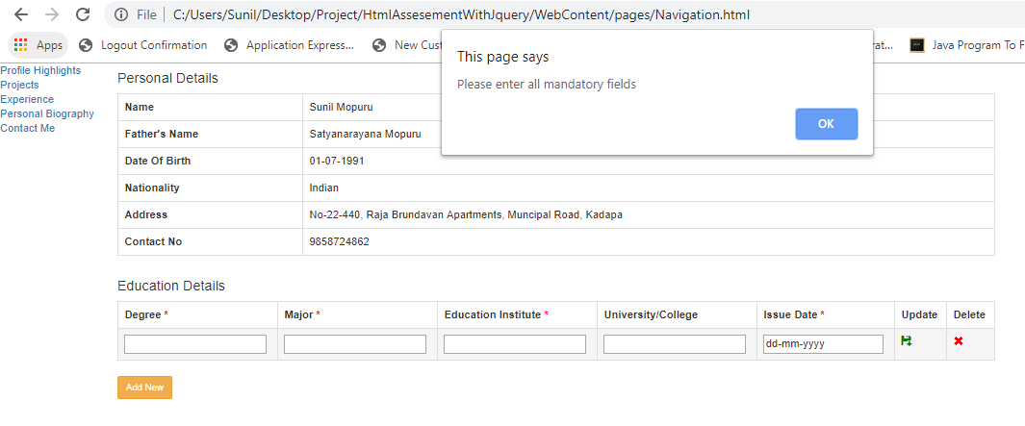

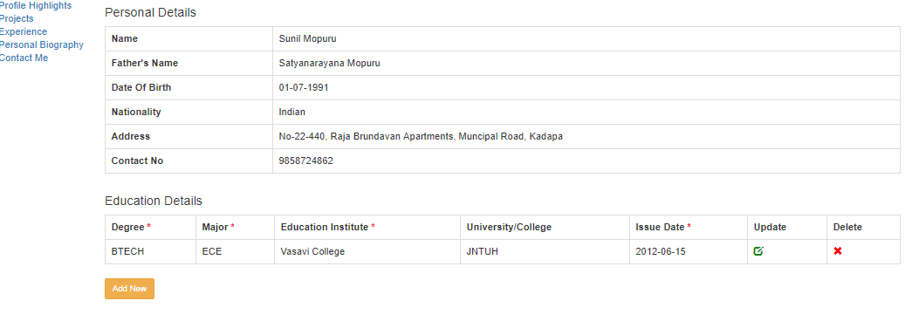

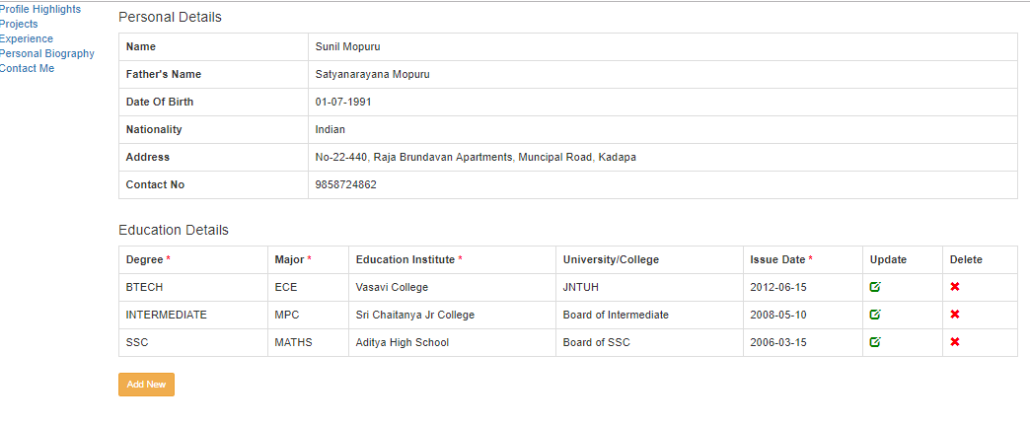

Edit features

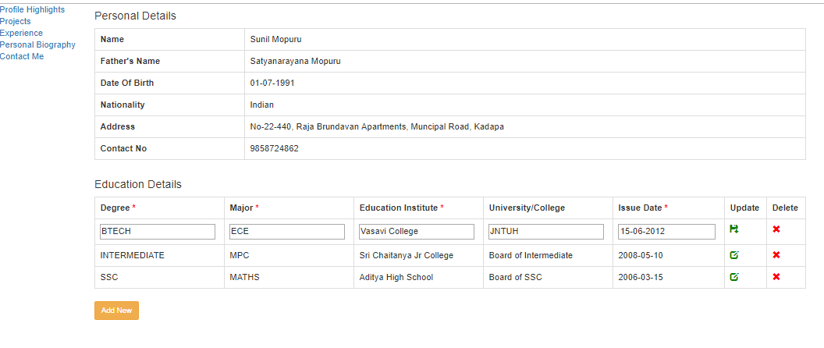

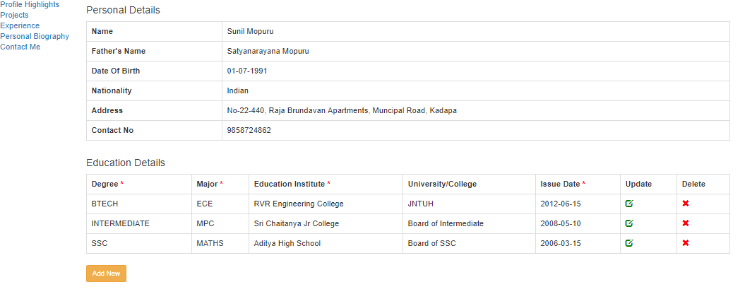

Delete feature

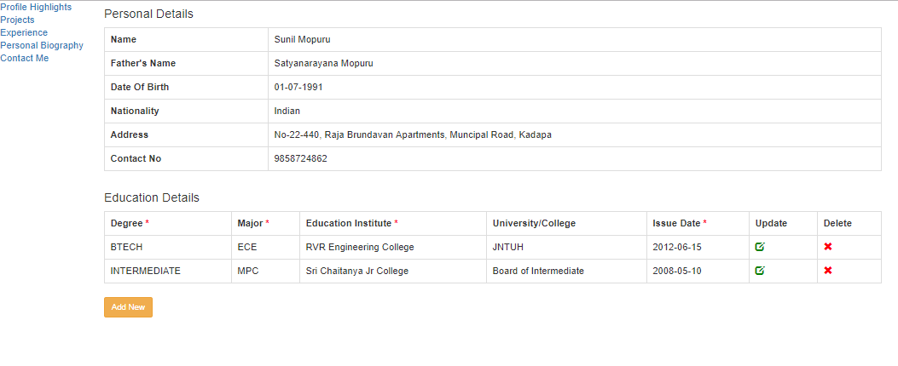

Experience page#

1. By submitting row am saving the data into html page

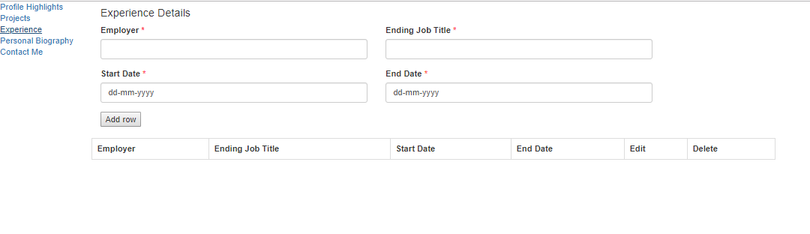

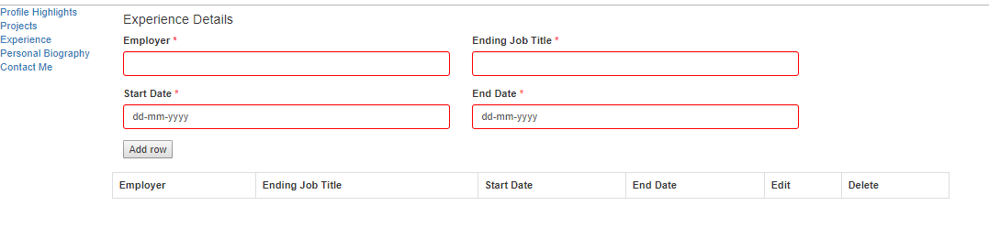

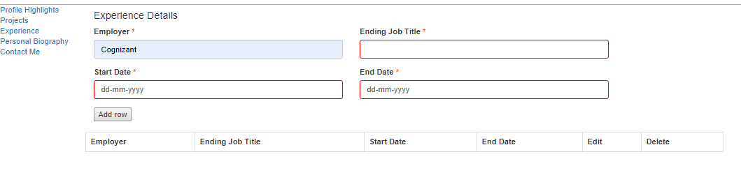

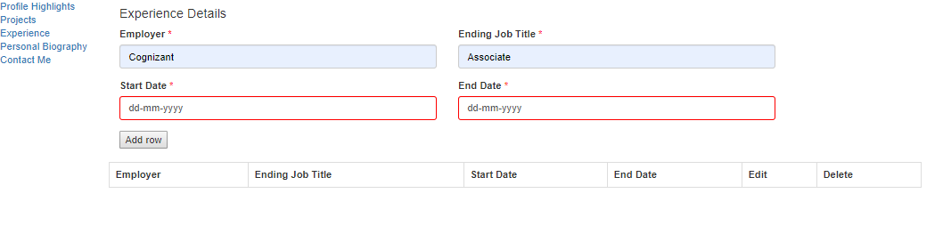

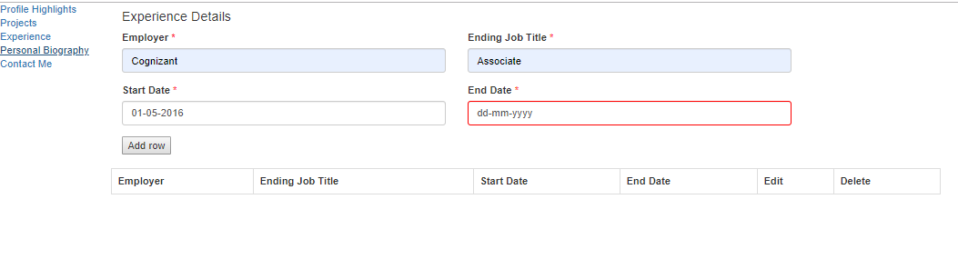

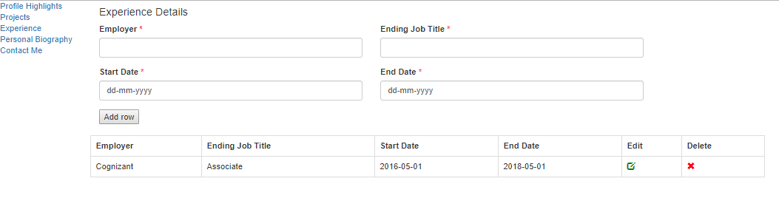

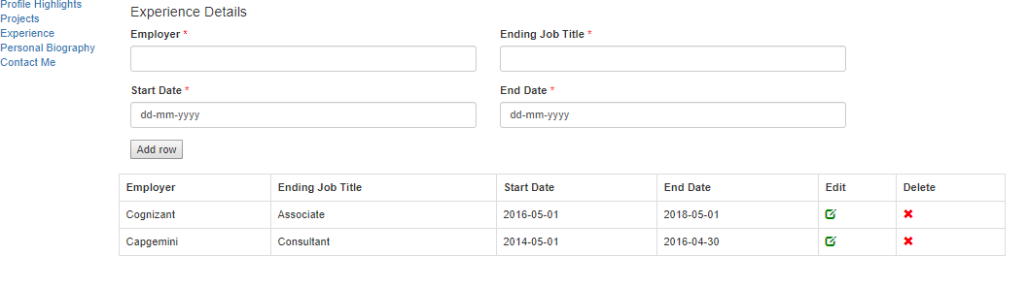

Edit features at row level

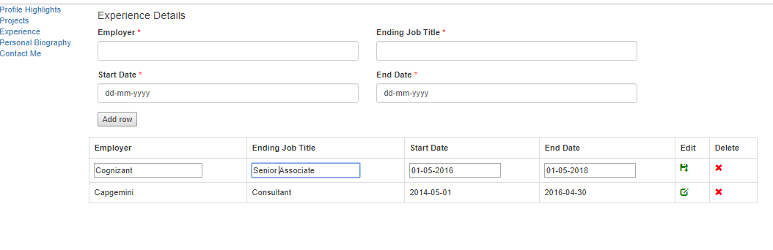

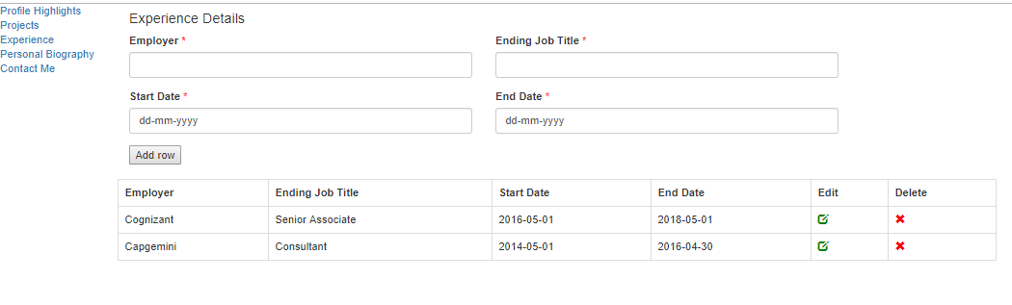

Delete feature at row level

