GitHub Tutorial

# Create Account At Github

Create an account at Github.

The URL of Github is<https://github.com>

If You don’t have github account then click SignUp for Github button.

If You have github account then click SignIN button.

# Create Repository

If you want to create new Repository then click New Repository Button. After create repository you will get a ssh link for connect github from desktop command prompt. Like<https://github.com/DemoGit/demo_maven.git>

# Install git at your machine

* Install git at your windows machine from
  + <https://gitforwindows.org/>

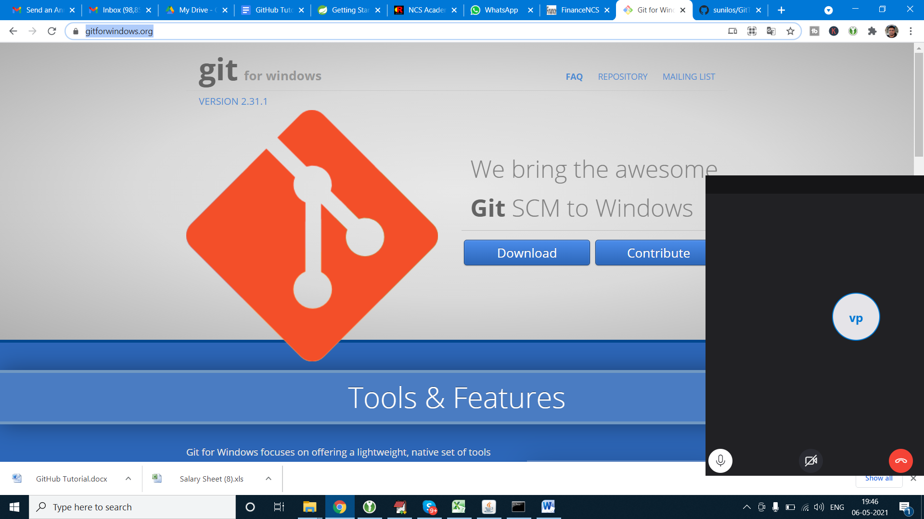

* Install git at your linux machine :

sudo apt-get update

sudo apt-get install git

Now that you have git installed

Configure git :

git config --global user.name "Your Name"

git config --global user.email "youremail@domain.com"

# Connect Git via machine

1. Create directory where you want to store your repo

mkdir TestGit

2. After create directory enter in directory

cd TestGit/

3. Clone the repository at your machine by link which is provide by git at the time of create repository

git clone <https://github.com/DemoGit/demo_maven.git>

4. After successful cloning repo at your machine check the repository and enter in repo

cd demo_maven

5. For get branch

git branch

6. Gor check update –

git status

7. Add Folder of file in git –

git add .

8. After this commit and add comment –

git commit -am "add new project”

9. If ask for mail-

git config --global user.email "emailaddress"

10. If ask Username –

git config --global user.name "name"

11. Push at master –

git push origin master

12. For check Configuration –

git config --list

## Create new Subbranch

1. Create sunbranch of master in web test_demo

2. For add master code in subbranch –

git pull

git pull origin audi

3. Then it give all sub branch name

4. For pull in specific branch give branch name –

git checkout test_demo

5. Now we enter in subbranch.

6. For get branch –

git branch

7. Repeat procedure 7-11 of **Connect Git via machine** if any changes.

8. For add changes in master click **compare and pull request** at web.

9. **Step 1:** From your project repository, bring in the changes and test.

git fetch origin

git checkout -b test_demo origin/test_demo

git merge master

**Step 2:** Merge the changes and update on GitHub.

git checkout master

git merge --no-ff test_demo

git push origin master

10. Check Subbranch and master at web manually

git checkout master & git merge --no-ff test_demo &git push origin master

**Setting your email address for every repository on your computer**

1. Open Terminal (for Mac and Linux users) or the command line (for Windows users).
2. Set your email address with the following command:

git config --global user.email "[*your_email@example.com*](mailto:your_email@example.com)"

1. Confirm that you have set your email address correctly with the following command.

git config --global user.email

# [your_email@example.com](mailto:your_email@example.com)

## Commit on Branch

Check branch

git status

Change Branch

git checkout SLJuly2015

Commit to branch

git push origin SLJuly2015

## Setting your email address for a single repository

You may need to set a different email address for a single repository, such as a work email address for a work-related project.

1. Open Terminal (for Mac and Linux users) or the command line (for Windows users).
2. Change the current working directory to the local repository in which you want to set your Git config email.
3. Set your email address with the following command:

git config user.email "*your_email@example.com*"

1. Confirm that you have set your email address correctly with the following command.

git config user.email

your_email@example.com