\*\*\*\*\*\*\*\*\*\*\*\*\*\*\*\*\*\*\*\*\*\*\*\*\*\*\*\*\*\*\*\*\*\*\*\*\*\*\*\*\*\*\*\*\*\*\*\*\*\*\*\*\*\*\*\*\*\*\*\*\*\*\*\*\*\*\*\*\*\*\*\*\*\*\*

Summary

\*\*\*\*\*\*\*\*\*\*\*\*\*\*\*\*\*\*\*\*\*\*\*\*\*\*\*\*\*\*\*\*\*\*\*\*\*\*\*\*\*\*\*\*\*\*\*\*\*\*\*\*\*\*\*\*\*\*\*\*\*\*\*\*\*\*\*\*\*\*\*\*\*\*\*

Provided 3 custom heuristic functions, for calculating best evaluation heuristic, they are

1. Open move Score – calculating the number of moves made by the player, the more moves by the player, better the score.
2. Improved Score – calculating the number of moves difference between the player, the more moves made by player, becomes ahead in the game by the extra move made.
3. Large move score – calculating the difference of numbers of move made by player with twice the number of moves made by opponent player, penalizing more on number of moves, which gives better result with open moves.

Here is the result of tournament.

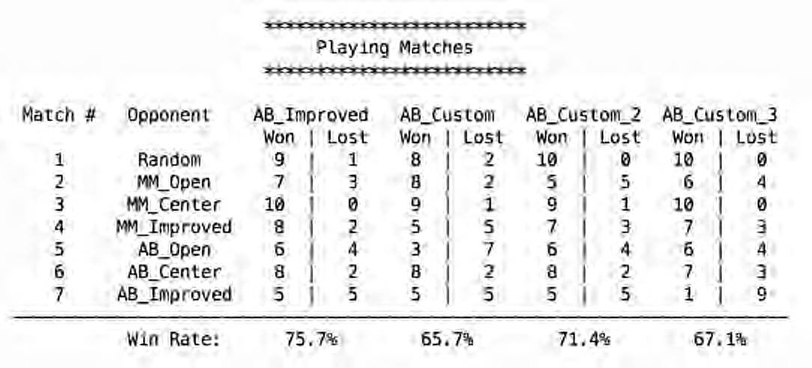

Here, the improved one have higher winning rate than others, which was difference between the moves and will be recommended.