Procedure of the Experiment

For the experiment, Sound and Video from the speaker was recorded for Spanish and Sinhala languages with recorded image sequence have each 6 emotional set like Angry, Happy, Sad, Surprise, Dislike and Fear. Total of 36 video clips recorded of similar length.

Experiment A- Original Emotions

Consent for each media clip was recorded from the subjects in different types like With audio, With Video and With both audio and video. Audio and Video Dominance was observed and recorded.

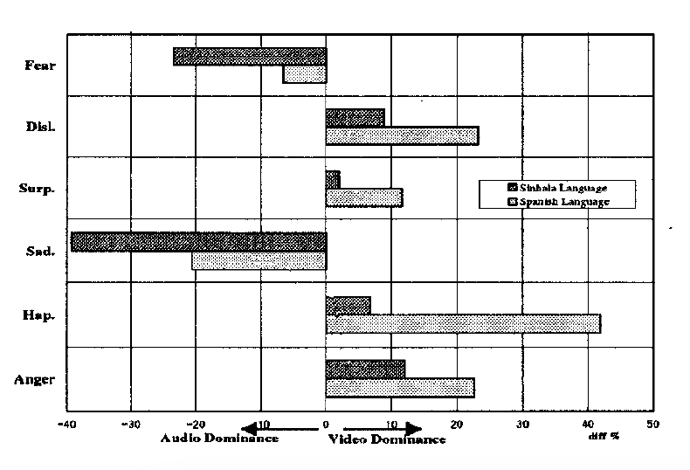

It is observed that humans are good at recognizing emotions with visual rather than audio appearances. Majority of percentage of dominations was recorded with Spanish and Sinhala for Video which are 22% and 42% respectively.