Work

Games links

Games:

1. Roller Madness

<https://eshwar-13.itch.io/rollermadness>



1. Box Shooter

<https://eshwar-13.itch.io/boxshooter>

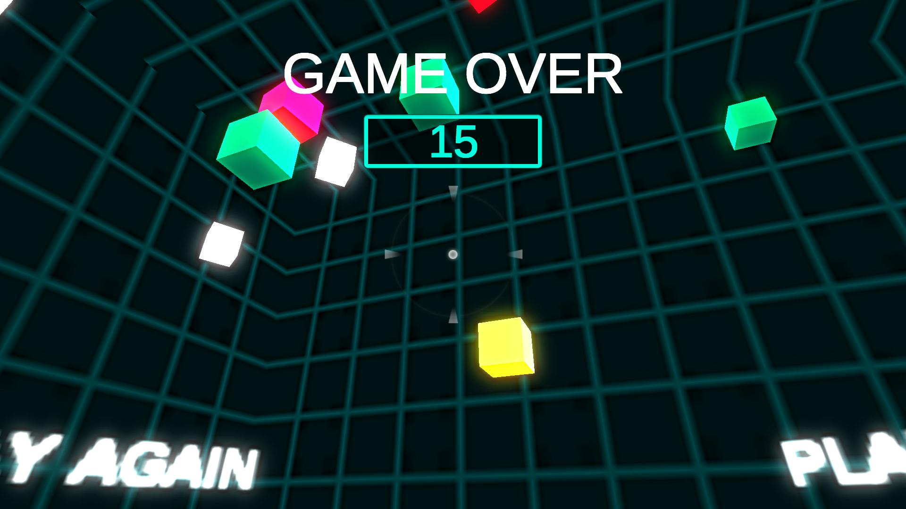

1. Solar system simulation

<https://eshwar-13.itch.io/solar-system-simulation>

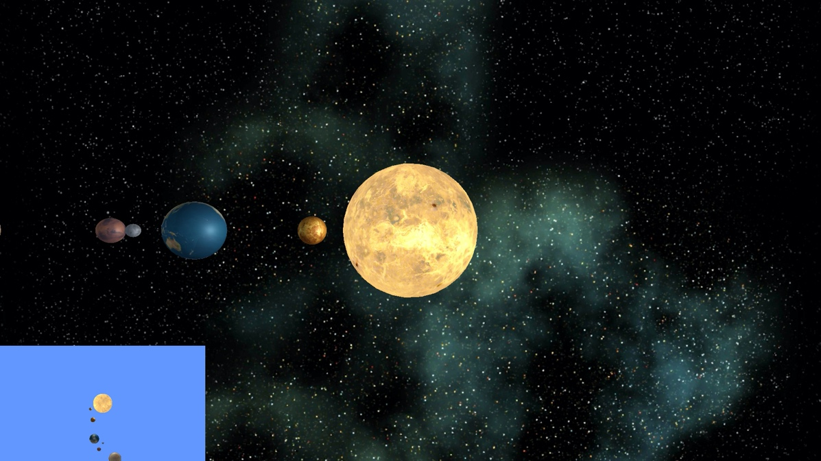

Articles:

<https://eshwar-veesam.medium.com/>

<https://eshwar-veesam.medium.com/natural-user-interfaces-84925be14a93>

<https://medium.com/@eshwarveesam09/useful-design-links-to-bookmark-b782c8495f12>

<https://medium.com/@eshwarveesam09/best-curated-newsletters-%EF%B8%8F-c3bff40074c4>

<https://medium.com/@eshwarveesam09/masters-d10b33cc2f6>