INTERNAL — EXECUTIVE BRIEFING

Profound vs. Evidence-GEO
Capability Comparison & Gap Analysis
Where the commercial market leader is ahead, where our build leads, and what to prioritize

Audience: leadership, product, and engineering
August 2026

Contents

1. Executive summary 3
2. Context, scope, and method 5
3. The two products at a glance 6
4. How each product operates 7
5. The core methodological difference 9
6. Capability comparison (head to head) 10
7. Where Profound leads — the gaps 11
8. Where Evidence-GEO leads 14
9. Prioritization and roadmap 16
10. Recommendation 18
11. Appendix: matrix, figures, definitions 19

1. Executive summary
This briefing compares Profound, the leading commercial platform for AI-search visibility and Answer Engine Optimization (AEO), against Evidence-GEO, our internally developed system for monitoring what large language models say about our therapies. The objective is practical: identify what Profound provides that Evidence-GEO does not, quantify where it matters, and recommend what to prioritize — while being explicit about the capabilities where Evidence-GEO already leads and should be protected.
The two products are not direct competitors. Profound is a horizontal, marketing-led platform used by consumer and enterprise brands to measure and grow their presence across consumer AI answer engines, and increasingly to act on that data through automated content generation. Evidence-GEO is a vertical, governance-first system built for a regulated pharmaceutical context, where medical accuracy, adverse-event handling, auditability, and Medical-Affairs approval are primary requirements. A material share of Profound's feature set — commerce visibility, advertising, autonomous publishing — is either irrelevant or counter-indicated in pharma. Conversely, several of Evidence-GEO's core capabilities have no equivalent in Profound.
Read against that backdrop, the gaps that genuinely matter for the Evidence-GEO roadmap concentrate in seven areas:
- Answer-engine coverage. Profound captures answers from up to ten consumer answer engines as users experience them. Evidence-GEO queries five model APIs, which are the underlying models rather than the consumer products our audiences read. This is the most consequential gap.
- AI-search demand data. Profound's Prompt Volumes exposes real AI-search demand from a proprietary dataset of user prompts. Evidence-GEO harvests forum questions with no volume signal, and therefore cannot prioritize by how frequently a question is actually asked.
- Citation and source analytics. Profound quantifies which domains most influence AI answers. Evidence-GEO captures cited URLs per response but produces no aggregate source-influence view.
- The action layer. Profound converts findings into a prioritized, executable work plan. Evidence-GEO surfaces recommendations but does not operationalize them.
- Enterprise platform maturity. Profound is a multi-tenant SaaS with role-based access, single sign-on, a public API, extensive integrations, and SOC 2 / HIPAA / GDPR / CCPA posture. Evidence-GEO is a single-tenant proof of concept without formal controls or certifications.
- Regional and language coverage. Profound covers 150+ regions and 30+ languages. Evidence-GEO is English-only and single-region.
- Own-property analytics. Profound measures how AI crawlers reach the brand's own sites and how AI referrals convert. Evidence-GEO has no server-side analytics.
Evidence-GEO nonetheless leads Profound on the dimensions that define its mission: cross-model consensus with an arbitration step and verified ground-truth fallback; an immutable, role-tagged audit trail with versioned scoring and human override; PII/PHI scrubbing, prompt-injection screening, and fail-closed adverse-event routing to pharmacovigilance; a clinician-grade answer path; a pharma-specific competitive-positioning taxonomy; and the ability to run inside the organization's controlled environment. These are not features Profound offers, and they are precisely what a pharmaceutical deployment requires.
Recommendation. Protect and deepen the compliance-first differentiators; close the two gaps that most undermine our own value proposition — real answer-engine coverage and aggregate citation analytics — and move the platform out of proof-of-concept status with a durable datastore, access controls, and a formal compliance roadmap. Treat the broad horizontal features (commerce, advertising, autonomous publishing) as explicitly out of scope.

2. Context, scope, and method

Why this matters
For a growing share of patients, prospects, and clinicians, an AI assistant's answer is the first — and sometimes only — research they conduct before forming a view on a therapy. That channel is generated on demand, varies by phrasing and by model, and changes over time as models are retrained. It is largely invisible to the manufacturer, and it can misstate an indication, omit a brand, favour a competitor, or surface an adverse-event narrative. Measuring and, where possible, correcting that exposure is the reason Evidence-GEO exists. Benchmarking it against the strongest commercial platform in the category is the fastest way to see where our capability is genuinely differentiated and where it lags.

What was compared, and how
Evidence-GEO was assessed directly from its source repository and documentation — the project overview, the full technical design, and the complete product-requirements specification — giving an authoritative, current view of what the system does and what it explicitly treats as out of scope. Profound was assessed from its public product site, knowledge base, pricing, and multiple third-party reviews, as we do not hold an internal account.
A note on Profound's figures. Profound releases new capabilities frequently, and several public figures vary across sources and announcement dates — the size of the prompt dataset, the exact engine count, and self-serve pricing minimums among them. Where a specific number is used in this briefing it should be re-verified against the current product before any external use. The comparison is also deliberately asymmetric: a Profound capability marked "absent" in Evidence-GEO is not automatically a build target, because some Profound features do not fit — or actively conflict with — a regulated pharmaceutical setting. Each gap in Section 7 therefore carries a recommended disposition, not merely a presence/absence flag.

3. The two products at a glance
Profound is a mature commercial platform used chiefly by marketing, SEO, and e-commerce teams to measure and improve brand visibility across AI answer engines. Evidence-GEO is an internally built, compliance-first system that monitors what AI assistants say about specific therapies and flags inaccurate, risky, or competitor-favouring answers for Medical-Affairs review.
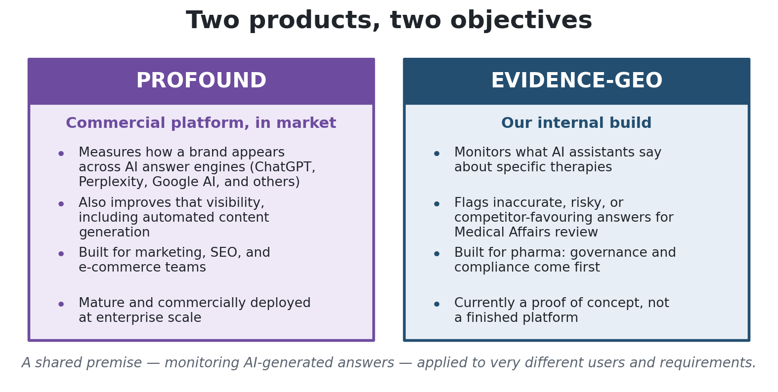
Figure 1 — A shared premise applied to very different users and requirements.
The difference in intent is what makes the comparison selective rather than a like-for-like scorecard:
Dimension | Profound | Evidence-GEO
Category | Horizontal AEO / AI-search analytics and automation | Vertical, compliance-first pharma evidence monitoring
Primary buyer | Marketing, SEO, e-commerce, growth | Medical Affairs, Brand, Pharmacovigilance, Market Access
Core objective | Measure and grow AI-search visibility | Detect risk and misrepresentation; auditable measurement
Mode of operation | Read and write (measure, then optimize/publish) | Read-only (measure and recommend; do not act)
Data surface | Consumer answer engines, as users see them | Model APIs (the underlying models, grounded where possible)
Governance | Standard enterprise SaaS; SOC 2 / HIPAA posture | Approval gates, PII/PHI scrubbing, AE routing, immutable audit
Deployment | Multi-tenant cloud SaaS | Single-tenant, in-environment (proof of concept)
Maturity | Mature, funded, fast-shipping | Proof of concept on synthetic but realistic data

4. How each product operates

Profound: measure, improve, act
Profound is organized into three pillars. Monitor measures visibility across AI answer engines — visibility score, share of voice, sentiment, keyword themes, citation authority, and competitor benchmarking — refreshed daily, alongside Conversation Explorer (intent, audience, and keyword-hierarchy views) and Prompt Volumes (real AI-search demand). Create generates and publishes AEO-optimized content through autonomous agents that research what engines cite, draft matching content, publish it, and then track whether it earns citations. Operate converts the data into a ranked action plan — surfacing the highest-impact opportunities, decomposing them into tasks, and, where appropriate, executing them, with Ads Studio extending this into paid placement.
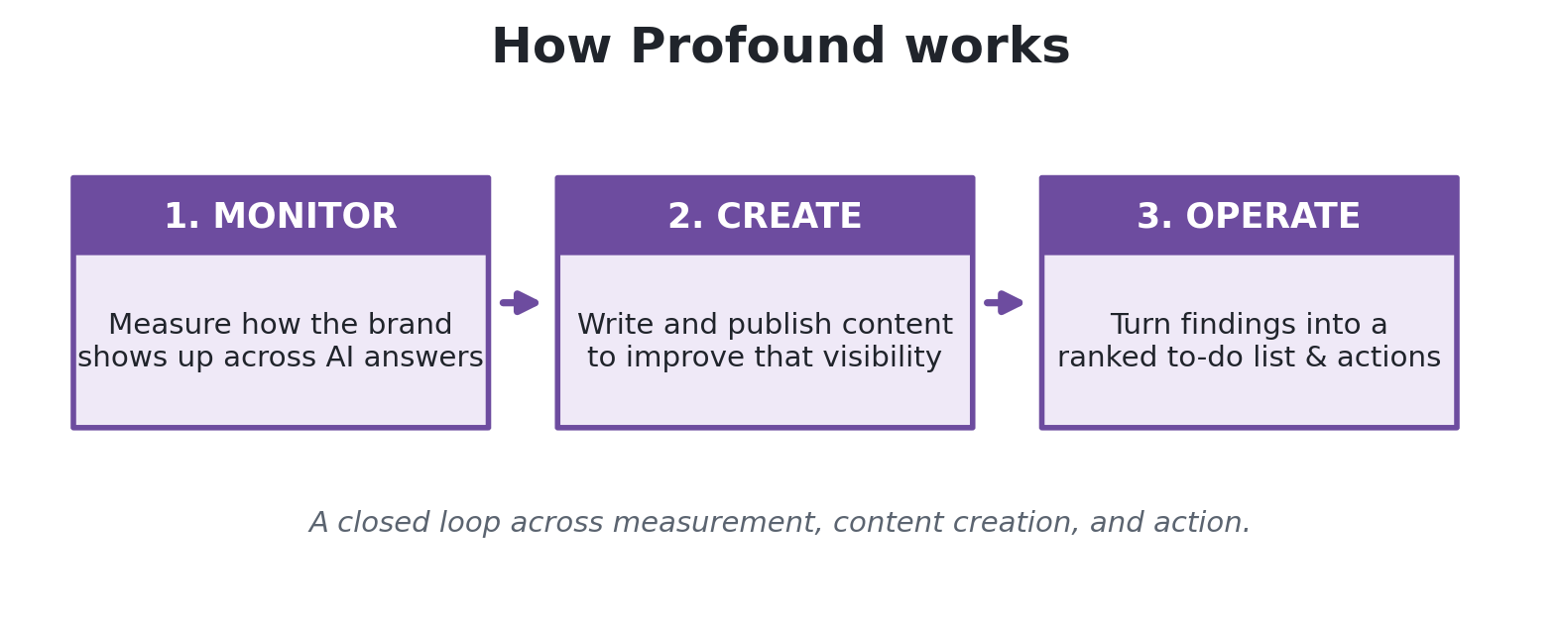
Figure 2 — Profound spans measurement, content creation, and action as a closed loop.

Evidence-GEO: monitor with governance and an auditable record
Evidence-GEO runs a six-stage workflow. It discovers real patient questions from public health communities, has Medical Affairs approve the question bank through a two-gate governance flow, then dispatches each approved question to every enabled model across three audiences — Prospect, Patient, and Provider — with retry, rate-limiting, budget controls, resume, and cancellation. Every answer is stored immutably and scored by a judge model for brand sentiment and competitive position. A consensus step compares the models and, on disagreement, pulls verified ground-truth; deterministic rules then raise alerts, and results surface on a dashboard with a natural-language query option.
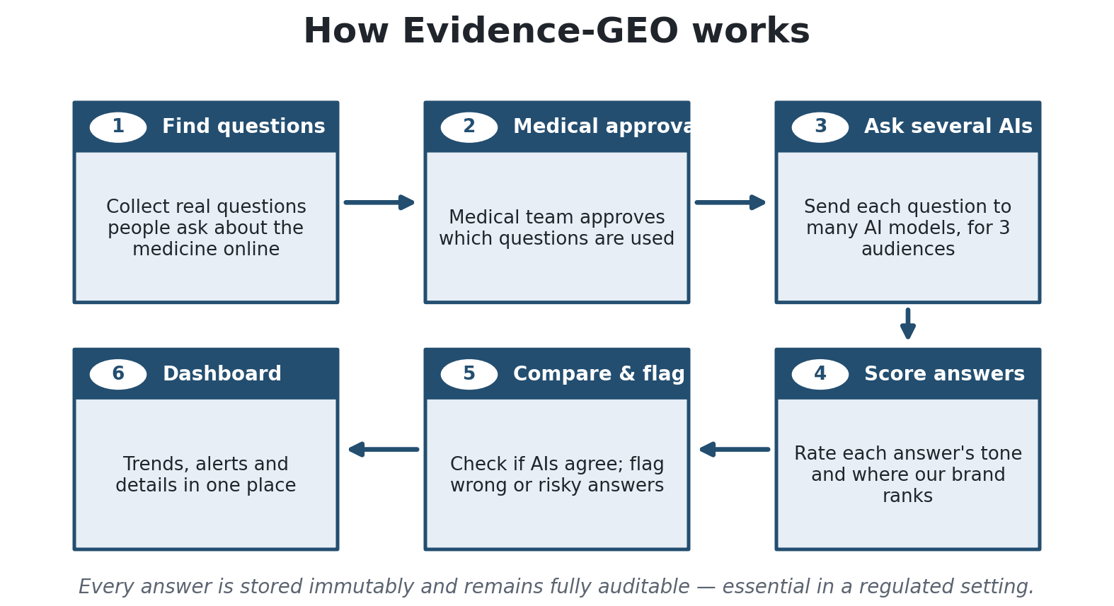
Figure 3 — Evidence-GEO emphasizes approval, immutability, and cross-model consensus at every step.

Specifics worth noting
The monitored models are Anthropic Claude, Amazon Nova Pro, and Meta Llama (via Amazon Bedrock), Google Gemini, and OpenAI GPT-4o (grounded with live web search for real citations), plus EvidenceMD — an automated clinical-reasoning API — for the Provider audience. Each response receives a sentiment score from −1.0 to +1.0 and one of five competitive positions (first-line recommended, among options, second-line, not recommended, or not mentioned), with extracted brand mentions and up to five key claims. Consensus is classified as full, partial, or missing; when it is not full, the system attaches verified ground-truth (a curated llms.txt plus schema.org/Drug structured data). A complementary social-listening surface captures posts and comments with separate comment-level sentiment, auto-translation, and adverse-event routing. The system runs today as a proof of concept on SQLite in a single container, on synthetic but realistic data with no PII.

5. The core methodological difference
The single most consequential difference between the two systems is what each one measures. Profound captures the answer a real user receives from the consumer product — ChatGPT, Perplexity, Google AI Overviews, Copilot, and others — including that product's retrieval, ranking, safety layers, and system prompts, through the browser. Evidence-GEO queries the underlying model APIs. Those APIs are grounded with live web search where possible to recover citations, but they are not the same artifact a patient or clinician sees inside the consumer product.
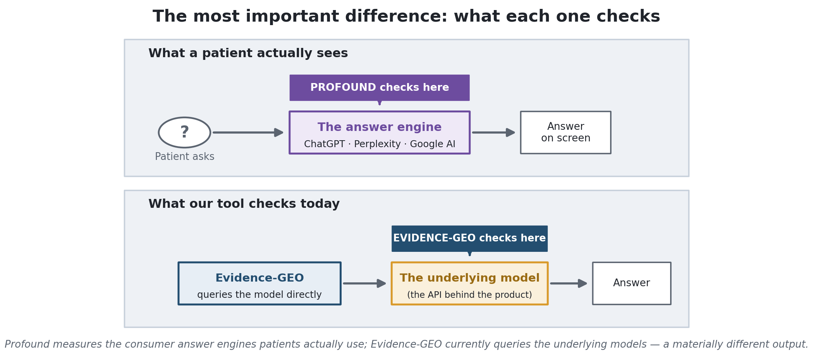
Figure 4 — Profound measures the consumer answer engines; Evidence-GEO currently queries the underlying models.
For a system whose purpose is to measure the real exposure of our therapies, measuring the model rather than the product is a substantive limitation. It also explains several individual gaps that follow — engine coverage, citation analytics, and regionality are all facets of this one choice. The API approach is not without merit: it buys determinism, reproducibility, cost control, and the clean audit trail that underpins Evidence-GEO's consensus and governance layers. The recommendation is therefore additive rather than a replacement — add consumer-surface capture for the highest-traffic engines while retaining the API path for auditable, model-level measurement.

6. Capability comparison (head to head)
The table below compares the two products on the monitoring capabilities that directly overlap. "Assessment" is stated from the Evidence-GEO perspective.
Capability | Profound | Evidence-GEO | Assessment
Visibility / presence in AI answers | Visibility score, share of voice, prominence; daily | Five-class positioning incl. not-mentioned; per run | Even  Profound more quantified
Brand sentiment | Good/neutral/bad, with depth | −1.0 to +1.0, plus rationale and key claims | Lead  Richer per answer
Competitive positioning | Share of voice vs competitors | Five-class line-of-therapy taxonomy + alert | Lead  Pharma-specific
Answer-engine coverage | Up to ten consumer engines | Five model APIs + clinical model | Gap  Models, not products
Citations / sources | Aggregate citation share and authority | Per-response cited URLs; ground-truth | Partial  No aggregate view
Cross-model consensus | None (per engine) | Arbitration + ground-truth fallback | Lead  Unique to us
Change / drift over time | Time-series visibility trends | Run-over-run diff (lexical) | Even  Ours per-answer; upgrade to semantic
Themes / trending topics | Themes, trending, hierarchies | Theme discovery | Partial  No trending/hierarchies
AI-search demand | Prompt Volumes (proprietary) | Forum harvest, no volume | Gap  Profound moat
Regions / languages | 150+ regions, 30+ languages | English, single region | Gap  —
Natural-language query | Ask Profound | 'Ask a Question' (optional) | Even  Parity
Alerts / notifications | Monitoring + channels (Slack) | Typed deterministic rules | Even  Ours typed; add channels

7. Where Profound leads — the gaps
Each gap below states what Profound provides, Evidence-GEO's current status, the business impact, the build effort, and a recommended disposition. Relevance is judged against the Evidence-GEO mission, not Profound's general market value.

7.1 Answer-engine coverage
Relevance: High
Profound. Captures answers from up to ten consumer answer engines as users experience them — ChatGPT, Perplexity, Google AI Overviews and AI Mode, Copilot, Gemini, Grok, DeepSeek, and Meta AI — via browser capture with screenshot archiving.
Evidence-GEO. Queries five model APIs (Claude, Nova, Llama, Gemini, GPT-4o) plus EvidenceMD. It does not cover Perplexity, Google AI Overviews/AI Mode, Copilot, Grok, or DeepSeek, and even the shared models are measured at the API layer rather than the product layer.
Impact. We under-measure the surfaces our audiences actually use — AI Overviews and Perplexity are heavily used for health queries — and we measure raw models rather than the retrieval-augmented answers patients read.
Effort. High. It requires a browser-capture harness with handling for non-determinism, anti-bot measures, and screenshot storage — a different data-acquisition paradigm from the current provider abstraction.
Recommendation. Priority. Add consumer-surface capture for at least Google AI Overviews/AI Mode and Perplexity, retaining the API path for deterministic, auditable measurement and consensus. Present the two as clearly distinct surfaces.

7.2 AI-search demand data
Relevance: High
Profound. Prompt Volumes exposes AI-search demand and trending terms from a proprietary panel of user prompts, refreshed weekly, with a data-driven prompt-recommendation and content-gap engine.
Evidence-GEO. Harvests verbatim questions from health communities — directionally similar for discovery, but with no volume, frequency, or trend signal.
Impact. Without demand weighting, the approved question bank is prioritized on clinical judgment alone, so we may over-monitor rare questions and miss high-volume ones.
Effort. High to match; medium for a proxy. Profound's panel is a genuine data moat we cannot replicate, but a usable proxy (cross-forum frequency plus third-party search-volume data) is achievable.
Recommendation. Build a demand-proxy score to rank the question bank; treat a true prompt-volume dataset as a longer-term or partner-sourced ambition.

7.3 Citation and source-influence analytics
Relevance: High
Profound. Quantifies which domains most influence AI answers — citation share, citation authority, enhanced categories, and gap analysis of prompts where competitors are cited but the brand is not.
Evidence-GEO. Captures the specific URLs and claims a grounded model cited on an individual response, and publishes ground-truth, but produces no aggregate view of which sources most shape answers about our therapies.
Impact. Aggregate citation analytics is precisely the artifact that turns our evidence-gap mission into action: it shows Medical Affairs where to publish and which third-party sources to correct. We already collect the raw material and stop short of the analysis.
Effort. Medium. The per-response citation data exists; this is largely aggregation, domain normalization, and new dashboard surfaces.
Recommendation. Priority. High value at moderate effort, directly on-mission.

7.4 The action layer (optimization and opportunity workflow)
Relevance: Medium
Profound. A read/write platform: Aim, Projects/Actions, and gap analysis convert visibility data into a ranked list of opportunities, each decomposed into tasks, with an AEO content score to rate draft content.
Evidence-GEO. Measurement-only. It surfaces recommended next steps and per-alert guidance but does not formalize them into a ranked, trackable workflow, and does not score or act on content.
Impact. Users receive insight but must translate it into work manually. A lightweight opportunity/action layer would materially increase operational value without crossing regulatory lines.
Effort. Medium for a recommendations/opportunity tracker; the autonomous-execution and auto-publishing components are high effort and largely out of scope for pharma.
Recommendation. Build a prioritized, human-led action tracker on existing alerts and evidence gaps. Exclude autonomous publishing, which conflicts with medical review.

7.5 Enterprise platform maturity
Relevance: High
Profound. Multi-tenant SaaS with an agency mode, role-based access control, single sign-on (SAML/OIDC), a public REST API with documentation, extensive CMS/analytics/CDN integrations, and SOC 2 Type II / HIPAA / GDPR / CCPA posture with encryption and daily backups.
Evidence-GEO. A single-tenant proof of concept on SQLite in one container, with no end-user authentication, no role-based access, no single sign-on, no multi-tenancy, no formal certifications, and no customer-facing API. Privacy-by-design is strong, but formal enterprise controls are out of scope for this phase.
Impact. For any move beyond proof of concept to an enterprise pharmaceutical deployment, these are table stakes — particularly HIPAA/SOC 2 posture, single sign-on, access control, a durable multi-user datastore, and multi-brand tenancy for different franchise teams.
Effort. High and multi-quarter, but well-understood engineering.
Recommendation. Priority for hardening the data and runtime layer (durable database, a real job queue, resumable runs, authentication, and access control); a formal certification roadmap and multi-tenancy follow. Our privacy-by-design foundation shortens this path.

7.6 Regional and language coverage
Relevance: Medium
Profound. 150+ regions and 30+ languages, with region-based prompting and localized monitoring.
Evidence-GEO. English-only, single region.
Impact. Global brands need to know what AI says in the markets and languages their patients use; today we are blind outside English.
Effort. Medium. Question banks and prompts are already configuration-driven, so adding locales is largely content plus translation, which the social-listening surface already performs.
Recommendation. Sequence after answer-engine coverage; reuse the existing translation capability.

7.7 Own-property (AI-crawler) analytics
Relevance: Low
Profound. Agent Analytics tracks AI crawlers reaching the brand's own sites from server logs, attributes AI-driven human referrals and conversions, benchmarks pages against a large network, verifies authentic bots, and offers submit-to-AI-search.
Evidence-GEO. No server-side or own-website analytics.
Impact. Useful for closing the loop on ground-truth publishing (whether AI crawlers pick up corrected evidence), but requires access to the brand's web properties and is a distinct data domain.
Effort. Medium to high; requires log access and infrastructure integration.
Recommendation. Backlog. Revisit once ground-truth publishing is an active workflow with a concrete site owner to integrate.

7.8 Additional gaps (summary)
The remaining differences are lower relevance or off-mission and are consolidated here.
Gap | Note | Relevance | Disposition
Conversation / audience analytics | Demographics, keyword hierarchies, query fanouts, trending topics | Medium | Later (prioritize trending)
Update cadence & scale | Daily runs, near-real-time crawler data; smoother trends | Medium | Fold into hardening
Semantic drift detection | Ours is lexical today; embeddings would catch reworded shifts | Medium | Quick win — upgrade
E-commerce / Shopping visibility | Built for retail; off-mission | Low | Out of scope
Ads Studio / paid placement | Advertising optimization; off-mission | Low | Out of scope
Autonomous content publishing | Conflicts with medical review (MLR) | Low | Out of scope
Public Index / leaderboard | Inappropriate for regulated therapies | Low | Out of scope

8. Where Evidence-GEO leads
A comparison that lists only shortfalls would misdirect the roadmap. Evidence-GEO has defensible advantages that Profound does not offer and has little reason to build. Protecting and deepening these should rank alongside closing the gaps.
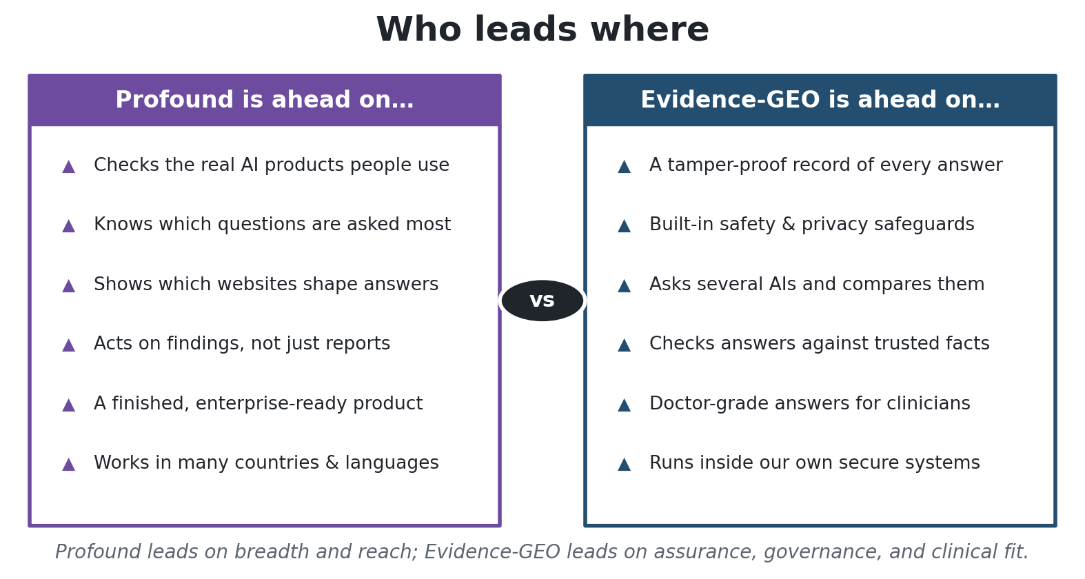
Figure 5 — Profound leads on breadth and reach; Evidence-GEO leads on assurance, governance, and clinical fit.
Advantage | What Evidence-GEO provides | Profound
Cross-model consensus | Arbitration across models — agreement level, divergence, confidence, and a synthesized answer — with verified ground-truth fallback on disagreement | None (per-engine only)
Compliance-grade audit | Append-only responses and audit log, role-tagged (orchestrator vs target), versioned scoring, human override that preserves the AI score | Standard SaaS logging
Pharma governance | Two-gate Medical-Affairs approval, PII/PHI scrubbing, prompt-injection screening, fail-closed adverse-event routing to pharmacovigilance | Not built for regulated pharma
Clinical-grade answers | A clinician-reasoning path (EvidenceMD / OpenEvidence) for the Provider audience | No clinical model
Pharma positioning model | Five-class line-of-therapy taxonomy, brand-vs-competitor sentiment, key-claim extraction, typed alerts | Generic share-of-voice / sentiment
Ground-truth publishing | Consumes and publishes structured brand truth (llms.txt + schema.org/Drug) | Content optimization, not domain schema
Data residency | Runs inside the organization's controlled environment; content-agnostic and configuration-driven | Multi-tenant cloud SaaS

Strategic read. Profound wins on breadth, demand data, and action; Evidence-GEO wins on depth, defensibility, and fit to a regulated vertical. The correct posture is not to replicate Profound, but to be the system a pharmaceutical company can actually deploy — closing the coverage and analytics gaps that undermine our own mission while preserving the governance advantages Profound cannot easily cross.

9. Prioritization and roadmap
Not every gap is worth closing, and effort varies widely. The map below plots each candidate by value to the mission against build effort; the strongest candidates sit toward the top.
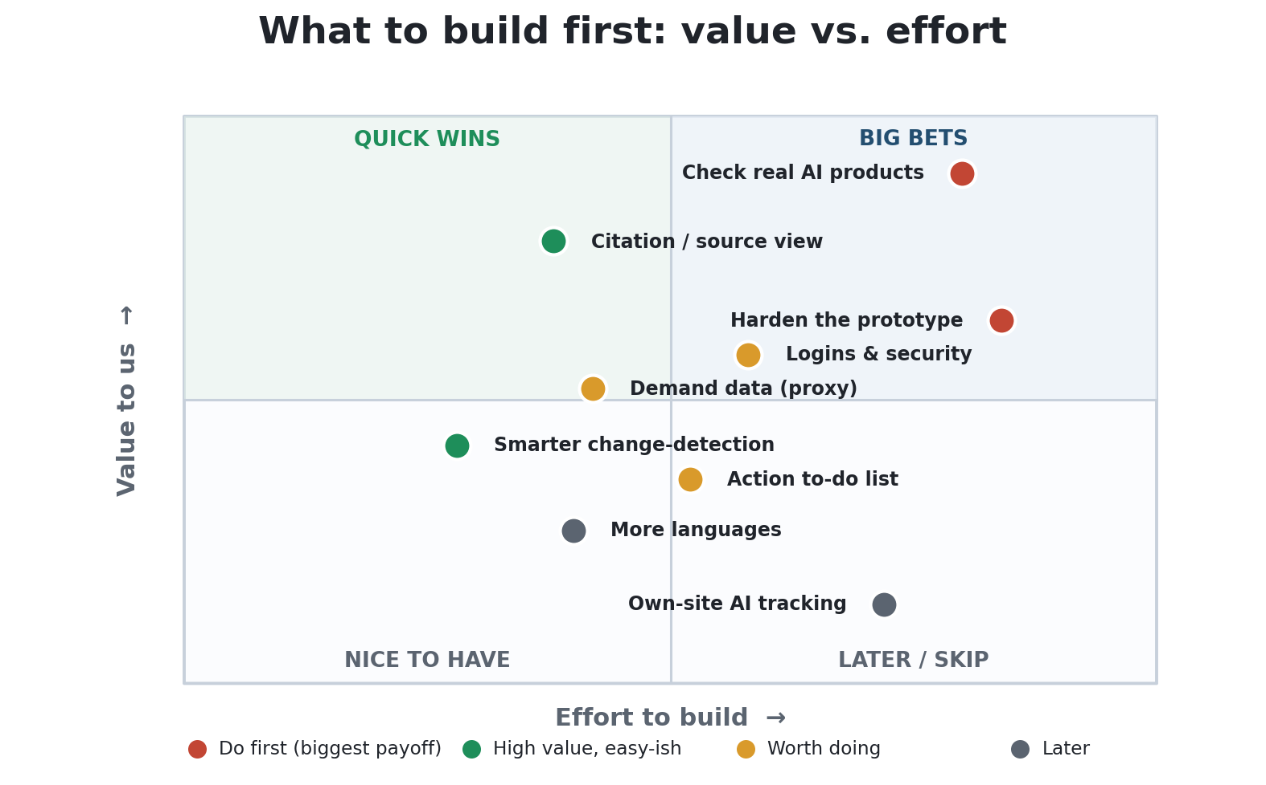
Figure 6 — Candidate initiatives, plotted by value and effort.
Translated into a phased plan:
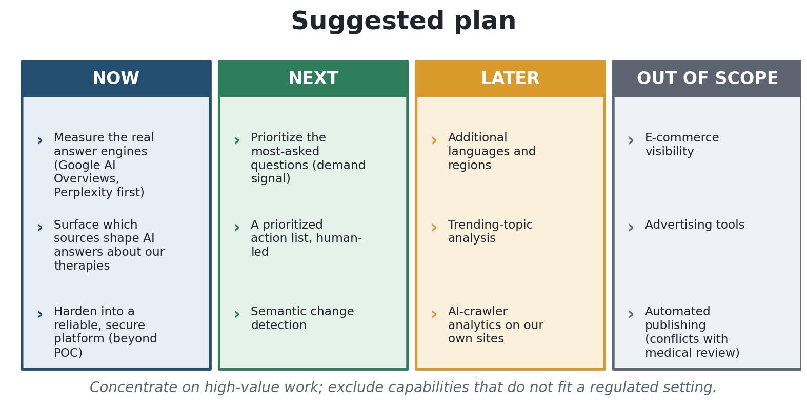
Figure 7 — A phased plan: immediate, next, later, and out of scope.
Now. Add consumer-surface capture for the highest-traffic engines (Google AI Overviews and Perplexity first); build the aggregate citation/source-influence analytics our mission already implies; and harden the platform out of proof-of-concept status with a durable database, a job queue, resumable runs, and authentication with role-based access. These items deliver the largest credibility gain from "prototype" to "deployable."
Next. Introduce a demand-proxy score so the question bank reflects real usage; formalize alerts and evidence gaps into a prioritized, human-led action list; and upgrade drift detection from lexical to semantic. Begin multi-tenancy and a formal HIPAA/SOC 2 roadmap in parallel — the privacy-by-design foundation shortens this path.
Later. Extend to priority non-English markets using the existing translation capability, add trending-topic and keyword-hierarchy analytics, and evaluate own-site AI-crawler analytics once ground-truth publishing is a live workflow.
Out of scope. E-commerce visibility, advertising tools, a public leaderboard, and autonomous publishing. Recording these as deliberate exclusions keeps the roadmap from drifting toward horizontal-platform parity that a regulated buyer neither needs nor can use.

10. Recommendation
Evidence-GEO is not behind because it was built to the wrong specification. It was built as a more careful, compliance-ready system for a harder, regulated problem — and on the dimensions that define that problem, it already exceeds the commercial market leader.
Profound is broader, more polished, and commercially proven, but it was designed for marketing and e-commerce rather than medicine. Evidence-GEO is narrower, yet it delivers what a pharmaceutical organization actually requires: an immutable, auditable record; built-in safety and privacy controls; cross-model consensus checked against verified facts; and clinician-grade answers.
To make Evidence-GEO a system a pharmaceutical company would adopt, the priority is to close a small number of specific gaps — chiefly measuring the real consumer answer engines, surfacing which sources shape AI answers, and hardening the platform beyond proof of concept — while protecting the governance and assurance advantages that are already our strongest differentiator.
In one line: adopt Profound's strengths in coverage, demand data, and citation analytics where they fit; protect the compliance-first advantages Profound cannot match; and deliberately exclude the capabilities that do not belong in a regulated setting.

11. Appendix

11.1 Consolidated feature matrix
Y = present/strong; ~ = partial/limited/POC; N = absent. "Rel." is relevance to the Evidence-GEO mission (H/M/L).
Feature | Profound | Evidence-GEO | Rel. | Note
Visibility / share of voice | Y | ~ | H | Ours: positioning incl. not-mentioned
Brand sentiment | Y | Y | H | Ours: numeric + rationale + claims
Competitive positioning | Y | Y | H | Ours: five-class line-of-therapy
Consumer answer-engine coverage | Y | N | H | Ours = model APIs, not products
Cross-model consensus | N | Y | H | Arbitration + ground-truth
Aggregate citation analytics | Y | N | H | Per-response only today
Per-response cited sources | Y | Y | H | Parity
Real AI-search demand | Y | N | H | Prompt Volumes moat
Question / prompt discovery | Y | Y | H | Ours: governed forum harvest
Drift / change over time | Y | ~ | H | Lexical → semantic
Themes / trending topics | Y | ~ | M | No trending / hierarchies
Demographics / audience data | Y | N | M | Hard to source compliantly
Natural-language query | Y | Y | M | Ours optional (Cortex)
Regions / languages | Y | N | M | English / one region
Alerts & notifications | Y | Y | M | Ours typed; add channels
Action / opportunity workflow | Y | ~ | M | Recommendations, not workflow
Content scoring (AEO) | Y | N | L | —
Autonomous publishing | Y | N | L | MLR conflict — exclude
E-commerce / advertising | Y | N | L | Off-mission
Own-site crawler analytics | Y | N | L | Needs site access
Immutable audited evidence | ~ | Y | H | Ours: append-only, role-tagged
Medical-Affairs governance | N | Y | H | Two-gate approval
PII/PHI + adverse-event routing | N | Y | H | Fail-closed to pharmacovigilance
Clinical-reasoning answers | N | Y | H | EvidenceMD / OpenEvidence
Multi-tenancy / RBAC / SSO | Y | N | H | Single-tenant POC
SOC 2 / HIPAA posture | Y | ~ | H | Privacy-by-design, no certs
Data residency / in-env deploy | N | Y | H | Runs in our environment

11.2 Selected figures (verify before external use)
Profound (public sources) | Evidence-GEO (current build)
Up to ~10 consumer answer engines | 5 model APIs + EvidenceMD (clinical)
Prompt dataset cited from 130M+ to 1.5B+ prompts | Forum-harvested question bank (no volume signal)
150+ regions, 30+ languages | English, single region
Citation analytics at scale (millions/day) | Per-response cited URLs only
Pricing: ~$99 / ~$399 / custom (per public tiers) | Internal build (no pricing)
SOC 2 Type II, HIPAA, GDPR, CCPA | Privacy-by-design; no formal certifications
Multi-tenant, RBAC, SSO, public API | Single-tenant; strong internal API only

11.3 Definitions
Term | Meaning
Answer engine | A consumer product that responds to natural-language questions (e.g., ChatGPT, Perplexity, Google AI Overviews).
Model / API | The underlying model that generates text. The consumer answer engine is built on top of it and adds retrieval, ranking, and safety layers.
GEO / AEO | Generative Engine Optimization / Answer Engine Optimization — ensuring a brand's information is well represented in AI-generated answers.
Citation / source | The web page a model drew on to construct an answer; aggregate citation analysis shows which sources shape answers.
Share of voice | How often a brand appears relative to competitors.
Consensus | Cross-model agreement on a question — full, partial, or missing — with divergence points and a synthesized answer.
Ground truth | Verified, structured brand facts (llms.txt + schema.org/Drug) used as the authority when models disagree.
Immutable / auditable | Records are append-only and never altered, so the original output and analysis history are preserved for review.
Multi-tenant / RBAC / SSO | Enterprise controls: separate client environments, role-based access, and single sign-on.
Adverse event (AE) | Content describing harm from a therapy; routed for pharmacovigilance review.

11.4 Sources
Evidence-GEO: repository documentation (overview, technical design, and product requirements). Profound: tryprofound.com product and pricing pages, help.tryprofound.com knowledge base, and third-party reviews. Profound figures should be re-verified against current public materials before any external use.

Internal executive briefing — Evidence-GEO product & roadmap. Prepared August 2026.

